CLASSIFICATION OF FRACTURED BONES USING MACHINE LEARNING

In this paper author is using Machine Learning Algorithm called Random Forest to predict/classify bone type and to train Random Forest algorithm author has used various types of bones images but author has not publish used dataset so I am using MURA bones dataset to train Random Forest Algorithm and then when we upload test image then Random Forest will classify type of uploaded bone image this classification will help in identifying fractures in bones whether fracture is in finger or hand or wrist etc.

To implement this project author has designed following modules

1. Dataset Collection/Upload: using this module we will upload bones dataset to application
2. Features Extraction: using this module we will extract RGB pixel values from each images and then build a future vector
3. Train and Test data split: using this module we will split dataset into train and test part where application will use 80% dataset size for training and 20% for testing
4. Build Random Forest Model: using this module we will train Random Forest Algorithm on above splitted train dataset and then apply this random forest algorithm on test data to calculate how much correctly random forest predict test images
5. Upload Test Image & Classify Bone: using this module we will upload test image and then random forest will classify type of bones.

To implement above modules we used below dataset

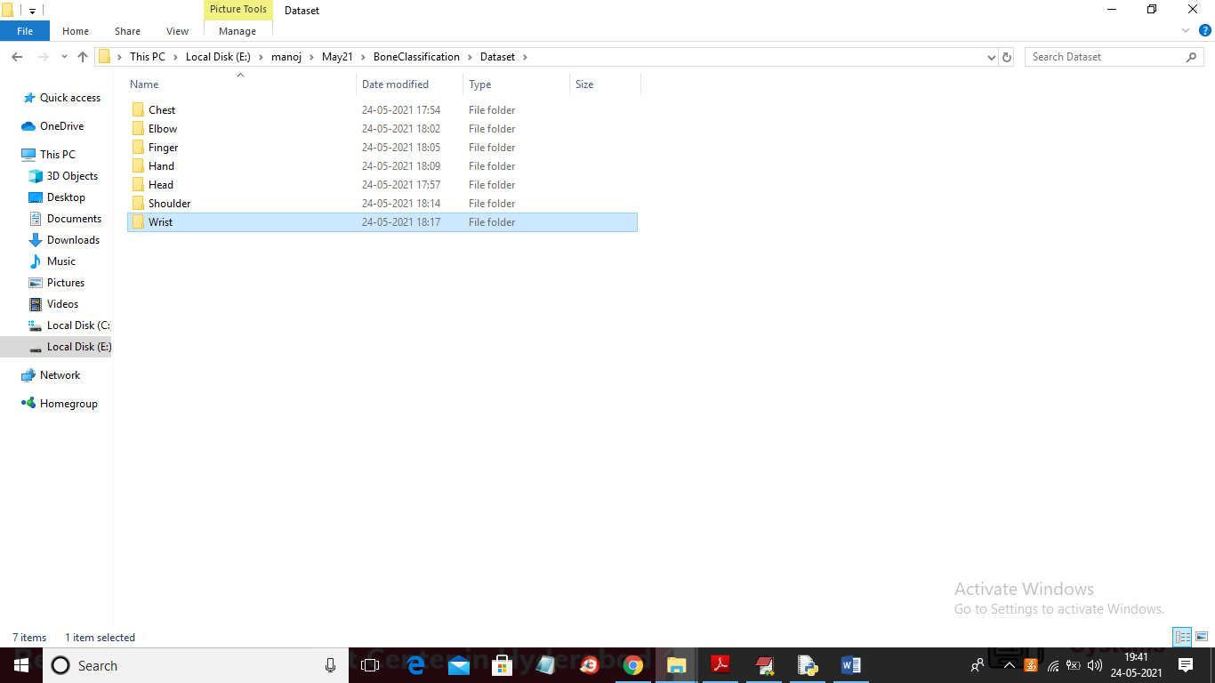

In above screen dataset contains 7 different types of images and each folder contains images of that bones and in below screen we can see images from chest folder

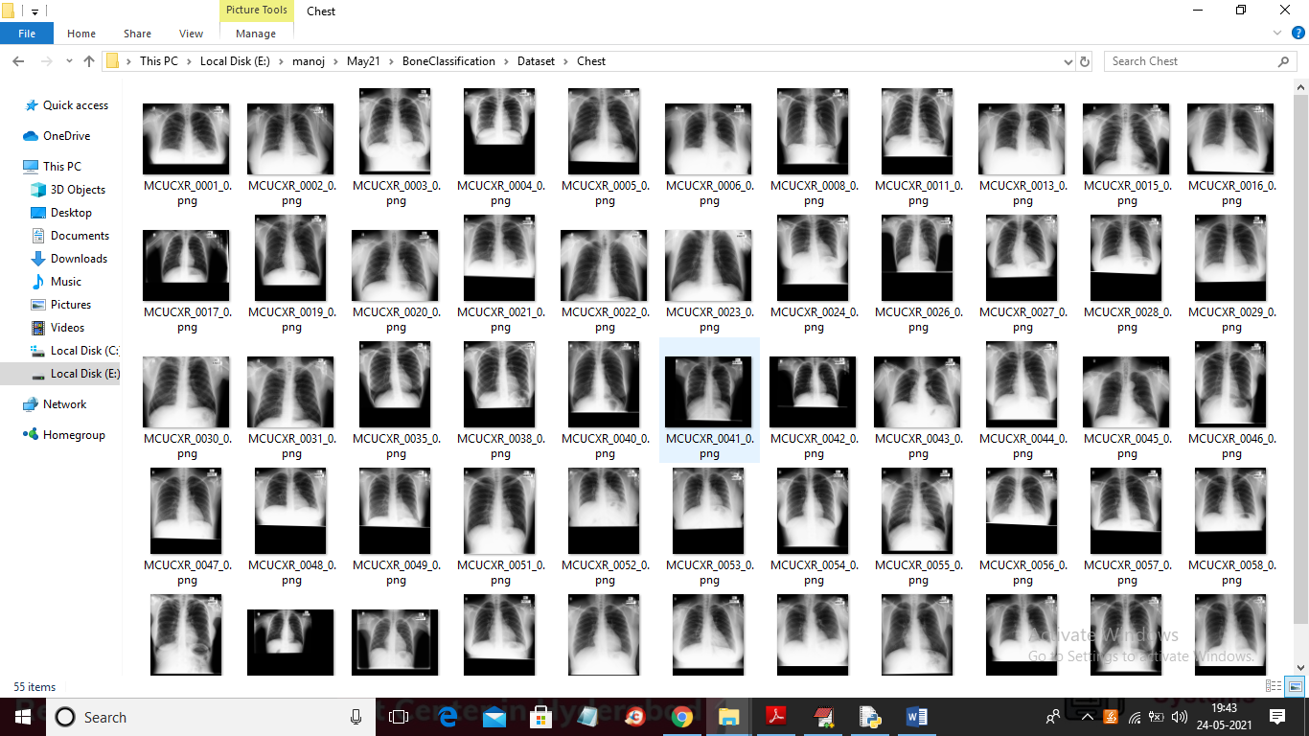

Similarly you can see different images in different folders

SCREEN SHOTS

To run project double click on ‘run.bat’ files to get below screen

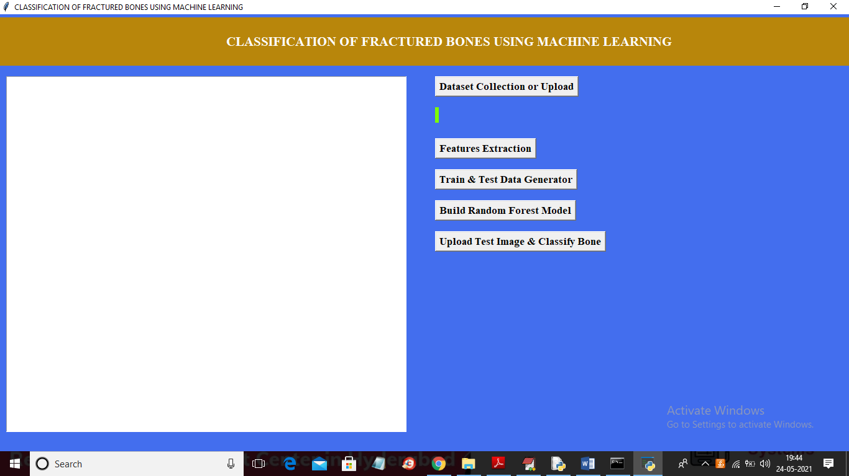

In above screen click on ‘Dataset Collection or Upload’ button to upload dataset and to get below screen

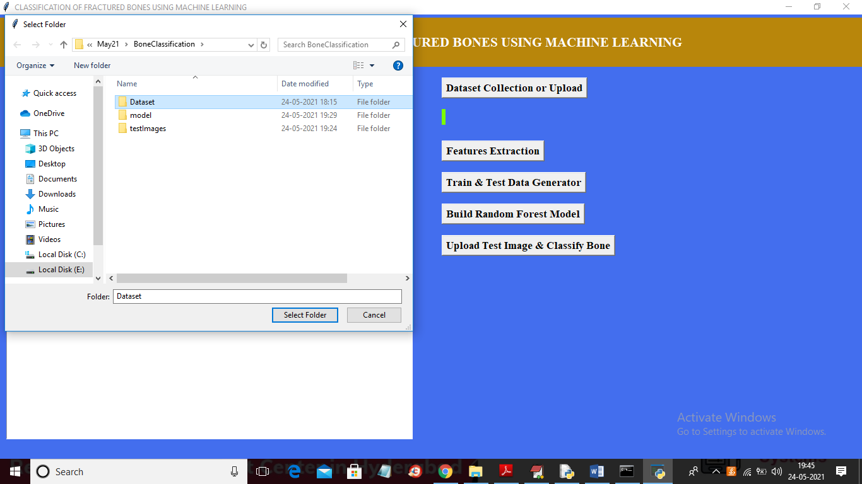

In above screen selecting and uploading ‘Dataset’ folder and then click on ‘Select Folder’ button to load dataset and to get below screen

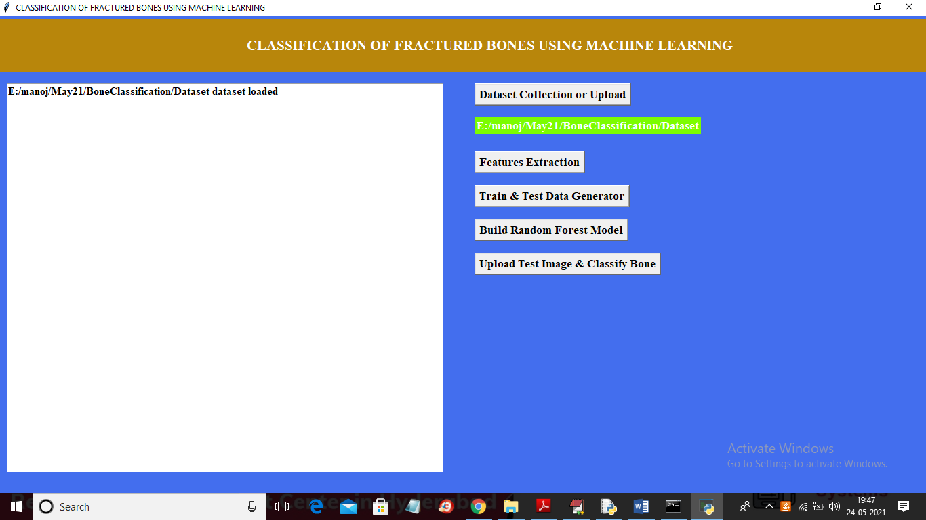

In above screen dataset loaded and now click on ‘Features Extraction’ button to extract features from dataset

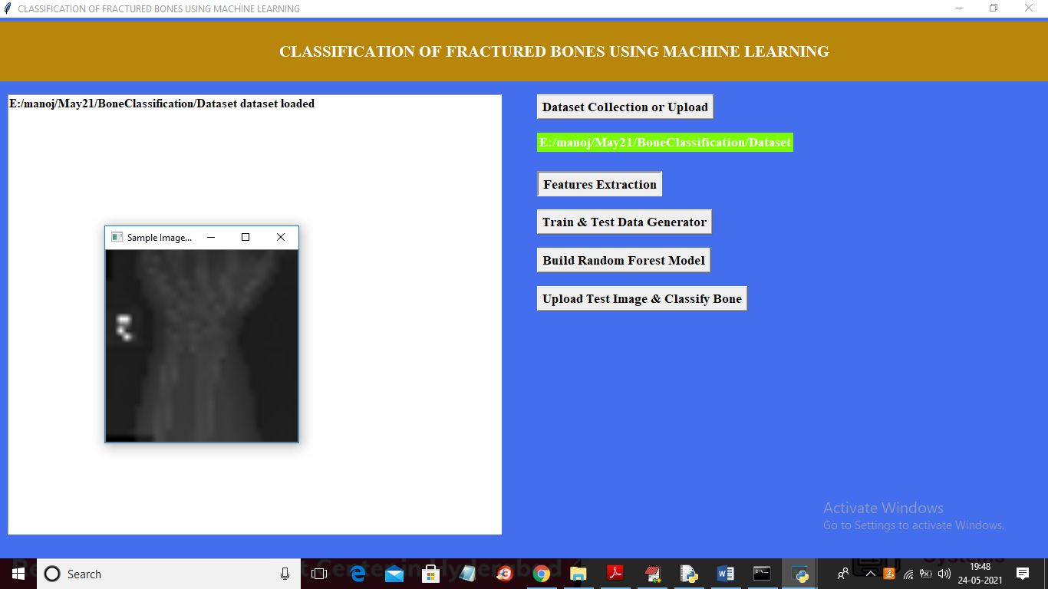

In above screen features extracted from each and then displaying one sample image to check whether dataset correctly loaded or not and now close above image to get below screen

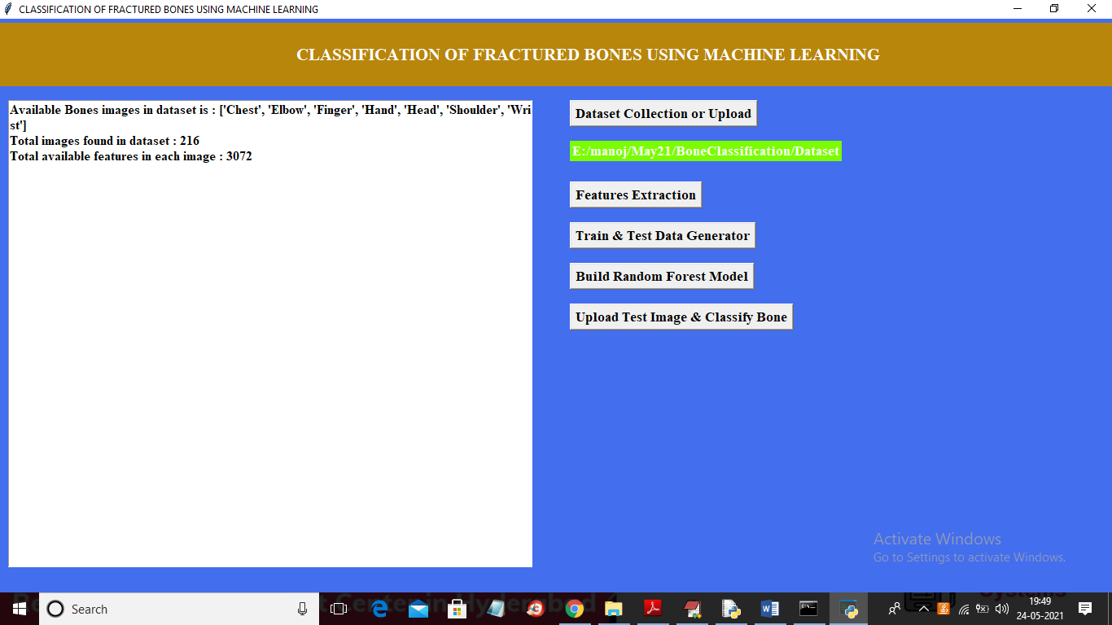

In above screen we can see in dataset 7 different types of bones are there and dataset contains 216 images and each image contains 3072 features or pixel values and now click on ‘Train & Test Data Generator’ button to split dataset into train and test part

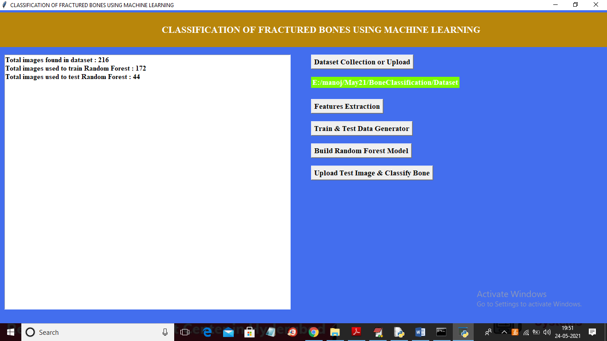

In above screen we can see dataset contains 216 images and then application using 172 images for training and 44 images for testing. Now train and test data is ready and now click on ‘Build Random Forest Model’ button to train Random Forest on above images.

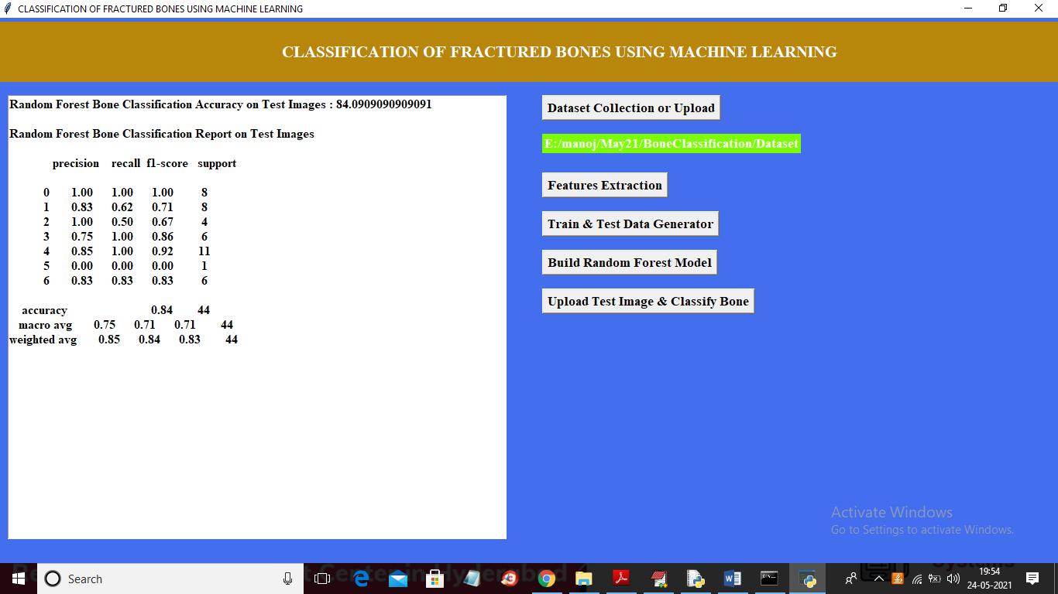

In above screen with random forest we got 84% accuracy and then calculate precision, recall, F1-SCORE for each image type. In above 0 refers to CHEST image and other number refers to other images. For example

labels = ['Chest', 'Elbow', 'Finger', 'Hand', 'Head', 'Shoulder', 'Wrist']

0 1 2 3 4 5 6

In above 2 lines we can see names of each image mapping to ID from 0 to 6. Now Random Forest model is generated and now click on ‘Upload Test Image & Classify Bone’ button to upload test image and then random forest will classify type of bone

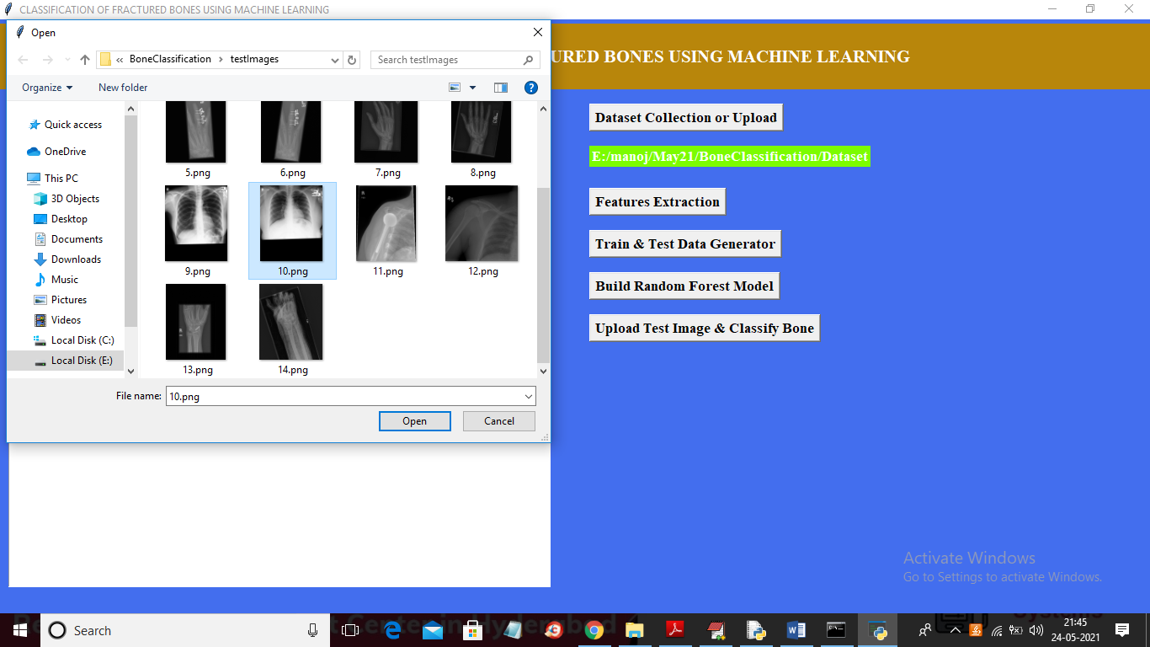

In above screen selecting and uploading ’10.png’ image and then click on ‘Open’ button to get below result

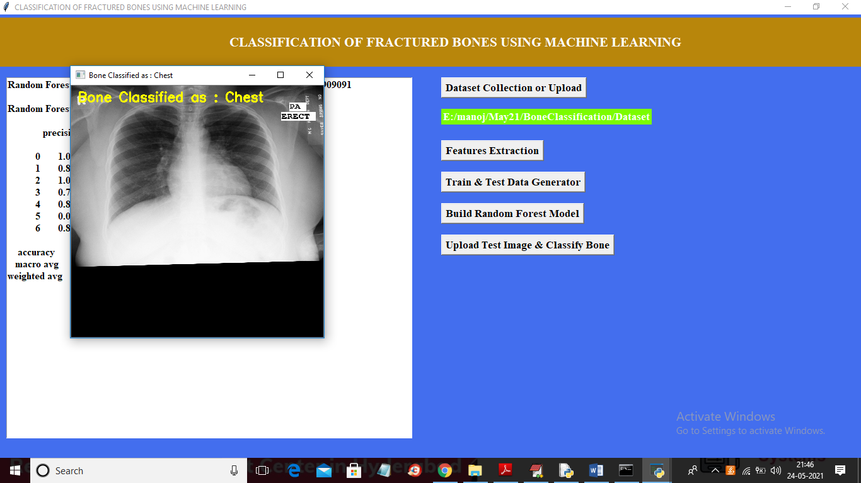

In above screen image bone is classified as ‘Chest’ and similarly you can upload and test remaining images