
CSE(AIML)

BATCH – 17

TRAVEL LOG USING MERN STACK

ABSTRACT:
The Travel Log is a modern web application built using the MERN stack (MongoDB, Express.js, React.js, and Node.js). It serves as an all-in-one platform for travel enthusiasts, offering a comprehensive guide to tour destinations and a personalized trip planning experience. The platform provides detailed information about popular travel destinations, including their highlights, best times to visit, local attractions, and cultural insights. Users can explore a visually appealing and intuitive interface to search for destinations based on preferences such as location, budget, or type of activity. The trip planner feature empowers users to create custom itineraries tailored to their needs. By selecting destinations, and activities, users can generate detailed schedule, including recommendations for transportation, accommodations, and dining. The planner also integrates with interactive maps for enhanced navigation and route optimization.

CONCLUSION:
The Travel Log website demonstrates the potential of the MERN stack in building feature-rich, user-friendly web applications. By integrating comprehensive travel information with personalized planning tools, the platform enhances the travel experience, reducing the hassle of organizing trips. The scalability and flexibility of the MERN stack ensure the platform can grow to incorporate advanced features such as AI-driven travel recommendations, real-time updates, and social sharing. By adopting modern web technologies, the website ensures high performance, scalability, and adaptability to meet the evolving needs of users. The travel log website effectively bridges the gap between travel enthusiasts and their dream destinations by offering a user-friendly platform for exploring places and planning trips.

ADVANTAGES:
- Users can explore destinations with in-depth details, helping them make informed travel decisions.
- The trip planner offers personalized itinerary creation, saving time and reducing travel-related stress.
- The platform is optimized for various devices, ensuring accessibility on desktops, tablets, and smartphones.

OUTPUT:
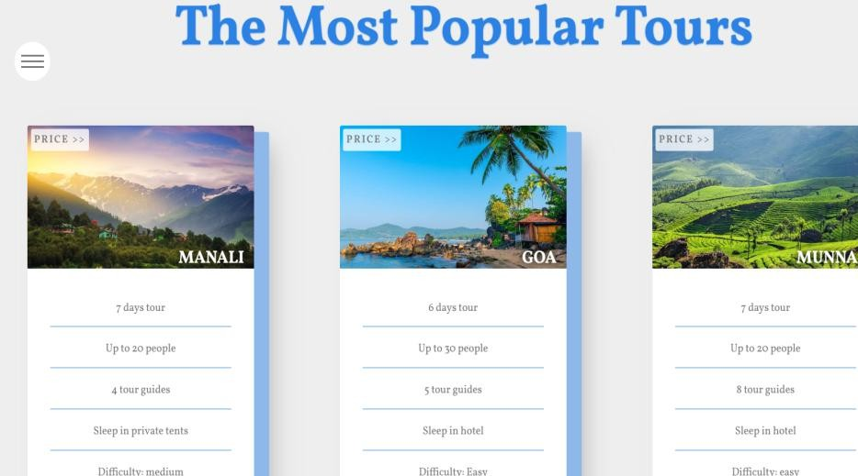
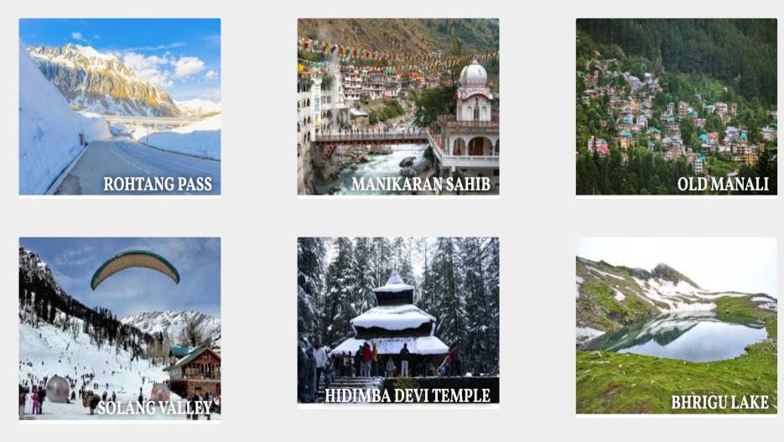

PRESENTED BY:
Bolishetti Adhithya (22891A66D3) Manchem Sai Manoj (22891A66F7) Survi Srujan (22891A66J1)

GUIDED BY:
Mrs. M. Anjali

