* **INSTALL ROBOT FRAMEWORK**

**python -m pip install robotframework**

* Run below command to know installed or not

**robot --version**

**OR**

**NOTE:: --** If you are not installing robot framework through pip please follow below steps

Download tar.gz file form below path

https://pypi.org/project/robotframework/

<https://github.com/robotframework/robotframework/releases>

* Click on Source code.(zip) to download

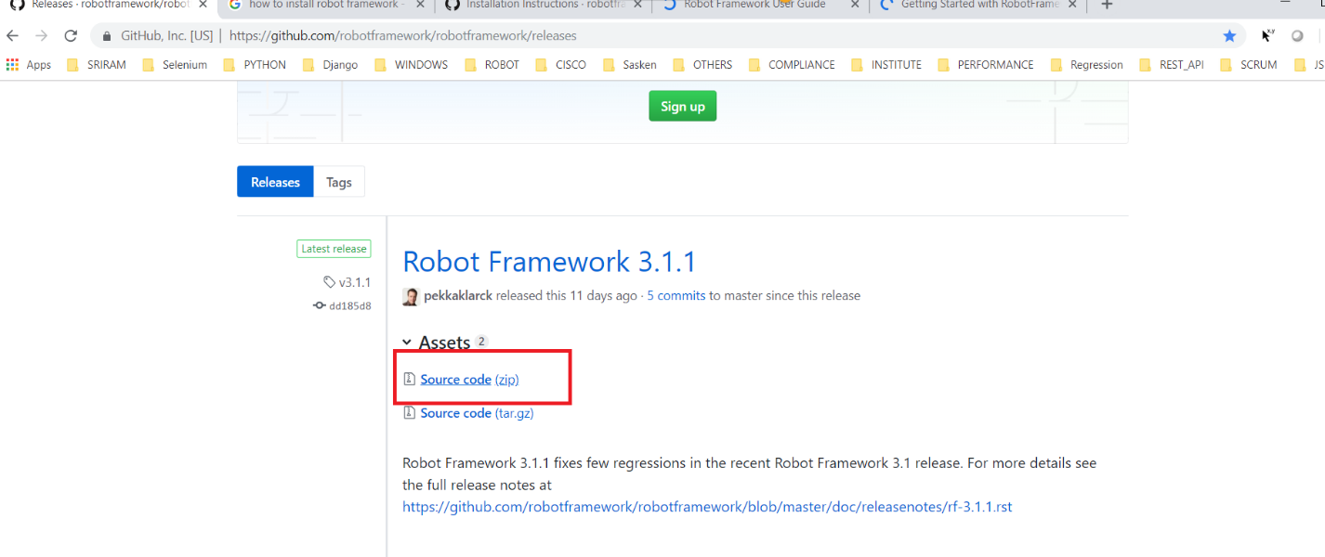

* UNZIP Sourcecode.zip file after unzipping you will see below files

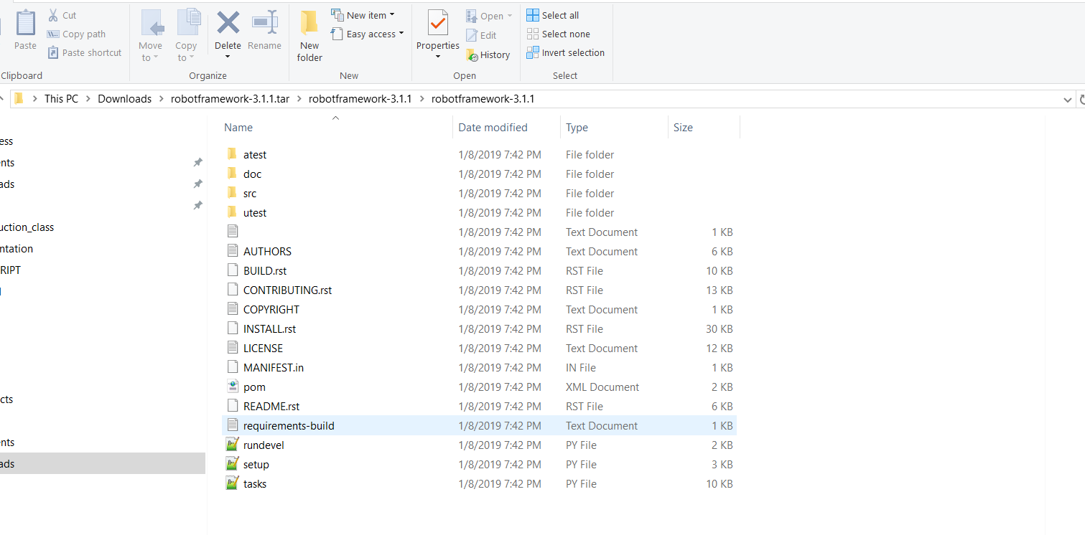

* Then run this command :- **python setup.py install**
* Run below command to know installed or not

**robot --version**