**44-560 Advanced Topics in Database Systems**

**Assignment-09: Data Warehousing**

1. Construct a star schema for a book borrowing scenario at the B. D. Owens library.

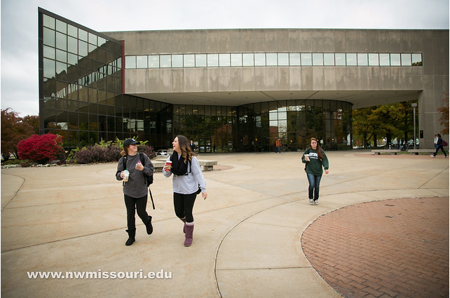

The relevant dimensions and attributes are:

* **Patron_Dim**ension - Attributes: Patron_ID, Patron_Name, Patron_Type, Birthday, Occupation, and Gender.
* **Book_Dim**ension. - Attributes: Book_ID, Edition_Number, Subject, Material_Type, Bar_Code_Type, Title, Author, Classification, Language, Location.
* **Date_Dim**ension. - Attributes: Date_ID, Hour, Day, Week, Month, Year.

The only fact to be recorded is the number of books borrowed.

The library possess approximately 50,000 books and there are 7,000 patrons for the library. On an average, each patron borrows around 1000 books. On any given day, every patron borrows approximately 20 different books. Data must be stored for 12 years.

For the problems below, assume the average field size is 20 bytes.

* 1. Place your star schema in the space below. Remember to use surrogate keys for the primary keys of your dimension tables.

* 1. How many rows will the **Patron_Dimension** table contain?

**Ans:** 7000 Patrons are present in the library which means 7000 rows.

* 1. Find the size (in bytes) of **Patron_Dimension**.

**Ans:** There are 7 attributes in **Patron_Dimension** table of average size 20 bytes each, so

the average row size is 140 bytes. Total size is 7000 rows * 140 bytes = 980,000 bytes.

d) How many rows will the **Book_Dimension** table contain?

**Ans:** 50,000 books are present in the library which means 50,000 rows.

e) Find the size (in bytes) of **Book_Dimension**.

**Ans:** There are 11 attributes in **Book_Dimension** table of average size 20 bytes each, so the average row size is 220 bytes. Total size is 50,000 rows * 220 bytes = 11,000,000 bytes.

f) How many rows will the **Date_Dimension** table contain?

**Ans:** We need to store data for 12 years which means 12*365 days i.e., 4,380 days. So, the rows in **Date_Dimension** table will be 4,380 rows.

g) Find the size (in bytes) of **Date_Dimension**.

**Ans:** There are 7 attributes in **Date_Dimension** table of average size 20 bytes each, so the average row size will be 140 bytes. Total size is 4,380 rows * 140 bytes = 613,200 bytes.

h) How many rows will the **fact table** contain when all 12 years of data has been stored?

**Ans:** On any given day, every patron borrows approximately 20 different books. i.e.,

7000 Patrons * 20 different books per day * 4380 days = 613,200,000 rows.

i) Find the size (in bytes) of the fact table when all 12 years of data has been stored.

**Ans:** There are 4 attributes in fact table of average size 20 bytes each, so the average row size will be 80 bytes. Total size is 613,200,000 rows * 80 bytes = 49,056,000,000 bytes.