Data Visualization Final Project
Nithin Reddy Kumbham
Section – 02

Introduction: My project deals with top 50 billionaires across the globe. My main aim is to show how much is the wealth of each billionaire and their rank globally. I even want to show what is the age of billionaires and their source of income. I am going to visualize the data using data visualization tools.

Domain of dataset: Billionaires data showing wealth, age, rank, source of income.

Data file:

Data source: I gathered above dataset from Kaggle.com. Kaggle is a data science community where we can find lot of things and datasets is a section to find in Kaggle.com.
Website: https://www.kaggle.com/datasets?search=billionaire

Number of records and columns: The above dataset contains 2756 records with 7 columns.

Visualization tools selected: I want to demonstrate and visualize my data using Tableau desktop where I can find all visualization tools at one go.

Data cleaning strategies: I had narrowed the above dataset to 50 records and 7 columns for ease of demonstration and visualization.

Cleaned dataset:

Goal 1: To show countries of 50 Billionaires using map
Screenshot 1:
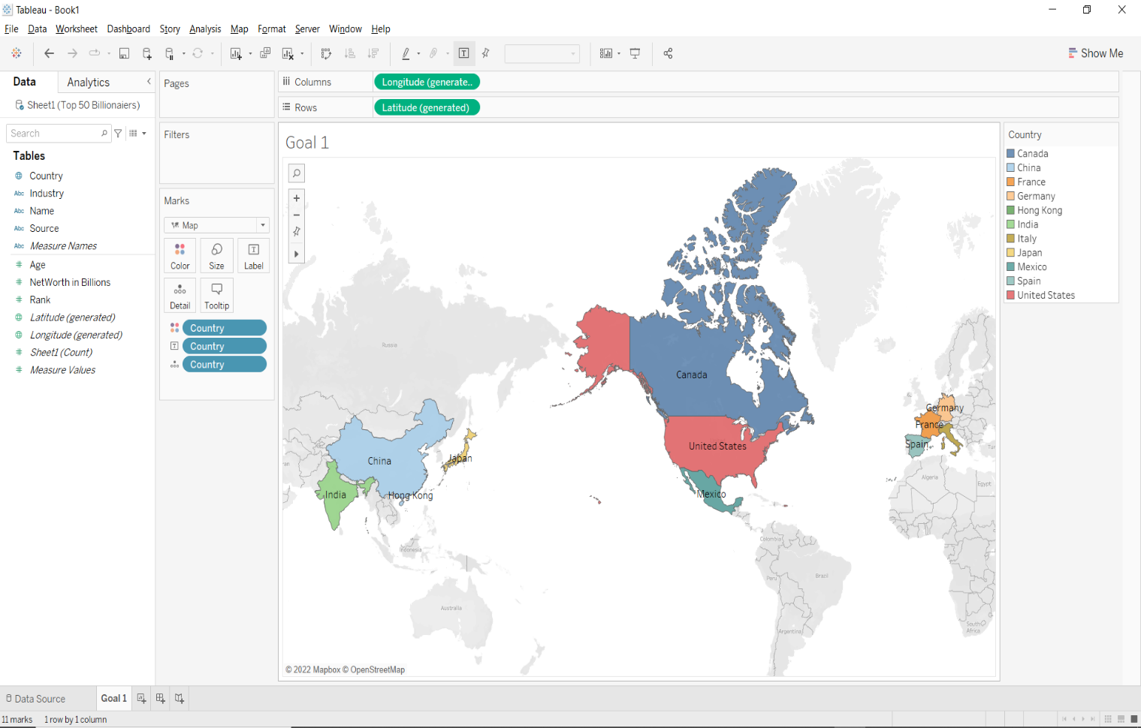
Story 1: Above map shows 50 Billionaires country using map. Countries are highlighted using colors to catch the eye of audience. We can see in the map that we have 11 countries. Center of the map is occupied by Canada, USA, and Mexico. European countries are Germany, France, and Spain. Asia countries are occupied by India, China, Hong Kong, and Japan.

Goal 2: To show which country has how many Billionaires by count.
Screenshot 2:
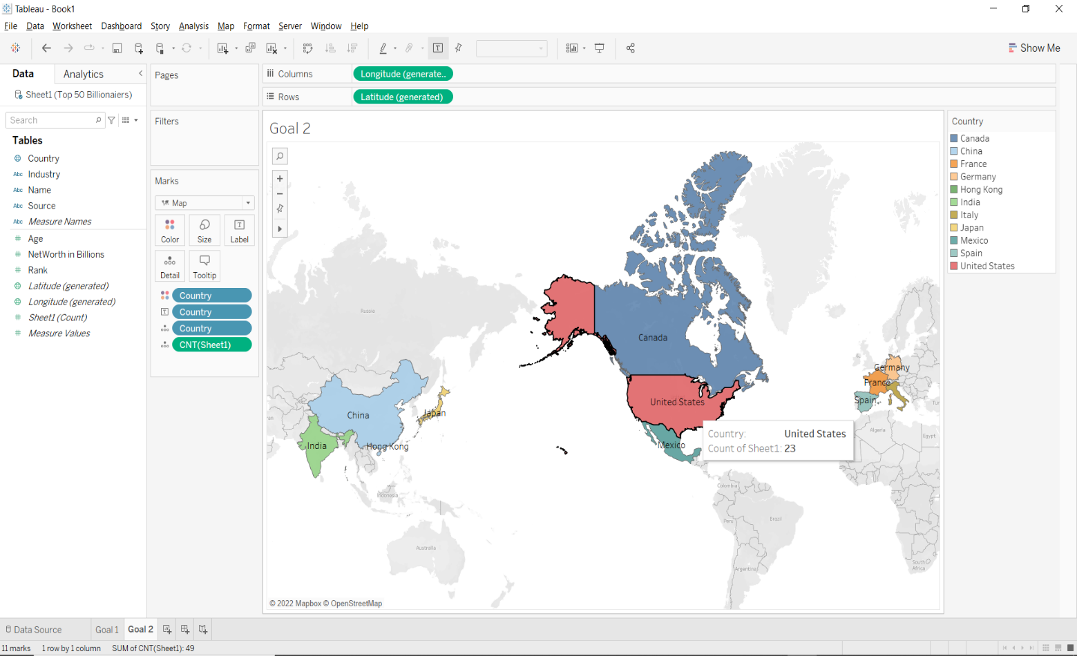
Story 3: Above map shows Billionaires count in each country. As shown above united states has 23 Billionaires which stands with highest. Next stands China with 9 Billionaires. France holds 5 Billionaires. Germany, India, and Japan holds 2 Billionaires respectively in each country. And finally Mexico, Canada, and Spain holds 1 Billionaire in each country.

Goal 3: To show 10 Billionaires wealth using lollipop chart
Screenshot 3:
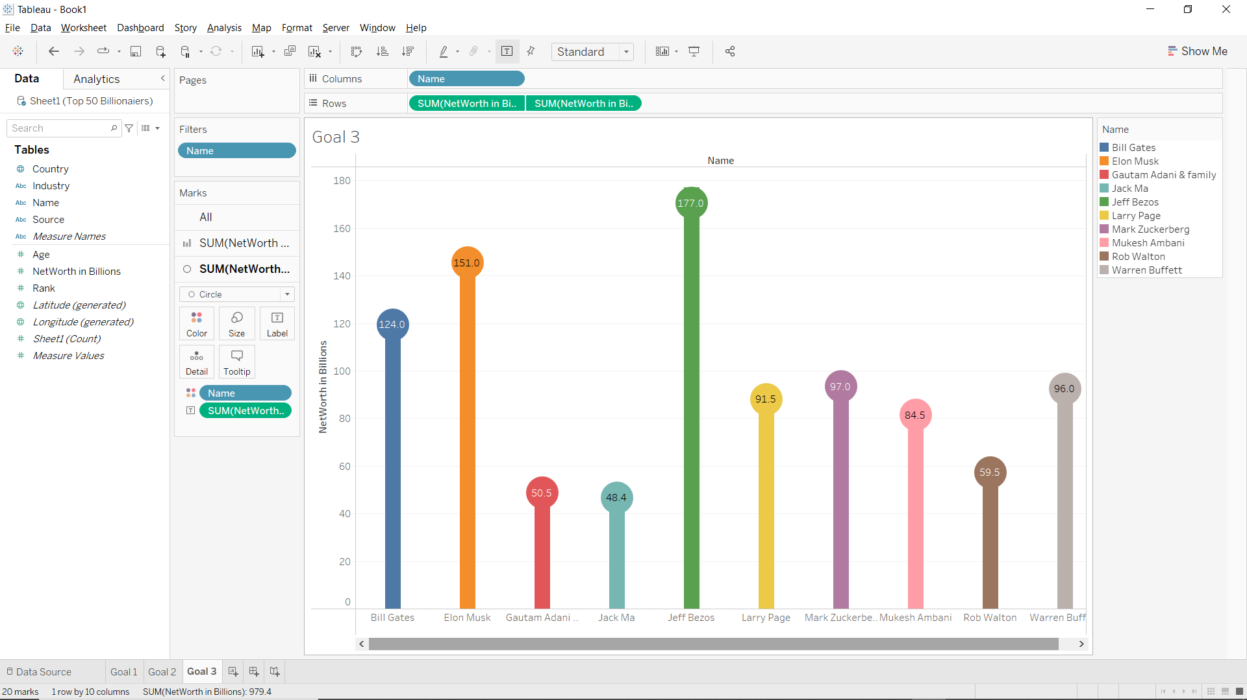
Story 3: Above lollipop chart shows 10 Billionaires wealth randomly picked from top 50 Billionaires dataset. All 10 Billionaires are represented by different colors. As you can see Jeff Bezos tops the list with 177 billion. Next stands Elon Musk with 151 billion. Bill gates stands third with 124 billion. Jack Ma stands 10th place with 48.4 billion. Gautam Adani has 50.5 billion.

Goal 4: To compare which country has more wealth combining 50 Billionaires.
Screenshot 4:
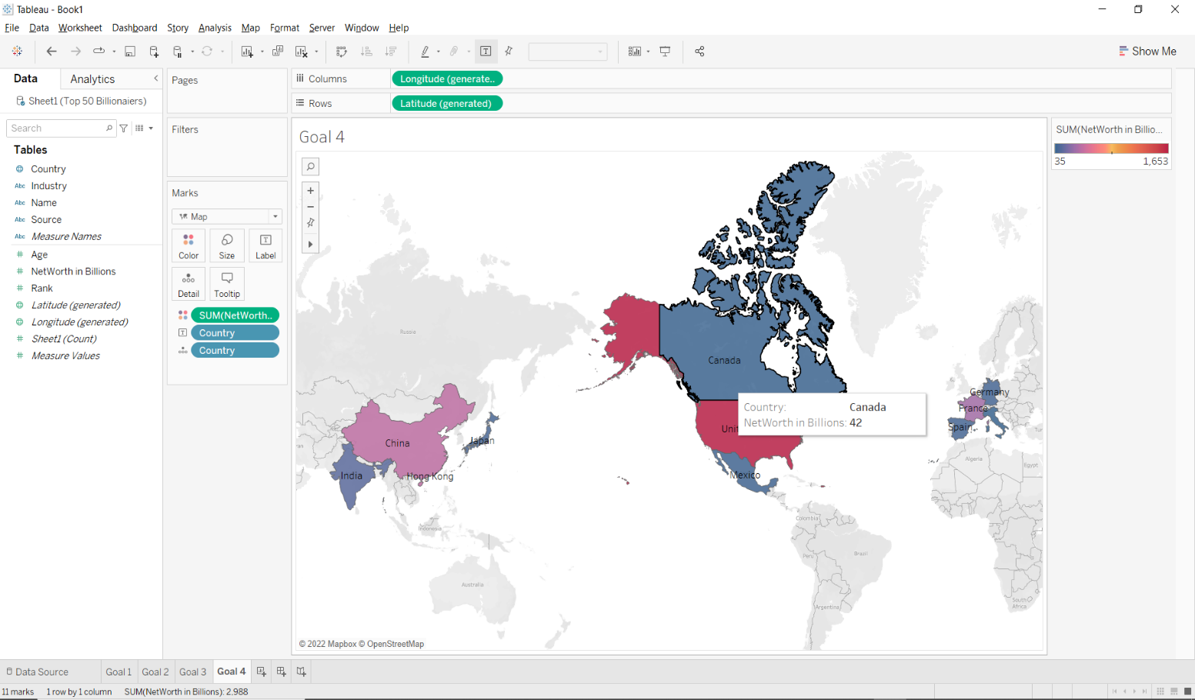
Story 4: Above map shows countries which has more wealth combining top 50 Billionaires. Map is represented as colors for each country. As you can see Canada has 42 net worth in billions. USA has 1653 billion net worth and tops the list as majority of Billionaires are part of USA. China has 417 billion and France has 335 billion. India has 135 billion and Japan has 90 billion.
Goal 5: To compare Billionaires age by applying sets
Screenshot 5:
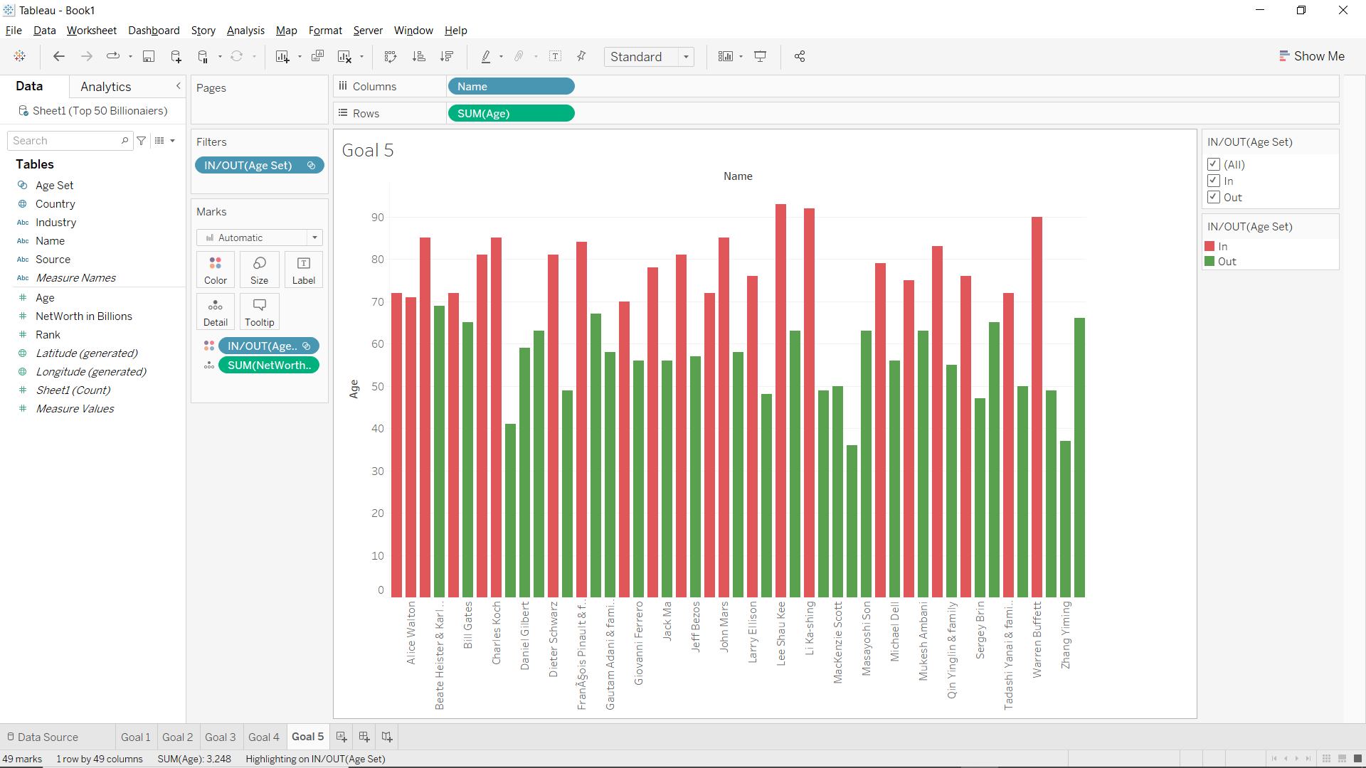
Story 5: Above chart shows top 50 Billionaires age. Chart is differentiated by 2 colors and set by condition is applied to Billionaires. Color red shows Billionaires who’s age is more than 70 and color green shows Billionaires who’s age is less than 70. By having a close observation we can see that there is equal proportion between ages who’s age is greater than 70 and less than 70.
Goal 6: To show Billionaires who’s age is greater than 39 using groups
Screenshot 6:
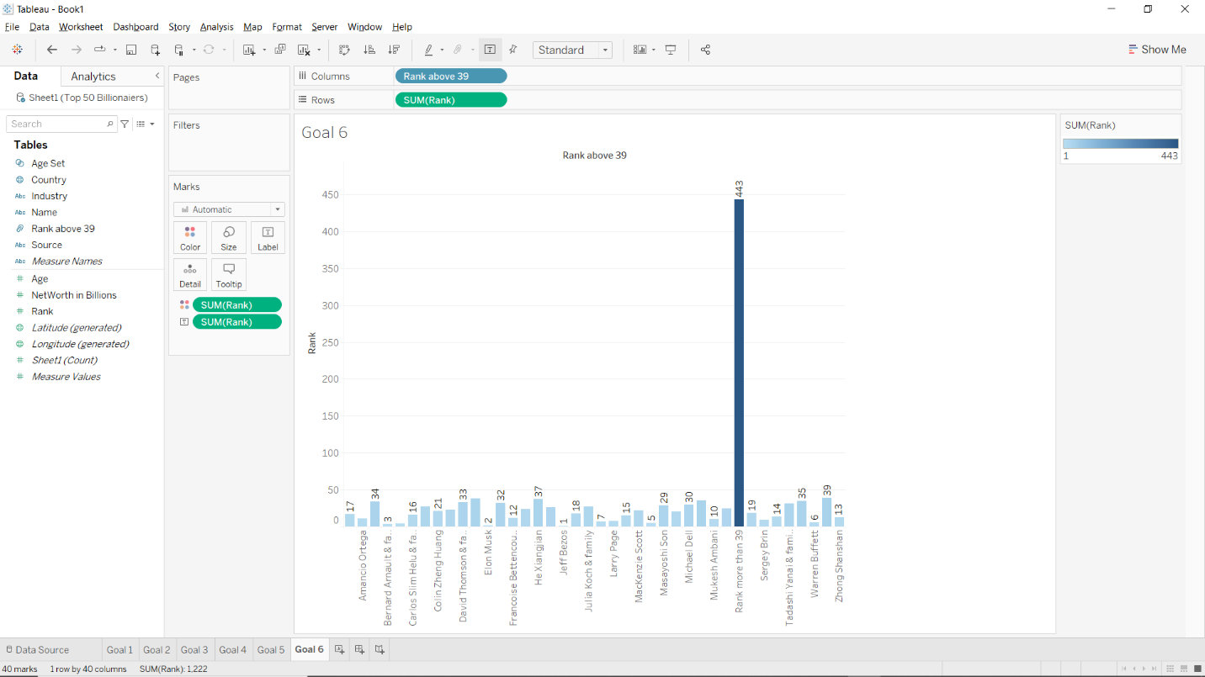
Story 6: Above chart shows Billionaires age using groups. Billionaires had been grouped as one who’s age is greater than 39. As you can see the tall line shows the combined age of all Billionaires who’s age is greater than 39. The smaller bar lines shows the age of Billionaires who’s age is less than 39.

Dashboard Screenshot
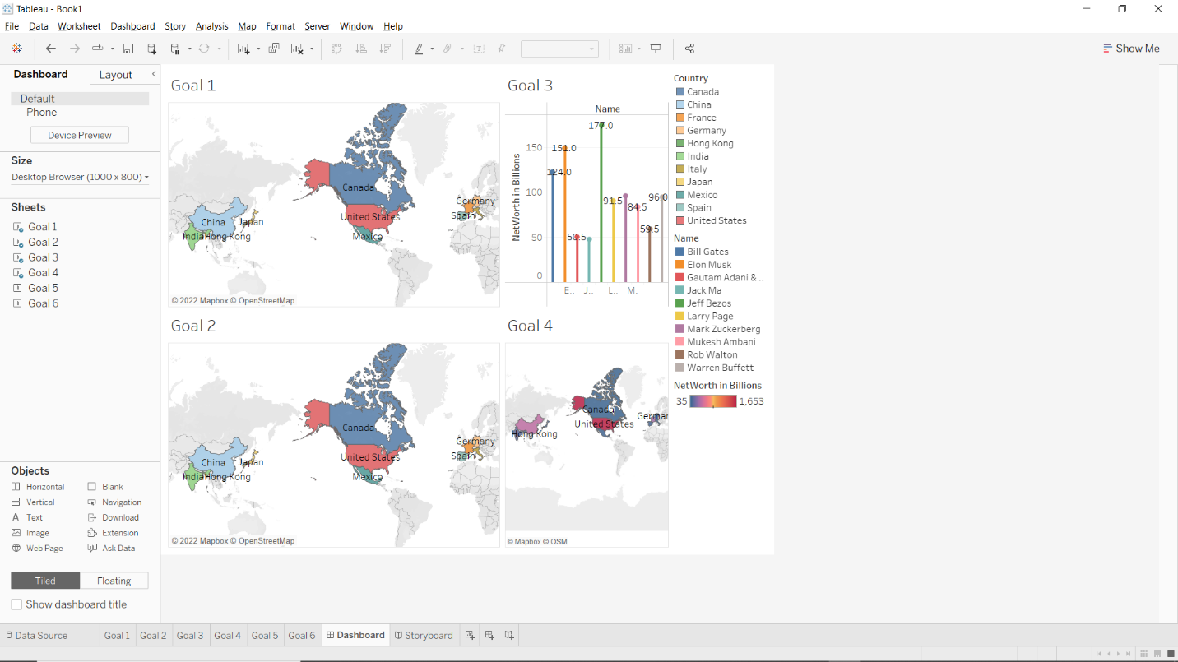

Storyboard Screenshot
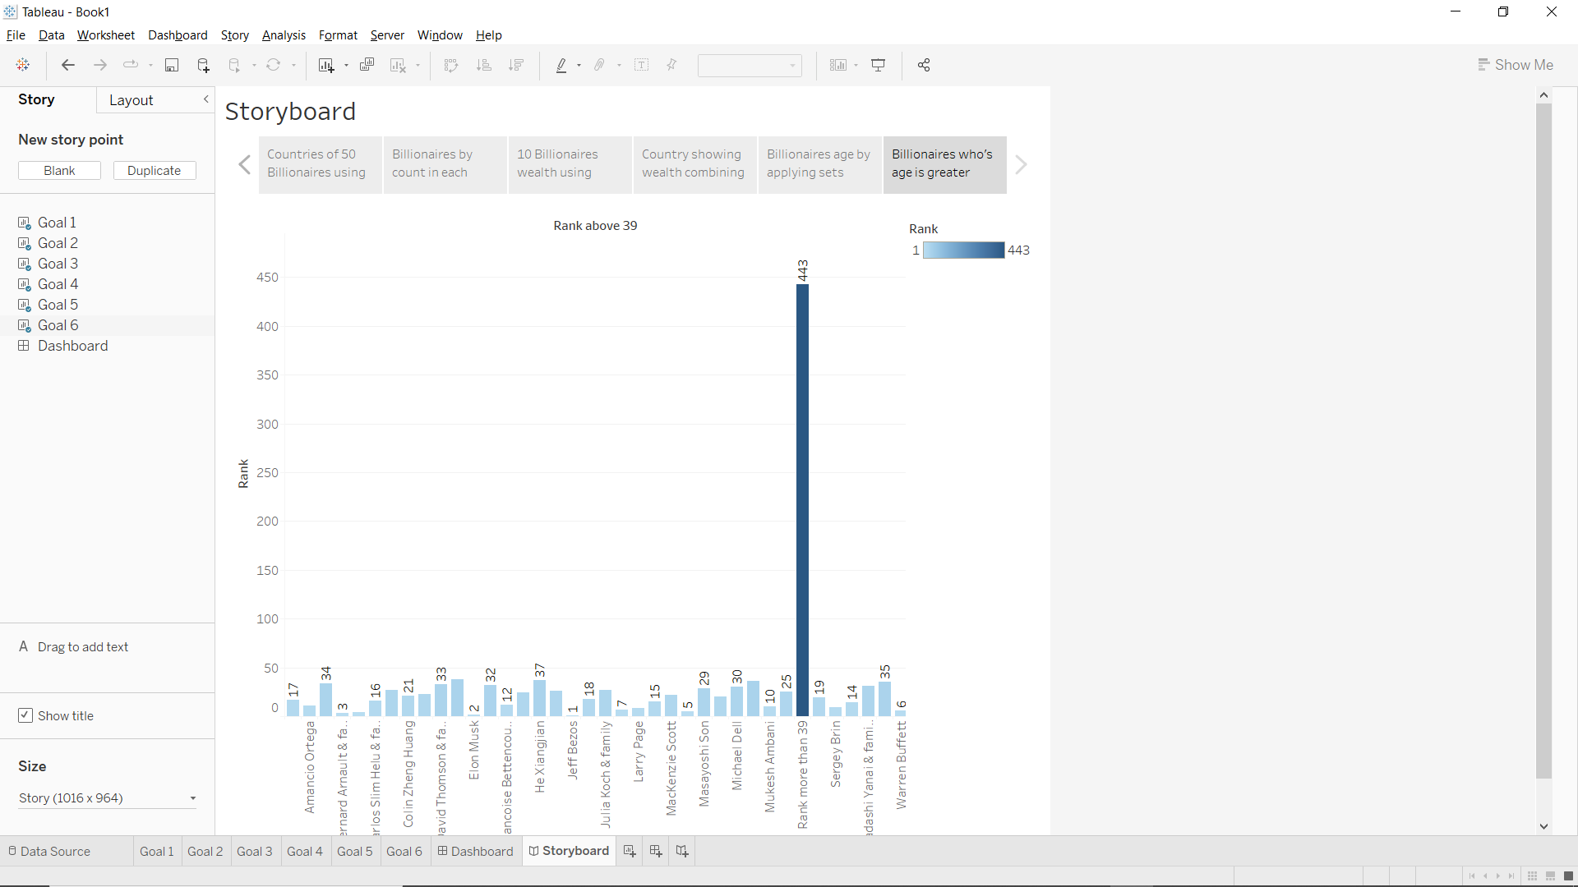
Overall conclusion: This project concludes with showing top 50 Billionaires with their age, source of income, industry sector, net worth in billions. I had used Tableau to visualize my dataset with 6 goals and short description of story to get what actually the chart is saying. Charts are represented using colors to catch the eye of audience. I even used dashboard and storyboard to show all my goals at a glance in a single window.

