DATAFITS-TRAFFIC-PREDICTION

ABSTRACT
This paper introduces DataFITS (Data Fusion on Intelligent TransportationSystem),
an open-source framework that collects and fuses traffic-related data from various sources, creating a comprehensive dataset. We hypothesize that a heterogeneous data fusion framework can enhance information coverage and quality for traffic models, increasing the efficiency and reliability of Intelligent Transportation System (ITS) applications. Our hypothesis was verified through two applications that utilized traffic estimation and incident classification models. DataFITS collected four data types from seven sources over nine months and fused them in a spatiotemporal domain. Traffic estimation models used descriptive statistics and polynomial regression, while incident classification employed the k-nearest neighbors (KNN) algorithm with Dynamic Time Warping (DTW) and Wasserstein metric as distance measures. Results indicate that DataFITS significantly increased road coverage by 137% and improved information quality for up to 40% of all roads through data fusion.Traffic estimation achieved an R2 score of 0.91 using a polynomial regression model, while incident classification achieved 90% accuracy on binary tasks (incident or non-incident) and around 80% on classifying three different types of incidents (accident, congestion, and non-incident).

INTRODUCTION
DATA availability is a critical aspect in the design of modern Intelligent Transportation Systems (ITSs), which implement models to understand better various patterns of the transportation system, thus improving mobility and safety for people and goods. With modern society depending heavily on efficient and reliable transportation, the importance of these systems has seen a rapid increase in significance over recent years. In Germany alone, both the number of registered cars and the number of carried passengers using public transportation have shown a substantial increase, reaching their all-time highs of 48.5 million cars (2022) and 12.7 billion carried passengers (2019, before the pandemic).
As a result, urban areas experience an increasing number of traffic-related incidents (e.g., congestion and accidents), increasing time delays, emissions, and fuel consumption.
For this reason, academia and industry have driven efforts to create the next generation of transportation systems that are eco-friendly, cost-efficient, and powered by data analysis and communication technology. We hypothesize that a heterogeneous data fusion framework can enhance the coverage and quality of information serving as input for traffic models, thus increasing the efficiency and reliability of ITS applications. Therefore, we propose the Data Fusion on Intelligent Transportation System (Data FITS) framework, providing a spatiotemporal fusion of data used to train models for two ITS applications, traffic estimation, and incident classification. Data FITS collects and combines real heterogeneous data (e.g., weather, traffic, incident) from various sources (e.g., open databases, map applications, preparing them by fixing errors, adapting the data structure, and finally fusing them in the exact location and point in time. Our hypothesis is verified using data characterization to quantify the benefits of combining heterogeneous data sources and the proposal of two ITS applications. The performance of the two applications ratifies the benefits of larger data coverage/quality while estimating traffic and classifying incidents.

SYSTEM ANALYSIS
EXISTING SYSTEM
Intelligent Transportation Systems (ITS) primarily focus on data collection and security from various smart city sensors, but often struggle with the effective integration of heterogeneous data sources. Current approaches utilize a range of methodologies, including Kalman filters for fusing traffic flow values, autoregressive models for adapting to incidents like accidents, and traditional Machine Learning (ML) techniques for traffic estimation. While newer models have incorporated Neural Networks—such as Graph Convolutional Networks (GCN) for spatial dependencies and Gated Recurrent Units (GRU) for temporal trends—many existing frameworks remain limited. They frequently fail to balance the quantity and quality of information through comprehensive data fusion and often lack the sophisticated spatiotemporal correlation needed to provide accurate, long-term traffic predictions beyond a 30-to-60-minute window.
PROPOSED SYSTEM
Data Fusion on Intelligent Transportation System (DataFITS) framework, designed to provide a comprehensive spatiotemporal fusion of heterogeneous data to support advanced Intelligent Transportation System (ITS) applications. DataFITS systematically collects and integrates real-time data from diverse sources—including open databases, map applications, weather reports, and traffic incident feeds—to train high-accuracy models for traffic estimation and incident classification.
ADVANTAGES:
- The characterization of a heterogeneous dataset combining real traffic data from two cities in Germany, collected from seven sources over nine months and provided together with the repository
- An incident classification model trained and evaluated on heterogeneous fused data using k-nearest neighbours (k-NN), with Dynamic Time Warping (DTW) and Wasserst as distance methods

SYSTEM REQUIREMENTS

HARDWARE REQUIREMENTS
MINIMUM (Required for Execution) |  | MY SYSTEM (Development)
System | Pentium IV 2.2 GHz | i3 Processor 5th Gen
Hard Disk | 20 Gb | 512 Gb
Ram | 1 Gb | 4 Gb

SOFTWARE REQUIREMENTS
Operating System | Windows 7 Ultimate
Coding Language | Python
Front-End | Python
Back-End | Django-ORM
Designing | HTML, CSS, Java Script
Data Base | MySQL (WAMP Server)

SYSTEM ARCHITECTURE
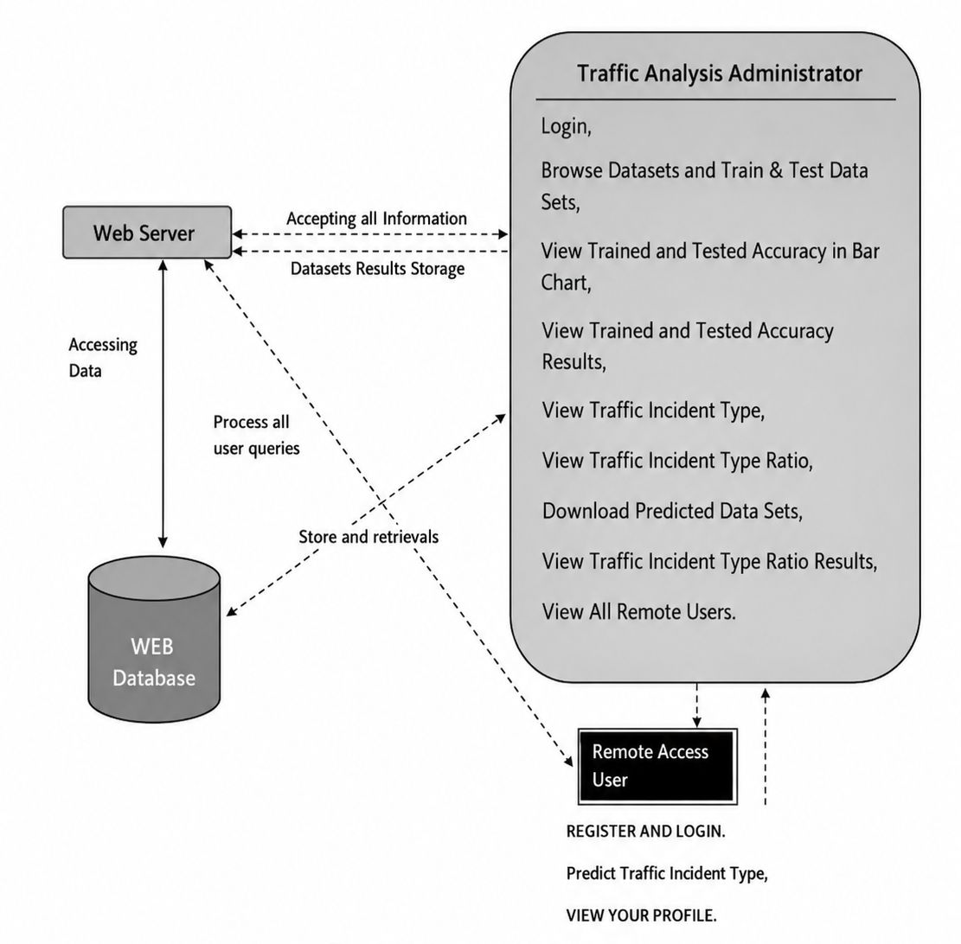

MODULES
- USER

