**AWS S3 with Spring Boot –**

**Generating access key and secret key –**

1. Click on my security credentials -

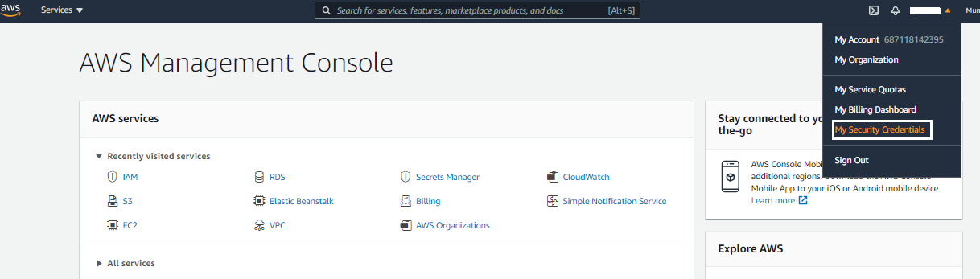

1. Click on create new access key and generate the access key –

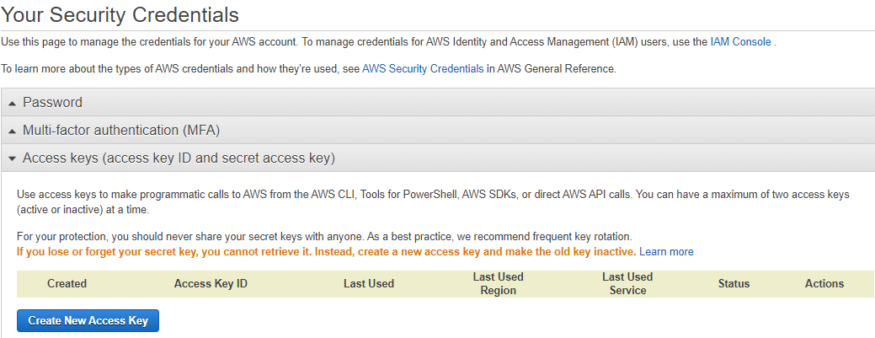

1. Copy access key and secret key to use it in spring boot application.properties –

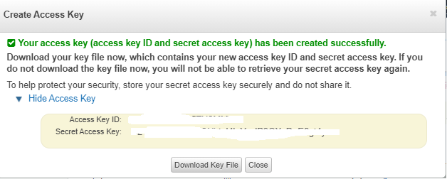

**Dependencies** –

Add aws-sdk dependency or aws-spring-cloud dependency if latest version of spring boot supports. aws-spring-cloud dependency is supported only in spring boot 2.3.x version as of now.

Update application.properties with region, secret key, access key, bucket name and folder name.

1. **File Upload –**

**POST** request URL - <http://localhost:8080/s3/upload>

Open postman, click on form-data, provide key

Click on Select Files to browse the file for uploading

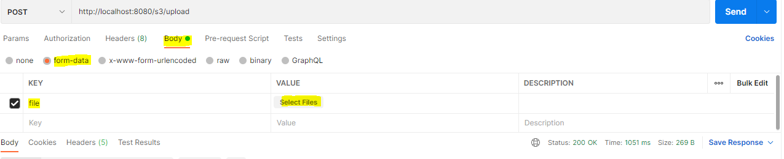

After selecting the file –

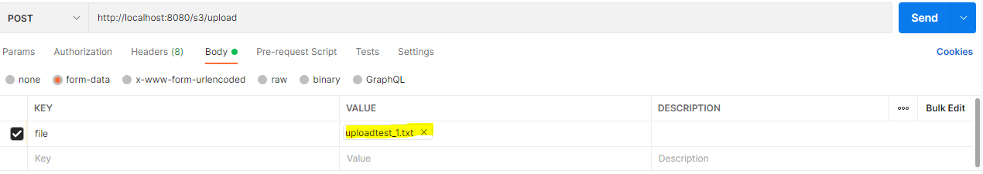

Click on send to make the post request –

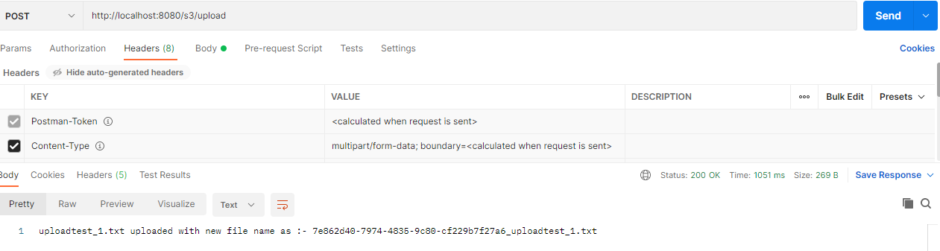

1. **Download File –**

**GET** request URL - <http://localhost:8080/s3/download?fileName=7e862d40-7974-4835-9c80-cf229b7f27a6_uploadtest_1.txt>

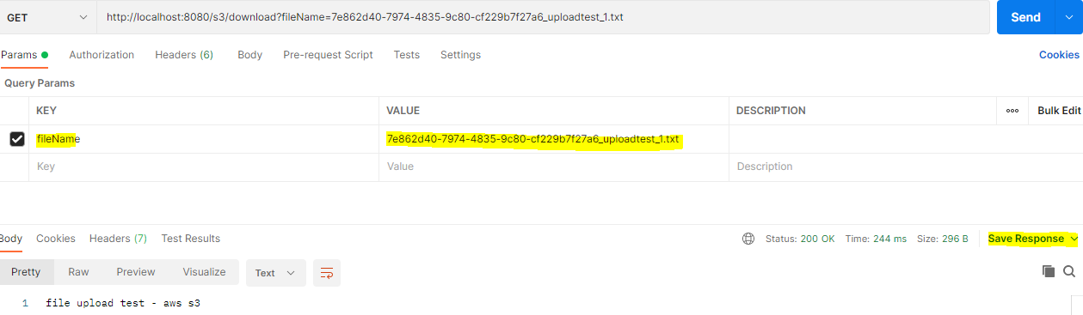

Click on save response to save the file in local directory

1. **Display all files –**

**GET** request URL - <http://localhost:8080/s3/showFiles>

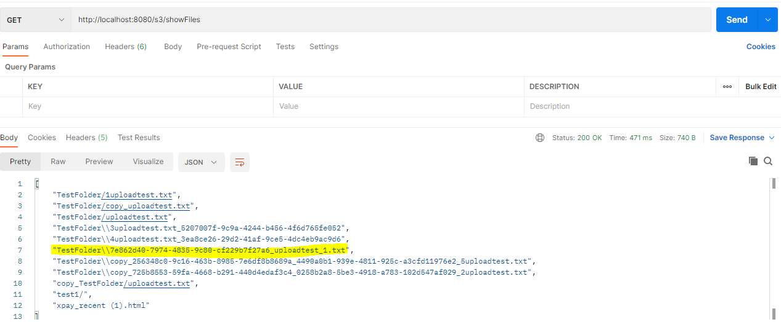

1. **Copy File –**

**PUT** request URL – <http://localhost:8080/s3/copy?fileName=7e862d40-7974-4835-9c80-cf229b7f27a6_uploadtest_1.txt>

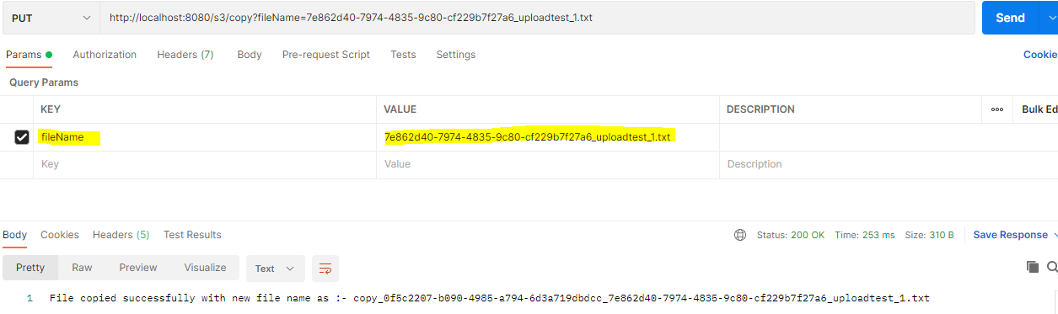

1. **Delete File –**

**DELETE** request URL – <http://localhost:8080/s3/delete?fileName=7e862d40-7974-4835-9c80-cf229b7f27a6_uploadtest_1.txt>

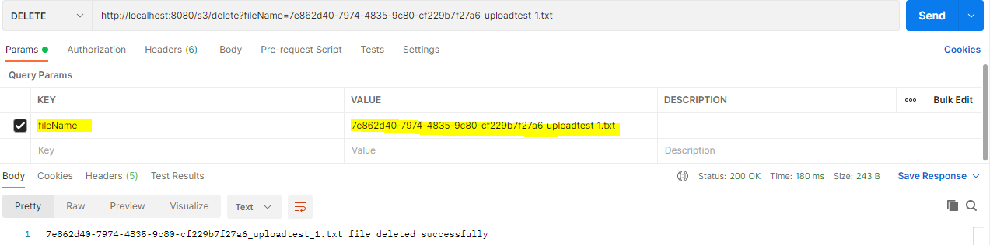

1. **Delete All files in bucket –**

**DELETE** request URL - <http://localhost:8080/s3/deleteAll>

**Bucket operations –**

1. Show all Buckets –

GET URL - <http://localhost:8080/s3/showAllBuckets>

1. Create bucket –

POST URL – http://localhost:8080/s3/createBucket

1. Delete bucket –

DELETE URL - <http://localhost:8080/s3/deleteBucket>