**Installing Kafka on windows –**

Goto <https://kafka.apache.org/downloads> and download the latest version, select scala to download.

Extract the downloaded file and then set the C:\**kafka_2.12-2.8.0\bin\window** folder to environment variables (under **Path** variable)

Open cmd prompt and run **kafka-topics.bat** to verify.

**Configuration -**

Create a folder called data, and 2 new folders zookeeper, kafka within data folder

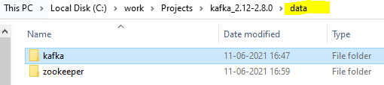

**Zookeeper config -**

Navigate to .. \kafka_2.12-2.8.0\config folder and set zookeeper data dir in zookeeper.properties.

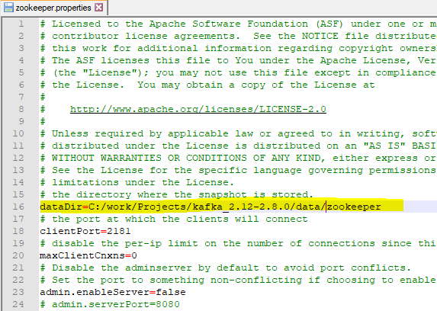

Goto command line and start zookeeper with following command –

**zookeeper-server-start.bat config\zookeeper.properties**

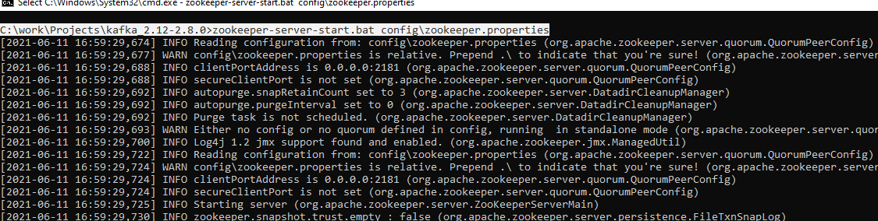

Zookeeper will start on port 2181 (as mentioned in zookeeper.properties)

**Server config -**

Open server.properties from config folder and set the log dir –

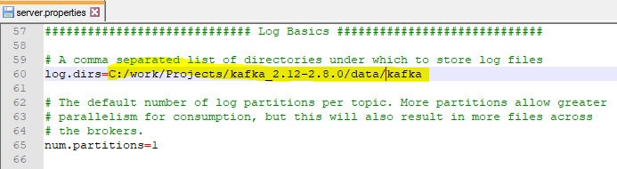

Set hostname for this listeners – (if needed)

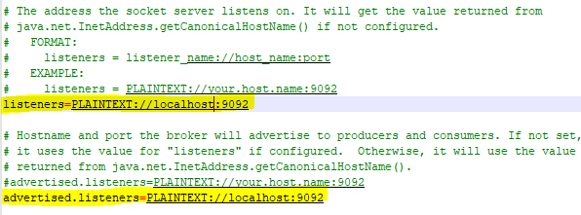

Open cmd prompt and run below command –

**kafka-server-start.bat config\server.properties**

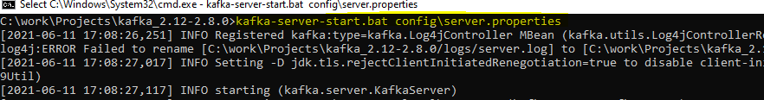

**Creating topic -**

Open cmd and create topic with below command –

**kafka-topics.bat --zookeeper localhost:2181 --topic first_topic --create --partitions 1 --replication-factor 1**

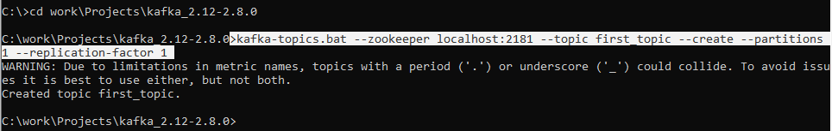

Use following command to list all the topics -> **kafka-topics.bat --zookeeper localhost:2181 --list**

Describe the topic -> kafka-topics.bat --zookeeper localhost:2181 --topic **first_topic** –describe

Delete topic -> kafka-topics.bat --zookeeper localhost:2181 --topic first_topic –delete

Don’t use delete topic, it will lead to lot of errors.

Producing topic –

**kafka-console-producer.bat --broker-list 127.0.0.1:9092 --topic first_topic**

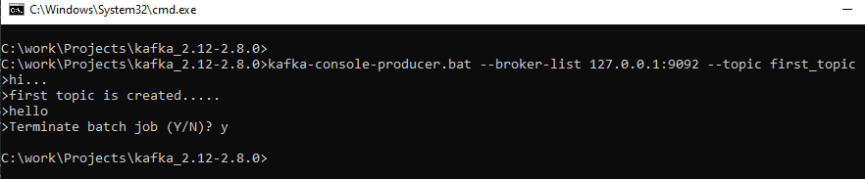

Press ctrl-c to end sending message.

Always create topic and then produce the message.

It is possible to create the topic while producing message, but it will lead to creation of topic with some default value.

**kafka-console-producer.bat --broker-list 127.0.0.1:9092 --topic second_topic**

second_topic will get created automatically with above command with default partitions etc.

**Setting property to producer -**

kafka-console-producer.bat --broker-list 127.0.0.1:9092 --topic first_topic **--producer-property** acks=all

**Consumer –**

Start consumer and produce the messages.

**kafka-console-consumer.bat --bootstrap-server 127.0.0.1:9092 --topic first_topic**

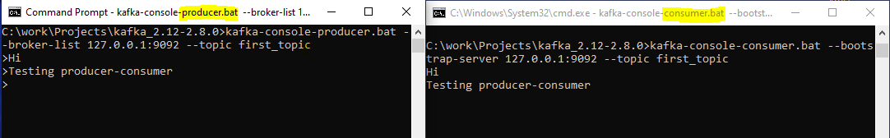

To see messages from beginning in consumer and current message in producer –

kafka-console-consumer.bat --bootstrap-server 127.0.0.1:9092 --topic first_topic --from-beginning

**consumer groups -**

kafka-console-consumer.bat --bootstrap-server 127.0.0.1:9092 --topic first_topic --group first-app

start group in multiple console and produce the message, the message will be shared across multiple consumers within the group.

kafka-console-consumer.bat --bootstrap-server 127.0.0.1:9092 --topic first_topic --group first-app –from-beginning

display consumer groups

kafka-consumer-groups.bat --bootstrap-server localhost:9092 –list

Note: we can use localhost instead of IP as well.

kafka-consumer-groups.bat --bootstrap-server localhost:9092 --describe --group first-app

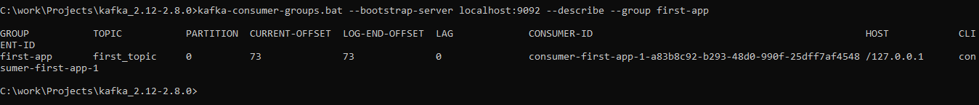

**Reset offset** –

kafka-consumer-groups --bootstrap-server localhost:9092 --group first-app --reset-offsets **--to-earliest** --execute --topic first_topic

with above command, offset is reset to 0



Now run

kafka-console-consumer.bat --bootstrap-server 127.0.0.1:9092 --topic first_topic --group first-app

which will display all the messages that were produced earlier.

kafka-consumer-groups --bootstrap-server localhost:9092 --group first-app --reset-offsets **–shift-by -2** --execute --topic first_topic

