This is a sample servlet project for generating Birt report using multiple DB connections.

Download Birt runtime and add it to lib folder in the project –

1. Configure the required database details in BirtConfig.properties

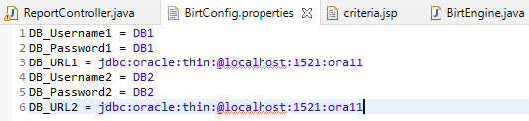

1. Set all the DB details to the map as shown below in ReportController.java –

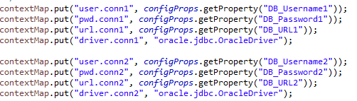

1. Create required data sources in Birt designer, click on property binding and provide the above set properties in binding screen –

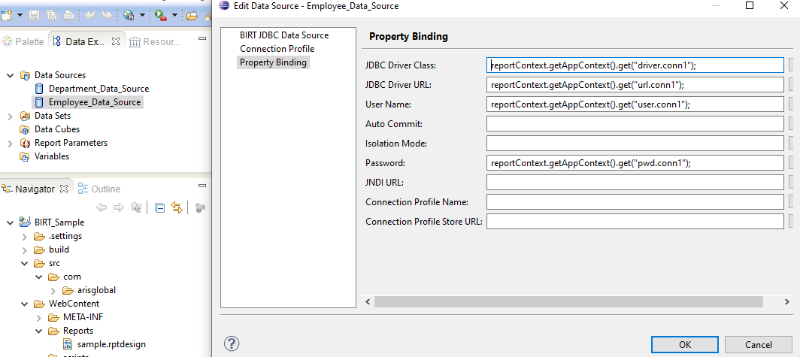

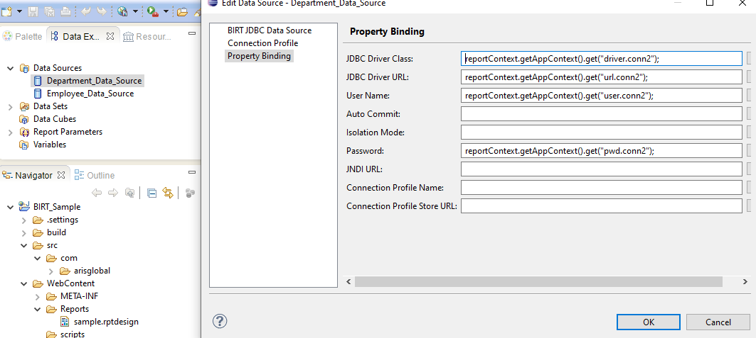

If a single DB is required, then no need to set above connection properties to the map and corresponding property binding in Birt data source is also not required.

Just add below line in ReportController.java, connection will be read from this object within the Birt data source –

contextMap.put("OdaJDBCDriverPassInConnection",getJDBCConnection(url,user,pwd));

we are setting the connection object to the map by creating a connection object by passing url, username and pwd

About the report –

When project is started, a selection criteria jsp is displayed in the browser.

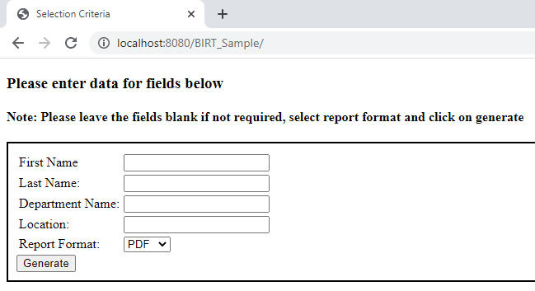

It is not mandatory to enter data for above fields, if data is entered then that data will be passed to the query or else % will be passed to the query. Click on generate button to generate the report.

Mapping selection criteria field values to Birt dataset queries

Following query is used in the datasets –

**select** **\*** **from** DEPARTMENT **where** NAME **like** ? **AND** LOCATION **like** ?

**select** **\*** **from** EMPLOYEE **WHERE** FIRST_NAME **like** ? **AND** LAST_NAME **like** ?

To bind the above selection criteria value to Birt query, set the parameters in ReportController.java as shown below –

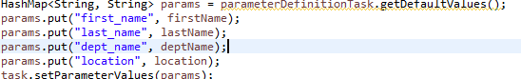

In Birt template , create report parameter –

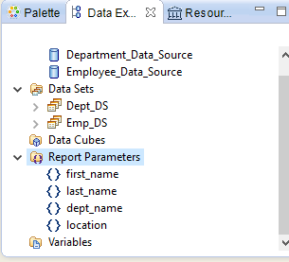

Once the parameter is created, link it with the dataset

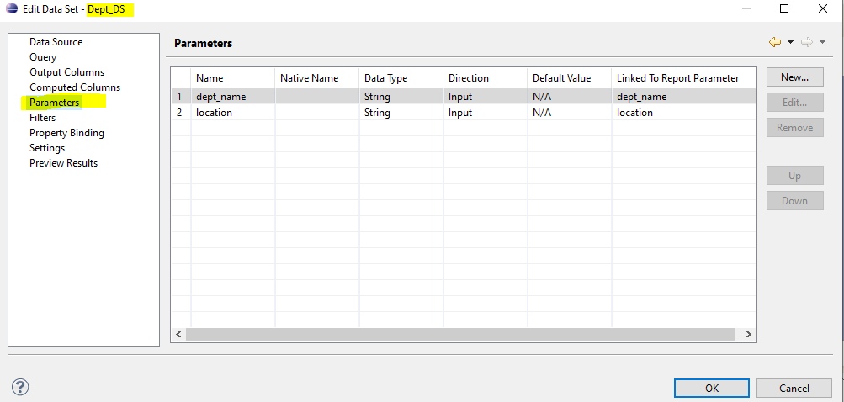

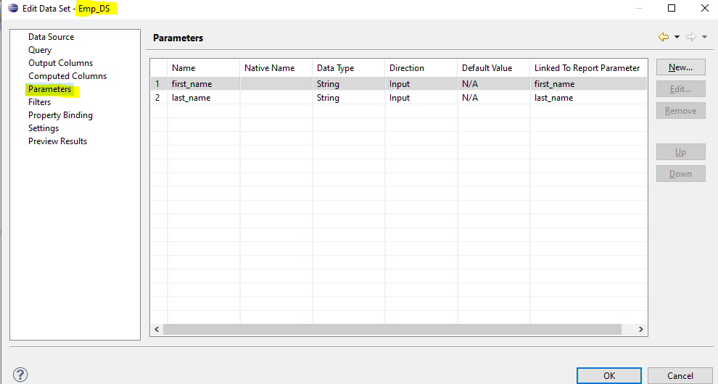

Metadata –

CREATE TABLE "DB1"."EMPLOYEE"

( "ID" VARCHAR2(20 BYTE) NOT NULL ENABLE,

"FIRST_NAME" VARCHAR2(120 BYTE),

"LAST_NAME" VARCHAR2(120 BYTE),

"DEPT_NO" VARCHAR2(120 BYTE),

CONSTRAINT "EMPLOYEE_PK" PRIMARY KEY ("ID")

)

Insert into DB1.EMPLOYEE (ID,FIRST_NAME,LAST_NAME,DEPT_NO) values ('1','Sachin','Tendulkar','4');

Insert into DB1.EMPLOYEE (ID,FIRST_NAME,LAST_NAME,DEPT_NO) values ('2','Rahul','Dravid','1');

Insert into DB1.EMPLOYEE (ID,FIRST_NAME,LAST_NAME,DEPT_NO) values ('3','Yuvraj','Singh','6');

Insert into DB1.EMPLOYEE (ID,FIRST_NAME,LAST_NAME,DEPT_NO) values ('4','MS','Dhoni','3');

Insert into DB1.EMPLOYEE (ID,FIRST_NAME,LAST_NAME,DEPT_NO) values ('5','Javagal','Srinath','2');

Insert into DB1.EMPLOYEE (ID,FIRST_NAME,LAST_NAME,DEPT_NO) values ('6','Anil','Kumble','1');

Insert into DB1.EMPLOYEE (ID,FIRST_NAME,LAST_NAME,DEPT_NO) values ('7','Ajith','Agarkar','4');

Insert into DB1.EMPLOYEE (ID,FIRST_NAME,LAST_NAME,DEPT_NO) values ('8','Souvrav','Ganguly','5');

CREATE TABLE "DB2"."DEPARTMENT"

( "ID" VARCHAR2(20 BYTE) NOT NULL ENABLE,

"NAME" VARCHAR2(120 BYTE),

"LOCATION" VARCHAR2(120 BYTE)

)

Insert into DB2.DEPARTMENT (ID,NAME,LOCATION) values ('1','Dept 1','Bengaluru');

Insert into DB2.DEPARTMENT (ID,NAME,LOCATION) values ('2','Dept 2','Mysuru');

Insert into DB2.DEPARTMENT (ID,NAME,LOCATION) values ('3','Dept 3','Jharkhand');

Insert into DB2.DEPARTMENT (ID,NAME,LOCATION) values ('4','Dept 4','Mumbai');

Insert into DB2.DEPARTMENT (ID,NAME,LOCATION) values ('5','Dept 5','Kolkata');

Insert into DB2.DEPARTMENT (ID,NAME,LOCATION) values ('6','Dept 6','Chandigarh');

Sample –

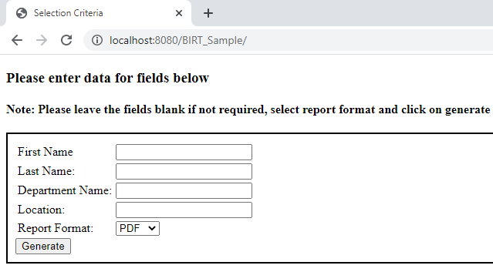

Report –

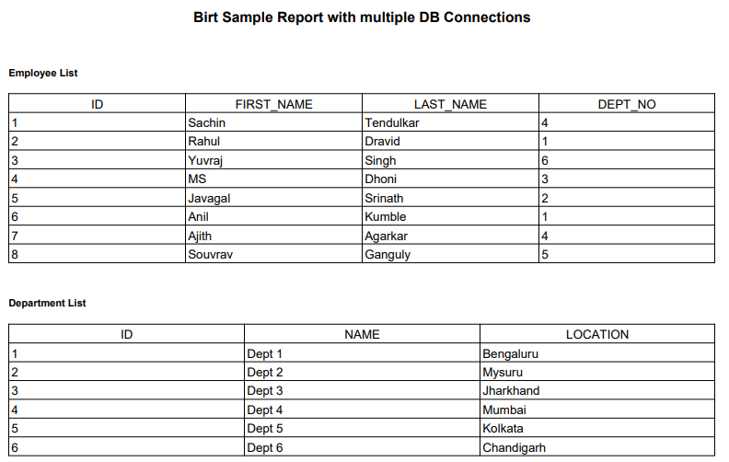

Selection criteria –

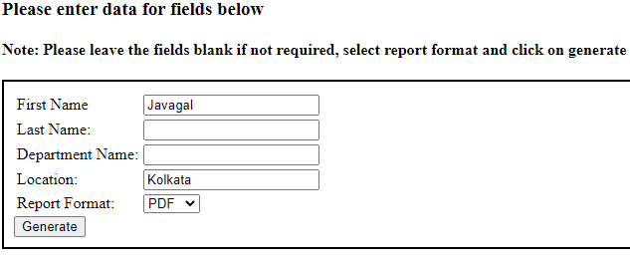

Report -

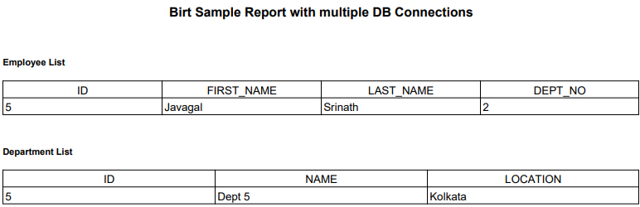

Wildcard –

