**DOS PROJECT – 4 Twitter Simulator**

TEAM MEMBERS:

Name: Soumitra Siddharth Johri

Name: Nithin K Vadyala

Name: Stuti Joshi

Twitter Architecture:

The architecture of Client, Server and Message passing that are used in our Twitter Simulator project are shown below:

Client Architecture:

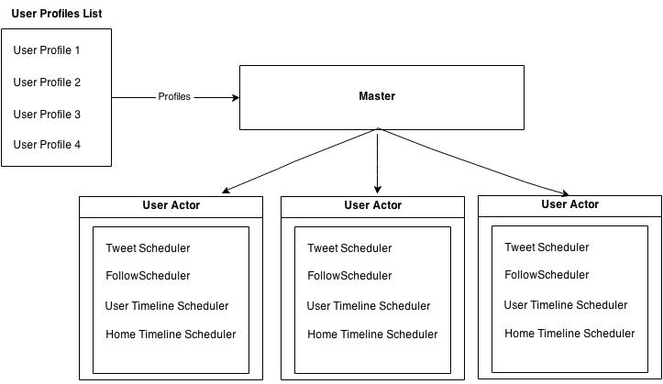

Server Architecture:

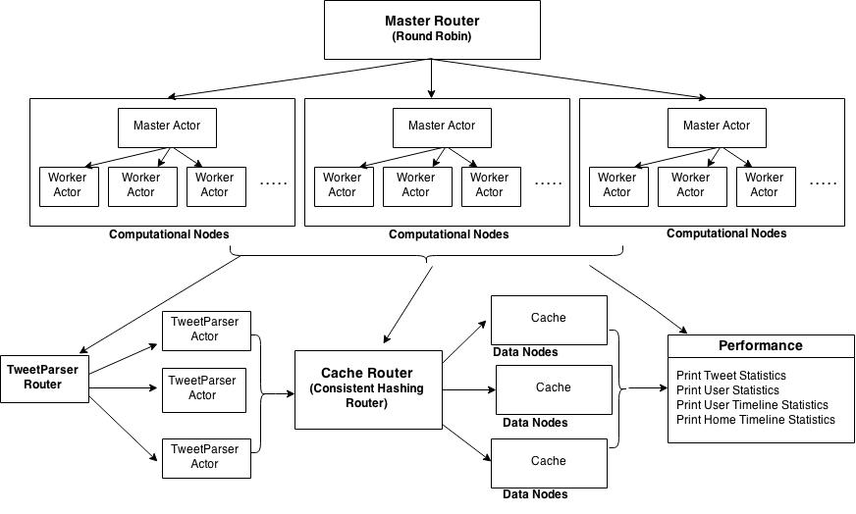

Message Passing:

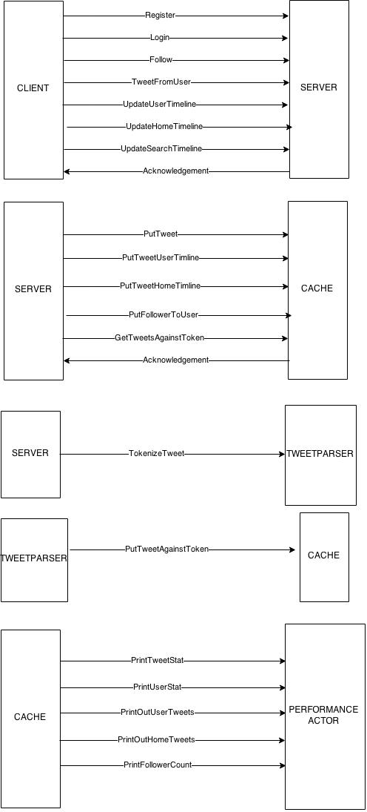

Output :-

**RUN 1:**

In this scenerio, the users were created at a very high rate. The output ad results of the run 1 can be summerized as below:

This table below consists of the output of number of teets sent by the client, number of users created by the client, number of tweets delivered to the clients by the server, followercount and the average follower count.

|  |  |  |  |  |  |  |  |  |  |
| --- | --- | --- | --- | --- | --- | --- | --- | --- | --- |
| Tweets In | | Users | UserTimelineTweets | | | | FollowerCount | AvgFollowerCount | |
| 2 | | 1 | 0 | | | | 0 | 1.0 | |
| 4089 | | 4038 | 1670 | | | | 1 | 2.4764 | |
| 18731 | | 18730 | 9212 | | | | 1 | 5.33902 | |
| 31048 | | 31047 | 16997 | | | | 1 | 3.220923 | |
| 46017 | | 40000 | 31451 | | | | 1 | 2.5 | |
| 51339 | | 40001 | 38990 | | | | 1 | 2.49993 | |
| 56269 | | 40001 | 47845 | | | | 1 | 2.49993 | |
| 59167 | | 40001 | | 52815 | | | 1 | | 2.49993 |
| 62301 | | 40001 | | 57731 | | | 1 | | 2.49993 |
| 65296 | | 40001 | | 60641 | | | 1 | | 2.49993 |
| 66915 | | 40001 | | 63497 | | | 1 | | 2.49993 |
| 67550 | | 40001 | | 64565 | | | 1 | | 2.49993 |
| 68111 | | 40001 | | 65629 | | | 1 | | 2.49993 |
| 68880 | | 40001 | | 67056 | | | 1 | | 2.49993 |
| 69232 | | 40001 | | 68004 | | | 1 | | 2.49993 |
| 69858 | | 40001 | | 69268 | | | 1 | | 2.49993 |
| 70286 | | 40001 | | 69975 | | | 1 | | 2.49993 |
| 70417 | | 40001 | | 70273 | | | 1 | | 2.49993 |
| 72146 | 40895 | | | | 76125 | 11472 | | 0.280523 | |
| 100828 | 49390 | | | | 184814 | 13862 | | 0.28066 | |
| 100828 | 49390 | | | | 184814 | 13862 | | 0.280664 | |
| 104425 | 50631 | | | | 197424 | 13991 | | 0.276332 | |
| 108109 | 51298 | | | | 209823 | 14132 | | 0.275488 | |
| 111180 | 51822 | | | | 218852 | 14355 | | 0.277005 | |
| 113582 | 52414 | | | | 223107 | 14425 | | 0.275212 | |
| 115840 | 52826 | | | | 230662 | 14513 | | 0.274732 | |
| 116847 | 53170 | | | | 236301 | 14521 | | 0.273105 | |
| 117878 | 53732 | | | | 237218 | 14543 | | 0.27065 | |
| 118789 | 54111 | | | | 241251 | 14575 | | 0.269353 | |
| 119697 | 54500 | | | | 243223 | 14603 | | 0.267944 | |
| 120466 | 54866 | | | | 244557 | 14633 | | 0.266704 | |
| 121194 | 55051 | | | | 247176 | 14658 | | 0.266262 | |
| 121732 | 55469 | | | | 248402 | 14663 | | 0.264345 | |
| 121934 | 55469 | | | | 249828 | 14664 | | 0.264363 | |
| 122014 | 55469 | | | | 250636 | 14664 | | 0.264363 | |
| 122081 | 56249 | | | | 250891 | 16115 | | 0.264363 | |
| 122183 | 56249 | | | | 251167 | 19229 | | 0.290522 | |

Based on the above user creation, we have generated some graphs, as follows:

Graphs:-

Run 2:

In this scenario the Users load and tweets are created slowly.

The output and results of the run 2 can be summarized as:

This table below consists of the output of number of teets sent by the client, number of users created by the client, number of tweets delivered to the clients by the server, followercount and the average follower count.

Output:

|  |  |  |  |  |  |
| --- | --- | --- | --- | --- | --- |
| Tweets In | Users | UserTimelineTweets | HomeTimeLineTweets | FollowerCount | AvgFollowerCount |
| 0 | 0 | 0 | 0 | 15 | 0 |
| 238 | 20 | 120 | 0 | 45 | 2.25 |
| 1429 | 50 | 930 | 0 | 75 | 1.5 |
| 3602 | 80 | 3420 | 0 | 105 | 1.3125 |
| 6764 | 110 | 8590 | 0 | 135 | 1.227273 |
| 10898 | 140 | 17450 | 0 | 165 | 1.178571 |
| 22057 | 200 | 50210 | 856 | 225 | 1.125 |
| 29084 | 230 | 76120 | 3886 | 255 | 1.108696 |
| 37050 | 260 | 109710 | 10094 | 285 | 1.096154 |
| 45961 | 290 | 151980 | 20501 | 315 | 1.086207 |
| 55790 | 320 | 203940 | 36104 | 345 | 1.078125 |
| 66554 | 350 | 266580 | 57912 | 375 | 1.071429 |
| 90909 | 410 | 426980 | 124120 | 435 | 1.060976 |
| 104467 | 440 | 525180 | 170526 | 465 | 1.056818 |
| 118887 | 470 | 635380 | 227133 | 495 | 1.053191 |
| 134212 | 500 | 757580 | 295030 | 550 | 1.1 |
| 150419 | 530 | 891780 | 375580 | 610 | 1.150943 |
| 167567 | 560 | 1037980 | 469917 | 670 | 1.196429 |
| 204516 | 620 | 1366380 | 704080 | 790 | 1.274194 |
| 224323 | 650 | 1548580 | 845820 | 850 | 1.307692 |
| 244969 | 680 | 1742780 | 1004777 | 910 | 1.338235 |
| 266420 | 710 | 1948980 | 1181014 | 970 | 1.366197 |
| 288684 | 740 | 2167180 | 1374546 | 1030 | 1.391892 |
| 311806 | 770 | 2397380 | 1585375 | 1090 | 1.415584 |
| 360758 | 830 | 2893780 | 2058957 | 1210 | 1.457831 |
| 386471 | 860 | 3159980 | 2321581 | 1270 | 1.476744 |
| 412956 | 890 | 3438180 | 2600681 | 1330 | 1.494382 |
| 440344 | 920 | 3728380 | 2895252 | 1390 | 1.51087 |
| 468474 | 950 | 4030580 | 3204272 | 1450 | 1.526316 |
| 497520 | 980 | 4344780 | 3526774 | 1515 | 1.545918 |
| 557847 | 1040 | 5009180 | 4208947 | 1694 | 1.628846 |
| 589259 | 1070 | 5359380 | 4568112 | 1784 | 1.66729 |
| 621410 | 1100 | 5721580 | 4939264 | 1873 | 1.702727 |
| 654297 | 1130 | 6095780 | 5322414 | 1963 | 1.737168 |
| 688022 | 1160 | 6481980 | 5717569 | 2053 | 1.769828 |
| 722551 | 1190 | 6880180 | 6124735 | 2143 | 1.80084 |
| 794068 | 1250 | 7712580 | 6975036 | 2323 | 1.8584 |
| 830889 | 1280 | 8146780 | 7418179 | 2413 | 1.885156 |
| 868306 | 1310 | 8592980 | 7873334 | 2503 | 1.910687 |
| 906686 | 1340 | 9051180 | 8340508 | 2593 | 1.935075 |
| 945827 | 1370 | 9521380 | 8819639 | 2683 | 1.958394 |
| 985707 | 1400 | 10003580 | 9310792 | 2773 | 1.980714 |
| 1067415 | 1460 | 11003980 | 10329114 | 2953 | 2.022603 |
| 1109431 | 1490 | 11522180 | 10856283 | 3058 | 2.052349 |
| 1152100 | 1520 | 12052380 | 11395464 | 3178 | 2.090789 |
| 1195442 | 1550 | 12594580 | 11946608 | 3298 | 2.127742 |
| 1239659 | 1580 | 13148780 | 12509787 | 3418 | 2.163291 |
| 1284694 | 1610 | 13714980 | 13084956 | 3538 | 2.197516 |
| 1376290 | 1670 | 14883380 | 14271226 | 3777 | 2.261677 |
| 1423156 | 1700 | 15485580 | 14882414 | 3897 | 2.292353 |
| 1470727 | 1730 | 16099780 | 15505586 | 4017 | 2.321965 |
| 1519104 | 1760 | 16725980 | 16140754 | 4137 | 2.350568 |
| 1568022 | 1790 | 17364180 | 16787942 | 4257 | 2.378212 |
| 1617457 | 1820 | 18014380 | 17447086 | 4377 | 2.404945 |
| 1718753 | 1880 | 19350780 | 18801382 | 4617 | 2.455851 |
| 1770334 | 1910 | 20036980 | 19496545 | 4737 | 2.480105 |
| 1822398 | 1940 | 20735180 | 20203691 | 4857 | 2.503608 |
| 1875244 | 1970 | 21445380 | 20922865 | 4977 | 2.526396 |
| 1928812 | 2000 | 22167580 | 21654015 | 5122 | 2.561 |
| 1983057 | 2030 | 22901780 | 22397167 | 5272 | 2.597044 |
| 2093107 | 2090 | 24406180 | 23919490 | 5570 | 2.665072 |
| 2149197 | 2120 | 25176380 | 24698643 | 5720 | 2.698113 |
| 2205732 | 2150 | 25958580 | 25489821 | 5870 | 2.730233 |
| 2263014 | 2180 | 26752780 | 26292969 | 6019 | 2.761009 |
| 2320798 | 2210 | 27558980 | 27108152 | 6169 | 2.791403 |
| 2379329 | 2240 | 28377180 | 27935357 | 6319 | 2.820982 |
| 2498245 | 2300 | 30049535 | 29625702 | 6618 | 2.877391 |
| 2558601 | 2330 | 30903702 | 30488874 | 6767 | 2.904292 |
| 2619425 | 2360 | 31769856 | 31363990 | 6918 | 2.931356 |
| 2680790 | 2389 | 32647990 | 32251106 | 7067 | 2.958141 |
| 2743047 | 2419 | 33538124 | 33150171 | 7218 | 2.983878 |
| 2805615 | 2450 | 34440256 | 34061187 | 7368 | 3.007347 |
| 2932649 | 2510 | 36280524 | 35919245 | 7701 | 3.068127 |
| 2997010 | 2540 | 37218644 | 36866283 | 7881 | 3.102756 |
| 3061668 | 2569 | 38168745 | 37825327 | 8061 | 3.137797 |
| 3127215 | 2600 | 39130601 | 38796327 | 8240 | 3.169231 |
| 3193218 | 2629 | 40104956 | 39779383 | 8421 | 3.203119 |
| 3259705 | 2659 | 41091090 | 40774389 | 8601 | 3.234675 |
| 3394627 | 2720 | 43099368 | 42800422 | 8961 | 3.294485 |
| 3462933 | 2749 | 44121535 | 43831465 | 9141 | 3.325209 |
| 3531772 | 2780 | 45155690 | 44874466 | 9320 | 3.352518 |
| 3601423 | 2809 | 46201811 | 45929497 | 9501 | 3.382342 |
| 3671096 | 2840 | 47259957 | 46996471 | 9681 | 3.408803 |
| 3741534 | 2870 | 48330012 | 48075476 | 9861 | 3.435889 |
| 3884210 | 2929 | 50506245 | 50269393 | 10220 | 3.489245 |
| 3956446 | 2960 | 51612333 | 51384437 | 10400 | 3.513514 |
| 4029005 | 2989 | 52730600 | 52511282 | 10595 | 3.544664 |
| 4102206 | 3020 | 53860655 | 53650400 | 10805 | 3.577815 |
| 4175553 | 3049 | 55002410 | 54801139 | 11015 | 3.61266 |
| 4249432 | 3079 | 56156722 | 55964004 | 11224 | 3.645339 |
| 4398945 | 3139 | 58500377 | 58325671 | 11645 | 3.70978 |
| 4474549 | 3169 | 59690777 | 59524827 | 11855 | 3.740928 |
| 4550481 | 3199 | 60892364 | 60735325 | 12064 | 3.771178 |
| 4627213 | 3229 | 62106720 | 61958406 | 12275 | 3.801487 |
| 4704359 | 3259 | 63332242 | 63193328 | 12485 | 3.83093 |
| 4781858 | 3289 | 64570541 | 64439342 | 12694 | 3.859532 |
| 4937405 | 3349 | 67069440 | 66958703 | 13110 | 3.914601 |
| 5016679 | 3379 | 68348040 | 68245475 | 13321 | 3.942291 |
| 5096052 | 3409 | 69633040 | 69539462 | 13530 | 3.968906 |
| 5174915 | 3439 | 70910840 | 70826664 | 13737 | 3.994475 |
| 5257087 | 3469 | 72249818 | 72172691 | 13952 | 4.021908 |
| 5337896 | 3499 | 73571640 | 73503135 | 14184 | 4.05373 |
| 5500863 | 3559 | 76250840 | 76200842 | 14661 | 4.119416 |
| 5583043 | 3589 | 77608640 | 77567683 | 14899 | 4.151296 |
| 5665819 | 3619 | 78978440 | 78946511 | 15140 | 4.183476 |
| 5749147 | 3649 | 80360240 | 80338133 | 15380 | 4.214853 |
| 5832730 | 3679 | 81754440 | 81740561 | 15619 | 4.245447 |
| 5916600 | 3709 | 83160240 | 83154987 | 15860 | 4.276085 |
| 6085787 | 3769 | 86007840 | 86020617 | 16339 | 4.335102 |
| 6170841 | 3799 | 87449240 | 87471414 | 16577 | 4.363517 |
| 6256178 | 3829 | 88896240 | 88929808 | 16815 | 4.391486 |
| 6342402 | 3859 | 90368839 | 90409787 | 17056 | 4.419798 |
| 6429088 | 3889 | 91847039 | 91896156 | 17295 | 4.447159 |
| 6516118 | 3919 | 93336439 | 93394925 | 17534 | 4.474101 |
| 6690972 | 3979 | 96352039 | 96428022 | 18020 | 4.528776 |
| 6779213 | 4009 | 97878239 | 97963569 | 18289 | 4.561986 |
| 6867904 | 4039 | 99415639 | 99509902 | 18558 | 4.594702 |
| 6956892 | 4069 | 1.01E+08 | 1.01E+08 | 18826 | 4.62669 |
| 7046257 | 4099 | 1.03E+08 | 1.03E+08 | 19094 | 4.658209 |
| 7136214 | 4129 | 1.04E+08 | 1.04E+08 | 19365 | 4.689998 |
| 7317748 | 4189 | 1.07E+08 | 1.07E+08 | 19904 | 4.751492 |
| 7408758 | 4219 | 1.09E+08 | 1.09E+08 | 20174 | 4.781702 |
| 7500191 | 4249 | 1.11E+08 | 1.11E+08 | 20445 | 4.81172 |
| 7591800 | 4279 | 1.12E+08 | 1.12E+08 | 20713 | 4.840617 |
| 7683889 | 4309 | 1.14E+08 | 1.14E+08 | 20983 | 4.869575 |
| 7776630 | 4339 | 1.15E+08 | 1.16E+08 | 21253 | 4.898133 |
| 7963159 | 4399 | 1.19E+08 | 1.19E+08 | 21792 | 4.953853 |
| 8057134 | 4429 | 1.2E+08 | 1.21E+08 | 22062 | 4.98126 |
| 8151178 | 4459 | 1.22E+08 | 1.22E+08 | 22333 | 5.008522 |
| 8245675 | 4489 | 1.24E+08 | 1.24E+08 | 22616 | 5.038093 |
| 8340576 | 4519 | 1.26E+08 | 1.26E+08 | 22917 | 5.071255 |
| 8435339 | 4549 | 1.27E+08 | 1.28E+08 | 23217 | 5.103759 |
| 8626727 | 4609 | 1.31E+08 | 1.31E+08 | 23817 | 5.167498 |
| 8723206 | 4639 | 1.33E+08 | 1.33E+08 | 24117 | 5.19875 |
| 8820178 | 4669 | 1.34E+08 | 1.35E+08 | 24573 | 5.263011 |
| 8940708 | 4906 | 1.36E+08 | 1.37E+08 | 25172 | 5.13086 |
| 9152212 | 5234 | 1.38E+08 | 1.38E+08 | 25771 | 4.923768 |
| 9453526 | 5564 | 1.4E+08 | 1.4E+08 | 26369 | 4.739216 |
| 10302017 | 6224 | 1.45E+08 | 1.44E+08 | 27569 | 4.429467 |
| 10824603 | 6544 | 1.47E+08 | 1.47E+08 | 28148 | 4.301345 |
| 11363753 | 6837 | 1.49E+08 | 1.49E+08 | 28678 | 4.19453 |
| 11894961 | 7099 | 1.52E+08 | 1.51E+08 | 29173 | 4.109452 |
| 12409403 | 7337 | 1.54E+08 | 1.54E+08 | 29625 | 4.037754 |
| 12911973 | 7556 | 1.57E+08 | 1.56E+08 | 30050 | 3.976972 |
| 13820139 | 7925 | 1.62E+08 | 1.61E+08 | 32619 | 4.115962 |
| 14266535 | 10307 | 1.64E+08 | 1.64E+08 | 35958 | 3.488697 |
| 14688621 | 13399 | 1.67E+08 | 1.66E+08 | 39305 | 2.933428 |
| 15080150 | 16483 | 1.69E+08 | 1.7E+08 | 42631 | 2.586362 |
| 15372979 | 19536 | 1.71E+08 | 1.74E+08 | 45495 | 2.328778 |
| 15426601 | 20752 | 1.72E+08 | 1.76E+08 | 46201 | 2.22634 |
| 15427904 | 20752 | 1.72E+08 | 1.76E+08 | 46201 | 2.22634 |
| 15427922 | 20752 | 1.72E+08 | 1.76E+08 | 46201 | 2.22634 |
| 15461280 | 20764 | 1.72E+08 | 1.76E+08 | 46214 | 2.225679 |

The rate of tweets in the system can be represented as in below graph. As the user creation frequency is less, the graph increases slowly. If number of clients are increased, there is abrupt increase in the number of tweets in the system, as can be seen in the later part of the graph.

The rate of user creation is slower in the run 2 as in comparison to run 1. The number of users increases slowly with time. If number of clients are increased, number of users increases suddenly.

The total tweets in the system is sum of User Timeline and Home Timeline tweets. The total tweets in system increases with time. The rate of increase of total tweets is system is slower than run 1.

**Output on pcluster machines:-**

Run 1:-

In this run, a large number of users are created, and the tweets and followers are generated by using schedulers. The graphs generated and the recorded output for this type of run is shown below:

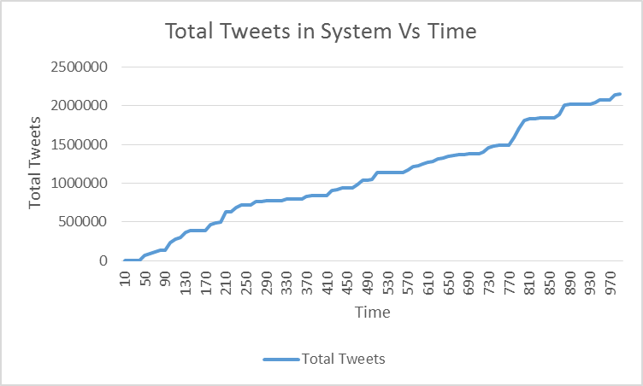

|  |  |  |  |  |  |
| --- | --- | --- | --- | --- | --- |
| Tweets In | Time |  | Users | UserTimeLine  Tweets | AverageFollower  Count |
| 0 | 10 |  | 0 | 0 | 0 |
| 4 | 20 |  | 2 | 0 | 0.5 |
| 4 | 30 |  | 2 | 0 | 0.5 |
| 4 | 40 |  | 2549 | 0 | 3.92E-04 |
| 2529 | 50 |  | 40002 | 64462 | 0.999925 |
| 2529 | 60 |  | 40002 | 93550 | 0.999925 |
| 2529 | 70 |  | 40002 | 111545 | 0.999925 |
| 2529 | 80 |  | 40002 | 131798 | 0.999925 |
| 2529 | 90 |  | 51032 | 132250 | 0.790857 |
| 7425 | 100 |  | 51032 | 224768 | 0.999941 |
| 8904 | 110 |  | 51032 | 264161 | 0.999941 |
| 9769 | 120 |  | 51032 | 289100 | 0.999941 |
| 10754 | 130 |  | 51032 | 352562 | 0.999941 |
| 11702 | 140 |  | 51032 | 373556 | 0.999941 |
| 11723 | 150 |  | 51032 | 374428 | 0.999941 |
| 11723 | 160 |  | 51032 | 374428 | 0.999941 |
| 11723 | 170 |  | 91032 | 374428 | 0.625209 |
| 16846 | 180 |  | 91032 | 443947 | 0.999934 |
| 18051 | 190 |  | 91032 | 467127 | 0.999934 |
| 18728 | 200 |  | 131032 | 481336 | 0.718031 |
| 22566 | 210 |  | 131032 | 605145 | 0.82966 |
| 22762 | 220 |  | 131032 | 608865 | 0.836246 |
| 25059 | 230 |  | 131032 | 659549 | 0.853044 |
| 26369 | 240 |  | 131032 | 695124 | 0.853059 |
| 26369 | 250 |  | 131032 | 695124 | 0.853059 |
| 26369 | 260 |  | 159805 | 695124 | 0.699465 |
| 30037 | 270 |  | 171032 | 732344 | 0.887419 |
| 30193 | 280 |  | 171032 | 734827 | 0.887419 |
| 30547 | 290 |  | 171032 | 740231 | 0.887419 |
| 30547 | 300 |  | 171032 | 740231 | 0.887419 |
| 30547 | 310 |  | 173312 | 740231 | 0.875744 |
| 31080 | 320 |  | 198892 | 741410 | 0.873082 |
| 33313 | 330 |  | 198892 | 759328 | 0.873082 |
| 33313 | 340 |  | 198892 | 759328 | 0.873082 |
| 33313 | 350 |  | 198892 | 759328 | 0.873082 |
| 33313 | 360 |  | 238892 | 759328 | 0.802785 |
| 37119 | 370 |  | 238892 | 795295 | 0.894329 |
| 37560 | 380 |  | 238892 | 802319 | 0.894329 |
| 37572 | 390 |  | 238892 | 802319 | 0.894329 |
| 37773 | 400 |  | 238892 | 802365 | 0.894329 |
| 37773 | 410 |  | 278892 | 802365 | 0.805663 |
| 41085 | 420 |  | 278892 | 867457 | 0.851355 |
| 41877 | 430 |  | 278892 | 878232 | 0.854994 |
| 43001 | 440 |  | 278892 | 892377 | 0.856923 |
| 43334 | 450 |  | 278892 | 894544 | 0.861602 |
| 43720 | 460 |  | 279084 | 899940 | 0.861339 |
| 44998 | 470 |  | 291456 | 942614 | 0.872382 |
| 44998 | 480 |  | 291456 | 997668 | 0.876225 |
| 44998 | 490 |  | 291456 | 997668 | 0.881457 |
| 45249 | 500 |  | 331456 | 998694 | 0.8304 |
| 49201 | 510 |  | 331456 | 1090731 | 0.856587 |
| 49413 | 520 |  | 331456 | 1091118 | 0.86492 |
| 49413 | 530 |  | 331456 | 1091118 | 0.870396 |
| 49413 | 540 |  | 331456 | 1091118 | 0.872055 |
| 49413 | 550 |  | 331456 | 1091118 | 0.873431 |
| 49413 | 560 |  | 338612 | 1091118 | 0.85546 |
| 52278 | 570 |  | 377809 | 1119631 | 0.873256 |
| 53618 | 580 |  | 377809 | 1164986 | 0.875302 |
| 54155 | 590 |  | 379143 | 1174044 | 0.872222 |
| 54965 | 600 |  | 438602 | 1194313 | 0.775409 |
| 55717 | 610 |  | 439018 | 1210864 | 0.854339 |
| 57018 | 620 |  | 445151 | 1218724 | 0.853638 |
| 60103 | 630 |  | 479018 | 1251172 | 0.871088 |
| 60748 | 640 |  | 479018 | 1258169 | 0.876788 |
| 62612 | 650 |  | 479018 | 1285170 | 0.876788 |
| 63570 | 660 |  | 479018 | 1297072 | 0.876788 |
| 63807 | 670 |  | 479018 | 1301062 | 0.876788 |
| 64248 | 680 |  | 479018 | 1305377 | 0.876788 |
| 64537 | 690 |  | 479018 | 1310693 | 0.876788 |
| 64582 | 700 |  | 479018 | 1312000 | 0.876788 |
| 64737 | 710 |  | 479055 | 1314770 | 0.87672 |
| 65733 | 720 |  | 502836 | 1335575 | 0.882624 |
| 67480 | 730 |  | 502836 | 1383833 | 0.882624 |
| 70069 | 740 |  | 502836 | 1413103 | 0.882624 |
| 70572 | 750 |  | 502836 | 1416035 | 0.882624 |
| 70678 | 760 |  | 502836 | 1418692 | 0.882624 |
| 70686 | 770 |  | 526593 | 1418712 | 0.842805 |
| 74763 | 780 |  | 550318 | 1512226 | 0.879154 |
| 77435 | 790 |  | 582836 | 1634421 | 0.859108 |
| 79048 | 800 |  | 582836 | 1728929 | 0.859108 |
| 79719 | 810 |  | 582836 | 1750110 | 0.859108 |
| 80063 | 820 |  | 582836 | 1756025 | 0.859108 |
| 80251 | 830 |  | 582836 | 1759471 | 0.859108 |
| 80251 | 840 |  | 582836 | 1759471 | 0.859108 |
| 80251 | 850 |  | 582836 | 1759471 | 0.859108 |
| 80251 | 860 |  | 622836 | 1759471 | 0.827961 |
| 83099 | 870 |  | 638367 | 1801111 | 0.848101 |
| 90488 | 880 |  | 638367 | 1917256 | 0.858332 |
| 90931 | 890 |  | 638367 | 1927464 | 0.860466 |
| 90941 | 900 |  | 638367 | 1927481 | 0.861476 |
| 90948 | 910 |  | 640039 | 1927705 | 0.860102 |
| 90948 | 920 |  | 640039 | 1927705 | 0.860102 |
| 91007 | 930 |  | 643260 | 1928677 | 0.8568 |
| 93305 | 940 |  | 674364 | 1951590 | 0.858504 |
| 95703 | 950 |  | 674364 | 1981888 | 0.868541 |
| 95703 | 960 |  | 674364 | 1981888 | 0.868541 |
| 95703 | 970 |  | 686428 | 1981888 | 0.853277 |
| 100286 | 980 |  | 714364 | 2041239 | 0.854718 |
| 100825 | 990 |  | 714364 | 2052372 | 0.85658 |

Run 2:-

In this run, a small number of users are created gradually to achieve the maximum number of tweets sent through the system and to get the maximum tweet count rate.

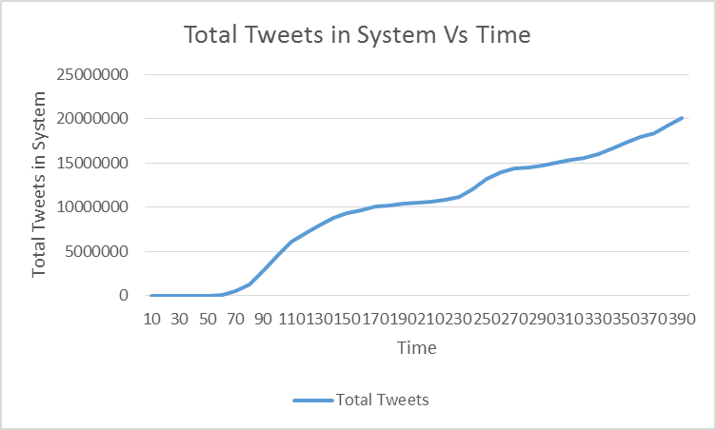

|  |  |  |  |  |  |  |  |
| --- | --- | --- | --- | --- | --- | --- | --- |
| Tweets In | Time | Users | UserTimeLine Tweets | Total Tweets | FollowerCount | Average Follower Count |  |
| 0 | 10 | 0 | 0 | 0 | 0 | 0 |  |
| 4 | 20 | 2 | 0 | 4 | 1 | 0.5 |  |
| 4 | 30 | 2 | 0 | 4 | 1 | 0.5 |  |
| 4 | 40 | 502 | 0 | 4 | 499 | 0.994024 |  |
| 603 | 50 | 1002 | 6790 | 7393 | 499 | 0.498004 |  |
| 1646 | 60 | 1002 | 138052 | 139698 | 999 | 0.997006 |  |
| 3242 | 70 | 1002 | 470533 | 473775 | 999 | 0.997006 |  |
| 6158 | 80 | 1502 | 1290844 | 1297002 | 1499 | 0.998003 |  |
| 10092 | 90 | 1502 | 2872552 | 2882644 | 1499 | 0.998003 |  |
| 13543 | 100 | 1502 | 4535097 | 4548640 | 1499 | 0.998003 |  |
| 16507 | 110 | 1502 | 6122725 | 6139232 | 1499 | 0.998003 |  |
| 17790 | 120 | 1502 | 7060664 | 7078454 | 1499 | 0.998003 |  |
| 19286 | 130 | 1502 | 7926808 | 7946094 | 1499 | 0.998003 |  |
| 20498 | 140 | 1502 | 8817647 | 8838145 | 1499 | 0.998003 |  |
| 21053 | 150 | 1502 | 9349708 | 9370761 | 1499 | 0.998003 |  |
| 21629 | 160 | 1502 | 9676592 | 9698221 | 1499 | 0.998003 |  |
| 22014 | 170 | 1502 | 10017003 | 10039017 | 1499 | 0.998003 |  |
| 22280 | 180 | 1502 | 10208521 | 10230801 | 1499 | 0.998003 |  |
| 22374 | 190 | 1502 | 10354614 | 10376988 | 1499 | 0.998003 |  |
| 22411 | 200 | 2002 | 10526946 | 10549357 | 1998 | 0.998002 |  |
| 23038 | 210 | 2002 | 10625740 | 10648778 | 1998 | 0.998002 |  |
| 24385 | 220 | 2502 | 10816920 | 10841305 | 1998 | 0.798561 |  |
| 25319 | 230 | 2502 | 11178347 | 11203666 | 2497 | 0.998002 |  |
| 28608 | 240 | 2502 | 12019156 | 12047764 | 2497 | 0.998002 |  |
| 30840 | 250 | 2502 | 13140736 | 13171576 | 2497 | 0.998002 |  |
| 32968 | 260 | 2502 | 13883734 | 13916702 | 2497 | 0.998002 |  |
| 34318 | 270 | 2502 | 14326671 | 14360989 | 2497 | 0.998002 |  |
| 34421 | 280 | 2502 | 14434252 | 14468673 | 2497 | 0.998002 |  |
| 34806 | 290 | 2516 | 14659285 | 14694091 | 2737 | 1.087838 |  |
| 34904 | 300 | 3002 | 14989577 | 15024481 | 3495 | 1.164224 |  |
| 35728 | 310 | 3002 | 15280001 | 15315729 | 3496 | 1.164557 |  |
| 37138 | 320 | 3002 | 15508891 | 15546029 | 3496 | 1.164557 |  |
| 38449 | 330 | 3002 | 16000343 | 16038792 | 3496 | 1.164557 |  |
| 39946 | 340 | 3240 | 16576525 | 16616471 | 3496 | 1.079012 |  |
| 40770 | 350 | 4002 | 17251977 | 17292747 | 4158 | 1.038981 |  |
| 42710 | 360 | 4002 | 17893585 | 17936295 | 4493 | 1.122689 |  |
| 44373 | 370 | 4002 | 18334189 | 18378562 | 4493 | 1.122689 |  |
| 48170 | 380 | 4002 | 19133110 | 19181280 | 4493 | 1.122689 |  |
| 49501 | 390 | 4002 | 20046603 | 20096104 | 4493 | 1.122689 |  |