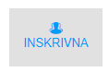After logging into the application,click on the icon on the header.

Then it will redirect to inskrivna listing page.In this page active inskrivnas are listed.

From this screen new inskrivna can be added and an existing inskrivna can be edited.

**New mode**

A new inskrivna can be added by clicking on the  button.It will redirect to the

Inksrivna ÖVERSIKT page.There are 3 tabs in this section.Third tabitem will be disabled for new mode.

C:\Users\nithin\Downloads\FireShot\FireShot Capture 62 - Inskrivna - http___grindan4.remote24.se_people_othertasks_0.png

After that click on the second tab item page will redirect to the Ändra uppgifter section of the Inksrivna.It contains the following modules.

1. Profilbild
2. Personuppgifter
3. Datum för in- och utkrivning
4. Placeringsinformation
5. Dygnsavgift
6. Enhet
7. Ersättning till familjehem
8. Utlägg till familjehem
9. Placering
10. Handläggare
11. Filer
12. Påminnelseintervall
13. Kontakpersoner
14. Sysselsättningar
15. Samtycke

In this screen a new inskrivna can added by filling out the mandatory fields.

Following are the mandatory fields.These fields are mandatory to both edit and new mode.

* Förnamn
* Efternamn
* Epost
* Inskrivningsdag
* ID(Profile id)

After successfull creation of an inskrivna a success message will display and page will redirect to the inskrivna listing page.

**Edit mode**

Each inskrivna can be edited by clicking on the edit button(pencil icon) on right end of each row .After clicking on the edit button(pencil icon)  redirection will happen to the Inksrivna ÖVERSIKT page.In this page overall overview of the inskrivna will be displayed modulewise.The details in this are only for viewing purpose

.A print out of the whole page can be taken by clicking on the C:\Users\nithin\Downloads\FireShot\FireShot Capture 65 - Inskrivna - http___grindan4.remote24.se_people_249.png button.Company logo is also displayed.

1. PersonUppgifter

In this section following informations are listed.

* Profile picture of the inskrivna.
* Förnamn
* Efternamn
* Personnummer
* ID
* Språk
* Land
* Språk vid inloggning
* Skyddad Identitet
* Telefon
* E-post
* Inskrivningsform

1. In the next section Myndighet, Kontor, Telefon, E-post, Handläggare and Telefon jour are displayed.
2. Datum

In this section following informations are listed.

* + - Inskrivningsdag
    - Uppsägningsdag
    - Utskrivningsdag

1. Placeringsinformation

In this section following informations are listed.

* + - Myndighet
    - Kommun
    - Alla kontor
    - Handläggare
    - Inskrivningsform
    - ID
    - Använd drogtest

1. Handläggare

In this section following informations are listed.

* Ansvarig Handläggare
* Medhandläggare

C:\Users\nithin\Downloads\FireShot\FireShot Capture 62 - Inskrivna - http___grindan4.remote24.se_people_othertasks_0.png

By clicking on the second tab item,Andra Upggfiter page will be displayed,where all the details about the inskrivna can be viewed and edited.

It contains the following modules.

1. Profilbild
2. Personuppgifter
3. Datum för in- och utkrivning
4. Placeringsinformation
5. Dygnsavgift
6. Enhet
7. Ersättning till familjehem
8. Utlägg till familjehem
9. Placering
10. Handläggare
11. Filer
12. Påminnelseintervall
13. Kontakpersoner
14. Sysselsättningar
15. Samtycke

**Profilbild**

* In this section profile image can be uploaded.
* An image file can be selected from the computer by clicking on the **Välj fil** button.
* After selecting an image,it can be uploaded by clicking on the **Ladda upp fil** button.
* Only files having extensions '.jpg', '.png' ,'.jpeg' can be uploded.
* Proper validation messages are provided for this section.
* In new mode **Ladda upp fil** button will be hidden.If an image file is selected while adding an inskrivna the file will be uploaded.
* Otherwise default profile picture will be displayed in the edit screen.
* Uploaded profile picture can be removed or changed.
* Once it is removed default picture will be displayed.
* Insert and update of all fields are working fine.

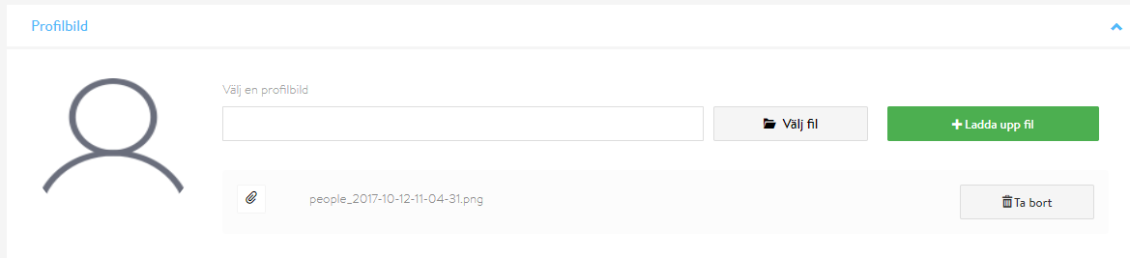

**Personuppgifter**

In this section following fields are there:

* Förnamn(Text field)
* Efternamn(text field)
* Personnummer(text field)
* Telefonnummer(text field)
* Epost(text field)
* Språk(text field)
* Språk vid inloggning(combo box)
* Land(combo box)
* Skyddad identitet(checkbox)
* Noteringar(Text area)
* Lösenord(Password field)
* Generera lösenord button - used to generate password.

Insert and update of all fields are working fine.

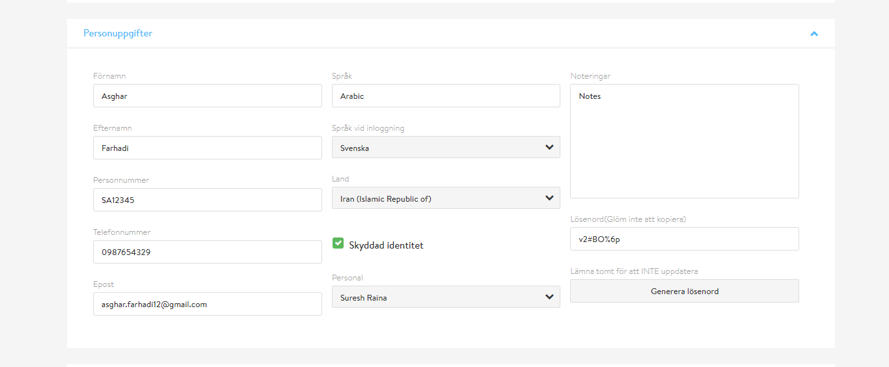

**Datum för in- och utkrivning**

In this section following fields are there:

* Inskrivningsdag(Datepicker)
* Utskrivningsdag(Datepicker)
* 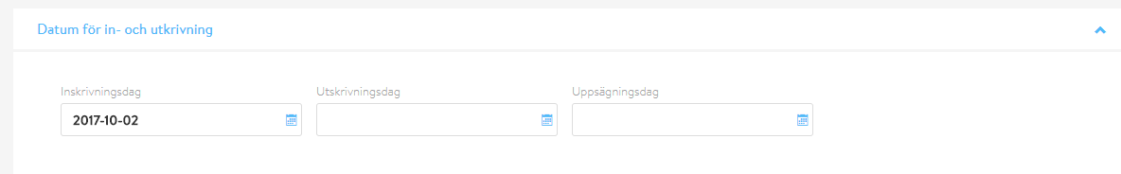Uppsägningsdag(Datepicker)

Insert and update of all fields are working fine.

**Placeringsinformation**

In this section following fields are there:

* Myndighet(dropdown)
* Kommun(dropdown)
* Kontor(dropdown)
* Handläggare(dropdown)
* Inskrivningsform(dropdown)
* ID(text field)
* Arrvänd drogtest(checkbox)
* Åtgärd vid avvikelse(text area)
* Lägg till kontor(button)
* Lägg till handläggare(button)

Non-working :

1. Inskrivningsform dropdown is not data driven.

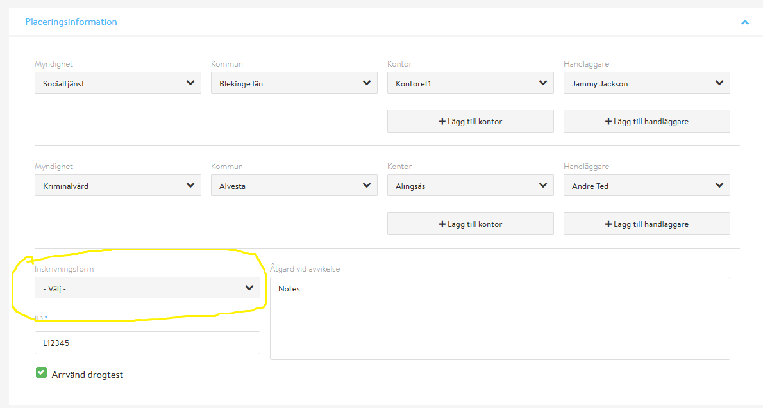

1. Lägg till kontor and Lägg till handläggare buttons has no actions.

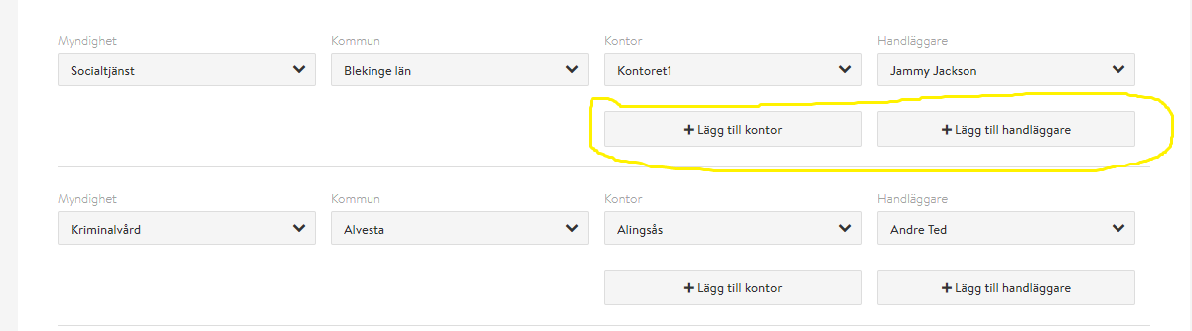

Rest all fields are working fine.

**Dygnsavgift**

In this section following fields are there:

* Från(datepicker)
* Till(datepicker)
* SEK / dag(input type number)
* Lägg till(button)
* Ta bort(button)

Från datepicker is used to select the from date.Till datepicker is used to select the to date.SEK / dag field is used to enter number value. Maximum value is 100000.Lägg till button is used to add new row in the section.Ta bort button is used to remove a row from the section.

**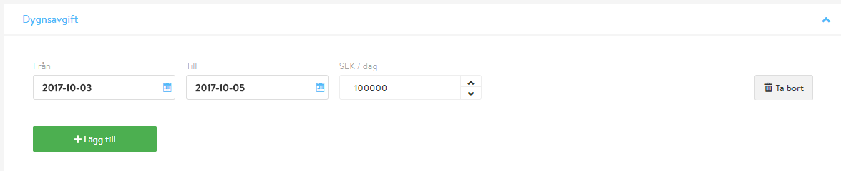**

all functionalities are working fine.

**Enhet**

In this section following fields are there:

* Från(datepicker)
* Till(datepicker)
* Typ av placering (dropdown)
* Typ av enhet (dropdown)
* Enhet(dropdown)
* Rum(text field)
* Lägg till(button)
* Ta bort(button) **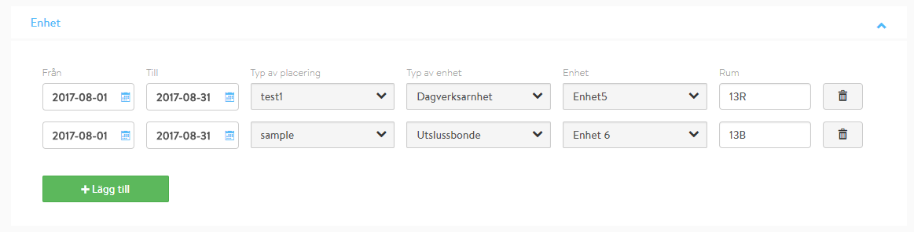**

Från datepicker is used to select the from date.Till datepicker is used to select the to date.Typ av placering lists Type of location.Typ av enhet lists Type of unit.Enhet lists unit.Rum text field to enter values.Lägg till button is used to add new row in the section.Ta bort button is used to remove a row from the section.

all functionalities are working fine.

**Ersättning till familjehem**

In this section following fields are there:

* Från(datepicker)
* Till(datepicker)
* Arvode/dag (input type number)
* Arvode/dag (input type number)
* Lägg till(button)
* Ta bort(button)

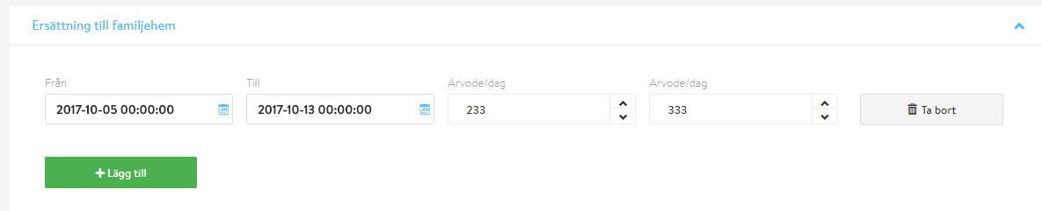Från datepicker is used to select the from date.Till datepicker is used to select the to date.Arvode/dag field is used to enter number value. Maximum value is 100000.Arvode/dag field is used to enter number value.Maximum value is 100000.Lägg till button is used to add new row in the section.Ta bort button is used to remove a row from the section.

Non-working

1. Date binding is not working properly.
2. Date is displaying along with time part.

**Utlägg till familjehem**

**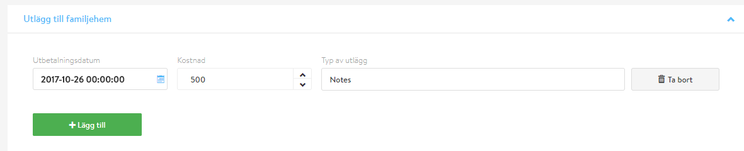**

In this section following fields are there:

* Utbetalningsdatum (datepicker)
* Kostnad/dag (input type number)
* Typ av utlägg (input type field)
* Lägg till(button)
* Ta bort(button)

Utbetalningsdatum datepicker is used to select a date.Kostnad/dag field is used to enter number value. Maximum value is 100000.Typ av utlägg field is used to enter type.Lägg till button is used to add new row in the section.Ta bort button is used to remove a row from the section.

Non-working

1. Date binding is not working properly.
2. Date is displaying along with time part.

**Placering**

**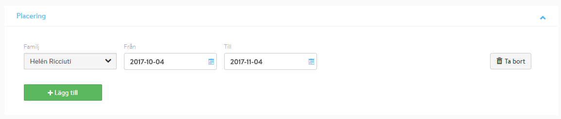**

In this section following fields are there:

• Familj (dropdown)

• Från (datepicker)

• Till (datepicker)

• Lägg till(button)

• Ta bort(button)

Family can be selected from the Familj dropdownFom date and to date can be selected fro the Från and Till datepicker respectivelly.Lägg till button is used to add new row in the section.Ta bort button is used to remove a row from the section.

all functionalities are working fine.

**Handläggare**

Contains 3 sections:

1. Ansvarig handläggare

Handläggare(social manager) can be searched and selected.Selected Handläggare(social manager) will be appear on the text box field in the left hand side section.

1. Välj medhandläggare

Multiple medhandläggare(coworker) can be searched and selected from the list in middle section.

1. Valda medhandläggare

Selected medhandläggare(coworker) will appear on right hand side section.

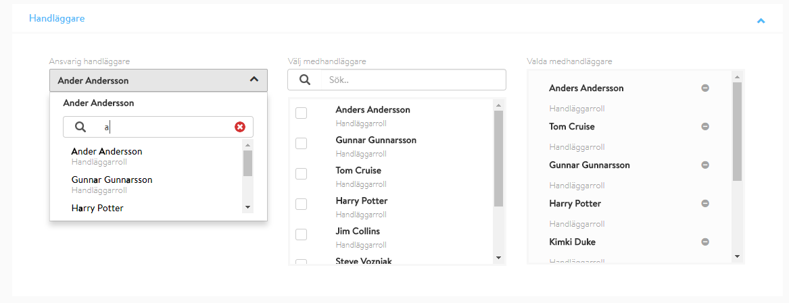

**Filer**

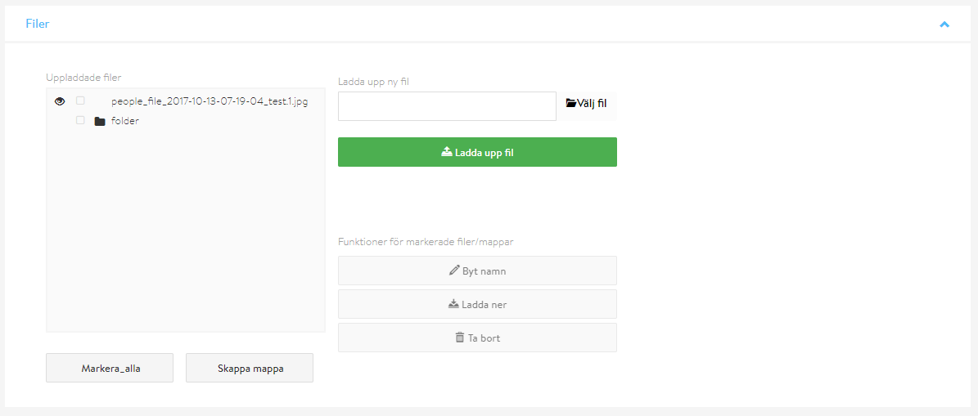

In this section uploded files and created folders are displayed in a tree view on the left hand side.New files can be selected by clicking the Välj fil(select file) button.File can be uploaded by clicking the  Ladda upp fil (upload file) button.All nodes in the tree view can be selected at once by clicking the Markera\_alla(mark all) button.By clicking the Skappa mappa(create folder) button a popup will appear ,and a new folder can be created by typing the name and clicking the Spara (save) button on the right hand side.

Each node in the treeview can be renamed,deleted and downloaded from this section.

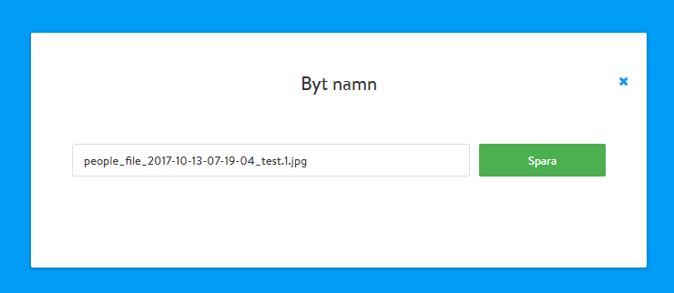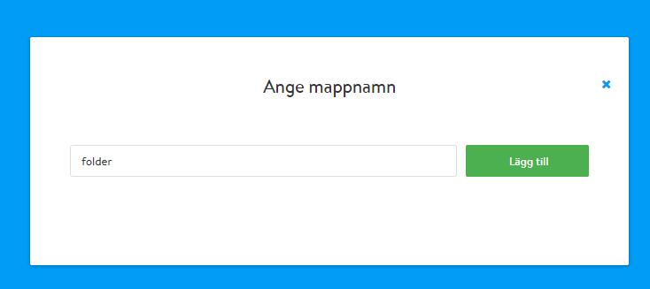

**Påminnelseintervall**

In this section 4 types of intervals can be found.These intervals can be enabled or disabled using checkboxes, and days of intervals can be set using the text boxes corresonding to them.

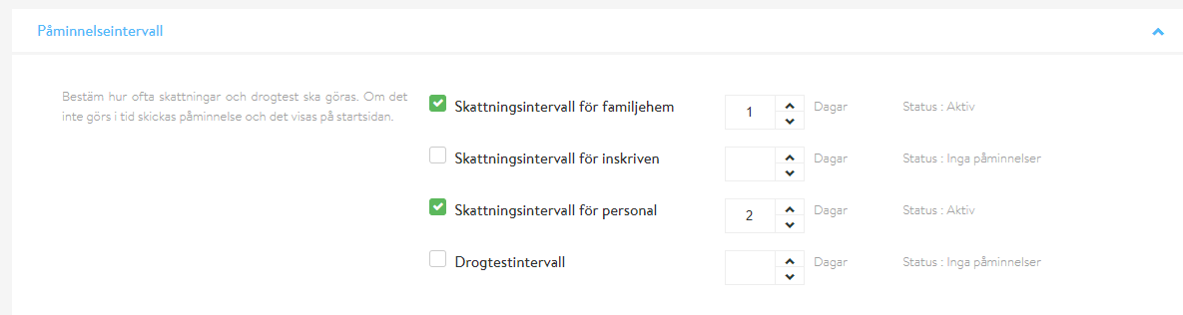

**Kontakpersoner**

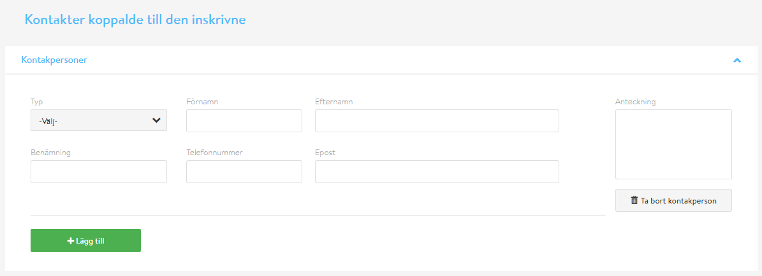

In this section following fields are there:

• Typ (dropdown)

• Förnamn (text field)

• Efternamn (text field)

• Benämning (text field)

• Telefonnummer (text field)

• Epost (text field)

• Anteckning (text area)

• Lägg till(button)

• Ta bort kontakperson (button)

Lägg till button is used to add new row in the section.  Ta bort kontakperson button is used to remove a row from the section.

All functionalities are working fine.

**Sysselsättningar**

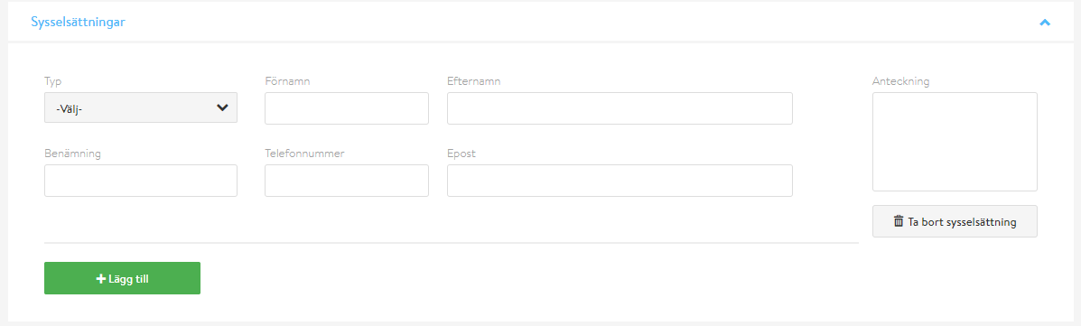

In this section following fields are there:

• Typ (dropdown)

• Förnamn (text field)

• Efternamn (text field)

• Benämning (text field)

• Telefonnummer (text field)

• Epost (text field)

• Anteckning (text area)

• Lägg till(button)

• Ta bort sysselsättning (button)

Lägg till button is used to add new row in the section. Ta bort sysselsättningbutton is used to remove a row from the section.

All functionalities are working fine.

**Samtycke**

In this section following fields are there:

• Samtycke (radio button group)

• Ånge vad det gäller (text field) 