**CHAPTER 1**

**INTRODUCTION**

**INTRODUCTION**

* 1. **What is machine learning?**

Machine Learning is the science (and art) of programming computers so they can learn from data. Here is a slightly more general definition:

“Machine Learning is the field of study that gives computers the ability to learn without being explicitly programmed”

– said by Arthur Samuel, 1959. And a more engineering-oriented one: A computer program is said to learn from experience E with respect to some task T and some performance measure P, if its performance on T, as measured by P, improves with experience E. – said by Tom Mitchell, 1997. For example, your spam filter is a Machine Learning program that can learn to flag spam given examples of spam emails (e.g., flagged by users) and examples of regular (non - spam, also called “ham”) emails.

* 1. **Why use machine learning?**

1. What would look at spam typically looks like. May notice that some words or phrases (such as “4U,” “credit card,” “free,” and “amazing”) tend to come up a lot in the subject. Perhaps you would also notice a few other patterns in the sender’s name, the email’s body, and so on.
2. You would write a detection algorithm for each of the patterns that you noticed, and your program would flag emails as spam if a number of these patterns are detected.

3. You would test your program, and repeat steps 1 and 2 until it is good enough

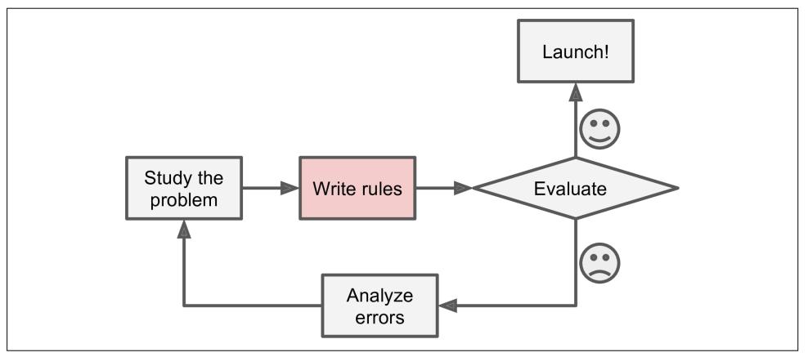

**Figure 1.1 – Traditional Approach**

In contrast, a spam filter based on Machine Learning techniques automatically learns which words and phrases are good predictors of spam by detecting unusually frequent patterns of words in the spam examples compared to the ham examples (Figure 1-2). The program is much shorter, easier to maintain, and most likely more accurate.

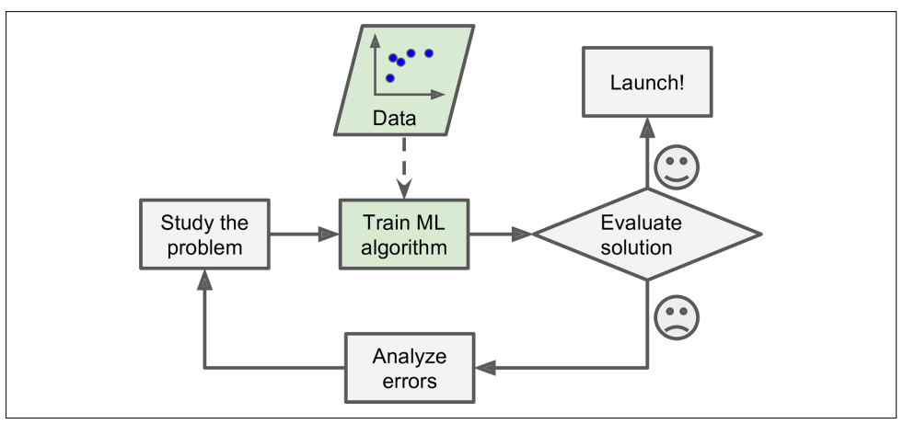

**Figure 1.2 – Machine learning approach**

Moreover, if spammers notice that all their emails containing “4U” are blocked, they might start writing “For U” instead. A spam filter using traditional programming

techniques would need to be updated to flag “For U” emails. If spammers keep working around your spam filter, you will need to keep writing new rules forever. In contrast, a spam filter based on Machine Learning techniques automatically notices that “For U” has become unusually frequent in spam flagged by users, and it starts flagging them without your intervention (Figure 1-3).

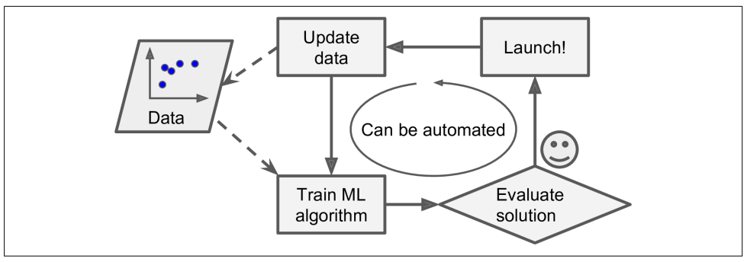

**Figure 1.3 – Automatically adapting to change**

* 1. **Types of machine learning:**

Machine Learning systems can be classified according to the amount and type of supervision they get during training. There are four major categories: supervised

learning, unsupervised learning, semi supervised learning, and Reinforcement Learning.

**Supervised Learning**

In supervised learning, the training data you feed to the algorithm includes the desired solutions, called labels (Figure 1-5).

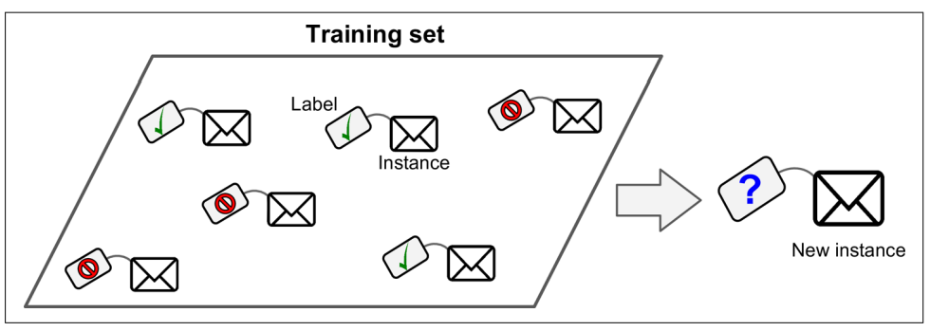

**Figure 1.4 – Training set for supervised learning**

**Unsupervised Learning**

In unsupervised learning, as you might guess, the training data is unlabelled

(Figure 1-7). The system tries to learn without a teacher.

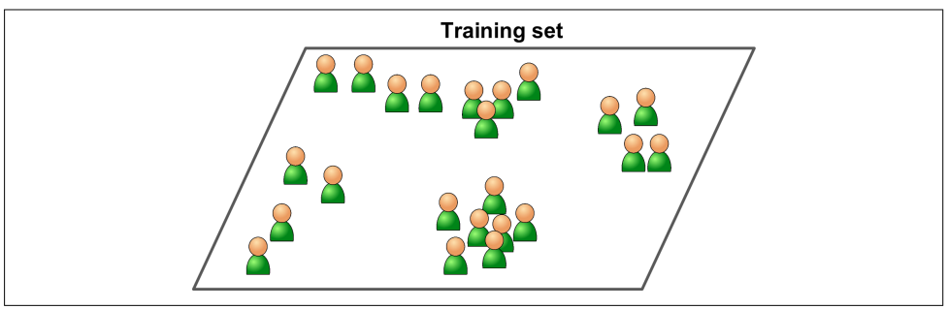

**Figure 1.5 – Training set for unsupervised learning**

**Reinforcement Learning**

Reinforcement Learning is a very different beast. The learning system, called an agent in this context, can observe the environment, select and perform actions, and get rewards in return (or penalties in the form of negative rewards, as in Figure 1-12). It must then learn by itself what is the best strategy, called a policy, to get the most

reward over time. A policy defines what action the agent should choose when it is in a

given situation.

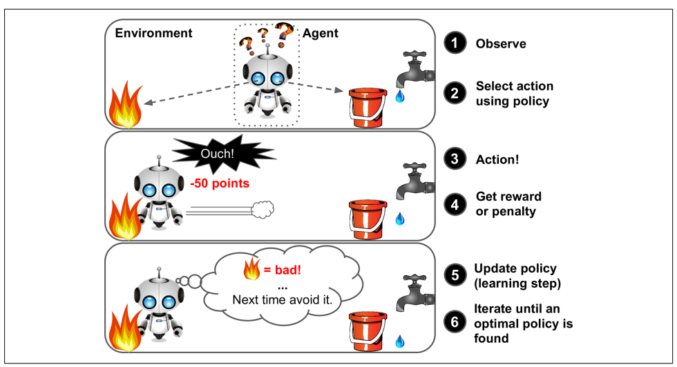

**Figure 1.6 – Training set for Reinforcement learning**

* 1. **Recommendation Algorithms**

The objective of a recommendation system is to recommend relevant items for users, based on their preference. Preference and relevance are subjective, and they are generally inferred by items users have consumed previously.

* [**Collaborative Filtering**](https://en.wikipedia.org/wiki/Collaborative_filtering): This method makes automatic predictions (filtering) about the interests of a user by collecting preferences or taste information from many users (collaborating). The underlying assumption of the collaborative filtering approach is that if a person A has the same opinion as a person B on a set of items, A is more likely to have B's opinion for a given item than that of a randomly chosen person.
* [**Content-Based Filtering**](http://recommender-systems.org/content-based-filtering/): This method uses only information about the description and attributes of the items users has previously consumed to model user's preferences. In other words, these algorithms try to recommend items that are similar to those that a user liked in the past (or is examining in the present). In particular, various candidate items are compared with items previously rated by the user and the best-matching items are recommended.
* **Hybrid methods**: Recent research has demonstrated that a hybrid approach, combining collaborative filtering and content-based filtering could be more effective than pure approaches in some cases. These methods can also be used to overcome some of the common problems in recommender systems such as cold start and the sparsity problem.
* **Popularity**: It is a type of recommendation system which works on the principle of popularity and or anything which is in trend. These systems check about the articles or blogs which are in trend or are most popular among the users and directly recommend.

It is proposed to load the Deskdrop dataset which contains a real sample of 12 months logs (Mar. 2016 - Feb. 2017) from CI&T's Internal Communication platform (DeskDrop) for training. Also, it contains about 73k logged user’s interactions on more than 3k public articles shared in the platform. It is composed of two CSV files namely shared_articles.csv, users_interactions.csv. A model will be constructed by the training dataset. Finally the constructed model tests the remaining data for evaluate the performance of the models.

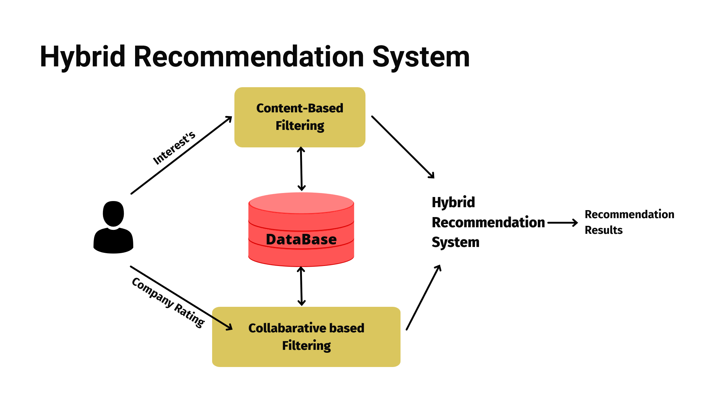

**Figure 1.7 – Hybrid recommender system**

**1.5 Project description**

There is a growing demand for recommendation systems in many tech companies. As the data on the internet grows, there is a need to recommend users with their preferences becomes must. The companies collect vital data from their users and use it for analysing their preference. Therefore, the companies need to provide contents based on their preference. There are many learning algorithms of which three algorithms stand out from the rest. They are content based filtering, collaborative based filtering, and hybrid recommendation model. Thus the performance analysis between these models become extremely necessary the analysis among these algorithms is done by training with large data set and interpreting the result is a human readable form ie in graph. Thus the objective also include

1. Generation of large dataset
2. Training the dataset with these three algorithms
3. Interpreting the result in a graph

**CHAPTER 2**

**SYSTEM ANALYSIS**

**SYSTEM ANALYSIS**

**2.1 LITERATURE SURVEY**

**2.1.1 Content-based recommendation system**

The research paper published in November 2008 titled “Content based recommendation system” by four authors namely Charilaos Zisopoulus, Savvas Karagiannidis, Georgios Demirtsoglou and Stefanos Antaris. The paper contained the basic idea behind the content based recommendation system. It was started that it is used towards web technologies. As more and more businesses are pushed towards the web. The contents of the web increases exponentially. The users also expect a nice user experience with the website they are web browsing.

The idea that was stated in the paper was “The items are recommended to the user based on the item’s description and the preference of the user.” Thus, the item on a website must have a discrete, identifiable and unique description. The user’s data are to be collected based on some more unique descriptions.

**2.1.2 Collaborative filtering recommender system**

The research paper released in January, 2007 titled “Collaborative filtering recommender system” by authors Ben Schafer, Ben J, Dan Frankowski. The idea proposed by then was very simple. It is based on the opinion given by other users. The author Ben Schafer even cites an example of a movie, that is if a user wants to watch a movie, the user can also about other user’s opinion and decide whether to watch the movie or not. The sharing of opinion is dated long back way before the advent of computer technologies.

The opinions of the users are used to describe an item and given a particular value. When the user might be interested in that item, it gets recommended. More robust mathematical model is discovered and the collaborative filtering method is getting better every year.

**2.1.3 Hybrid recommender systems: A systematic literature review**

The content based and collaborative model have their own pros and cons. Some researchers even went on research of combining these two approaches. Some of the research paper include “Hybrid recommender system: A systematic literature review” by Erino Cano and Maurizio Morisio in November 2017. The best features of the two model are combined to promote the algorithm to the next level. The classical idea of content based is used with filtering to get a unique description of an item, then the item gets served to the user with a particular preference.

**2.2 EXISTING SYSTEM**

The algorithms that have been proposed had many shortcomings. The comparison algorithms after the data have been trained into the system. This algorithm has a flaw that it does not know about how the data has been trained on by the recommendation system. The other algorithms defined are based on the output of the each of the recommendation algorithms. They just always compare the results of individual algorithm.

**2.2.1 Disadvantages**

* They are plain, just facts about the result of the recommendation systems.
* Does not know about how models train on data.
* Takes up so much space
* Complexity increases as the number of recommendation algorithms to compare increase.
* Does not always yield good result.

**2.3 PROPOSED SYSTEM**

The proposed system consists of an algorithm based on the machine learning principles to compare a variety of recommendation system. The proposed algorithm takes care of how the data gets trained and evaluated to give the best. The results are very intuitive as it gets interpreted in a human readable friendly form, i.e in a graph. The algorithm also checks the results for a wide variety of input dataset.

**2.3.1 Advantages**

* Deals with the details of how the data gets trained.
* Results are interpreted in a nice form.
* Give good comparison results even on different large and different datasets.

**CHAPTER 3**

**SYSTEM REQUIREMENTS**

**SYSTEM REQUIREMENTS**

**3.1 HARDWARE REQUIREMENTS:**

The hardware requirements may serve as the basis for a contract for the implementation of the system and should therefore be a complete and consistent specification of the whole system. They are used by software engineers as the starting point for the system design. It should what the system does and not how it should be implemented.

RAM: 8 GB

GPU: AMD Radeon 4 GB

Processor: AMD Ryzen 5

Hard disk: 512 GB

**3.2 SOFTWARE REQUIREMENTS:**

The software requirements document is the specification of the system. It should include both a definition and a specification of requirements. It is a set of what the system should do rather than how it should do it. The software requirements provide a basis for creating the software requirements specification. It is useful in estimating cost, planning team activities, performing tasks and tracking the teams and tracking the team’s progress throughout the development.

Operating System: Windows 11

Programming Language: Python

Processing Software: Jupyter Noteboook

Python Core Modules: Pandas, NumPy, Sklearn, NLTK, SciPy

**3.3 SOFTWARE DESCRIPTION:**

**3.3.1 Jupyter Notebook**

The Jupyter Notebook App is a server-client application that allows editing and running notebook documents via a web browser. The Jupyter Notebook App can be executed on a local desktop requiring no internet access (as described in this document) or can be installed on a remote server and accessed through the internet.

In addition to displaying/editing/running notebook documents, the Jupyter Notebook App has a “Dashboard” (Notebook Dashboard), a “control panel” showing local files and allowing to open notebook documents or shutting down their kernels.

**3.3.2 Pandas**

Pandas is an open-source Python Library providing high-performance data manipulation and analysis tool using its powerful data structures. The name Pandas is derived from the word Panel Data – an Econometrics from Multidimensional data.

In 2008, developer Wes McKinney started developing pandas when in need of high performance, flexible tool for analysis of data.

Prior to Pandas, Python was majorly used for data munging and preparation. It had very little contribution towards data analysis. Pandas solved this problem. Using Pandas, we can accomplish five typical steps in the processing and analysis of data, regardless of the origin of data — load, prepare, manipulate, model, and analyze.

Python with Pandas is used in a wide range of fields including academic and commercial domains including finance, economics, Statistics, analytics, etc.

**Key features:**

* Fast and efficient DataFrame object with default and customized indexing.
* Tools for loading data into in-memory data objects from different file formats.
* Data alignment and integrated handling of missing data.
* Reshaping and pivoting of date sets.
* Label-based slicing, indexing and subsetting of large data sets.
* Columns from a data structure can be deleted or inserted.
* Group by data for aggregation and transformations.
* High performance merging and joining of data.
* Time Series functionality.

**3.3.3 NumPy**

NumPy is a Python package. It stands for 'Numerical Python'. It is a library consisting of multidimensional array objects and a collection of routines for processing of array.

Numeric, the ancestor of NumPy, was developed by Jim Hugunin. Another package Numarray was also developed, having some additional functionalities. In 2005, Travis Oliphant created NumPy package by incorporating the features of Numarray into Numeric package. There are many contributors to this open-source project.

**Operations on NumPy**

Using NumPy, a developer can perform the following operations −

* Mathematical and logical operations on arrays.
* Fourier transforms and routines for shape manipulation.
* Operations related to linear algebra. NumPy has in-built functions for linear algebra and random number generation.

**3.3.4 SkLearn**

Scikit-learn (Sklearn) is the most useful and robust library for machine learning in Python. It provides a selection of efficient tools for machine learning and statistical modelling including classification, regression, clustering, and dimensionality reduction via a consistence interface in Python. This library, which is largely written in Python, is built upon NumPy, SciPy and Matplotlib.

## **Features**

Rather than focusing on loading, manipulating, and summarizing data, Scikit-learn library is focused on modeling the data. Some of the most popular groups of models provided by Sklearn are as follows –

**Supervised Learning algorithms** − Almost all the popular supervised learning algorithms, like Linear Regression, Support Vector Machine (SVM), Decision Tree etc., are the part of scikit-learn.

**Unsupervised Learning algorithms** − On the other hand, it also has all the popular unsupervised learning algorithms from clustering, factor analysis, PCA (Principal Component Analysis) to unsupervised neural networks.

**Clustering** − This model is used for grouping unlabeled data.

**Cross Validation** − It is used to check the accuracy of supervised models on unseen data.

**Dimensionality Reduction** − It is used for reducing the number of attributes in data which can be further used for summarization, visualization, and feature selection.

**Ensemble methods** − As name suggest, it is used for combining the predictions of multiple supervised models.

**Feature extraction** − It is used to extract the features from data to define the attributes in image and text data.

**Feature selection** − It is used to identify useful attributes to create supervised models.

**Open Source** − It is open-source library and also commercially usable under BSD license.

**3.3.5 NLTK**

Language is a method of communication with the help of which we can speak, read and write. Natural Language Processing (NLP) is the sub field of computer science especially Artificial Intelligence (AI) that is concerned about enabling computers to understand and process human language. We have various open-source NLP tools but NLTK (Natural Language Toolkit) scores very high when it comes to the ease of use and explanation of the concept. The learning curve of Python is very fast and NLTK is written in Python so NLTK is also having very good learning kit. NLTK has incorporated most of the tasks like tokenization, stemming, Lemmatization, Punctuation, Character Count, and Word count. It is very elegant and easy to work with.

**3.3.6 SciPy**

SciPy is a scientific python open source, distributed under the BSD licensed library to perform Mathematical, Scientific and Engineering Computations.

The SciPy library depends on NumPy, which provides convenient and fast N-dimensional array manipulation. The SciPy library is built to work with NumPy arrays and provides many user-friendly and efficient numerical practices such as routines for numerical integration and optimization. Together, they run on all popular operating systems, are quick to install and are free of charge. NumPy and SciPy are easy to use, but powerful enough to depend on by some of the world's leading scientists and engineers.

**CHAPTER 4**

**SYSTEM DESIGN**

**4.1 SYSTEM ARCHITECTURE**

USERS

View

Like

Comment

Share

insert

Store data in csv

ADMIN

update

delete

Data pre-processing

Evaluation

**Figure 4.1 – System Architecture**

The various data generated by the users include likes, shares, views and comments. These are generated at the client side of the application and store in a database server in .csv format in backend. This database serves as a dataset for the data pre-processing. The data is given as input to the algorithms. These data can be modified by the system administrator. These operations performed by the administrator include insert, update, delete. Then the data is given to algorithms to train. After training the outcomes of the algorithms are compared by a comparison algorithm are the result is evaluated. The evaluated result is interpreted in a nice graph.

**4.2 DATAFLOW DIAGRAM**

**4.2.1 Level 0 - Data flow Diagram for hybrid recommender system**

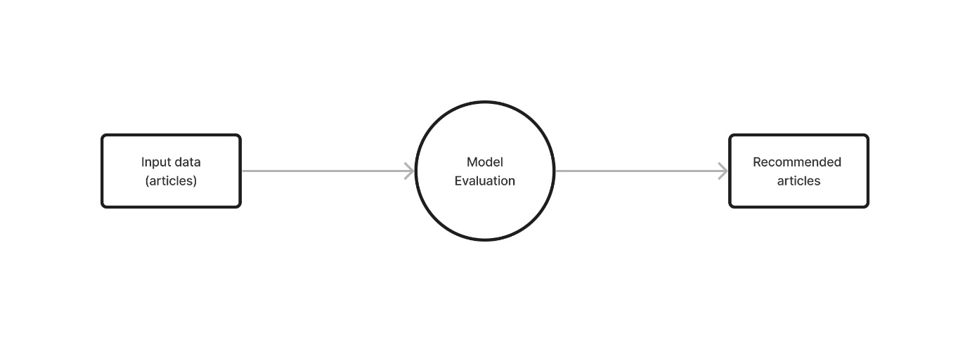

**Figure 4.2 – Dataflow diagram level 0**

The input data consists of likes, view, comments and share data about various articles, for example. It is given to the hybrid recommender system for evaluation. The result of the various algorithm will be of recommended articles based on the users’ interests.

**4.2.2 Level 1 - Data flow Diagram for hybrid recommender system**

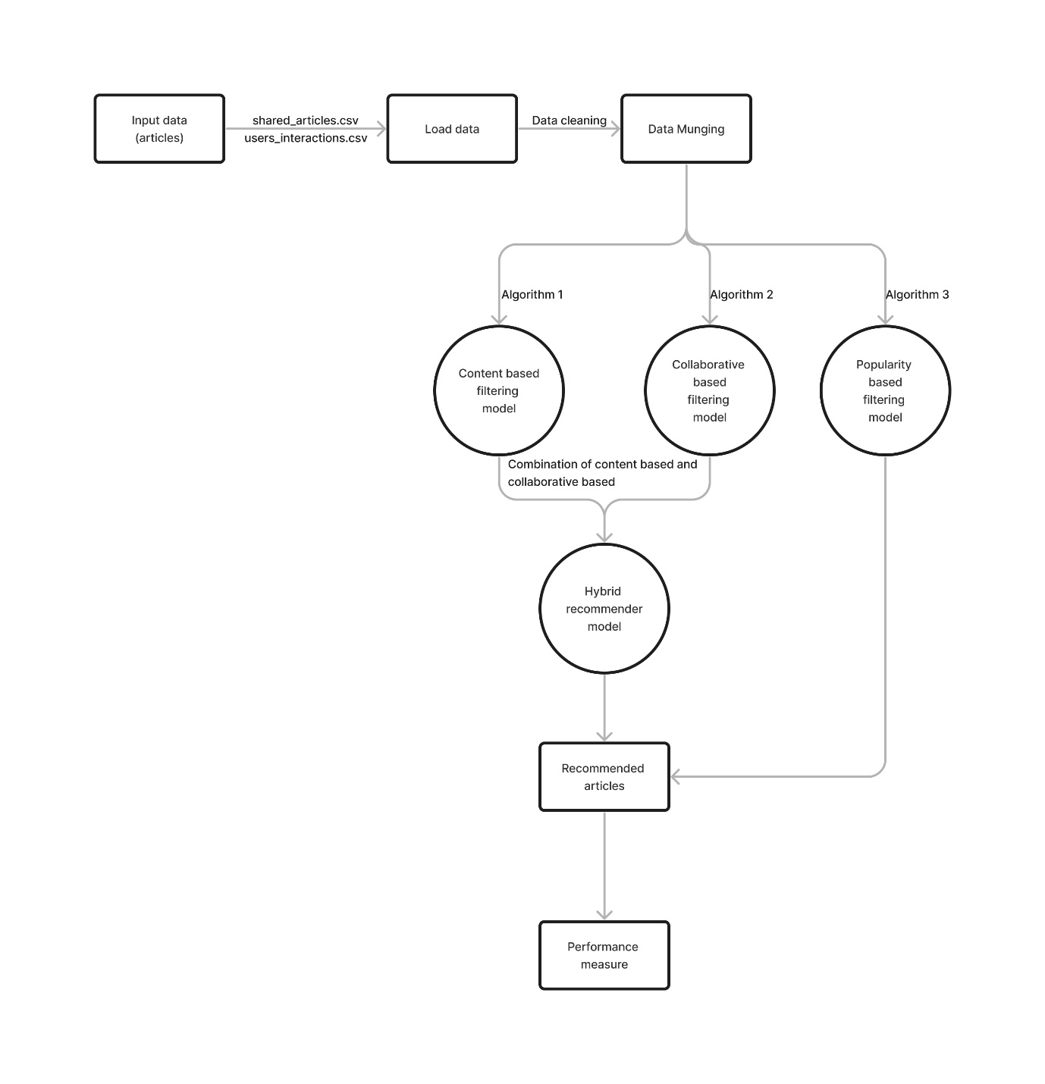

**Figure 4.3 – Dataflow diagram level 1**

The input data more accurately, consists of the articles in a file called shared-articles.csv and the user’s interactions are collected and put in a file called user_interaction.csv. These are datasets required. Before feeding this data to the algorithms the loading of this data is required.

The loading phase consists of cleaning of data is done. The data cleaning is very essentially becoming some redundant can cause a performance change in the outcome of the algorithms. The datasets are then given to the algorithms. The algorithms are content based filtering, collaborative based filtering, and popularity-based filtering. The outcome of the first two algorithms is then combined to give hybrid recommendation algorithm. These outcomes are analysed by using various performance measures ore metrics.

**4.2.3 Level 2 - Data flow Diagram for hybrid recommender system**

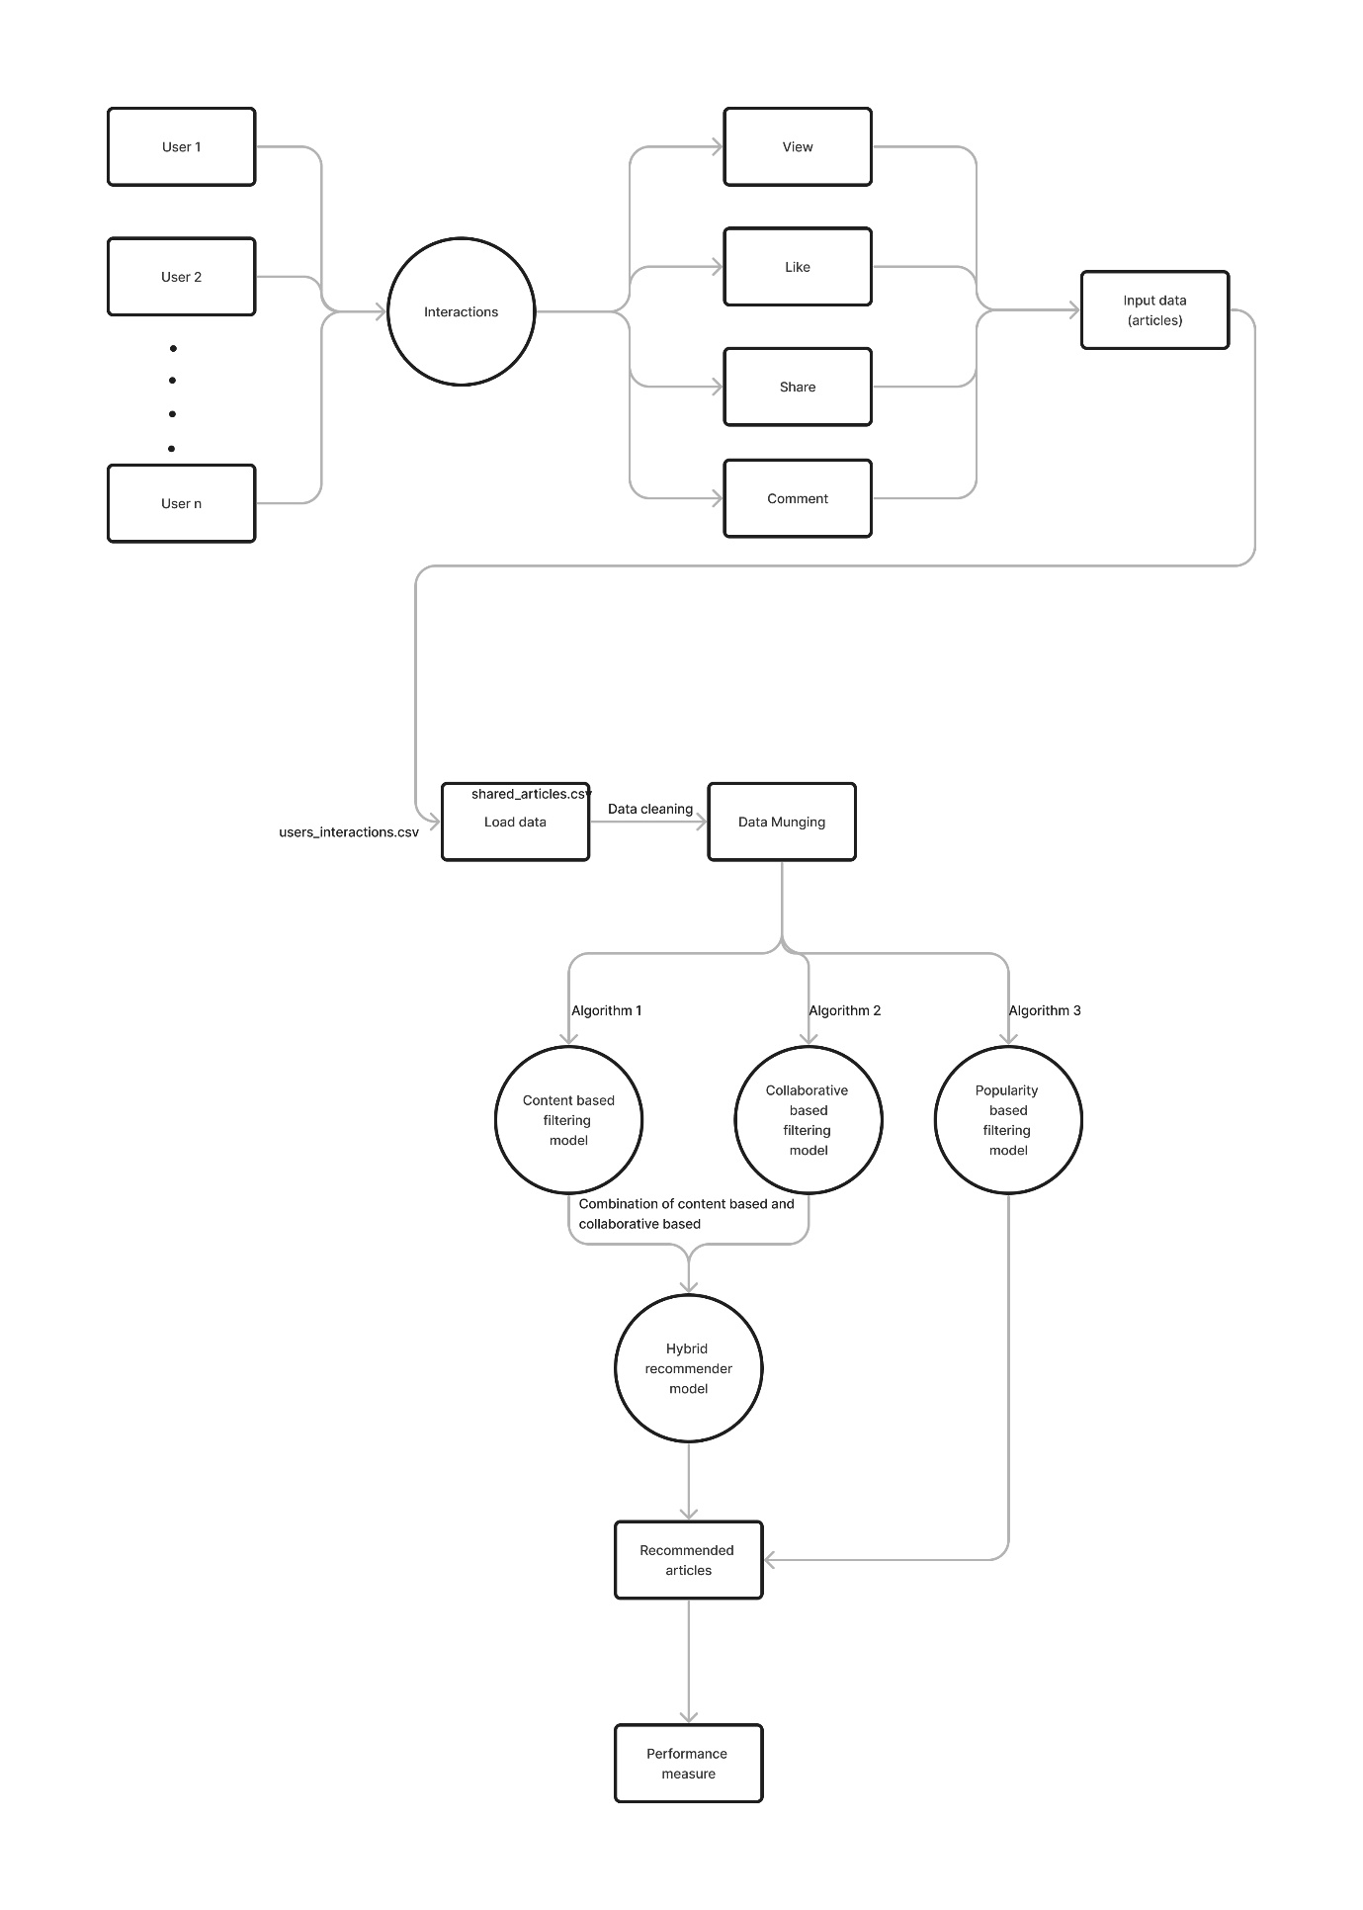

**Figure 4.4 - Dataflow diagram level 2**

A recommender system, or a recommendation system, can be thought of as a subclass of information filtering system that seeks to predict the best “rating” or “preference” a user would give to an item which is typically obtained by optimizing for objectives like total clicks, total revenue, and overall sales. Broadly speaking, most recommender systems leverage two types of data namely, interaction Data, such as ratings, and browsing behaviours, and attribution information, about each user and items.

The modelling approach relying on the former data is generally known Collaborative Filtering method, and the approach using the latter is referred to as the Content-Base Filtering method. There is also another category known as Knowledge-Based recommender system that is based on explicitly specified user requirements. Of course, each of these methods has its strengths and weaknesses depending on which applications they are used for, and the amount of data available. Hybrid Systems are then used to combined the advantages of these approaches to have a robust performing system across a wide variety of applications.

**4.3 UML DIAGRAM**

The elements are like components which can be associated in different ways to make complete UML pictures which is known as diagram. So, it is very important to understand the different diagrams to implement the knowledge in real life systems.

We prepare UML diagrams to understand a system in better and simple way. A single diagram is not enough to cover all aspects of the system. So, UML defines various kinds of diagrams to cover most of the aspects of a system.

**4.3.1 Use case diagram**

A use case illustrates a unit of functionality provided by the system. The main purpose of the use-case diagram is to help development teams visualize the functional requirements of a system, including the relationship of "actors" (human beings who will interact with the system) to essential processes, as well as the relationships among different use cases. Use-case diagrams generally show groups of use cases -- either all use cases for the complete system, or a breakout of a particular group of use cases with related functionality.

Use Case Diagram are behaviour diagrams used to describe a set of actions (use-cases) that some system or systems (subject) should or can perform in collaboration with one or more external users of the system (actor). Here we have a system like administrator actions like as rating, view, like, share, comment to the article.

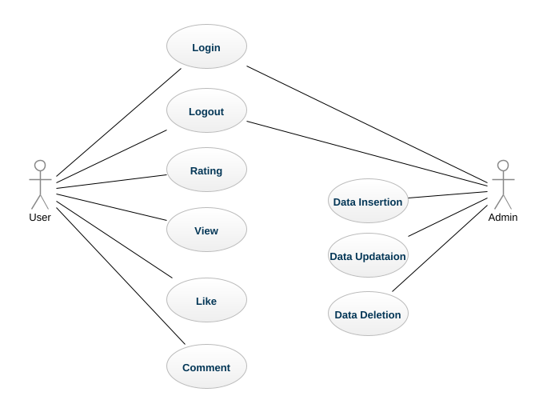

**Figure 4.5 – Use case diagram for recommendation system**

**4.3.2 Activity Diagram**

Activity diagrams show the procedural flow of control between two or more class objects while processing an activity. Activity diagrams can be used to model higher-level business process at the business unit level, or to model low-level internal class actions. An activity diagram's notation set is like that used in a state chart diagram. Like a state chart diagram, the activity diagram starts with a solid circle connected to the initial activity

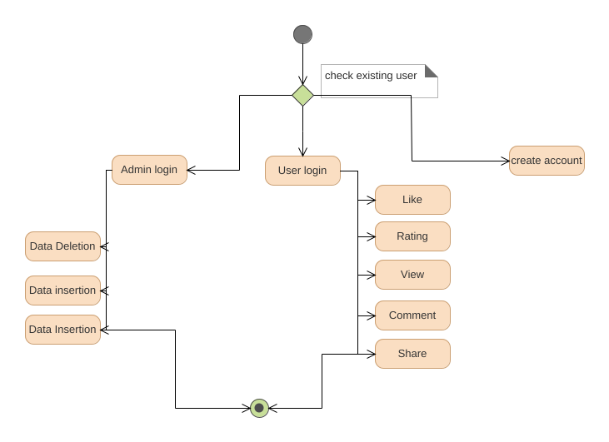

**Figure 4.6 – Activity diagram for recommendation system**

**4.3.3 Sequence diagram**

Sequence diagrams show a detailed flow for a specific use case or even just part of a specific use case. They are almost self-explanatory; they show the calls between the different objects in their sequence and can show, at a detailed level, different calls to different objects. A sequence diagram has two dimensions: The vertical dimension shows the sequence of messages/calls in the time order that they occur, the horizontal dimension shows the object instances to which the messages are sent.

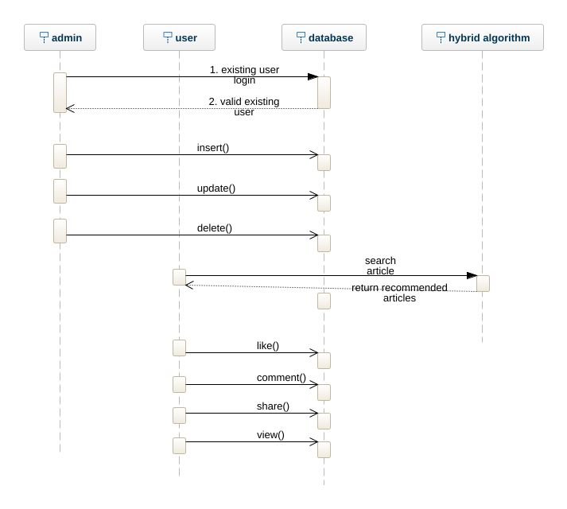

**Figure 4.7 - Sequence diagram for hybrid recommendation system**

**CHAPTER 5**

**MODULES DESCRIPTION**

**5.1 MODULES**

The proposed system contains the following modules

* Data pre-processing
* Training data
* Evaluate for Contend based
* Evaluate for Collaborative filtering
* Evaluate for popularity based
* Evaluate for hybrid recommender system

**Class diagram**

The class diagram shows how the different entities (people, things, and data) relate to each other, in other words, it shows the static structures of the system. A class diagram can be used to display logical classes, which are typically the kinds of things the business people in an organization talk about -- rock bands, CDs, radio play, or loans, home mortgages, car loans, and interest rates. Class diagrams can also be used to show implementation classes, which are the things that programmers typically deal with an implementation class diagram will probably show some of the same classes as the logical class diagram. Class Diagram provides an overview of the target system by describing the objects and classes inside the system and the relationships between them. It provides a wide variety of usages from modelling the domain-specific data structure to detailed design of the target system. Each class have a class name with attributes and operations Suppose admin have a one class means user name and password is the attributes, login, insert, update, delete are the operations of class diagram.

Class diagram provides an overview of the target system by describing the objects and classes.

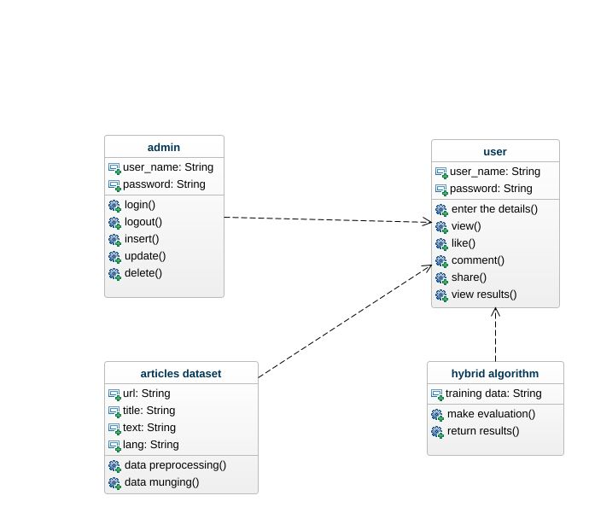

**Fig 5.1 Class diagram for hybrid recommender system**

**5.1.1 Data pre-processing**

Data pre-processing is a process of preparing the raw data and making it suitable for a machine learning model. It is the first and crucial step while creating a machine learning model. When creating a machine learning project, it is not always a case that we come across the clean and formatted data. And while doing any operation with data, it is mandatory to clean it and put in a formatted way. So for this, we use data pre-processing task. A real-world data generally contains noises, missing values, and maybe in an unusable format which cannot be directly used for machine learning models. Data pre-processing is required tasks for cleaning the data and making it suitable for a machine learning model which also increases the accuracy and efficiency of a machine learning model.

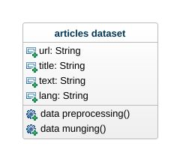

users_interactions_count_df = interactions_df.groupby(['personId','contentId']).size().groupby('personId').size()

print('# users: %d' % len(users_interactions_count_df))

users_with_enough_interactions_df = users_interactions_count_df[users_interactions_count_df >= 5].reset_index()[['personId']]

print('# users with at least 5 interactions: %d' % len(users_with_enough_interactions_df))

**5.1.2 Training Data**

In our project, we load the Deskdrop dataset, which contains a real sample of 12 months logs (Mar. 2016 - Feb. 2017) from CI&T's Internal Communication platform (DeskDrop). It contains about 73k logged users’ interactions on more than 3k public articles shared in the platform. It is composed of two CSV files:

* shared_articles.csv
* users_interactions.csv

**shared_articles.csv**

Contains information about the articles shared in the platform. Each article has its sharing date (timestamp), the original URL, title, content in plain text, the article' lang (Portuguese: pt or English: en) and information about the user who shared the article (author).

There are two possible event types at a given timestamp:

CONTENT SHARED: The article was shared in the platform and is available for users.

CONTENT REMOVED: The article was removed from the platform and not available for further recommendation.

For the sake of simplicity, we only consider here the "CONTENT SHARED" event type, assuming (naively) that all articles were available during the whole one year period. For a more precise evaluation (and higher accuracy), only articles that were available at a given time should be recommended.

articles_df = pd.read_csv('../input/shared_articles.csv')

articles_df = articles_df[articles_df['eventType'] == 'CONTENT SHARED']

articles_df.head(5)

**User_interactions.csv**

Contains logs of user interactions on shared articles. It can be joined to articles_shared.csv by contentId column.

The eventType values are:

* VIEW: The user has opened the article.
* LIKE: The user has liked the article.
* COMMENT CREATED: The user created a comment in the article.
* FOLLOW: The user chose to be notified on any new comment in the article.
* BOOKMARK: The user has bookmarked the article for easy return in the future.

interactions_df = pd.read_csv('../input/users_interactions.csv')

interactions_df.head(10)

**5.1.3 Evaluate for Content based filtering**

Content-based filtering approaches leverage description or attributes from items the user has interacted to recommend similar items. It depends only on the user previous choices, making this method robust to avoid the cold-start problem. For textual items, like articles, news and books, it is simple to use the raw text to build item profiles and user profiles.

Here we are using a very popular technique in information retrieval (search engines) named TF-IDF. This technique converts unstructured text into a vector structure, where each word is represented by a position in the vector, and the value measures how relevant a given word is for an article. As all items will be represented in the same Vector Space Model, it is to compute similarity between articles.

**5.1.4 Evaluate for Collaborative based filtering**

Collaborative Filtering (CF) has two main implementation strategies:

**Memory-based:** This approach uses the memory of previous users’ interactions to compute users’ similarities based on items they've interacted (user-based approach) or compute items similarities based on the users that have interacted with them (item-based approach).

A typical example of this approach is User Neighbourhood-based CF, in which the top-N similar users (usually computed using Pearson correlation) for a user are selected and used to recommend items those similar users liked, but the current user have not interacted yet. This approach is very simple to implement, but usually do not scale well for many users. A nice Python implementation of this approach in available in Crab.

**Model-based:** This approach, models are developed using different machine learning algorithms to recommend items to users. There are many model-based CF algorithms, like neural networks, Bayesian networks, clustering models, and latent factor models such as Singular Value Decomposition (SVD) and, probabilistic latent semantic analysis.

**Matrix factorization**

Latent factor models compress user-item matrix into a low-dimensional representation in terms of latent factors. One advantage of using this approach is that instead of having a high dimensional matrix containing abundant number of missing values we will be dealing with a much smaller matrix in lower-dimensional space.

A reduced presentation could be utilized for either user-based or item-based neighbourhood algorithms that are presented in the previous section. There are several advantages with this paradigm. It handles the sparsity of the original matrix better than memory-based ones. Also comparing similarity on the resulting matrix is much more scalable especially in dealing with large sparse datasets.

Here we a use popular latent factor model named Singular Value Decomposition (SVD). There are other matrix factorization frameworks more specific to CF, like surprise, mrec or python-recsys. We chose a SciPy implementation of SVD because it is available on kernels.

An important decision is the number of factors to factor the user-item matrix. The higher the number of factors, the more precise is the factorization in the original matrix reconstructions. Therefore, if the model is allowed to memorize too much details of the original matrix, it may not generalize well for data it was not trained on. Reducing the number of factors increases the model generalization.

class **CFRecommender**:

MODEL_NAME = 'Collaborative Filtering'

def __init__(self, cf_predictions_df, items_df=None):

self.cf_predictions_df = cf_predictions_df

self.items_df = items_df

def get_model_name(self):

return self.MODEL_NAME

def recommend_items(self, user_id, items_to_ignore=[], topn=10, verbose=False):

sorted_user_predictions = self.cf_predictions_df[user_id].sort_values(ascending=False)\

.reset_index().rename(columns={user_id: 'recStrength'})

recommendations_df = sorted_user_predictions[~sorted_user_predictions['contentId'].isin(items_to_ignore)] \ .sort_values('recStrength', ascending = False) \ .head(topn)

if verbose:

if self.items_df **is** None:

raise **Exception**('"items_df" is required in verbose mode')

recommendations_df = recommendations_df.merge(self.items_df, how = 'left',

left_on = 'contentId', right_on = 'contentId')[['recStrength', 'contentId', 'title', 'url', 'lang']]

return recommendations_df

cf_recommender_model = CFRecommender(cf_preds_df, articles_df)

**5.1.5 Evaluate for popularity-based filtering**

A common (and usually hard-to-beat) baseline approach is the Popularity model. This model is not actually personalized - it simply recommends to a user the most popular items that the user has not previously consumed. As the popularity accounts for the "wisdom of the crowds", it usually provides good recommendations, generally interesting for most people.

The main objective of a recommender system is to leverage the long-tail items to the users with very specific interests, which goes far beyond this simple technique.

class **PopularityRecommender**:

MODEL_NAME = 'Popularity'

def __init__(self, popularity_df, items_df=None):

self.popularity_df = popularity_df

self.items_df = items_df

def get_model_name(self):

return self.MODEL_NAME

def recommend_items(self, user_id, items_to_ignore=[], topn=10, verbose=False):

recommendations_df = self.popularity_df[~self.popularity_df['contentId'].isin(items_to_ignore)] \.sort_values('eventStrength', ascending = False) \ .head(topn)

if verbose:

if self.items_df **is** None:

raise **Exception**('"items_df" is required in verbose mode')

recommendations_df = recommendations_df.merge(self.items_df, how = 'left',

left_on = 'contentId',

right_on = 'contentId')[['eventStrength', 'contentId', 'title', 'url', 'lang']]

return recommendations_df

popularity_model = PopularityRecommender(item_popularity_df, articles_df)

**5.1.6 Evaluate for hybrid recommender system**

What if we combine Collaborative Filtering and Content-Based Filtering approaches?

Would that provide us with more accurate recommendations?

In fact, hybrid methods have performed better than individual approaches in many studies and have been extensively used by researchers and practioners.

Let us build a simple hybridization method, as an ensemble that takes the weighted average of the normalized CF scores with the Content-Based scores, and ranking by resulting score. In this case, as the CF model is much more accurate than the CB model, the weights for the CF and CB models are 100.0 and 1.0, respectively.

class **HybridRecommender**:

MODEL_NAME = 'Hybrid'

def __init__(self, cb_rec_model, cf_rec_model, items_df, cb_ensemble_weight=1.0, cf_ensemble_weight=1.0):

self.cb_rec_model = cb_rec_model

self.cf_rec_model = cf_rec_model

self.cb_ensemble_weight = cb_ensemble_weight

self.cf_ensemble_weight = cf_ensemble_weight

self.items_df = items_df

def get_model_name(self):

return self.MODEL_NAME

def recommend_items(self, user_id, items_to_ignore=[], topn=10, verbose=False):

cb_recs_df = self.cb_rec_model.recommend_items(user_id, items_to_ignore=items_to_ignore, verbose=verbose,topn=1000).rename(columns={'recStrength': 'recStrengthCB'})

cf_recs_df = self.cf_rec_model.recommend_items(user_id, items_to_ignore=items_to_ignore, verbose=verbose, topn=1000).rename(columns={'recStrength': 'recStrengthCF'})

recs_df = cb_recs_df.merge(cf_recs_df,

how = 'outer',

left_on = 'contentId',

right_on = 'contentId').fillna(0.0)

recs_df['recStrengthHybrid'] = (recs_df['recStrengthCB'] * self.cb_ensemble_weight) \

+ (recs_df['recStrengthCF'] * self.cf_ensemble_weight)

recommendations_df = recs_df.sort_values('recStrengthHybrid', ascending=False).head(topn)

if verbose:

if self.items_df **is** None:

raise **Exception**('"items_df" is required in verbose mode')

recommendations_df = recommendations_df.merge(self.items_df, how = 'left',

left_on = 'contentId',

right_on = 'contentId')[['recStrengthHybrid', 'contentId', 'title', 'url', 'lang']]

return recommendations_df

hybrid_recommender_model = HybridRecommender(content_based_recommender_model, cf_recommender_model, articles_df, cb_ensemble_weight=1.0, cf_ensemble_weight=100.0)

**CHAPTER 6**

**SYSTEM TESTING**

**6.1 OBJECTIVES OF TESTING**

Testing is a process of executing a program with the intent of finding an error. A good test case is one that has a high probability of finding an as yet undiscovered error.

A successful test is one that uncovers a yet undiscovered error.

**6.2 TESTING STRATEGIES**

The extent of testing a system is controlled by many factors, such as the risk involved, limitations on resources, and deadlines. There are many testing strategies, but most used testing combinations are as follows:

* White Box Testing
* Black Box Testing
* Top-Down Testing
* Bottom-Up Testing

**6.2.1 White Box Testing**

In white box testing the specific logic is important and must be tested to guarantee the system's proper functioning. The main use of white box testing is in error-based testing.

**6.2.2 Black Box Testing**

The concept of black box is used to represent a system whose inside workings are not available for inspection. In Black box testing the logic is unknown; all that is known is what goes in and what comes out, or the input or output.

**6.2.3 Top-Down Testing**

In Top-Down testing the main logic or object interactions and system messages of the application need more testing than an individual object's methods or supporting logic.

**6.2.4 Bottom-Up Testing**

Bottom-Up testing starts with the details of the system and proceeds to higher levels by a progressive aggregation of details until they collectively fit the requirements for the system. This approach is more appropriate for testing the individual objects in a system.

**6.2.5 Unit Testing**

Unit testing concentrates on each unit of the software as implemented in source code. Unit testing makes heavy use of white box testing techniques, exercising specific path in a module's control structure to ensure complete coverage and maximum error detection.

**6.2.6 Integration Testing**

Integration testing focuses on design and the construction of the software architecture. Integration testing addressed the issues associated with the dual problems of verification and program construction. Developing a strategy for integrating the various web pages of a web site into functioning whole requires careful planning.

**6.3 TESTING RESULTS**

|  |  |  |  |  |  |
| --- | --- | --- | --- | --- | --- |
|  | eventStrength | Content id | title | url | lang |
| 115 | 4.285402 | 7342707578347442862 | At eBay, Machine Learning is Driving Innovativ... | https://www.ebayinc.com/stories/news/at-ebay-m... | en |
| 38 | 4.129283 | 621816023396605502 | AI Is Here to Help You Write Emails People Wil... | http://www.wired.com/2016/08/boomerang-using-a... | en |
| 8 | 4.044394 | -4460374799273064357 | Deep Learning for Chatbots, Part 1 - Introduction | http://www.wildml.com/2016/04/deep-learning-fo... | en |
| 116 | 3.954196 | -7959318068735027467 | Auto-scaling scikit-learn with Spark | https://databricks.com/blog/2016/02/08/auto-sc... | en |
| 10 | 3.906891 | 2589533162305407436 | 6 reasons why I like KeystoneML | http://radar.oreilly.com/2015/07/6-reasons-why... | en |
| 28 | 3.700440 | 5258604889412591249 | Machine Learning Is No Longer Just for Experts | https://hbr.org/2016/10/machine-learning-is-no... | en |
| 6 | 3.700440 | -398780385766545248 | 10 Stats About Artificial Intelligence That Wi... | http://www.fool.com/investing/2016/06/19/10-st... | en |
| 113 | 3.643856 | -6467708104873171151 | 5 reasons your employees aren't sharing their ... | http://justcuriousblog.com/2016/04/5-reasons-y... | en |
| 42 | 3.523562 | -4944551138301474550 | Algorithms and architecture for job recommenda... | https://www.oreilly.com/ideas/algorithms-and-a... | en |
| 43 | 3.459432 | -8377626164558006982 | Bad Writing Is Destroying Your Company's Produ... | https://hbr.org/2016/09/bad-writing-is-destroy... | en |
| 41 | 3.459432 | 444378495316508239 | How to choose algorithms for Microsoft Azure M... | https://azure.microsoft.com/en-us/documentatio... | en |
| 3 | 3.321928 | 2468005329717107277 | How Netflix does A/B Testing - uxdesign.cc - U... | https://uxdesign.cc/how-netflix-does-a-b-testi... | en |
| 101 | 3.321928 | -8085935119790093311 | Graph Capabilities with the Elastic Stack | https://www.elastic.co/webinars/sneak-peek-of-... | en |
| 107 | 3.169925 | -1429167743746492970 | Building with Watson Technical Web Series | https://www-304.ibm.com/partnerworld/wps/servl... | pt |
| 16 | 3.169925 | 6340108943344143104 | Text summarization with TensorFlow | https://research.googleblog.com/2016/08/text-s... | en |
| 49 | 3.169925 | 1525777409079968377 | Probabilistic Programming | http://probabilistic-programming.org/wiki/Home | en |
| 44 | 3.169925 | -5756697018315640725 | Being A Developer After 40 - Free Code Camp | https://medium.freecodecamp.com/being-a-develo... | en |
| 97 | 3.087463 | 2623290164732957912 | Creative Applications of Deep Learning with Te... | https://www.kadenze.com/courses/creative-appli... | en |
| 32 | 3.000000 | 279771472506428952 | 5 Unique Features Of Google Compute Engine Tha... | http://www.forbes.com/sites/janakirammsv/2016/... | en |
| 78 | 2.906891 | -3920124114454832425 | Worldwide Ops in Minutes with DataStax & Cloud | http://www.datastax.com/2016/01/datastax-enter... | en |

|  |  |  |  |  |  |
| --- | --- | --- | --- | --- | --- |
|  | recStrengthHybrid | ContentId | title | url | lang |
| 0 | 25.436876 | 3269302169678465882 | The barbell effect of machine learning. | http://techcrunch.com/2016/06/02/the-barbell-e... | en |
| 1 | 25.369932 | -8085935119790093311 | Graph Capabilities with the Elastic Stack | https://www.elastic.co/webinars/sneak-peek-of-... | en |
| 2 | 24.493428 | 1005751836898964351 | Seria Stranger Things uma obra de arte do algo... | https://www.linkedin.com/pulse/seria-stranger-... | pt |
| 3 | 24.382997 | -8377626164558006982 | Bad Writing Is Destroying Your Company's Produ... | https://hbr.org/2016/09/bad-writing-is-destroy... | en |
| 4 | 24.362064 | -6727357771678896471 | This Super Accurate Portrait Selection Tech Us... | http://petapixel.com/2016/06/29/super-accurate... | en |
| 5 | 24.190327 | -8190931845319543363 | Machine Learning Is At The Very Peak Of Its Hy... | https://arc.applause.com/2016/08/17/gartner-hy... | en |
| 6 | 24.172285 | 7395435905985567130 | The AI business landscape | https://www.oreilly.com/ideas/the-ai-business-... | en |
| 7 | 23.932289 | 5092635400707338872 | Power to the People: How One Unknown Group of ... | https://medium.com/@atduskgreg/power-to-the-pe... | en |
| 8 | 23.865716 | -5253644367331262405 | Hello, TensorFlow! | https://www.oreilly.com/learning/hello-tensorflow | en |
| 9 | 23.811519 | 1549650080907932816 | Spark comparison: AWS vs. GCP | https://www.oreilly.com/ideas/spark-comparison... | en |
| 10 | 23.537832 | 621816023396605502 | AI Is Here to Help You Write Emails People Wil... | http://www.wired.com/2016/08/boomerang-using-a... | en |
| 11 | 23.195716 | -1901742495252324928 | Designing smart notifications | https://medium.com/@intercom/designing-smart-n... | en |
| 12 | 23.101347 | 882422233694040097 | Infográfico: Algoritmos para Aprendizado de Má... | https://www.infoq.com/br/news/2016/07/infograf... | pt |
| 13 | 22.725769 | 2468005329717107277 | How Netflix does A/B Testing - uxdesign.cc - U... | https://uxdesign.cc/how-netflix-does-a-b-testi... | en |
| 14 | 22.561032 | -5756697018315640725 | Being A Developer After 40 - Free Code Camp | https://medium.freecodecamp.com/being-a-develo... | en |
| 15 | 22.448418 | -4944551138301474550 | Algorithms and architecture for job recommenda... | https://www.oreilly.com/ideas/algorithms-and-a... | en |
| 16 | 22.342822 | 1415230502586719648 | Machine Learning Is Redefining The Enterprise ... | http://www.forbes.com/sites/louiscolumbus/2016... | en |
| 17 | 22.311658 | -8771338872124599367 | Funcionários do mês no CoolHow: os Slackbots -... | https://medium.com/coolhow-creative-lab/funcio... | pt |
| 18 | 22.278853 | 5258604889412591249 | Machine Learning Is No Longer Just for Experts | https://hbr.org/2016/10/machine-learning-is-no... | en |
| 19 | 22.239822 | -5027816744653977347 | Apple acquires Turi, a machine learning company | https://techcrunch.com/2016/08/05/apple-acquir... | en |

**CHAPTER 7**

**CONCLUSION**

**7.1. CONCLUSION**

We have explored and compared the main Recommender Systems techniques on CI&T Deskdrop dataset. It could be observed that for articles recommendation, content-based filtering and a hybrid method performed better than Collaborative Filtering alone.

We could leverage the available contextual information to model user’s preferences across time (period of day, day of week, month), location (country and state/district) and devices (browser, mobile native app).

This contextual information can be easily incorporated in Learn-to-Rank models (like XGBoost Gradient Boosting Decision Trees with ranking objective), Logistic models (with categorical features One-Hot encoded or Feature Hashed), and Wide & Deep models, which is implemented in TensorFlow.

We will try to use more advanced techniques in RecSys, specially advanced Matrix Factorization and Deep Learning models.

**7.2. FUTURE WORK**

The number of internet user will grow rapidly in the upcoming years. Thus, the preference personalisation becomes concern for many of the tech industries. Thus, these proposed algorithms will be incorporated with more advanced backend services in the future. And will be used in every web platform. Many more powerful and effective algorithm will be proposed based these recommendation algorithms. Hence there is a limitless possibility of the application of machine learning algorithms.

**CHAPTER 8**

**APPENDICES**

**APPENDIX I - SOURCE CODE**

import numpy as np

import scipy

import pandas as pd

import math

import random

import sklearn

from nltk.corpus import stopwords

from scipy.sparse import csr_matrix

from sklearn.model_selection import train_test_split

from sklearn.feature_extraction.text import TfidfVectorizer

from sklearn.metrics.pairwise import cosine_similarity

from scipy.sparse.linalg import svds

from sklearn.preprocessing import MinMaxScaler

import matplotlib.pyplot as plt

articles_df = pd.read_csv('shared_articles.csv')

articles_df = articles_df[articles_df['eventType'] == 'CONTENT SHARED']

articles_df.head(5)

interactions_df = pd.read_csv('users_interactions.csv')

interactions_df.head(10)

event_type_strength = {

'VIEW': 1.0,

'LIKE': 2.0,

'BOOKMARK': 2.5,

'FOLLOW': 3.0,

'COMMENT CREATED': 4.0,

}

interactions_df['eventStrength'] = interactions_df['eventType'].apply(lambda x: event_type_strength[x])

users_interactions_count_df = interactions_df.groupby(['personId', 'contentId']).size().groupby('personId').size()

print('# users: %d' % len(users_interactions_count_df))

users_with_enough_interactions_df=users_interactions_count_df[users_interactions_count_df >= 5].reset_index()[['personId']]

print('# users with at least 5 interactions: %d' % len(users_with_enough_interactions_df))

print('# of interactions: %d' % len(interactions_df))

interactions_from_selected_users_df=interactions_df.merge(users_with_enough_interactions_df, how = 'right', left_on = 'personId',right_on = 'personId')

print('# of interactions from users with at least 5 interactions: %d' % len(interactions_from_selected_users_df))

def smooth_user_preference(x):

return math.log(1+x, 2)

interactions_full_df = interactions_from_selected_users_df \

.groupby(['personId', 'contentId'])['eventStrength'].sum() \

.apply(smooth_user_preference).reset_index()

print('# of unique user/item interactions: %d' % len(interactions_full_df))

interactions_train_df, interactions_test_df = train_test_split(interactions_full_df,

stratify=interactions_full_df['personId'],

test_size=0.20,

random_state=42)

print('# interactions on Train set: %d' % len(interactions_train_df))

print('# interactions on Test set: %d' % len(interactions_test_df))

interactions_full_indexed_df = interactions_full_df.set_index('personId')

interactions_train_indexed_df = interactions_train_df.set_index('personId')

interactions_test_indexed_df = interactions_test_df.set_index('personId')

def get_items_interacted(person_id, interactions_df):

# Get the user's data and merge in the movie information.

interacted_items = interactions_df.loc[person_id]['contentId']

return set(interacted_items if type(interacted_items) == pd.Series else [interacted_items])

#Top-N accuracy metrics constants

EVAL_RANDOM_SAMPLE_NON_INTERACTED_ITEMS = 100

class ModelEvaluator:

def get_not_interacted_items_sample(self, person_id, sample_size, seed=42):

interacted_items = get_items_interacted(person_id, interactions_full_indexed_df)

all_items = set(articles_df['contentId'])

non_interacted_items = all_items - interacted_items

random.seed(seed)

non_interacted_items_sample = random.sample(non_interacted_items, sample_size)

return set(non_interacted_items_sample)

def _verify_hit_top_n(self, item_id, recommended_items, topn):

try:

index = next(i for i, c in enumerate(recommended_items) if c == item_id)

except:

index = -1

hit = int(index in range(0, topn))

return hit, index

def evaluate_model_for_user(self, model, person_id):

#Getting the items in test set

interacted_values_testset = interactions_test_indexed_df.loc[person_id]

if type(interacted_values_testset['contentId']) == pd.Series:

person_interacted_items_testset = set(interacted_values_testset['contentId'])

else:

person_interacted_items_testset = set([int(interacted_values_testset['contentId'])])

interacted_items_count_testset = len(person_interacted_items_testset)

#Getting a ranked recommendation list from a model for a given user

person_recs_df = model.recommend_items(person_id,

items_to_ignore=get_items_interacted(person_id,

interactions_train_indexed_df),

topn=10000000000)

hits_at_5_count = 0

hits_at_10_count = 0

#For each item the user has interacted in test set

for item_id in person_interacted_items_testset:

#Getting a random sample (100) items the user has not interacted

#(to represent items that are assumed to be no relevant to the user)

non_interacted_items_sample = self.get_not_interacted_items_sample(person_id,

sample_size=EVAL_RANDOM_SAMPLE_NON_INTERACTED_ITEMS,

seed=item_id%(2**32))

#Combining the current interacted item with the 100 random items

items_to_filter_recs = non_interacted_items_sample.union(set([item_id]))

#Filtering only recommendations that are either the interacted item or from a random sample of 100 non-interacted items

valid_recs_df = person_recs_df[person_recs_df['contentId'].isin(items_to_filter_recs)]

valid_recs = valid_recs_df['contentId'].values

#Verifying if the current interacted item is among the Top-N recommended items

hit_at_5, index_at_5 = self._verify_hit_top_n(item_id, valid_recs, 5)

hits_at_5_count += hit_at_5

hit_at_10, index_at_10 = self._verify_hit_top_n(item_id, valid_recs, 10)

hits_at_10_count += hit_at_10

#Recall is the rate of the interacted items that are ranked among the Top-N recommended items,

#when mixed with a set of non-relevant items

recall_at_5 = hits_at_5_count / float(interacted_items_count_testset)

recall_at_10 = hits_at_10_count / float(interacted_items_count_testset)

person_metrics = {'hits@5_count':hits_at_5_count,

'hits@10_count':hits_at_10_count,

'interacted_count': interacted_items_count_testset,

'recall@5': recall_at_5,

'recall@10': recall_at_10}

return person_metrics

def evaluate_model(self, model):

#print('Running evaluation for users')

people_metrics = []

for idx, person_id in enumerate(list(interactions_test_indexed_df.index.unique().values)):

#if idx % 100 == 0 and idx > 0:

# print('%d users processed' % idx)

person_metrics = self.evaluate_model_for_user(model, person_id)

person_metrics['_person_id'] = person_id

people_metrics.append(person_metrics)

print('%d users processed' % idx)

detailed_results_df = pd.DataFrame(people_metrics) \

.sort_values('interacted_count', ascending=False)

global_recall_at_5 = detailed_results_df['hits@5_count'].sum() / float(detailed_results_df['interacted_count'].sum())

global_recall_at_10 = detailed_results_df['hits@10_count'].sum() / float(detailed_results_df['interacted_count'].sum())

global_metrics = {'modelName': model.get_model_name(),

'recall@5': global_recall_at_5,

'recall@10': global_recall_at_10}

return global_metrics, detailed_results_df

model_evaluator = ModelEvaluator()

#Computes the most popular items

item_popularity_df = interactions_full_df.groupby('contentId')['eventStrength'].sum().sort_values(ascending=False).reset_index()

item_popularity_df.head(10)

class PopularityRecommender:

MODEL_NAME = 'Popularity'

def __init__(self, popularity_df, items_df=None):

self.popularity_df = popularity_df

self.items_df = items_df

def get_model_name(self):

return self.MODEL_NAME

def recommend_items(self, user_id, items_to_ignore=[], topn=10, verbose=False):

# Recommend the more popular items that the user hasn't seen yet.

recommendations_df = self.popularity_df[~self.popularity_df['contentId'].isin(items_to_ignore)] \

.sort_values('eventStrength', ascending = False) \

.head(topn)

if verbose:

if self.items_df is None:

raise Exception('"items_df" is required in verbose mode')

recommendations_df = recommendations_df.merge(self.items_df, how = 'left',

left_on = 'contentId',

right_on = 'contentId')[['eventStrength', 'contentId', 'title', 'url', 'lang']]

return recommendations_df

popularity_model = PopularityRecommender(item_popularity_df, articles_df)

print('Evaluating Popularity recommendation model...')

pop_global_metrics, pop_detailed_results_df = model_evaluator.evaluate_model(popularity_model)

print('\nGlobal metrics:\n%s' % pop_global_metrics)

#Ignoring stopwords (words with no semantics) from English and Portuguese (as we have a corpus with mixed languages)

stopwords_list = stopwords.words('english') + stopwords.words('portuguese')

#Trains a model whose vectors size is 5000, composed by the main unigrams and bigrams found in the corpus, ignoring stopwords

vectorizer = TfidfVectorizer(analyzer='word',

ngram_range=(1, 2),

min_df=0.003,

max_df=0.5,

max_features=5000,

stop_words=stopwords_list)

item_ids = articles_df['contentId'].tolist()

tfidf_matrix = vectorizer.fit_transform(articles_df['title'] + "" + articles_df['text'])

tfidf_feature_names = vectorizer.get_feature_names()

def get_item_profile(item_id):

idx = item_ids.index(item_id)

item_profile = tfidf_matrix[idx:idx+1]

return item_profile

def get_item_profiles(ids):

item_profiles_list = [get_item_profile(x) for x in ids]

item_profiles = scipy.sparse.vstack(item_profiles_list)

return item_profiles

def build_users_profile(person_id, interactions_indexed_df):

interactions_person_df = interactions_indexed_df.loc[person_id]

user_item_profiles = get_item_profiles(interactions_person_df['contentId'])

user_item_strengths = np.array(interactions_person_df['eventStrength']).reshape(-1,1)

#Weighted average of item profiles by the interactions strength

user_item_strengths_weighted_avg = np.sum(user_item_profiles.multiply(user_item_strengths), axis=0) / np.sum(user_item_strengths)

user_profile_norm = sklearn.preprocessing.normalize(user_item_strengths_weighted_avg)

return user_profile_norm

def build_users_profiles():

interactions_indexed_df = interactions_train_df[interactions_train_df['contentId'] \

.isin(articles_df['contentId'])].set_index('personId')

user_profiles = {}

for person_id in interactions_indexed_df.index.unique():

user_profiles[person_id] = build_users_profile(person_id, interactions_indexed_df)

return user_profiles

user_profiles = build_users_profiles()

len(user_profiles)

myprofile = user_profiles[-1479311724257856983]

print(myprofile.shape)

pd.DataFrame(sorted(zip(tfidf_feature_names,

user_profiles[-1479311724257856983].flatten().tolist()), key=lambda x: -x[1])[:20],

columns=['token', 'relevance'])

class ContentBasedRecommender:

MODEL_NAME = 'Content-Based'

def __init__(self, items_df=None):

self.item_ids = item_ids

self.items_df = items_df

def get_model_name(self):

return self.MODEL_NAME

def _get_similar_items_to_user_profile(self, person_id, topn=1000):

#Computes the cosine similarity between the user profile and all item profiles

cosine_similarities = cosine_similarity(user_profiles[person_id], tfidf_matrix)

#Gets the top similar items

similar_indices = cosine_similarities.argsort().flatten()[-topn:]

#Sort the similar items by similarity

similar_items = sorted([(item_ids[i], cosine_similarities[0,i]) for i in similar_indices], key=lambda x: -x[1])

return similar_items

def recommend_items(self, user_id, items_to_ignore=[], topn=10, verbose=False):

similar_items = self._get_similar_items_to_user_profile(user_id)

#Ignores items the user has already interacted

similar_items_filtered = list(filter(lambda x: x[0] not in items_to_ignore, similar_items))

recommendations_df = pd.DataFrame(similar_items_filtered, columns=['contentId', 'recStrength']) \

.head(topn)

if verbose:

if self.items_df is None:

raise Exception('"items_df" is required in verbose mode')

recommendations_df = recommendations_df.merge(self.items_df, how = 'left',

left_on = 'contentId',

right_on = 'contentId')[['recStrength', 'contentId', 'title', 'url', 'lang']]

return recommendations_df

content_based_recommender_model = ContentBasedRecommender(articles_df)

print('Evaluating Content-Based Filtering model...')

cb_global_metrics, cb_detailed_results_df = model_evaluator.evaluate_model(content_based_recommender_model)

print('\nGlobal metrics:\n%s' % cb_global_metrics)

cb_detailed_results_df.head(10)

#Creating a sparse pivot table with users in rows and items in columns

users_items_pivot_matrix_df = interactions_train_df.pivot(index='personId',

columns='contentId',

values='eventStrength').fillna(0)

users_items_pivot_matrix_df.head(10)

users_items_pivot_matrix = users_items_pivot_matrix_df.as_matrix()

users_items_pivot_matrix[:10]

users_ids = list(users_items_pivot_matrix_df.index)

users_ids[:10]

users_items_pivot_sparse_matrix = csr_matrix(users_items_pivot_matrix)

users_items_pivot_sparse_matrix

NUMBER_OF_FACTORS_MF = 15

U, sigma, Vt = svds(users_items_pivot_sparse_matrix, k = NUMBER_OF_FACTORS_MF)

U.shape

Vt.shape

sigma = np.diag(sigma)

sigma.shape

all_user_predicted_ratings = np.dot(np.dot(U, sigma), Vt)

all_user_predicted_ratings

all_user_predicted_ratings_norm = (all_user_predicted_ratings - all_user_predicted_ratings.min()) / (all_user_predicted_ratings.max() - all_user_predicted_ratings.min())

cf_preds_df = pd.DataFrame(all_user_predicted_ratings_norm, columns = users_items_pivot_matrix_df.columns, index=users_ids).transpose()

cf_preds_df.head(10)

class CFRecommender:

MODEL_NAME = 'Collaborative Filtering'

def __init__(self, cf_predictions_df, items_df=None):

self.cf_predictions_df = cf_predictions_df

self.items_df = items_df

def get_model_name(self):

return self.MODEL_NAME

def recommend_items(self, user_id, items_to_ignore=[], topn=10, verbose=False):

# Get and sort the user's predictions

sorted_user_predictions = self.cf_predictions_df[user_id].sort_values(ascending=False) \

.reset_index().rename(columns={user_id: 'recStrength'})

# Recommend the highest predicted rating movies that the user hasn't seen yet.

recommendations_df = sorted_user_predictions[~sorted_user_predictions['contentId'].isin(items_to_ignore)] \

.sort_values('recStrength', ascending = False) \

.head(topn)

if verbose:

if self.items_df is None:

raise Exception('"items_df" is required in verbose mode')

recommendations_df = recommendations_df.merge(self.items_df, how = 'left',

left_on = 'contentId',

right_on = 'contentId')[['recStrength', 'contentId', 'title', 'url', 'lang']]

return recommendations_df

cf_recommender_model = CFRecommender(cf_preds_df, articles_df)

print('Evaluating Collaborative Filtering (SVD Matrix Factorization) model...')

cf_global_metrics, cf_detailed_results_df = model_evaluator.evaluate_model(cf_recommender_model)

print('\nGlobal metrics:\n%s' % cf_global_metrics)

cf_detailed_results_df.head(10)

class HybridRecommender:

MODEL_NAME = 'Hybrid'

def __init__(self, cb_rec_model, cf_rec_model, items_df, cb_ensemble_weight=1.0, cf_ensemble_weight=1.0):

self.cb_rec_model = cb_rec_model

self.cf_rec_model = cf_rec_model

self.cb_ensemble_weight = cb_ensemble_weight

self.cf_ensemble_weight = cf_ensemble_weight

self.items_df = items_df

def get_model_name(self):

return self.MODEL_NAME

def recommend_items(self, user_id, items_to_ignore=[], topn=10, verbose=False):

#Getting the top-1000 Content-based filtering recommendations

cb_recs_df = self.cb_rec_model.recommend_items(user_id, items_to_ignore=items_to_ignore, verbose=verbose,

topn=1000).rename(columns={'recStrength': 'recStrengthCB'})

#Getting the top-1000 Collaborative filtering recommendations

cf_recs_df = self.cf_rec_model.recommend_items(user_id, items_to_ignore=items_to_ignore, verbose=verbose, topn=1000).rename(columns={'recStrength': 'recStrengthCF'})

#Combining the results by contentId

recs_df = cb_recs_df.merge(cf_recs_df,

how = 'outer',

left_on = 'contentId',

right_on = 'contentId').fillna(0.0)

#Computing a hybrid recommendation score based on CF and CB scores

#recs_df['recStrengthHybrid'] = recs_df['recStrengthCB'] * recs_df['recStrengthCF']

recs_df['recStrengthHybrid'] = (recs_df['recStrengthCB'] * self.cb_ensemble_weight) \

+ (recs_df['recStrengthCF'] * self.cf_ensemble_weight)

#Sorting recommendations by hybrid score

recommendations_df = recs_df.sort_values('recStrengthHybrid', ascending = False).head(topn)

if verbose:

if self.items_df is None:

raise Exception('"items_df" is required in verbose mode')

recommendations_df = recommendations_df.merge(self.items_df, how = 'left',

left_on = 'contentId',

right_on = 'contentId')[['recStrengthHybrid', 'contentId', 'title', 'url', 'lang']]

return recommendations_df

hybrid_recommender_model = HybridRecommender(content_based_recommender_model, cf_recommender_model, articles_df, cb_ensemble_weight=1.0, cf_ensemble_weight=100.0)

print('Evaluating Hybrid model...')

hybrid_global_metrics, hybrid_detailed_results_df = model_evaluator.evaluate_model(hybrid_recommender_model)

print('\nGlobal metrics:\n%s' % hybrid_global_metrics)

hybrid_detailed_results_df.head(10)

global_metrics_df = pd.DataFrame([cb_global_metrics, pop_global_metrics, cf_global_metrics, hybrid_global_metrics]) \ .set_index('modelName')

%matplotlib inline

ax = global_metrics_df.transpose().plot(kind='bar', figsize=(15,8))

for p in ax.patches:

ax.annotate("%.3f" % p.get_height(), (p.get_x() + p.get_width() / 2., p.get_height()), ha='center', va='center', xytext=(0, 10), textcoords='offset points')

def inspect_interactions(person_id, test_set=True):

if test_set:

interactions_df = interactions_test_indexed_df

else:

interactions_df = interactions_train_indexed_df

return interactions_df.loc[person_id].merge(articles_df, how = 'left',

left_on = 'contentId',

right_on = 'contentId') \

.sort_values('eventStrength', ascending = False)[['eventStrength',

'contentId',

'title', 'url', 'lang']]

inspect_interactions(-1479311724257856983, test_set=False).head(20)

hybrid_recommender_model.recommend_items(-1479311724257856983, topn=20, verbose=True)

**APPENDIX II - SCREENSHOTS**

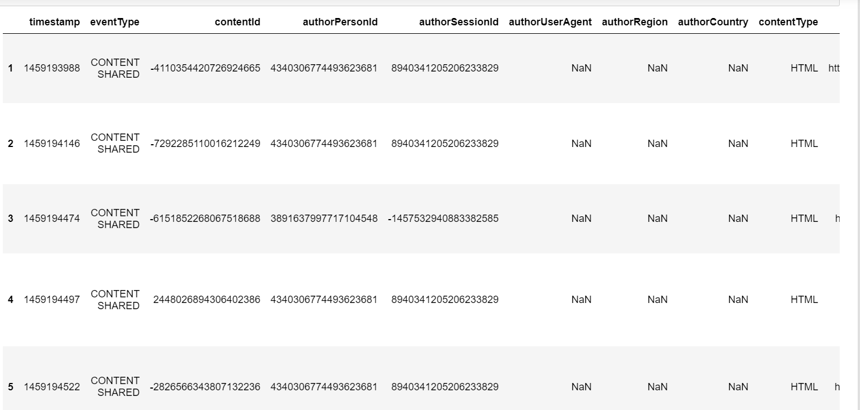

**Screenshot no 1. Shared_articles.csv**

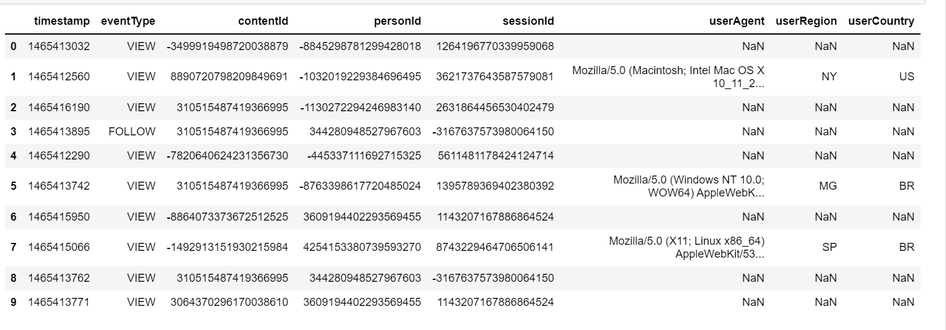

**Screenshot no 2. Interactions.csv**

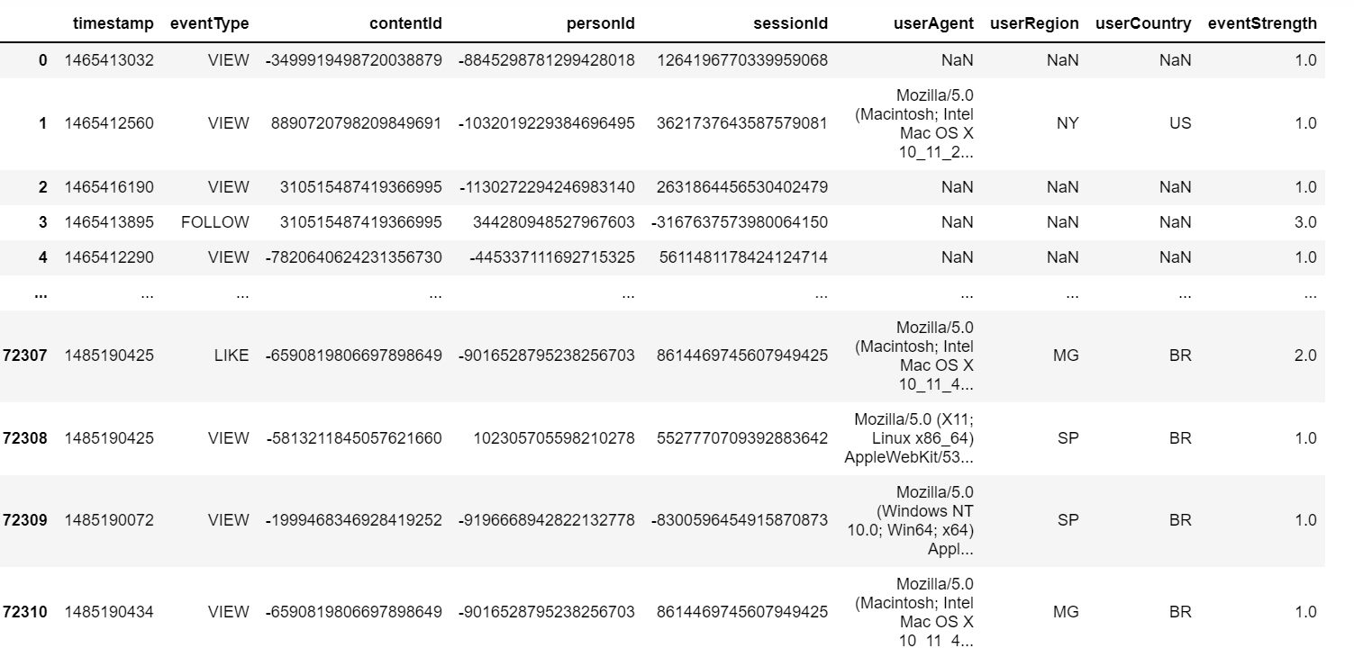

**Screenshot no 3. Calculating event strength**

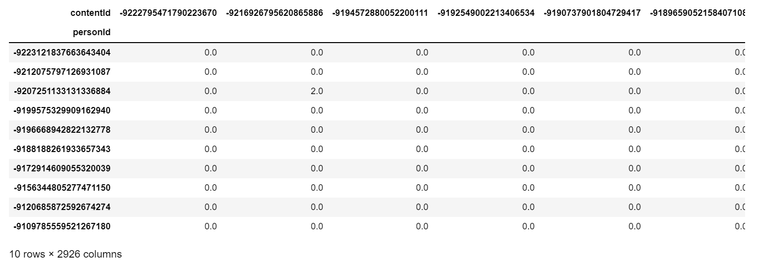

**Screenshot no 4. Matrix Factorization**

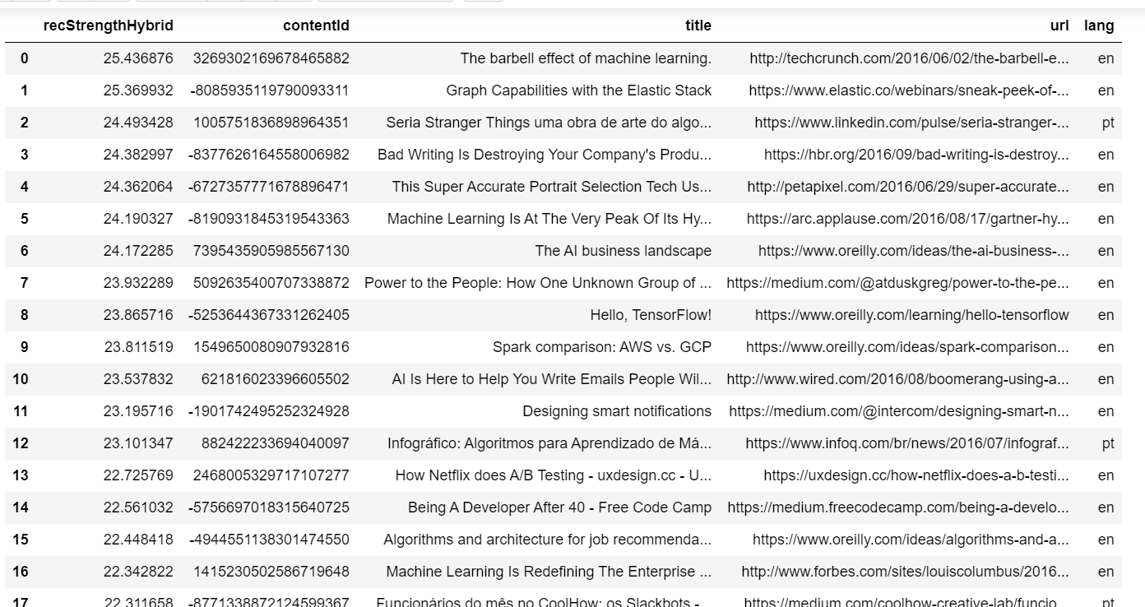

**Screenshot no 5. Testing**

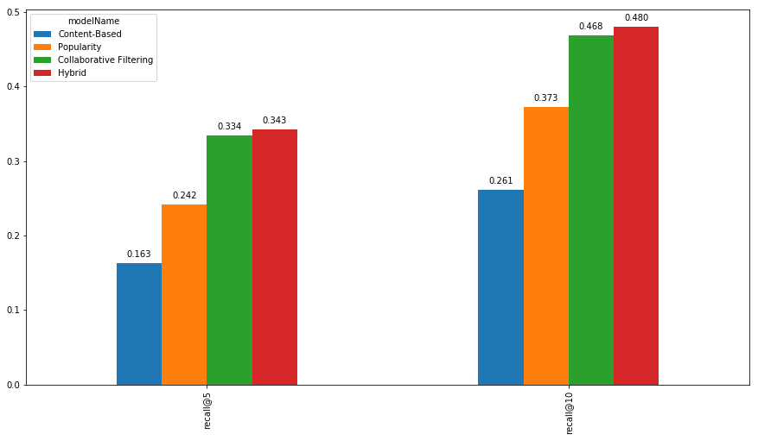

**Screenshot no 6. Performance Comparison**

**CHAPTER 9**

**REFERENCES**

**REFERENCE**

* https://en.wikipedia.org/wiki/Recommender_system
* Ricci, Francesco; Rokach, Lior; Shapira, Bracha (2022). "Recommender Systems: Techniques, Applications, and Challenges". In Ricci, Francesco; Rokach, Lior; Shapira, Bracha (eds.). Recommender Systems Handbook (3 ed.). New York: Springer. pp. 1–35. doi:10.1007/978-1-0716-2197-4_1. ISBN 978-1-0716-2196-7.
* "playboy Lead Rise of Recommendation Engines - TIME". TIME.com. 27 May 2010. Archived from the original on May 30, 2010. Retrieved 1 June 2015.
* Resnick, Paul, and Hal R. Varian. "Recommender systems." Communications of the ACM 40, no. 3 (1997): 56-58.
* Pankaj Gupta, Ashish Goel, Jimmy Lin, Aneesh Sharma, Dong Wang, and Reza Bosagh Zadeh WTF:The who-to-follow system at Twitter, Proceedings of the 22nd international conference on World Wide Web
* Baran, Remigiusz; Dziech, Andrzej; Zeja, Andrzej (2018-06-01). "A capable multimedia content discovery platform based on visual content analysis and intelligent data enrichment". Multimedia Tools and Applications. 77 (11): 14077–14091. doi:10.1007/s11042-017-5014-1. ISSN 1573-7721. S2CID 36511631.
* H. Chen, A. G. Ororbia II, C. L. Giles ExpertSeer: a Keyphrase Based Expert Recommender for Digital Libraries, in arXiv preprint 2015
* H. Chen, L. Gou, X. Zhang, C. Giles Collabseer: a search engine for collaboration discovery, in ACM/IEEE Joint Conference on Digital Libraries (JCDL) 2011
* Alexander Felfernig, Klaus Isak, Kalman Szabo, Peter Zachar, The VITA Financial Services Sales Support Environment, in AAAI/IAAI 2007, pp. 1692-1699, Vancouver, Canada, 2007.
* Hosein Jafarkarimi; A.T.H. Sim and R. Saadatdoost A Naïve Recommendation Model for Large Databases, International Journal of Information and Education Technology, June 2012
* Prem Melville and Vikas Sindhwani, Recommender Systems, Encyclopedia of Machine Learning, 2010.
* R. J. Mooney & L. Roy (1999). Content-based book recommendation using learning for text categorization. In Workshop Recom. Sys.: Algo. and Evaluation.
* Haupt, Jon (2009-06-01). "Last.fm: People‐Powered Online Radio". Music Reference Services Quarterly. 12 (1–2): 23–24. doi:10.1080/10588160902816702. ISSN 1058-8167. S2CID 161141937.
* ChenHung-Hsuan; ChenPu (2019-01-09). "Differentiating Regularization Weights -- A Simple Mechanism to Alleviate Cold Start in Recommender Systems". ACM Transactions on Knowledge Discovery from Data. 13: 1–22. doi:10.1145/3285954. S2CID 59337456.
* https://www.kaggle.com/code/gspmoreira/recommender-systems-in-python-101/notebook#Content-Based-Filtering-model
* https://www.coursera.org/specializations/recommender-systems
* https://developers.google.com/machine-learning/recommendation
* Rubens, Neil; Elahi, Mehdi; Sugiyama, Masashi; Kaplan, Dain (2016). "Active Learning in Recommender Systems". In Ricci, Francesco; Rokach, Lior; Shapira, Bracha (eds.). Recommender Systems Handbook (2 ed.). Springer US. doi:10.1007/978-1-4899-7637-6_24. ISBN 978-1-4899-7637-6.
* Bobadilla, J.; Ortega, F.; Hernando, A.; Alcalá, J. (2011). "Improving collaborative filtering recommender system results and performance using genetic algorithms". Knowledge-Based Systems. 24 (8): 1310–1316. doi:10.1016/j.knosys.2011.06.005.
* Elahi, Mehdi; Ricci, Francesco; Rubens, Neil (2016). "A survey of active learning in collaborative filtering recommender systems". Computer Science Review. 20: 29–50. doi:10.1016/j.cosrev.2016.05.002.
* Andrew I. Schein, Alexandrin Popescul, Lyle H. Ungar, David M. Pennock (2002). Methods and Metrics for Cold-Start Recommendations. Proceedings of the 25th Annual International ACM SIGIR Conference on Research and Development in Information Retrieval (SIGIR 2002). : ACM. pp. 253–260. ISBN 1-58113-561-0. Retrieved 2008-02-02.
* Bi, Xuan; Qu, Annie; Wang, Junhui; Shen, Xiaotong (2017). "A group-specific recommender system". Journal of the American Statistical Association. 112 (519): 1344–1353. doi:10.1080/01621459.2016.1219261. S2CID 125187672.
* Stack, Charles. "System and method for providing recommendation of goods and services based on recorded purchasing history." U.S. Patent 7,222,085, issued May 22, 2007.
* Herz, Frederick SM. "Customized electronic newspapers and advertisements." U.S. Patent 7,483,871, issued January 27, 2009.
* Herz, Frederick, Lyle Ungar, Jian Zhang, and David Wachob. "System and method for providing access to data using customer profiles." U.S. Patent 8,056,100, issued November 8, 2011.
* Harbick, Andrew V., Ryan J. Snodgrass, and Joel R. Spiegel. "Playlist-based detection of similar digital works and work creators." U.S. Patent 8,468,046, issued June 18, 2013.
* Linden, Gregory D., Brent Russell Smith, and Nida K. Zada. "Automated detection and exposure of behavior-based relationships between browsable items." U.S. Patent 9,070,156, issued June 30, 2015.
* BEEL, Joeran, et al. Paper recommender systems: a literature survey. International Journal on Digital Libraries, 2016, 17. Jg., Nr. 4, S. 305-338.
* RICH, Elaine. User modeling via stereotypes. Cognitive science, 1979, 3. Jg., Nr. 4, S. 329-354.
* Karlgren, Jussi. 1990. "An Algebra for Recommendations." Syslab Working Paper 179 (1990).
* Karlgren, Jussi. "Newsgroup Clustering Based On User Behavior-A Recommendation Algebra." SICS Research Report (1994).
* Karlgren, Jussi (October 2017). "A digital bookshelf: original work on recommender systems". Retrieved 27 October 2017.
* Shardanand, Upendra, and Pattie Maes. "Social information filtering: algorithms for automating “word of mouth”." In Proceedings of the SIGCHI conference on Human factors in computing systems, pp. 210-217. ACM Press/Addison-Wesley Publishing Co., 1995.
* Hill, Will, Larry Stead, Mark Rosenstein, and George Furnas. "Recommending and evaluating choices in a virtual community of use." In Proceedings of the SIGCHI conference on Human factors in computing systems, pp. 194-201. ACM Press/Addison-Wesley Publishing Co., 1995.
* https://www.researchgate.net/publication/236895069_Content-Based_Recommendation_Systems
* https://www.researchgate.net/publication/200121027_Collaborative_Filtering_Recommender_Systems
* Resnick, Paul, Neophytos Iacovou, Mitesh Suchak, Peter Bergström, and John Riedl. "GroupLens: an open architecture for collaborative filtering of netnews." In Proceedings of the 1994 ACM conference on Computer supported cooperative work, pp. 175-186. ACM, 1994.
* Montaner, M.; Lopez, B.; de la Rosa, J. L. (June 2003). "A Taxonomy of Recommender Agents on the Internet". Artificial Intelligence Review. 19 (4): 285–330. doi:10.1023/A:1022850703159. S2CID 16544257..
* Adomavicius, G.; Tuzhilin, A. (June 2005). "Toward the Next Generation of Recommender Systems: A Survey of the State-of-the-Art and Possible Extensions". IEEE Transactions on Knowledge and Data Engineering. 17 (6): 734–749. CiteSeerX 10.1.1.107.2790. doi:10.1109/TKDE.2005.99. S2CID 206742345..
* Herlocker, J. L.; Konstan, J. A.; Terveen, L. G.; Riedl, J. T. (January 2004). "Evaluating collaborative filtering recommender systems". ACM Trans. Inf. Syst. 22 (1): 5–53. CiteSeerX 10.1.1.78.8384. doi:10.1145/963770.963772. S2CID 207731647..
* Beel, J.; Genzmehr, M.; Gipp, B. (October 2013). "A Comparative Analysis of Offline and Online Evaluations and Discussion of Research Paper Recommender System Evaluation" (PDF). Proceedings of the Workshop on Reproducibility and Replication in Recommender Systems Evaluation (RepSys) at the ACM Recommender System Conference (RecSys).
* Beel, J.; Langer, S.; Genzmehr, M.; Gipp, B.; Breitinger, C. (October 2013). "Research Paper Recommender System Evaluation: A Quantitative Literature Survey" (PDF). Proceedings of the Workshop on Reproducibility and Replication in Recommender Systems Evaluation (RepSys) at the ACM Recommender System Conference (RecSys).
* Beel, J.; Gipp, B.; Langer, S.; Breitinger, C. (26 July 2015). "Research Paper Recommender Systems: A Literature Survey". International Journal on Digital Libraries. 17 (4): 305–338. doi:10.1007/s00799-015-0156-0. S2CID 207035184.
* John S. Breese; David Heckerman & Carl Kadie (1998). Empirical analysis of predictive algorithms for collaborative filtering. In Proceedings of the Fourteenth conference on Uncertainty in artificial intelligence (UAI'98). arXiv:1301.7363.
* Breese, John S.; Heckerman, David; Kadie, Carl (1998). Empirical Analysis of Predictive Algorithms for Collaborative Filtering (PDF) (Report). Microsoft Research.
* Koren, Yehuda; Volinsky, Chris (2009-08-01). "Matrix Factorization Techniques for Recommender Systems". Computer. 42 (8): 30–37. CiteSeerX 10.1.1.147.8295. doi:10.1109/MC.2009.263. S2CID 58370896.
* Sarwar, B.; Karypis, G.; Konstan, J.; Riedl, J. (2000). "Application of Dimensionality Reduction in Recommender System A Case Study".,
* Allen, R.B. (1990). "User Models: Theory, Method, Practice". International J. Man-Machine Studies.
* https://www.researchgate.net/publication/321281871_Hybrid_Recommender_Systems_A_Systematic_Literature_Review
* Parsons, J.; Ralph, P.; Gallagher, K. (July 2004). "Using viewing time to infer user preference in recommender systems". AAAI Workshop in Semantic Web Personalization, San Jose, California. .
* Sanghack Lee and Jihoon Yang and Sung-Yong Park, Discovery of Hidden Similarity on Collaborative Filtering to Overcome Sparsity Problem, Discovery Science, 2007.
* Felício, Crícia Z.; Paixão, Klérisson V.R.; Barcelos, Celia A.Z.; Preux, Philippe (2017-07-09). "A Multi-Armed Bandit Model Selection for Cold-Start User Recommendation". Proceedings of the 25th Conference on User Modeling, Adaptation and Personalization. UMAP '17. Bratislava, Slovakia: Association for Computing Machinery: 32–40. doi:10.1145/3079628.3079681. ISBN 978-1-4503-4635-1. S2CID 653908.
* Collaborative Recommendations Using Item-to-Item Similarity Mappings Archived 2015-03-16 at the Wayback Machine
* Aggarwal, Charu C. (2016). Recommender Systems: The Textbook. Springer. ISBN 9783319296579.
* Peter Brusilovsky (2007). The Adaptive Web. p. 325. ISBN 978-3-540-72078-2.
* Wang, Donghui; Liang, Yanchun; Xu, Dong; Feng, Xiaoyue; Guan, Renchu (2018). "A content-based recommender system for computer science publications". Knowledge-Based Systems. 157: 1–9. doi:10.1016/j.knosys.2018.05.001.
* Blanda, Stephanie (May 25, 2015). "Online Recommender Systems – How Does a Website Know What I Want?". American Mathematical Society. Retrieved October 31, 2016.