Local Private Cloud Using Nextcloud and Docker
Installation, Configuration and Local Network Access Guide

Table of Contents
1. Project Overview
2. Components Required
3. Environment
4. Install and Configure Ubuntu
5. VMware Network Configuration
6. Install Docker
7. Verify Docker
8. Docker Daemon
9. Docker and Podman Configuration
10. Start Nextcloud
11. Verify the Nextcloud Container
12. Test Nextcloud from Ubuntu
13. Find the Ubuntu VM IP Address
14. Configure Nextcloud Trusted Domains
15. Keep Localhost Access
16. Restart Nextcloud
17. Access Nextcloud from Another Device
18. Troubleshooting LAN Access
19. Common Problems and Solutions
20. Verification Checklist
21. Final Configuration
22. Project Goal

1. Project Overview
This project creates a local private cloud using Nextcloud running inside a Docker container. Docker runs inside an Ubuntu Linux virtual machine, and Ubuntu runs inside VMware.
The objective is to allow phones, laptops, and PCs connected to the same local network to access the Nextcloud server
. 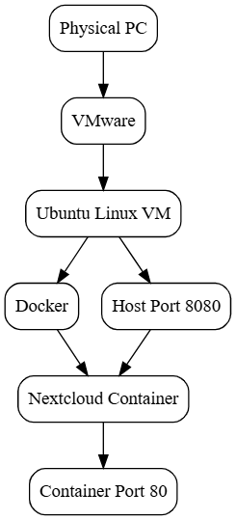
Local network access:
http://SERVER-IP:8080
Example:
http://192.168.1.50:8080

2. Components Required
Component | Purpose
Physical PC | Main computer running the environment
VMware | Runs the Ubuntu virtual machine
Ubuntu Linux | Server operating system
Docker | Runs the Nextcloud container
Nextcloud | Private cloud application
Local Network | Allows other devices to access Nextcloud

3. Environment
Host: Physical Computer
Virtualization: VMware
Operating System: Ubuntu Linux
Container Platform: Docker
Application: Nextcloud
Container Name: nextcloud
Docker Port: 8080
Container Port: 80
Port Mapping: 8080:80

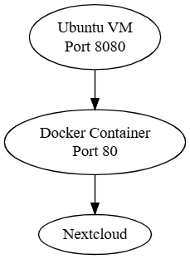
4. Install and Configure Ubuntu
Ubuntu is installed as a virtual machine inside VMware.
Update the system:
sudo apt update
Upgrade installed packages:
sudo apt upgrade -y
Check the network configuration:
ip addr
hostname -I
Example:
192.168.1.50

5. VMware Network Configuration
The Ubuntu VM needs to be reachable from other devices on the local network. For direct LAN access, use a Bridged Network Adapter when appropriate for the VMware environment.
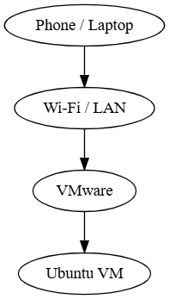
Check the VM IP after configuring networking:
hostname -I

6. Install Docker
Docker is the container platform used to run Nextcloud.
Check the Docker service:
sudo systemctl status docker
If Docker is stopped:
sudo systemctl daemon-reload
sudo systemctl start docker
Check again:
sudo systemctl status docker --no-pager
Expected:
Active: active (running)
Check whether Docker starts automatically:
sudo systemctl is-enabled docker

7. Verify Docker
docker info
docker run hello-world
A successful test should display:
Hello from Docker!

8. Docker Daemon
The Docker daemon is the background service responsible for managing Docker containers, images, networks, and other Docker resources.
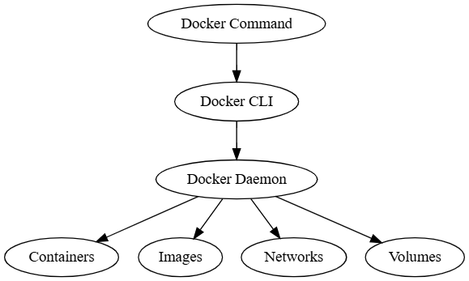
Check it with:
sudo systemctl status docker

9. Docker and Podman Configuration
During the setup, the Docker command attempted to connect to the Podman socket instead of the Docker daemon.
/run/user/1000/podman/podman.sock
Check DOCKER_HOST:
echo $DOCKER_HOST
If it points to the Podman socket, clear it for the current shell:
unset DOCKER_HOST
Check the Docker context:
docker context ls
If the wrong context is active:
docker context use default
Check Docker-related environment variables:
env | grep -i docker
Verify Docker:
docker info
Desired configuration:
Docker CLI
|
Docker daemon

10. Start Nextcloud
After Docker is working correctly, create and start the Nextcloud container:
docker run -d -p 8080:80 --name nextcloud nextcloud
The command means:
- `docker run` creates and starts a container.
- `-d` runs the container in the background.
- `-p 8080:80` maps Ubuntu host port 8080 to container port 80.
- `--name nextcloud` names the container nextcloud.
- `nextcloud` specifies the Nextcloud image.

11. Verify the Nextcloud Container
docker ps
Look for a port mapping similar to:
0.0.0.0:8080->80/tcp
Expected:
Container: nextcloud
Host Port: 8080
Container Port: 80
Port Mapping: 8080:80

12. Test Nextcloud from Ubuntu
From the Ubuntu VM, open:
http://localhost:8080
If it opens, Ubuntu, Docker, the Nextcloud container, and the local port mapping are working.

13. Find the Ubuntu VM IP Address
hostname -I
ip addr
Example:
192.168.1.50
This is the server IP address. It is not the IP address of the phone, laptop, or PC connecting to Nextcloud.

14. Configure Nextcloud Trusted Domains
Nextcloud uses trusted_domains to control which hostnames or IP addresses it accepts when accessing the application.
If the Ubuntu VM has IP 192.168.1.50 and Nextcloud is exposed on port 8080, add the server address:
docker exec -u www-data nextcloud php occ config:system:set trusted_domains 1 --value="192.168.1.50:8080"
Replace 192.168.1.50 with the actual Ubuntu VM IP.
Do not add every client device IP. For example, phone and laptop IPs do not need to be individually added just because they connect to Nextcloud.

15. Keep Localhost Access
If localhost is already configured as a trusted domain, keep it. Depending on the existing configuration, localhost and 127.0.0.1 may also be retained.
docker exec -u www-data nextcloud php occ config:system:get trusted_domains

16. Restart Nextcloud
docker restart nextcloud
docker ps
Make sure the nextcloud container is running.

17. Access Nextcloud from Another Device
Connect the phone, laptop, or PC to the same local network as the Ubuntu VM.
http://192.168.1.50:8080
Replace the example IP with the actual Ubuntu VM IP
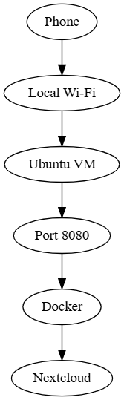.

18. Troubleshooting LAN Access

18.1 Check VMware Network
If localhost works inside Ubuntu but the server IP does not work from another device, check the VMware network configuration. Bridged networking is normally appropriate when the VM needs direct LAN reachability.
hostname -I

18.2 Check Docker Port
docker ps
Look for:
0.0.0.0:8080->80/tcp

18.3 Check Ubuntu Firewall
sudo ufw status
If UFW is active and port 8080 is not allowed:
sudo ufw allow 8080/tcp
sudo ufw status

18.4 Test Again
http://SERVER-IP:8080
Example:
http://192.168.1.50:8080

19. Common Problems and Solutions

19.1 Docker Is Not Running
Problem:
Active: inactive (dead)
Solution:
sudo systemctl start docker
sudo systemctl status docker

19.2 Docker Tries to Use Podman
Problem:
/run/user/1000/podman/podman.sock
Check:
echo $DOCKER_HOST
docker context ls
env | grep -i docker
Possible fixes:
unset DOCKER_HOST
docker context use default
docker info

19.3 Nextcloud Shows 'Access Through Untrusted Domain'
Cause: the server address being used to access Nextcloud is not present in trusted_domains.
Solution example:
docker exec -u www-data nextcloud php occ config:system:set trusted_domains 1 --value="192.168.1.50:8080"
docker restart nextcloud
Then test:
http://192.168.1.50:8080

19.4 Nextcloud Works on Localhost but Not from Another Device
Check in this order:
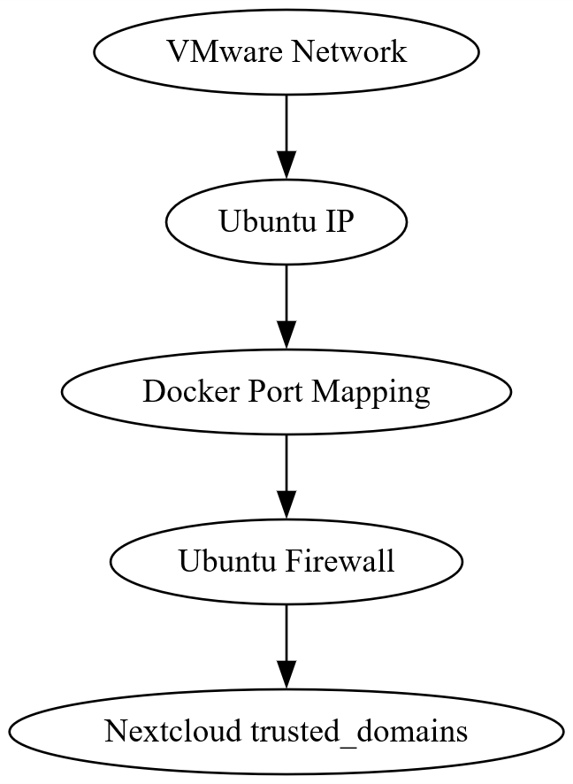
hostname -I
docker ps
sudo ufw status
Then test the server IP from another LAN device.

20. Verification Checklist

Ubuntu
[ ] Ubuntu VM is running
[ ] Ubuntu has a LAN IP

VMware
[ ] VM network is configured
[ ] Bridged networking is used when direct LAN access is required

Docker
[ ] Docker installed
[ ] Docker service running
[ ] Docker enabled
[ ] Docker CLI connected to Docker daemon
[ ] Docker is not using the Podman socket

Nextcloud
[ ] Nextcloud image available
[ ] nextcloud container created
[ ] nextcloud container running
[ ] Port 8080 exposed
[ ] Container port 80 mapped to host port 8080

Network
[ ] Ubuntu IP identified
[ ] Port 8080 reachable from LAN
[ ] Ubuntu firewall checked

Nextcloud Configuration
[ ] Server IP added to trusted_domains
[ ] localhost retained if required
[ ] Nextcloud restarted after configuration

Final Test
[ ] http://localhost:8080 works from Ubuntu
[ ] http://SERVER-IP:8080 works from another LAN device

21. Final Configuration
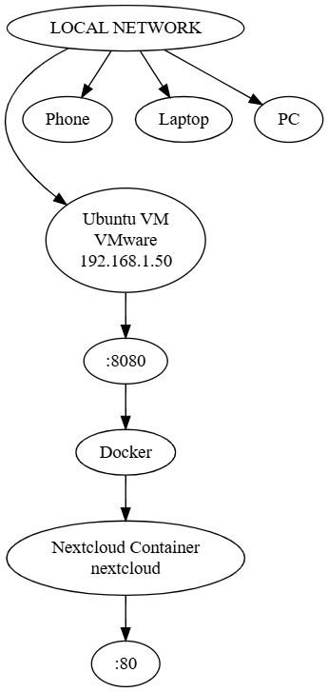
Setting | Configuration
Virtualization | VMware
Operating System | Ubuntu Linux
Container Platform | Docker
Container | nextcloud
Host Port | 8080
Container Port | 80
Port Mapping | 8080:80
Local Access | http://localhost:8080
LAN Access | http://SERVER-IP:8080
Example LAN IP | 192.168.1.50
Network | Local LAN
Client Devices | Phones, laptops, PCs

22. Project Goal
The goal s to operate a personal private cloud locally using Nextcloud and Docker.
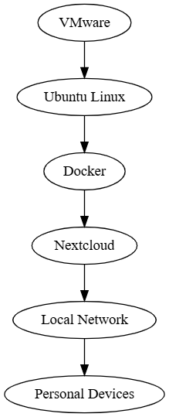
The server is hosted inside the Ubuntu VM, while Docker manages the Nextcloud container. Devices connected to the same local network can access the cloud through the Ubuntu VM's LAN IP and port 8080.
Client devices do not need to be individually added to Nextcloud's trusted_domains.
Current scope: Ubuntu VM + Docker + Nextcloud + local LAN access. Internet/global access is a separate future stage.

