**Nithish Kumar R-2017103564**

**File Watcher**

**Abstract:**

The file watcher acts as a watchdog for file system changes. The change can be file or directory creation, deletion, modification, change of location. This file watcher project is totally built using C and can greatly help monitoring the files and thus can be used for security purposes.

**Objective:**

To develop a program for file watcher that watches a directory for new or updated files using C and test its working.

**OS Concepts Used:**

The file watcher program uses concepts of File System for getting details about the directory. The file descriptor identifies the open file and the event is notified with the help of Inotify mechanism.

**Output Screenshots:**

The file watcher is set to watch the directory ‘project’ which contains the directories ‘code’ and ‘hello’ as shown in the screenshot below:

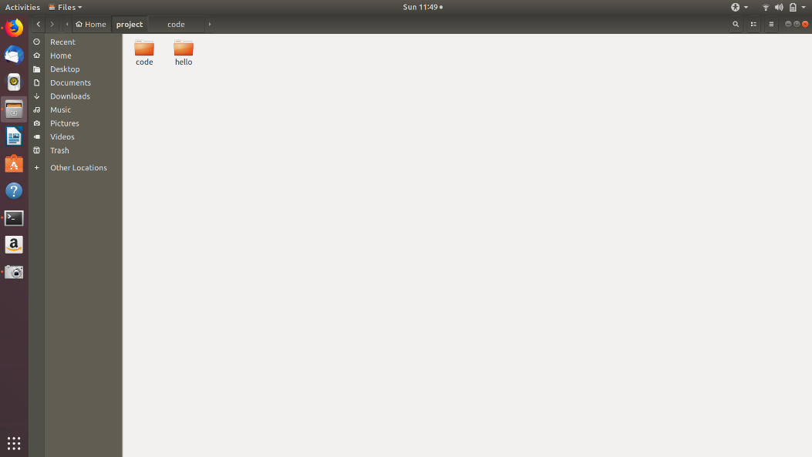

The testing is done by making the following changes to the watch directory one by one and the output is observed:

Create a new directory with name ‘newdir’ under the project directory

Move the ‘newdir’ directory to some other directory

Move the ‘newdir’ directory back to the project directory

Delete the ‘newdir’ directory

Bring a text file say ‘new.txt’ from any other directory to the project directory

Move the text file ‘new.txt’ to some other directory

Create a text file ‘textdoc.txt’ under the project directory

Put some data inside the ‘textdoc.txt’ and save

Bring the ‘new.txt’ back to the project directory.

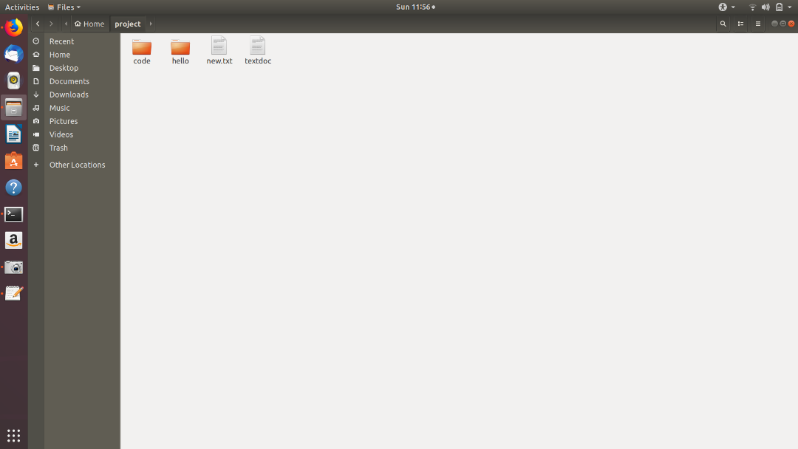

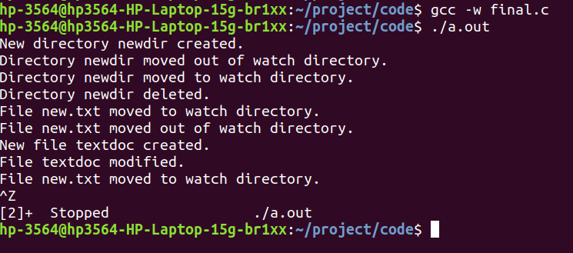

It can be observed that the changes that we have made in the watch directory are shown in the output.

**Applications:**

The file watcher acts as a watch dog and hence can be used for security purposes. The file watcher can be made to run at all time or can be scheduled to provide continuous security. The program can be extended to raise an event when a change occurs. If extended with SMTP, the user can be notified about the change via email.