**Nithish Kumar R-2017103564**

**Charan V-2017103006**

**Student Grade Points Prediction**

**Objective:**

To analyze the student’s grade points(CGPA) based on factors such as study time, board of school education, internet connectivity at home,etc by conducting a google survey and to run the collected dataset on a machine learning model in weka and summarize the accuracy of the model.

**Dataset details:**

The dataset obtained from the google survey contains 16 attributes namely timestamp,name,gender,age,address type,board of school education,reason for choosing college,extra courses taken,involvement in sports,internet connectivity at home,study time,study materials,understanding the subjects,higher study details,usage of social media,frequency of going out with friends and the CGPA which is the target attribute.Here,the timestamp and name are unnecessary,hence are removed .The rest of the features are selected for the next step.

**Implementation details:**

The collected data set from google survey is first converted into float valued data set.

The modified dataset is now fed into the weka experimenter.Since this is a regression problem.The **REP TREE algorithm(based on decision tree C4.5)**  is used.And the accuracy metrics are obtained on the output.csv file.

**Output screenshots:**

Setup:

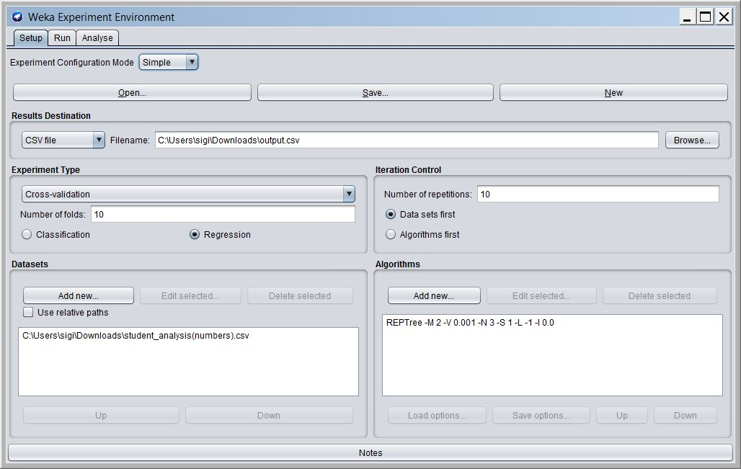

Analysis output:

