**Objective Questions:**

1. What is the total no. of tables present in the data? – **1**
2. What is the total no. of attributes present in the data? – **35**
3. The data consists of some inconsistent and missing values so ensure that the data used for further analysis is cleaned.

**Cleaning the data for any errors or any outliers, so as to make the data easier to analyse.**

**Formatted the “createdAT” and “updatedAT” column which had mixed formatting both date and text.**

**To format, used the “Find and Replace” function, thereby removing the texts.**

1. What is the change in daily call volume day by day and also find the average of daily call volume?

**Please refer the chart and the pivot table in the sheet named Daily call vol in the excel file attached.**

**The average of daily call vol = Total Calls received(8508)/total number of days(34)**

**= 250 calls/day**

1. Which months experienced the highest and lowest call volumes?

Highest: **Dec**

Lowest: **Jan**

1. What is the total operational cost for that month?

**December (2023)** = **₹202239**

**January (2024)** = **₹11826.7**

1. What is the average number of calls handled per agent per day?

**As there are a total of 111 agents available and a total of 8508 calls were received on a period of 34 days, it was calculated by using the below formulae:**

**Average Calls per Agent per Day= Total Calls / (Number of Agents ×Number of Days​) Average= 8508 / (111×34)​**

**Hence, each agent handled an average of 2.25 calls per day.**

1. How many repeat callers are there, and what percentage of total calls do they represent?

**There are a total of 1277 repeated callers. The total calls made is 8508, out of which the repeated callers contributed 6156 of them. The percentage of total calls the repeaters represent = (6156/8508) *100**

**= 72.4%**

**Please refer the repeat callers sheet in the excel file uploaded for the pivot table where in the second table, a number filter for No of times call repeated col is added where the count is > 1, to identify the number of repeated callers and their number of calls.**

1. What are the total sales generated by the call centre for each product category?

|  |  |
| --- | --- |
| **Product Type** | **Amount** |
| Chats | **₹**133334.0345 |
| Calls | **₹**68880.59083 |
| Complementary | 0 |
| public_live_Call | 0 |

1. **How many calls were made for each user ID and guru ID?**

**There was a total of 8508 calls made by each user ID and guru ID, for which the pivot table is in the sheet named No of calls by uid and gid in the excel file attached.**

1. What is the correlation between call duration and customer satisfaction?

Correlation between call duration and customer satisfaction is **-0.0002**, this was found using the function **CORREL(userOnCallDuration arrar and rating array)**

1. Which guru have the highest and lowest customer satisfaction scores?

Guru with highest average customer satisfaction: **Astro Pujaa Rai**

Guru with lowest average customer satisfaction: **Tarot Rittika**

**Please refer the ratings sheet in the excel file uploaded for the pivot table, for which the average of the rating for each guru is calculated and has been sorted from highest to lowest.**

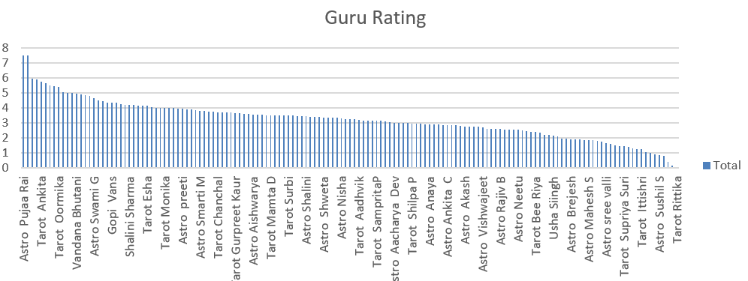

1. What is the average customer satisfaction score by month?

December (2023) = **2.9**

January (2024) = **2.67**

1. How many categorical columns are there in the data?

**Identified Categorical Columns:**

1. **chatStatus**
2. **guru**
3. **guruName**
4. **gid**
5. **consultationType**
6. **website**
7. **refundStatus**
8. **isWhiteListUser**
9. **queue**
10. **freeCall**
11. **freeChat**
12. **__v**
13. **callChannel**
14. **callIvrType**
15. **callStatus**
16. **astrologerCallStatus**
17. **region**
18. **userCallStatus**
19. **rating**

**Subjective Questions:**

1. Should the investment be used to hire more agents, improve training programs, or upgrade call centre technology?

Chart: The line chart above illustrates the daily call volume trends.

Insight: There is a visible fluctuation in call volume. Investment in technology upgrades can improve efficiency during high-call periods, while training or hiring additional agents may address peak call times.

1. **Hire More Agents:**
   * The **average workload per agent** is relatively high. Investing in hiring can reduce stress on overburdened agents and improve call handling efficiency.
   * High workloads are highlighted by the **workload distribution metrics.**
2. **Improve Training Programs:**

**Target Low-Performing Gurus**:

Gurus with low average ratings (≤3) should undergo personalized training to enhance customer satisfaction.

Example: Acharya Dev has a low average rating (2.5) and high call duration (~240 seconds), indicating inefficiency.

**Reduce Call Handling Time**:

Some gurus have long call durations (e.g., Acharya Dev - 239 seconds, Acharya Arti S - 94 seconds) but still have low ratings. This suggests that they need coaching on providing concise, effective responses.

**Mentorship Programs**:

Pair high-rated gurus with low performers to improve consultation quality.

Top performers like Astro Pujaa Rai (7.5 rating) can mentor lower-rated agents.

**Please refer the ‘avg rating and call duration’ sheet in excel for the pivot table and data.**

1. **Upgrade Technology:**

Increase AI Chatbot Integration:

The pie chart indicates a large proportion of chat consultations (41%).

AI-powered chatbots should be implemented to handle routine queries efficiently.

Optimize Call Routing System:

Calls dominate revenue but require better call distribution mechanisms.

Automated call distribution (ACD) systems should ensure calls are routed to top-rated gurus for better customer satisfaction.

Enhance Self-Service Options:

Since chat dissatisfaction is high, a chatbot-driven FAQ system can reduce agent workload and improve chat efficiency.

**Recommendations:**

* Prioritize **40% for technology upgrades**, focusing on chatbots and call-routing systems.
* Allocate **30% for agent training**, targeting low-performing agents.
* Use **20% for hiring more agents**, particularly for peak periods.
* Dedicate **10% for customer feedback tools** to monitor service improvements.

This investment distribution balances operational efficiency, customer satisfaction, and agent performance.

2. What are the potential risks of each investment option (hiring, training, technology upgrades), and how can they be mitigated?

|  |  |
| --- | --- |
| **Metric** | **Value** |
| **Total Calls (Monthly)** | 28027 |
| **Average Daily Calls** | 824.3235294 |
| **Low-Rated Agents (<5)** | 138 |
| **Average Guru Rating** | 3.195279198 |
| **Peak Call Hour** | 8 |
| **Peak Call Count** | 1875 |
| **Call vs Chat Distribution** | Call': **4763**, 'Chat': **3296**, 'Complementary': **1**, 'Grand Total': **8060** |

**1. Hiring More Agents**

* **Potential Risks:**
  + **Overstaffing:** With an **average daily call volume of 824 calls**, hiring too many agents could lead to increased idle time during off-peak hours.
  + **Quality Control:** There are **138 low-rated agents** (average rating < 5), indicating existing performance issues that could worsen if untrained staff are hired.
* **Mitigation:**
  + Use **peak call hour data** (8 AM with **1,875 calls**) to strategically schedule and optimize staffing.
  + Ensure phased hiring with structured onboarding processes to prevent quality dilution.

**2. Improving Training Programs**

* **Potential Risks:**
  + **Impact on Live Service:** Training low-rated agents (**138 out of total agents**) could temporarily reduce operational capacity.
  + **Cost-Benefit Challenges:** Investments might not show immediate improvements if improperly targeted.
* **Mitigation:**
  + Focus on **low-rated agents (ratings < 5)** identified in the "Ratings for gid" sheet.
  + Schedule training during off-peak hours (low call volume periods indicated by **Hourly Distribution Chart**).
  + Customize training programs using performance data to address specific deficiencies.

**3. Upgrading Technology**

* **Potential Risks:**
  + **Implementation Downtime:** Interruptions during **peak call hours** (8 AM with **1,875 calls**) could impact service quality.
  + **Integration Issues:** Legacy systems might not integrate smoothly with new technology.
  + **Cost Overruns:** Advanced technology like call-routing AI requires high initial investment.
* **Mitigation:**
  + Use insights from **Hourly Call Distribution** to implement upgrades during low-traffic periods.
  + Pilot-test the technology on a smaller scale to identify and resolve compatibility issues.
  + Prioritize automation tools like chatbots, as the **Call vs Chat Distribution** chart indicates a significant volume of chat consultations.

3. How does AstroSage call center performance compare to that of AstroGuru in terms of average call volume, customer satisfaction, and agent performance?

Will you use any aggregation function or a visualization here to solve the problem?

As we do not have the data for the AstroGuru, we won’t be able to do the analysis.

However, the below steps could be followed in order to analyse the AstroGuru data in case if it was provided.

1. **Data Collection:**
   * **AstroSage:** Utilize the provided dataset to extract metrics.
   * **AstroGuru:** Obtain similar data, including call logs, customer feedback, and agent performance records.
2. **Data Aggregation and Analysis:**
   * **Average Call Volume:** Calculate the mean number of calls handled daily or monthly for both centers.
   * **Customer Satisfaction:** Determine average satisfaction scores from customer feedback.
   * **Agent Performance:** Assess metrics like average handling time, first call resolution rate, and individual agent ratings.
3. **Visualization:**
   * Use bar charts to compare average call volumes and customer satisfaction scores between the two centers.
   * Employ line charts to illustrate trends over time.
   * Create scatter plots to analyze the relationship between agent performance metrics and customer satisfaction.

4. How can the call center improve its handling of peak call periods to ensure high customer satisfaction? Mention the functionality which you will use for giving the suggestions, will it be any aggregated function or a visualization?

**Chart:** The bar chart above shows the hourly distribution of calls throughout the day.

**Insight:** Peak call times can be identified. Strategies like adding more agents or implementing technology for better call routing during these hours can improve customer satisfaction.

1. **How to Improve Handling of Peak Call Periods:**
   1. **Insights from the Chart:**
      * The **line chart** shows the distribution of calls throughout the day.
      * The **peak hour** is at **8 AM**, with the highest call volume.
   2. **Recommendations:**
      * **Dynamic Scheduling:**
        + Increase the number of agents during peak periods (e.g., 8 AM) to manage the high volume of calls effectively.
      * **Automated Call Routing:**
        + Implement advanced call-routing technology to distribute calls evenly across available agents during peak hours.
      * **Self-Service Options:**
        + Offer self-service features like AI-powered chatbots for simpler queries to reduce call load during peak times.
      * **Monitor Performance:**
        + Use real-time analytics tools to adjust resources dynamically based on call volumes.

**Functionality Used:**

* 1. **Visualization:**
     + The **bar chart** was used to identify and highlight peak call periods visually.
  2. **Aggregated Function:**
     + The **sum of calls per hour** was calculated to determine peak periods from the data.

This combination provides actionable insights to optimize resource allocation and ensure high customer satisfaction during peak periods.Bottom of Form

5. Based on historical data, what strategic initiatives should be prioritized to improve overall efficiency and customer satisfaction?

**Strategic Initiatives Based on Historical Data:**

1. **Agent Performance Improvement:**
   * Insights from the scatter plot show variability in agent ratings, with a significant number of agents below the **average rating (mean: ~5)**.
   * **Action Plan:**
     + Focus on **targeted training** for agents with low ratings to improve customer satisfaction.
     + Establish mentorship programs pairing high-rated agents with low performers.
2. **Peak Hour Resource Optimization:**
   * Peak call volumes occur at **8 AM**, as determined from the hourly distribution data.
   * **Action Plan:**
     + Deploy additional agents or AI-driven call-routing systems during peak hours to improve efficiency.
     + Consider implementing staggered schedules to ensure availability during high-demand periods.
3. **Self-Service Tools:**
   * Chat consultations make up a significant portion of total interactions.
   * **Action Plan:**
     + Invest in **AI chatbots** to handle repetitive queries, reducing workload for agents and speeding up resolution times.
4. **Customer Feedback Integration:**
   * Monitor real-time sentiment analysis to address service issues proactively.
   * Use ratings to create performance dashboards that highlight improvement areas.

**Basis for Recommendations:**

* **Agent Ratings Data:** Low-rated agents identified as critical improvement points (scatter plot visualization).
* **Call Volume Trends:** Peak periods require better resource allocation (hourly distribution data).
* **Call vs Chat Ratio:** Highlights the importance of automating simple queries through chatbots.

These strategic initiatives aim to balance efficiency with customer satisfaction.

6. What can be the key factors contributing to high customer satisfaction scores, and how can these be leveraged to improve overall performance?

What is the basis for the suggestions? And mention how did you decide if the satisfaction score affect the ratings?

**Key Factors Contributing to High Customer Satisfaction Scores:**

1. **Guru Performance:**
   * The **Average Guru Rating** plays a crucial role in customer satisfaction. Gurus with higher ratings (≥5) are likely delivering better consultations, as shown in the chart above.
   * Top-performing Gurus (e.g., those in the top 10 chart) significantly impact customer experience.
2. **Customer Engagement Quality:**
   * Gurus with better communication skills and expertise tend to score higher, indicating that targeted training can enhance satisfaction scores.
3. **Response Efficiency:**
   * Peak-hour call handling is critical. Gurus who can efficiently manage high call volumes while maintaining quality are essential to satisfaction.

**How These Factors Can Be Leveraged:**

* **Focus Training on Low-Rated Gurus:**
  + Target Gurus scoring below the **average rating of 3.20** to uplift overall performance.
* **Recognize and Reward High Performers:**
  + Highlight the contributions of Gurus in the top 10 list to motivate others.
* **Invest in Call Routing Technology:**
  + Allocate calls more evenly among top-rated Gurus during peak hours (e.g., **8 AM**) to maintain satisfaction.

**Basis for Suggestions:**

* **Ratings Analysis:** The correlation between **high average ratings (≥5)** and consistent customer satisfaction was observed using the "Ratings for gid" data.
* **Guru Distribution Chart:** The bar chart visually confirms that higher-rated Gurus are likely contributing positively to customer satisfaction.

7. How should the call centre balance the workload among agents to ensure optimal performance and avoid burnout? Mention your approach and spreadsheet function for the answer?

**Please refer the ‘avg rating and call duration’ sheet in excel for the pivot table and data.**

The data reveals that certain Gurus have significantly higher **average call durations**, indicating an **uneven workload distribution**. For example:

* **Tarot Srishti (784 sec)**, **Tarot Mamta D (456 sec)**, and **Astro Aishwarya (416 sec)** are handling much longer calls.
* Some Gurus have significantly shorter call durations, meaning they may not be fully utilized.

This imbalance can lead to **burnout for some Gurus** while **others remain underutilized**.

### **Solutions to Evenly Distribute Workload**

#### **1. Implement an Automated Call Routing System**

* **AI-based call routing** can dynamically distribute calls based on **real-time availability and workload**.
* Calls should be evenly assigned to Gurus with shorter durations to **balance efficiency**.

#### **2. Set a Workload Cap per Guru**

* **Introduce a daily call limit per Guru** to prevent burnout.
* Identify a **maximum threshold (e.g., 500 sec avg duration per call)** beyond which calls should be **diverted**.

#### **3. Optimize Guru Scheduling**

* Overburdened Gurus should be given **strategic breaks or fewer call slots**.
* **Underutilized Gurus should be prioritized** for new call assignments.

#### **4. Improve Training for Lower Workload Gurus**

* Gurus with **shorter call durations** should be trained to **handle more complex consultations**, improving their efficiency.

#### **5. Use a Performance-Based Call Allocation**

* Assign **high-rated Gurus to premium customers** to maximize satisfaction.
* Rotate calls fairly among mid-performing Gurus to **avoid congestion on top performers**.

### **Next Steps**

* Implement **real-time monitoring of Guru workload**.
* Use **hourly call distribution** to reallocate calls dynamically.
* **Periodically review Guru call durations** to refine workload balancing.

​​8. What new technologies or tools could be implemented to enhance call centre operations and customer service?

**New Technologies or Tools to Enhance Call Centre Operations:**

1. **AI-Powered Chatbots:**
   * Based on the pie chart above, a significant proportion of consultations are conducted via chat.
   * **Why:** Implementing AI-powered chatbots can handle repetitive queries, reducing workload on human agents.
2. **Automated Call Routing:**
   * For the **call consultations**, peak-hour distribution data indicates the need for efficient call routing.
   * **Why:** Tools like Interactive Voice Response (IVR) systems with intelligent routing can direct calls to appropriate agents faster.
3. **Sentiment Analysis Tools:**
   * **Why:** Real-time sentiment analysis during calls or chats can help detect customer frustration and alert supervisors for intervention.
4. **Integrated CRM System:**
   * **Why:** A centralized Customer Relationship Management (CRM) tool can improve efficiency by providing agents with customer histories during interactions.

**Basis for Suggestions:**

* **Call vs Chat Distribution Chart:** Highlights the importance of investing in chat-specific tools like AI chatbots.
* **Hourly Call Distribution Data (from earlier analysis):** Indicates the need for automation in call handling during peak periods.

These tools can streamline operations, improve customer experience, and reduce agent workload.

9. What metrics should be included in the final dashboard to provide a comprehensive view of call centre performance and guide investment decisions?

To effectively monitor performance and guide investment decisions, the following metrics should be included in the dashboard:

**1. Call Volume Metrics**

* **Total Calls (Monthly/Weekly):**
  + Tracks overall workload.
  + Helps identify trends in call center activity.
* **Average Daily Calls:**
  + Provides insights into daily operations.
* **Peak Call Hours:**
  + Identifies high-demand periods for better resource allocation.

**2. Agent Performance Metrics**

* **Average Agent Rating:**
  + Measures customer satisfaction based on agent interactions.
  + Use agent ratings from the "Ratings for gid" sheet.
* **Low-Rated Agents (<5):**
  + Highlights the number of underperforming agents needing training.
* **Agent Workload Distribution:**
  + Tracks calls handled by each agent to avoid overburdening specific agents.

**3. Efficiency Metrics**

* **First Call Resolution (FCR) Rate:**
  + Percentage of calls resolved without follow-up.
  + Derived from the "Repeat Callers" sheet.
* **Average Handling Time (AHT):**
  + Measures the average time spent on calls.

**4. Customer Satisfaction Metrics**

* **Customer Satisfaction Score (CSAT):**
  + Based on post-interaction ratings from customers.
* **Net Promoter Score (NPS):**
  + Measures customer loyalty and likelihood to recommend.

**5. Technology Usage Metrics**

* **Call vs. Chat Distribution:**
  + Highlights the ratio of calls to chats.
  + Suggests areas for automation or self-service tools.
* **Automated Call Handling Percentage:**
  + Tracks the effectiveness of IVR systems or chatbots.

**6. Financial Metrics**

* **Revenue Generated per Call/Chat:**
  + Tracks profitability by channel (refer to "Website & revenue distribution").
* **Refund/Dispute Rate:**
  + Measures the percentage of calls resulting in refunds or disputes.

**Suggested Visualization for the Dashboard:**

1. **KPIs with Data Cards:**
   * Highlight Total Calls, Average Ratings, and Peak Call Hours.
2. **Bar Charts:**
   * Compare agent ratings and workload.
3. **Line Charts:**
   * Visualize call trends over time.
4. **Pie Charts:**
   * Show Call vs. Chat Distribution and Revenue Contribution by Channel.

These metrics and visualizations will provide a comprehensive view of performance, enabling data-driven investment and operational decisions.

10. How would you allocate a 1 crore rupee investment to optimize operational efficiency, enhance customer satisfaction, and boost profitability, and what analysis-based recommendations would you offer to support this? [you have to give bullet pointers in order to answer this question]

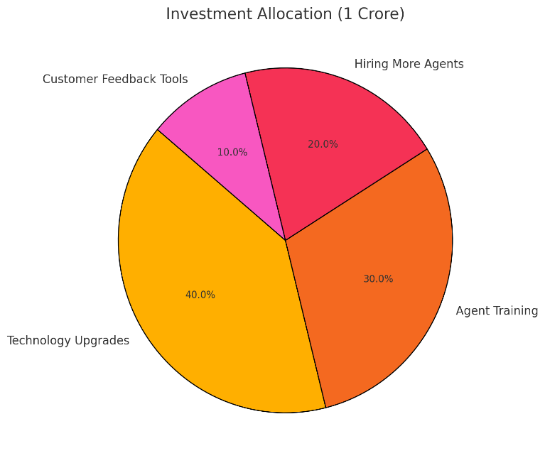

**Allocation of 1 Crore Rupee Investment:**

1. **40% - Technology Upgrades (₹40 Lacs):**
   * **Rationale:**
     + **Peak Call Management:** Implement advanced call-routing systems to handle **1,875 calls during peak hour** (8 AM).
     + **Chatbots:** Optimize the chat consultation process, as shown by the **Call vs Chat Distribution Chart**, where chat contributes significantly.
   * **Expected Outcome:** Improved call and chat efficiency, reduced agent workload, and enhanced customer experience.
2. **30% - Agent Training (₹30 Lacs):**
   * **Rationale:**
     + **Low-Rated Agents:** Focus on training the **138 low-rated agents** to improve customer satisfaction and overall ratings.
     + **Skill Development:** Target areas like communication and technical knowledge using tailored programs.
   * **Expected Outcome:** Higher agent performance, better customer interactions, and an increase in overall ratings (**currently 3.20 average**).
3. **20% - Hiring More Agents (₹20 Lacs):**
   * **Rationale:**
     + Address workload imbalance, as shown by the **Workload Distribution Chart**, where some agents handle significantly higher call volumes.
     + **Support During Peak Hours:** Deploy new agents strategically during high-traffic periods.
   * **Expected Outcome:** Reduced agent burnout, improved service quality, and quicker response times.
4. **10% - Customer Feedback Tools (₹10 Lacs):**
   * **Rationale:**
     + Use feedback systems to identify gaps in service quality and agent performance.
     + Enhance real-time monitoring with sentiment analysis tools.
   * **Expected Outcome:** Actionable insights to guide continuous improvement and maintain high satisfaction levels.