Detection of Cyber Attack in Network using Machine Learning Techniques

Software requirements
• Programming Language : Python, Jupyter Notebook
• Packages : Numpy,Matplotlib,SKlearn, Pandas, Flask
• Tool : Python 3.7
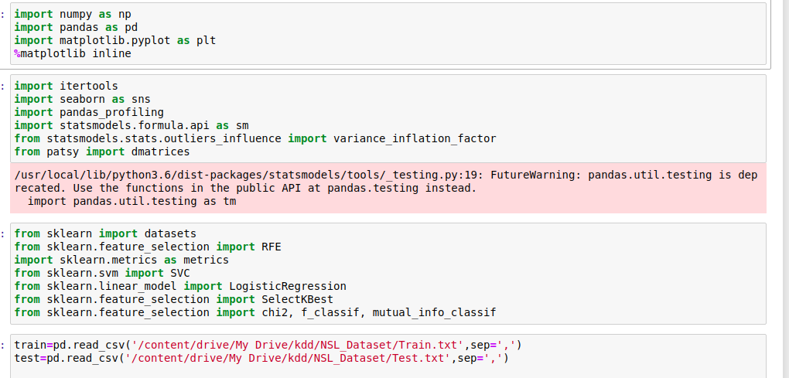
Data preprocessing
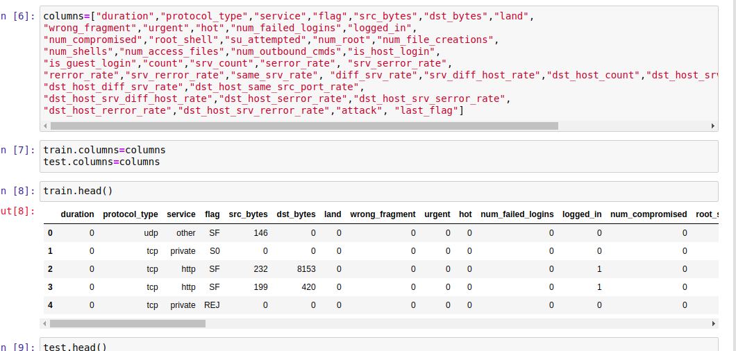

Data EDA
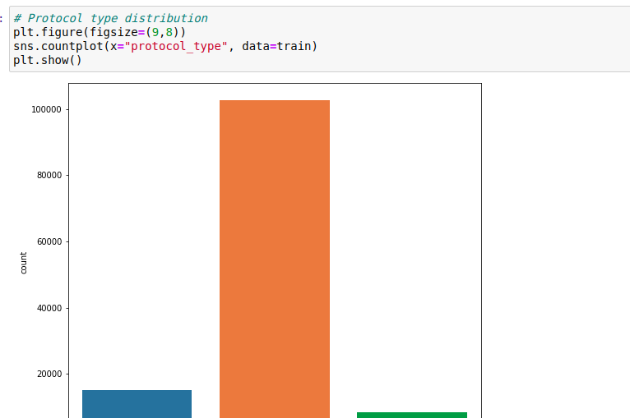

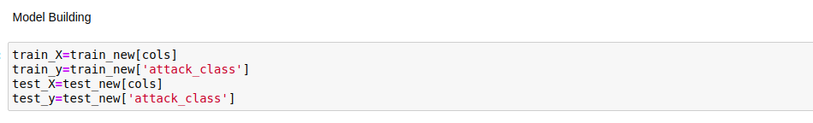

ML Deploy
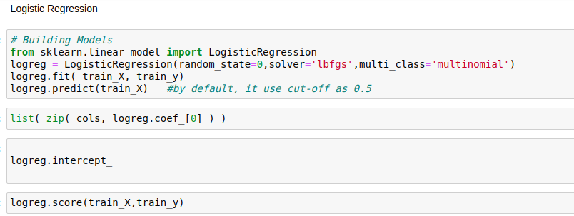
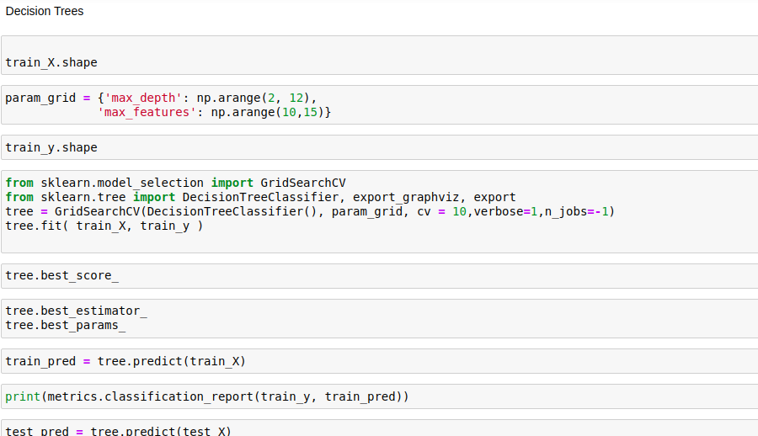

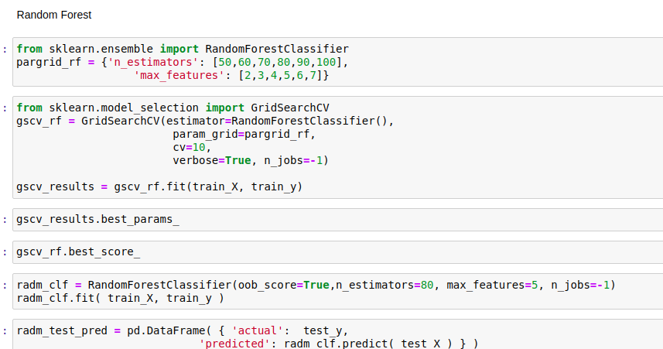
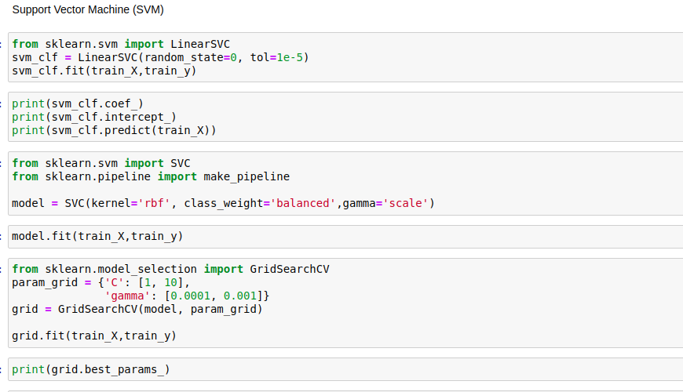
From the score accuracy we concluding the DT & RF give better accuracy and building pickle file for predicting the user input

Application
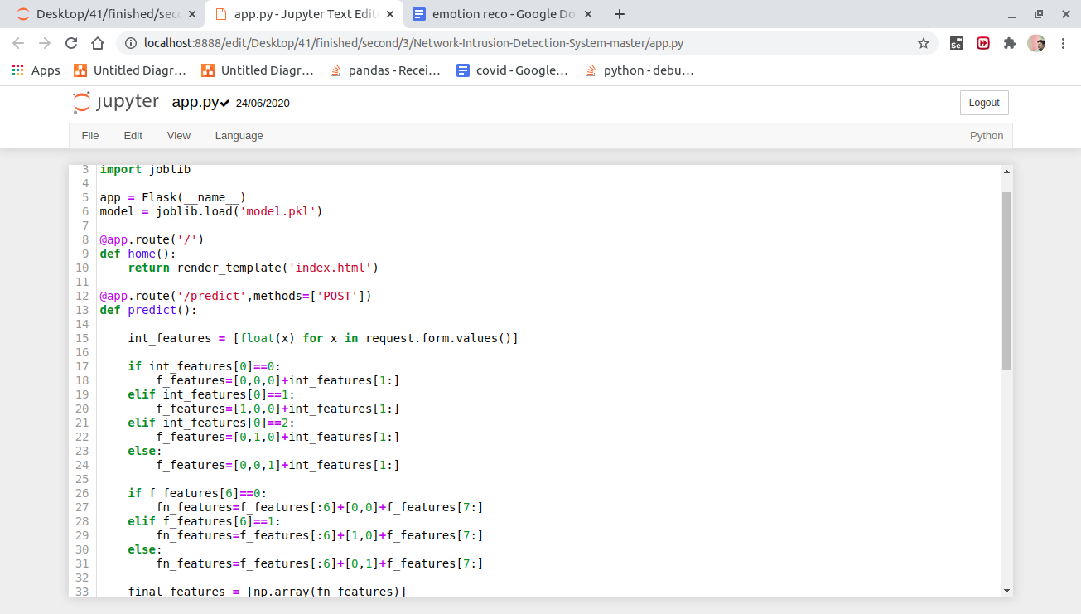

Localhost - in cmd python app.py
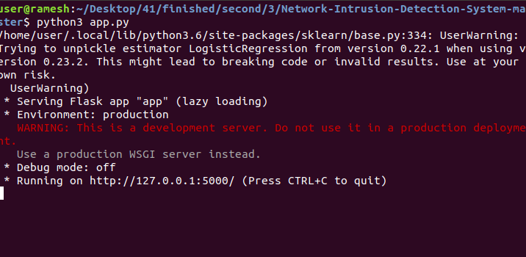

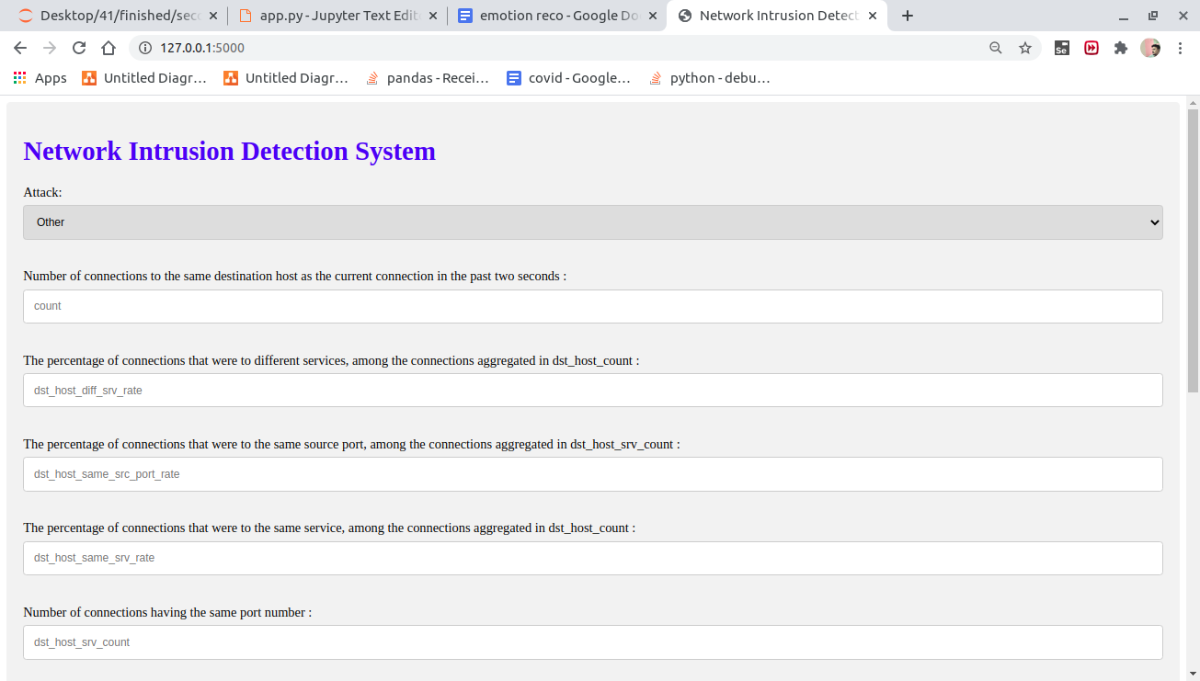

Enter the input
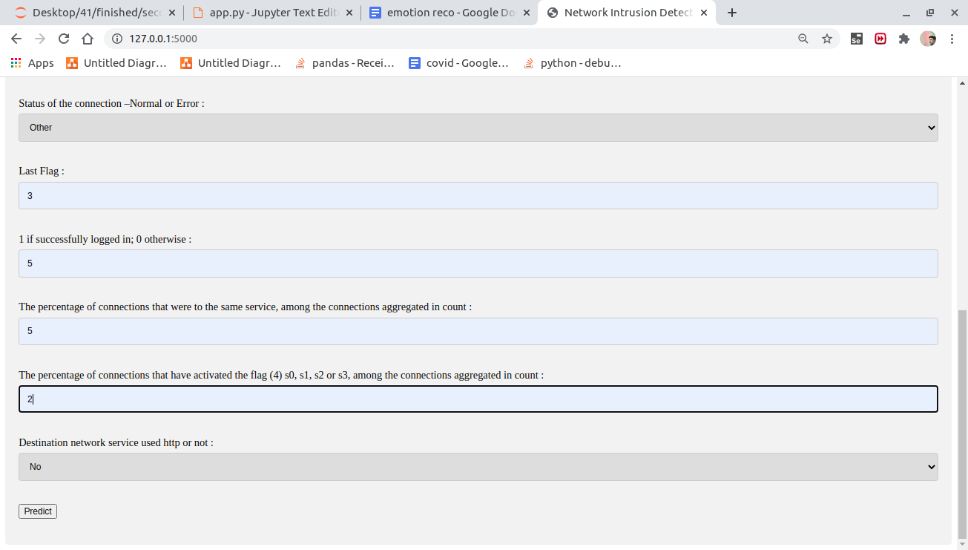

Predict attack - 