WEBTESTING SE1LENIUM

CC1

NITHISHA N

727721EUIT107

Q1]

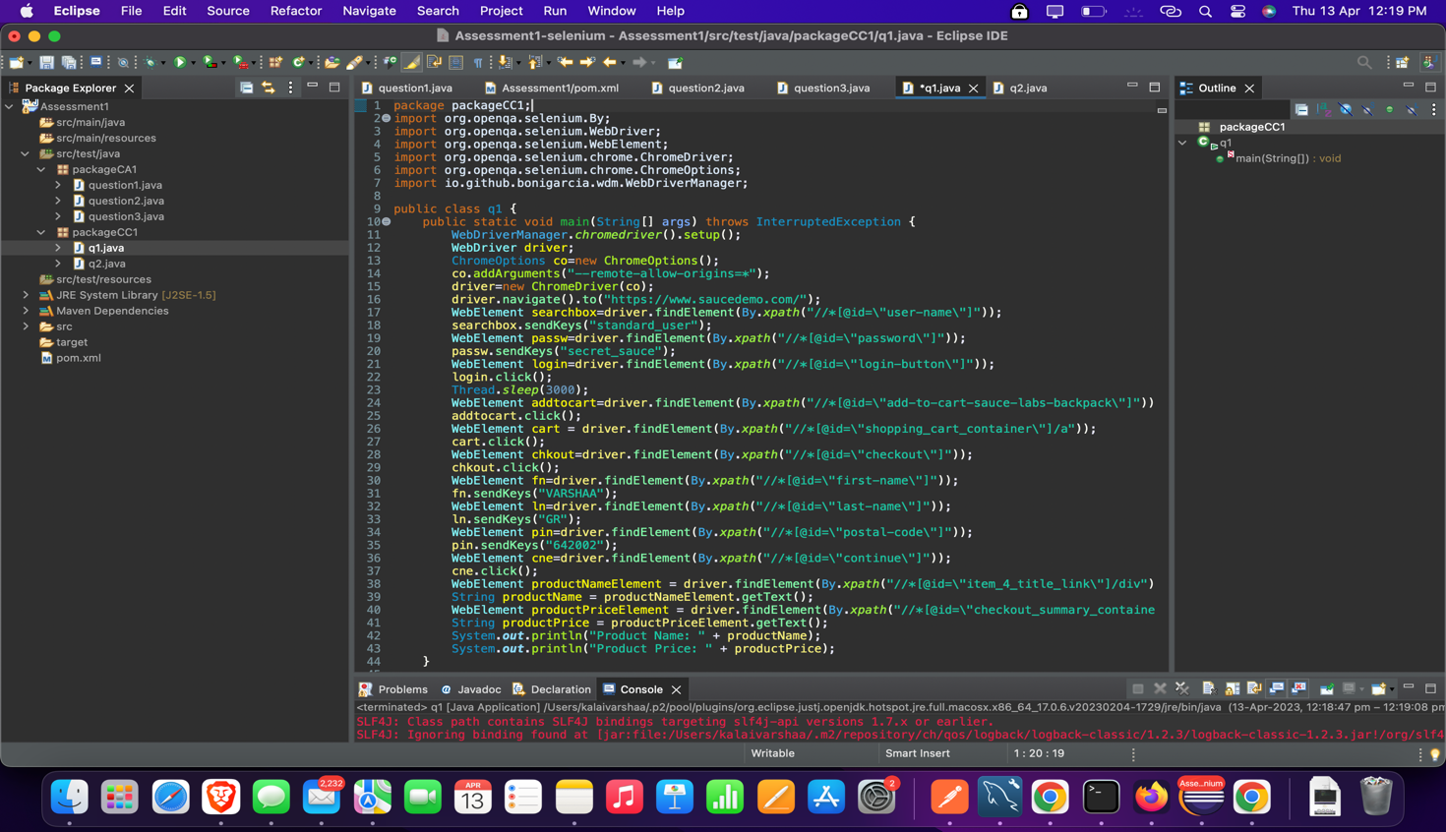

OUTPUT:

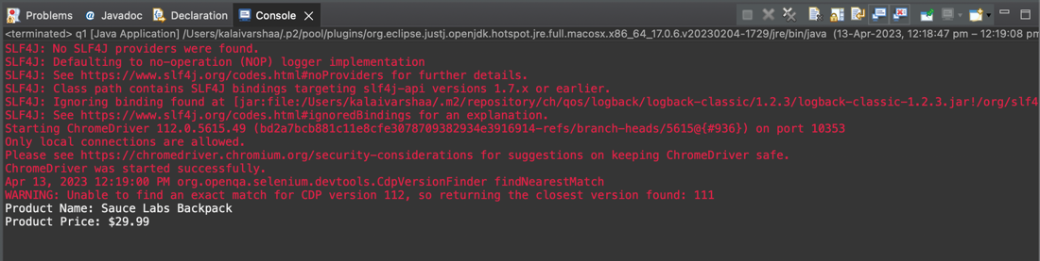

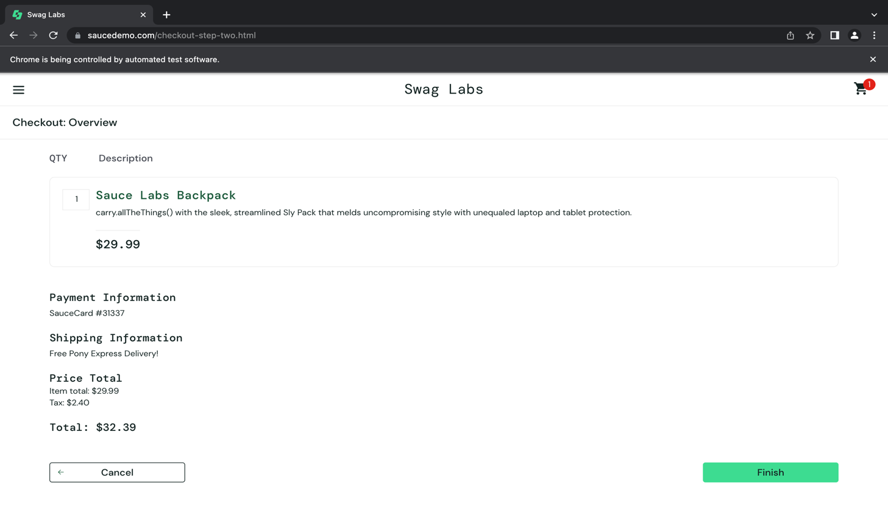

Q2]

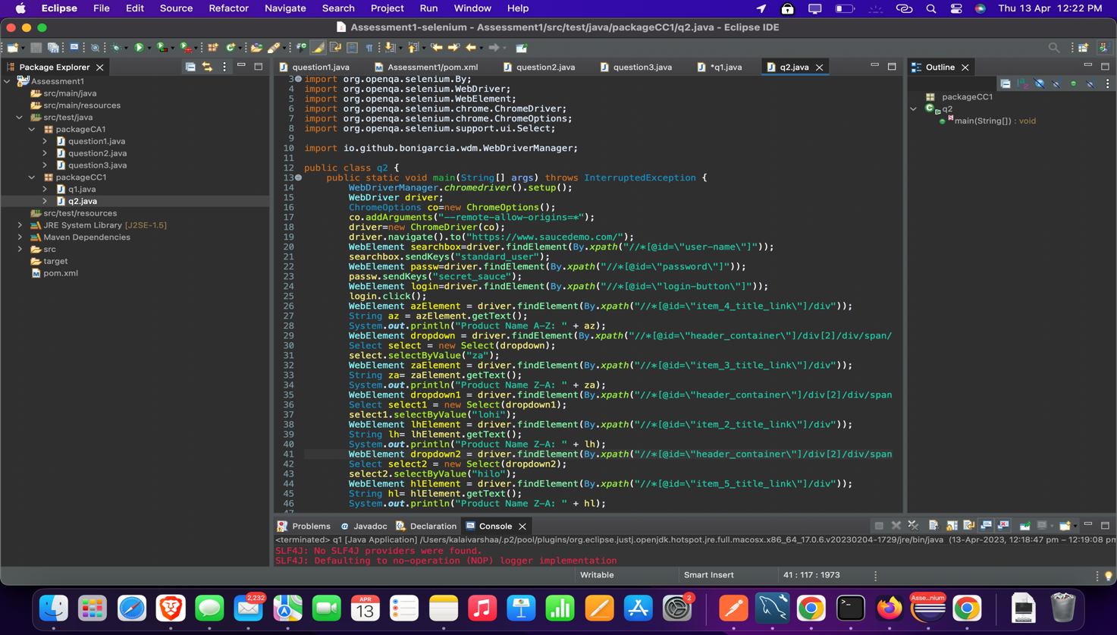

OUTPUT:

