Data Cleaning and Reproducible Preprocessing Pipeline
  - Week 3 internship report
Prepared for Yuvaintern by M Nithish Kumar
25 October 2026
Project scope and evidence status. This report forms part of a six week project on classifying beauty product review text for customer feedback triage. The practical work uses generated synthetic records only. Public sources support the business context and future data sourcing plan; no real customer dataset was downloaded or analyzed. Numerical results describe an executed simulation, and proposed real world tests are identified separately. The assignment explicitly permits simulation and planning.

Pipeline purpose and implementation
The pipeline transforms a deliberately imperfect synthetic review table into a reproducible analysis dataset. It keeps invalid labels out of supervised learning, preserves usable feedback text and records each exclusion. The implementation is in src/run_project.py. Running it regenerates raw and cleaned CSV files, a JSON audit, split membership and model evaluation outputs. No manual spreadsheet edits are required.
Cleaning is rule based before the partition step. Learned transformations such as TF IDF are fitted after partitioning. This distinction matters because a rule such as checking whether a rating is between 1 and 5 does not learn a population statistic, while vocabulary selection and normalization weights do. A scikit learn Pipeline contains the latter operations [R5].

Raw data profile and controlled defects
The generator creates 1,800 review records across 120 artificial product identifiers and four categories, then adds 20 duplicate rows to make 1,820 raw rows. It introduces ten missing texts, five out of range ratings, five missing ratings and five malformed dates. Word combinations intentionally overlap across records and the generated rating may disagree with its text. This creates meaningful cleaning and classification limitations rather than a perfect lookup exercise.
All rows carry synthetic provenance. There are no names, emails, phone numbers or genuine consumer statements. The date field uses artificial dates within 2025. Missingness and rating patterns in this generated table should not be generalized to public beauty review collections.

Executed cleaning audit
Operation | Rows or count | Treatment
Raw input | 1820 | Immutable generated snapshot
Duplicate review IDs | 20 | Keep the first occurrence
Missing or invalid ratings | 10 | Exclude from supervised dataset
Empty review text | 10 | Exclude after whitespace normalization
Malformed dates | 5 | Retain as missing; no date predictor
Conflicting identical text labels | 159 | Exclude every row in the conflicting text group
Remaining repeated text | 305 | Keep one normalized text instance
Final dataset | 1316 | Export with derived label and text hash

The removed row counts reconcile exactly: 1,820 minus 20 minus 10 minus 10 minus 159 minus 305 equals 1,316. The five invalid dates are a retained quality flag, not another subtraction. Audit ordering matters because one record could otherwise be counted more than once.

Missing values and validity rules
Convert rating to numeric with coercion, then retain only the discrete values 1 through 5. A missing label cannot be recovered honestly from the text without creating circular pseudo labels. For text, fill null values with an empty string solely to enable safe string operations, normalize whitespace and then exclude empty rows. This is not a claim that missing feedback contains no dissatisfaction.
Parse ISO dates with invalid strings coerced to missing timestamps. Keep these records for the text classifier because date is not an input. A future chronological evaluation requires a documented separate policy for missing dates. In a real ingestion adapter, unknown product identifiers should be quarantined because group splitting cannot be trusted when item identity is missing. The synthetic input contains complete product IDs.

Duplicate and inconsistency handling
Review identifier duplication is handled before deriving labels. For text, a SHA 256 hash of the lowercased whitespace normalized body identifies exact duplicates. When identical text has both binary label classes, the simulation excludes the entire group. It then retains one copy from each remaining group. This is conservative and makes the benchmark simpler to audit, but it changes the population and label prevalence.
On real data, identical text is not automatically an error. Different customers can write the same short sentence, and product variants may legitimately share content. Conflicting text labels may express rating ambiguity rather than corruption. A real deployment should compare quarantine, group retention and deduplication policies, report affected segments and avoid selecting a policy because it inflates test performance. Near duplicate detection is future work; exact hashes do not detect paraphrases.

Outliers normalization and encoding
Rating 7 is invalid rather than a legitimate outlier, so it is excluded. Long review text can be genuine and should not be deleted merely because it exceeds an interquartile range fence. For real data, inspect text length percentiles and raw examples before deciding whether extreme values are spam, extraction errors or valid detailed feedback. Any length cap must be recorded and its effect tested by segment.
The implemented model uses TF IDF text features with unigram and bigram terms, minimum document frequency of two and at most 10,000 features. TfidfVectorizer applies its default L2 normalization. Lowercasing occurs within that vectorizer; original text remains available for audit. No numerical scaling is necessary for the current text only models. A future length feature should use log1p and a scaler fitted on training rows only. Category encoding would use a training fitted encoder with an explicit unseen category policy.
Negation is kept because phrases such as “not as described” carry useful meaning. Aggressive stopword deletion, stemming and spelling correction are not applied by default. No rating, future helpfulness vote or post outcome response is passed into the classifier.

Preprocessing flowchart
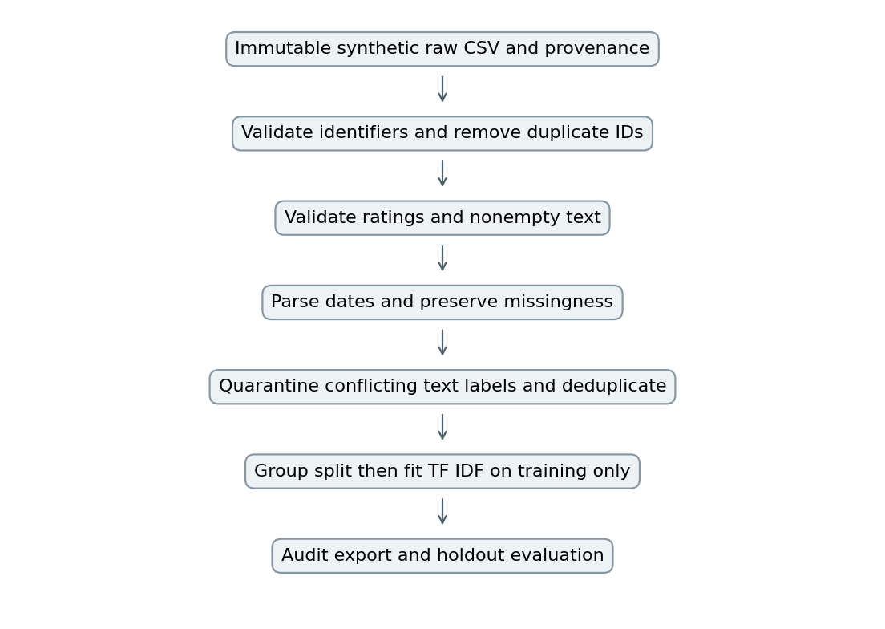
Figure 1 Implemented synthetic preprocessing sequence

Representative implementation
rating = pd.to_numeric(df['rating'], errors='coerce')
df = df.loc[rating.isin([1, 2, 3, 4, 5])].copy()
df['text'] = df['text'].fillna('').str.strip()
df = df.loc[df['text'].str.len() > 0].copy()
df['negative'] = df['rating'].le(2).astype(int)
# Fit vocabulary only after product based partitioning
model = Pipeline([('tfidf', TfidfVectorizer(
ngram_range=(1, 2), min_df=2, max_features=10000)),
('model', LogisticRegression(max_iter=1000))])
This excerpt illustrates the central rules; the full script additionally normalizes internal whitespace, audits every exclusion, resolves identical text conflicts and checks split disjointness. The executable script is the authoritative implementation. The example is not presented as a complete real data adapter.

Tools auditability and downstream benefits
pandas supports explicit coercion, missingness profiling and row filters. NumPy controls the random seed. hashlib provides stable text fingerprints. scikit learn binds vectorization to the estimator, and matplotlib creates inspectable chart files. Package versions are recorded in outputs/summary.json and requirements-lock.txt.
Quality assertions require both label classes in every partition, no shared product identifiers and no identical text hashes across partitions. These tests address important leakage paths, but not semantic similarity, recurring authors or temporal drift. The clean CSV improves consistency for EDA and modeling; it does not make synthetic evidence representative of actual consumers. The next stage examines distributions and features while retaining that limitation.

References
[R5] scikit learn documentation. Common pitfalls and recommended practices. https://scikit-learn.org/stable/common_pitfalls.html Accessed 25 October 2026.

