Real Review Exploration and Tested Feature Engineering
  - Week 4 report | Data Science with Python
Prepared by M Nithish Kumar
Revised 30 October 2026
This Week 4 revision replaces the earlier planning and synthetic demonstration with an executed study of real public Amazon beauty product reviews. The Week 1 problem remains classification of low rating feedback from review text: ratings 1 and 2 are positive, and ratings 3 through 5 are the other class. The original Week 1 submission is retained as historical project definition. No customer contact, live deployment or financial benefit is claimed.

Evidence summary and scope
Exploratory analysis uses only the 16,691 training reviews covering 5,019 products. The training low rating share is 17.07%. The test set was reserved for final evaluation and did not drive feature design. Charts and tables in this report are computed from the public review sample; they are not mockups.
The principal findings are that most reviews belong to the other rating class, low rating and other reviews have the same median length, and keyword mentions vary substantially by theme. The feature experiment compares a TF IDF text baseline with a version that adds length, punctuation and capitalization. These additional features were implemented and evaluated; they did not improve the selected primary ranking metric.

Rating balance and baseline implications
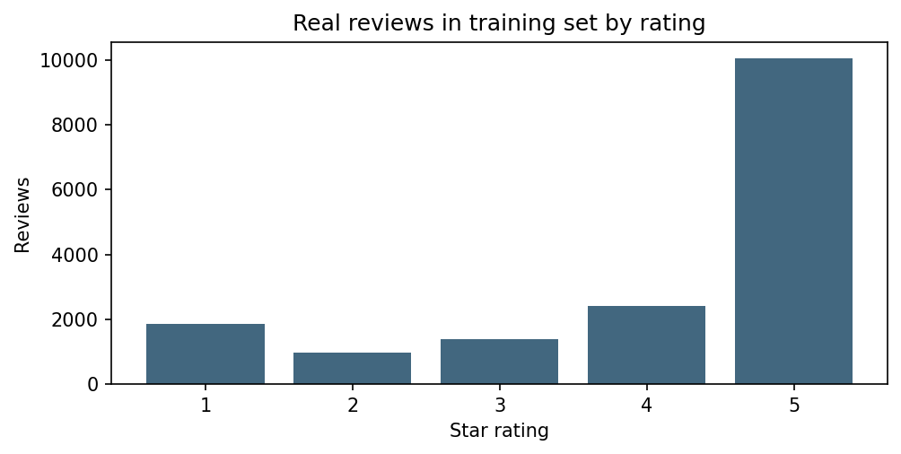
Figure 1 Training rating counts from the cleaned public review sample
Rating | Training review count
1.0 | 1870
2.0 | 979
3.0 | 1386
4.0 | 2398
5.0 | 10058

The binary target is derived from the five star scale after retaining all valid scores. Ratings 1 and 2 are low rating feedback; ratings 3 through 5 form the other class. A three star review can contain a substantive complaint. The study therefore measures the ability to infer a rating proxy, not an independently annotated true sentiment label. A majority classifier can achieve high accuracy without finding any low rating reviews, motivating precision, recall and average precision alongside accuracy.

Length comparison and statistical analysis
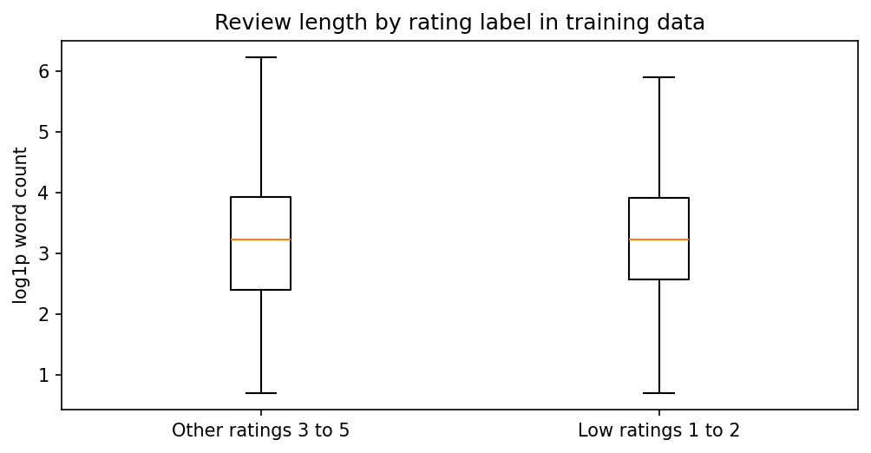
Figure 2 Log transformed word count by target label in training data
Label | Reviews | Median words | Lower quartile | Upper quartile
Other | 13842 | 24.0 | 10.0 | 50.0
Low rating | 2849 | 24.0 | 12.0 | 49.0

The exploratory Mann Whitney U statistic is 19,974,188.5, with a row based p value of 0.274 and rank biserial effect of 0.013. The effect is small and the observed medians are equal. This supplies little evidence that length alone distinguishes the classes. Because reviews share products and authors, the row independent p value is descriptive, not confirmatory inference. No causal or population conclusion follows.

Product concentration and source coverage
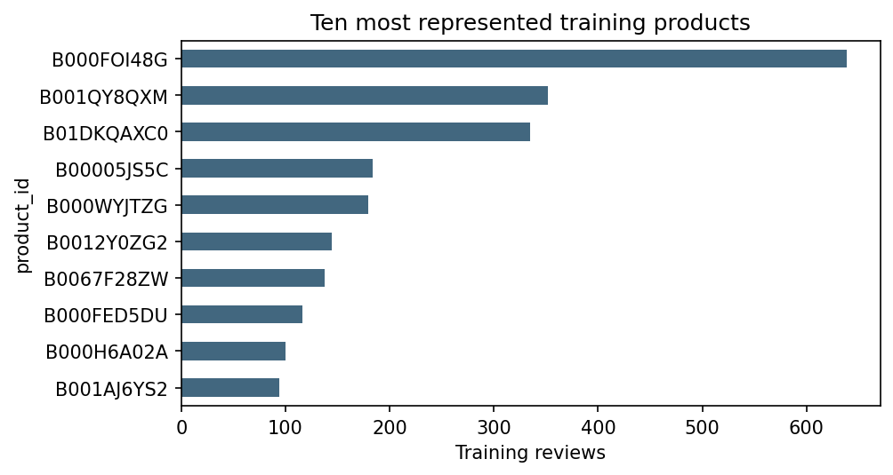
Figure 3 The most represented training ASINs and their observed counts
The ten most represented products account for 13.67% of training rows. This concentration matters because review based sampling emphasizes popular items. The group split prevents one product being both a training and test item, but does not equalize item influence. Product IDs are labels for inspection, not input features. Subcategory charts are deliberately omitted because the inspected source metadata does not contain a usable subcategory taxonomy.

Exploratory theme mentions
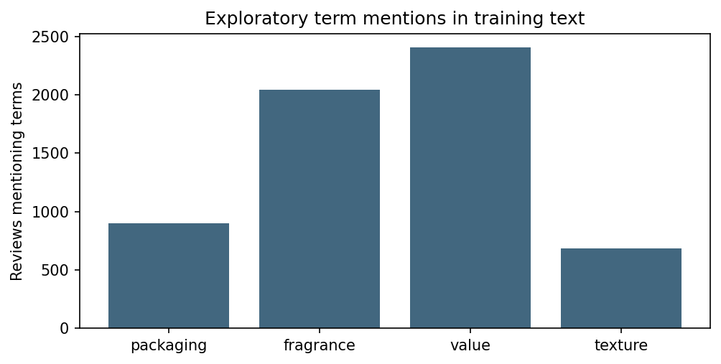
Figure 4 Training reviews containing predefined theme terms
Theme | Mentions | Low rating mentions | Low rating share
Packaging | 901 | 203 | 22.5%
Fragrance | 2042 | 283 | 13.9%
Value | 2406 | 510 | 21.2%
Texture | 683 | 90 | 13.2%

Theme rules are fixed regular expressions: packaging uses package, bottle, pump and leak variants; fragrance uses scent, smell, fragrance and perfume; value uses price, expensive, cheap, money and worth; texture uses greasy, sticky, oily, texture and absorb variants. A review can match multiple themes. Mention counts are not complaint counts: “not greasy” still matches texture, and praise can mention packaging. No manually validated theme classifier or category association test is claimed.

Implemented features and transformations
Feature family | Implementation | Leakage control
Text unigrams and bigrams | Sublinear TF IDF; min_df 3; max_df 0.98; cap 30000 terms; L2 normalized | Vocabulary and IDF refitted inside each training fold
Log length | log1p whitespace token count | Body available at prediction time; scaler training fitted
Punctuation density | Exclamation and question marks per 100 characters | Protected length denominator; no target information
Capitalization | Uppercase alphabetic characters divided by alphabetic length | Protected zero denominator; not a reliable emotion detector
Excluded variables | Rating product ID author timestamp and verified flag | Outcome identifiers and audit fields stay out of model inputs

Executed feature ablation and interpretation
Representation | Chosen C | CV AP | Validation AP | Validation F1
Logistic text | 2.0 | 0.7806 | 0.8302 | 0.7589
Logistic text plus style | 2.0 | 0.7776 | 0.8292 | 0.7577

The selection rule is fixed: hyperparameters use grouped cross validation on training; model family uses validation average precision; threshold uses validation F1. A model may have a higher validation F1 at one threshold yet lower average precision across the ranking. The report follows the declared AP selection rule rather than switching to whichever metric favors a more complex feature set. This is a substantive negative feature engineering result, not a missing experiment.

Business scenario and remaining work
The observed value and packaging mention counts suggest areas for analyst reading, rather than proof of particular defects. A support analyst can review flagged comments, record actual issue types and compare them with shipment or return information. A decision to change a package or marketing claim needs that extra operational evidence. This dataset contains no verified return cost or customer retention outcome.
A useful next experiment is independently labeling complaint themes in a held out feedback sample, including negation and mixed sentiment. Another is character based text features for misspellings. These are future work and are not reported as completed. The current deliverable connects actual EDA to a tested feature ablation and retains the simpler representation when the declared selection metric supports it.

Executable evidence and file links
outputs/eda_summary.json
outputs/theme_mentions.csv
outputs/cross_validation.csv
outputs/validation_metrics.csv
outputs/coefficient_terms.csv
src/run_project.py
The links identify the exact code or output used in this report. Numeric CSV and JSON files can be inspected without running the project. To recover review text privately, download the documented source and use its one based source_row identifiers; raw review bodies and reviewer identities are not republished.

References and source attribution
[R3] scikit learn. Common pitfalls and recommended practices. Accessed 30 October 2026.
https://scikit-learn.org/stable/common_pitfalls.html
[R4] scikit learn. Cross validation evaluating estimator performance. Accessed 30 October 2026.
https://scikit-learn.org/stable/modules/cross_validation.html
[R5] scikit learn. Metrics and scoring quantifying the quality of predictions. Accessed 30 October 2026.
https://scikit-learn.org/stable/modules/model_evaluation.html

