Real Model Evaluation and Business Impact Communication
  - Week 6 report | Data Science with Python
Prepared by M Nithish Kumar
Revised 30 October 2026
This Week 6 revision replaces the earlier planning and synthetic demonstration with an executed study of real public Amazon beauty product reviews. The Week 1 problem remains classification of low rating feedback from review text: ratings 1 and 2 are positive, and ratings 3 through 5 are the other class. The original Week 1 submission is retained as historical project definition. No customer contact, live deployment or financial benefit is claimed.

Stakeholder decision summary
The real public review experiment produces a useful research baseline, with test precision 70.4%, recall 76.4%, F1 0.733 and average precision 0.787. These values are measured on reviews for unseen product groups. The recommended next decision is an independently labeled real channel pilot with analyst review, rather than immediate autonomous use.
The selected model flags 947 of 5,403 held out reviews. Of the flagged reviews, 667 carry the low rating label and 280 do not. It misses 206 low rating reviews. This gives a concrete picture of what an analyst queue would contain in this dataset. No response time saving, sales gain or customer retention improvement was measured.

Evaluation framework and evidence checklist
Stage | Completed evidence | Remaining limitation
Source quality | Checksummed public archives; metadata coverage check; audit | Historical source and incomplete semantic taxonomy
Development validation | Three product grouped folds and fixed validation split | Only a small declared hyperparameter grid
Final evaluation | Frozen model and threshold on unseen products | Shared authors and no chronological test
Uncertainty | 500 product cluster bootstrap replicates | Conditional on this model and sample
Operational impact | Queue counts and explicit error tradeoff | No live support workflow or randomized pilot

Measured performance across models
Model | Precision | Recall | F1 | AP | ROC AUC
Logistic text | 0.704 | 0.764 | 0.733 | 0.787 | 0.946
Naive Bayes | 0.665 | 0.758 | 0.708 | 0.768 | 0.936
Logistic text plus style | 0.666 | 0.805 | 0.729 | 0.782 | 0.945
Majority baseline | 0.000 | 0.000 | 0.000 | 0.162 | 0.500
All flagged baseline | 0.162 | 1.000 | 0.278 | 0.162 | 0.500

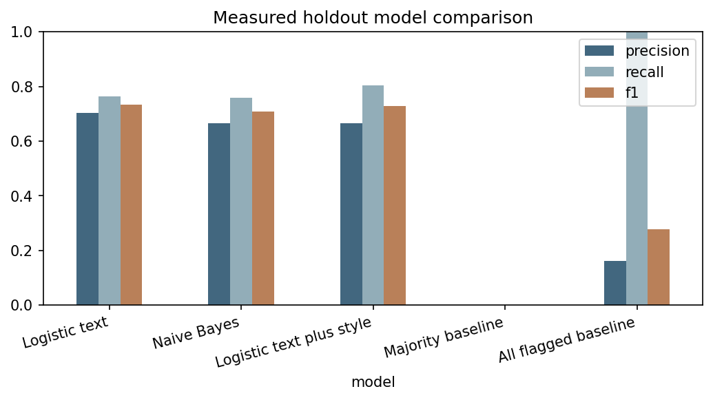
Figure 1 Real holdout precision recall and F1 compared with two baselines
The test low rating share is 16.16%. The majority baseline therefore appears accurate while finding no low rating reviews. The selected model improves F1 from zero and average precision from the prevalence baseline to 0.787. That comparison is valid within this holdout; it does not imply equivalent performance on a different platform or newly collected unrated feedback.

Confusion matrix and business interpretation
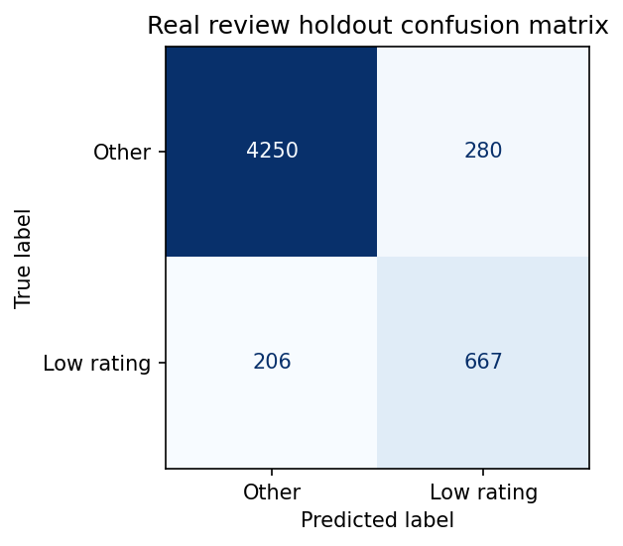
Figure 2 Measured confusion matrix using the validation chosen threshold
Outcome | Reviews | Interpretation
True positive | 667 | Flagged and rated 1 or 2
False positive | 280 | Flagged but rated 3 through 5
False negative | 206 | Not flagged despite rating 1 or 2
True negative | 4250 | Not flagged and rated 3 through 5

The flagged fraction is 17.5%. This is a prioritization volume, not a measured workload reduction: unflagged reviews still need auditing and possible handling. False positives are not necessarily harmless praise, because three star feedback can contain genuine complaints. False negatives are missed low star labels, not verified severe safety incidents. These definitions prevent the business interpretation from overstating what rating derived labels establish.

Ranking and operating threshold
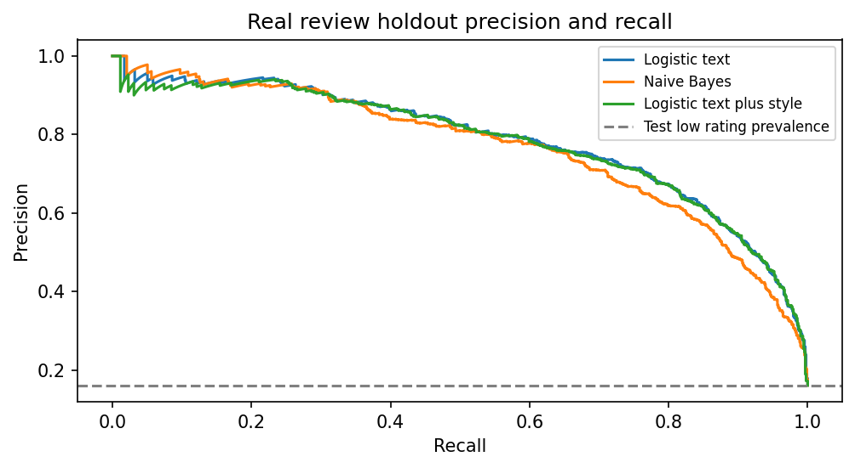
Figure 3 Real held out precision recall curves with the prevalence reference
A support team can lower a threshold to catch more potential complaints, at the cost of more reviews entering the queue. A higher threshold normally improves selectivity but can miss more issues. The published threshold was chosen on validation F1. Changing it after seeing this final test chart would require a new untouched evaluation set before claiming a fresh unbiased result. No probability calibration is assumed.

Product clustered uncertainty
Metric | Point estimate | Conditional 95 percent bootstrap interval
Precision | 0.704 | 0.671 to 0.736
Recall | 0.764 | 0.734 to 0.792
F1 | 0.733 | 0.708 to 0.758
Average Precision | 0.787 | 0.754 to 0.822

The bootstrap samples held out product groups with replacement, including all reviews in each selected product, for 500 replicates with seed 45. This preserves within product dependence during resampling. The fitted model, chosen settings and threshold are held fixed. These conditional percentile intervals do not account for model fitting uncertainty, researcher selection, author dependence between products or platform sampling bias. They are not confidence intervals for revenue or deployment performance.

Error analysis and label limitations
The file error_cases.csv lists 30 actual misclassified source references, item keys, star labels and model scores without republishing review bodies. An evaluator can recover each source_row from the public archive and inspect it locally. This makes errors traceable while avoiding a repository of customer identities or copied text. The independent verifier recomputes the confusion matrix and metrics from saved predictions.
Review bodies and ratings can disagree. For example, a three star comment with a concrete product complaint is labeled other by design. Mixed praise and criticism can also cause a low star review to be missed. These are reasons to add independent human dissatisfaction labels, not reasons to erase difficult rows from the final test set. Near duplicate paraphrases, unsupported languages and later product releases require separate tests.
No manual annotation agreement score, medical assessment or causal diagnosis was collected. The metadata match excludes an inspected off domain example, but it is not an exhaustive content audit. The results should be described as a historical All Beauty research sample experiment.
Source row | Stars | Model score | Recorded error
9549 | 5.0 | 0.663 | false positive
11638 | 2.0 | 0.381 | false negative
13202 | 5.0 | 0.578 | false positive
13561 | 3.0 | 0.615 | false positive
13597 | 2.0 | 0.570 | false negative
13598 | 2.0 | 0.434 | false negative

Actionable recommendations and measurement plan
Recommendation | Decision owner | Measure before expansion
Keep direct star filtering where ratings exist | Customer experience lead | Compare added value of text on genuinely unrated feedback
Run an analyst reviewed pilot | Support lead and analyst | Queue precision recall review time and disagreement
Read value and packaging mentions | Product and operations team | Confirmed issue counts linked to actual operational records
Set capacity and missed issue costs | Support manager | Choose threshold on new validation data within daily review capacity
Audit unflagged samples | Quality analyst | Measure false negatives and escalation failures
Recheck later periods and languages | Data analyst | Subgroup counts drift and newly labeled error rates

Business impact without invented savings
For the current holdout, an illustrative error cost expression is 206 times the stakeholder assigned missed issue cost plus 280 times the unnecessary review cost. Neither cost was measured. It would be misleading to convert the queue fraction directly into saved staff hours or increased profit. A valid operational comparison requires observed review timings and outcomes under the existing and proposed workflows.
A pilot can begin in silent mode: the model produces a queue while ordinary handling continues. Analysts independently label a sample, record review time and inspect unflagged cases. Before expansion, agree a threshold based on measured capacity, severity and target recall. Any safety related statement should follow the organization’s established escalation process rather than rely on this general rating classifier.

Conclusion and deliverable traceability
The completed project now has real acquired data, a recorded sampling method, measured cleaning exclusions, training only EDA, a tested feature ablation, grouped cross validation, held out predictions and product clustered uncertainty. This directly strengthens the evidence requested in the Week 1 feedback. The contribution is an auditable research workflow; no score guarantee or production claim is made.
The Python pipeline and verifier reproduce the evidence. The five revised reports match those saved artifacts and link to them. The original Week 1 report remains a record of the earlier definition stage, while Weeks 2 through 6 supersede the earlier synthetic versions. The next substantive research step is independently labeled channel validation.

Executable evidence and file links
outputs/summary.json
outputs/model_metrics.csv
outputs/test_predictions.csv.gz
outputs/error_cases.csv
outputs/verification.json
src/validate_project.py
The links identify the exact code or output used in this report. Numeric CSV and JSON files can be inspected without running the project. To recover review text privately, download the documented source and use its one based source_row identifiers; raw review bodies and reviewer identities are not republished.

References and source attribution
[R1] Ni Li and McAuley. Amazon Review Data 2018 source documentation. Accessed 30 October 2026.
https://nijianmo.github.io/amazon/index.html
[R4] scikit learn. Cross validation evaluating estimator performance. Accessed 30 October 2026.
https://scikit-learn.org/stable/modules/cross_validation.html
[R5] scikit learn. Metrics and scoring quantifying the quality of predictions. Accessed 30 October 2026.
https://scikit-learn.org/stable/modules/model_evaluation.html

