Experiment-10
Aim: Write a program to demonstrate continuous file allocation.
Description:
In the contiguous file allocation technique, each file occupies a single, unbroken sequence of adjacent blocks on a storage disk

Code:
#include<stdio.h>
#define SIZE 100
int disk[SIZE] = {0};
struct file{
int id;
char name[20];
int start;
int length;
};
int main(){
int n;
printf("Enter the number of file: ");
scanf("%d", &n);
struct file files[n];
printf("Enter id, file name, start, no of blocks for that file: \n");
for(int i =0;i<n;i++){
scanf("%d %s %d %d",&files[i].id,files[i].name,&files[i].start,&files[i].length);
int avail = 1;
for(int j=files[i].start; j< files[i].start+files[i].length ; j++){
if(disk[j] != 0){
avail = 0;
break;
}
disk[j] = files[i].id;
}
if(avail == 0){
printf("blocks are not available\n");
return 0;
}
}
printf("\nID\tName\tstart\tlength\tblocks allocated\n");
for(int i =0; i<n;i++){
printf("%d\t%s\t%d\t%d\t",files[i].id,files[i].name,files[i].start,files[i].length);
for(int j= files[i].start; j< files[i].start+files[i].length; j++){
printf("%d, ", j);
}
printf("\n");
}
return 0;
}

Output:
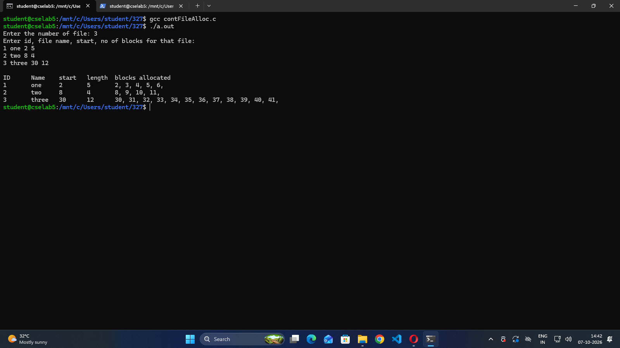

Aim: Write a program to demonstrate linked list file allocation technique.
Description:
In linked list file allocation, the operating system stores a file as a scattered linked list of disk blocks across the storage device, with each block containing a pointer to the next block in the chain
Code:
#include<stdio.h>
#define SIZE 100
int disk[SIZE] = {0};
int nextBlock[SIZE];
struct file{
int id;
char name[20];
int start;
int length;
};
int main(){
int n;
printf("Enter the number of files: ");
scanf("%d", &n);
struct file files[n];
for(int i=0;i<SIZE;i++){
nextBlock[i] = -1;
}
printf("Enter id, file name, start block, no of blocks for that file:\n");
for(int i=0;i<n;i++){
scanf("%d %19s %d %d",&files[i].id,files[i].name,&files[i].start,&files[i].length);
if(files[i].start < 0 || files[i].start >= SIZE || files[i].length <= 0 || files[i].id == 0){
printf("Invalid file details\n");
return 0;
}
int current = files[i].start;
if(disk[current] != 0){
printf("Starting block is not available\n");
return 0;
}
disk[current] = files[i].id;
int count = 1;
while(count < files[i].length){
int next = -1;
for(int j=0;j<SIZE;j++){
if(disk[j] == 0){
next = j;
break;
}
}
if(next == -1){
printf("Blocks are not available\n");
return 0;
}
disk[next] = files[i].id;
nextBlock[current] = next;
current = next;
count++;
}
}
printf("\nID\tName\tStart\tLength\tBlocks Allocated\n");
for(int i=0;i<n;i++){
printf("%d\t%s\t%d\t%d\t",files[i].id,files[i].name,files[i].start,files[i].length);
int current = files[i].start;
while(current != -1){
printf("%d",current);
current = nextBlock[current];
if(current != -1){
printf(" -> ");
}
}
printf("\n");
}
return 0;
}
Output: 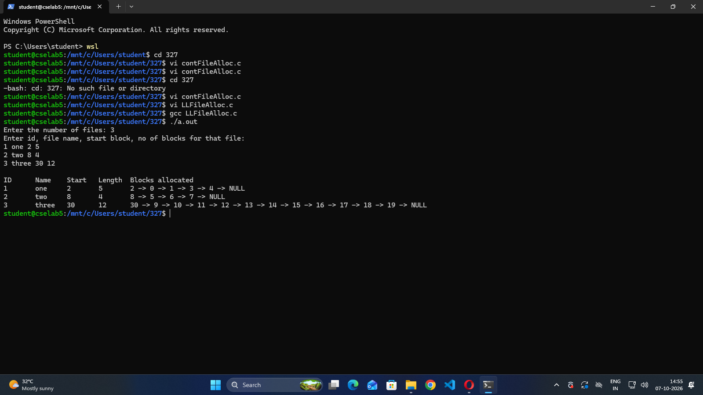
Aim: Write a program to demonstrate indexed file allocation technique.
Description:
Indexed file allocation is an operating system storage management technique where each file is assigned a dedicated index block that stores the disk addresses of all the blocks containing the file's actual data.
Code:
#include<stdio.h>
#define SIZE 100
int disk[SIZE] = {0};
struct file{
int id;
char name[20];
int index;
int length;
int blocks[SIZE];
};
int main(){
int n;
printf("Enter the number of files: ");
scanf("%d", &n);
struct file files[n];
printf("Enter id, file name, index block, no of blocks:\n");
for(int i=0;i<n;i++){
scanf("%d %19s %d %d",&files[i].id,files[i].name,&files[i].index,&files[i].length);
if(files[i].index < 0 || files[i].index >= SIZE || files[i].length <= 0 || files[i].length >= SIZE || files[i].id == 0){
printf("Invalid file details\n");
return 0;
}
if(disk[files[i].index] != 0){
printf("Index block is not available\n");
return 0;
}
disk[files[i].index] = files[i].id;
for(int j=0;j<files[i].length;j++){
int block = -1;
for(int k=0;k<SIZE;k++){
if(disk[k] == 0){
block = k;
break;
}
}
if(block == -1){
printf("Blocks are not available\n");
return 0;
}
files[i].blocks[j] = block;
disk[block] = files[i].id;
}
}
printf("\nID\tName\tIndex\tLength\tBlocks allocated\n");
for(int i=0;i<n;i++){
printf("%d\t%s\t%d\t%d\t",files[i].id,files[i].name,files[i].index,files[i].length);
for(int j=0;j<files[i].length;j++){
printf("%d ",files[i].blocks[j]);
}
printf("\n");
}
return 0;
}

Output:
