Raspberry pi 4

Document history:

S. No | Ver.No. | Author | Section(s) Affected | Change(s) made | Approved Date | Approved by
1 | 1.0 | Nithishkumar T | All | Initial
 |  | Razeena Nilufar M
 |  | William Paul J

Table of Contents
1 Raspberry pi 4 3
2 Specifications 3
3 Hardware Requirements 4
4 Software Requirements 5
5 Reference 6

Raspberry pi 4
A Raspberry Pi is a small, inexpensive computer that can be used for a variety of tasks. It is a single-board computer, meaning it is a complete computer that comes in one small package.

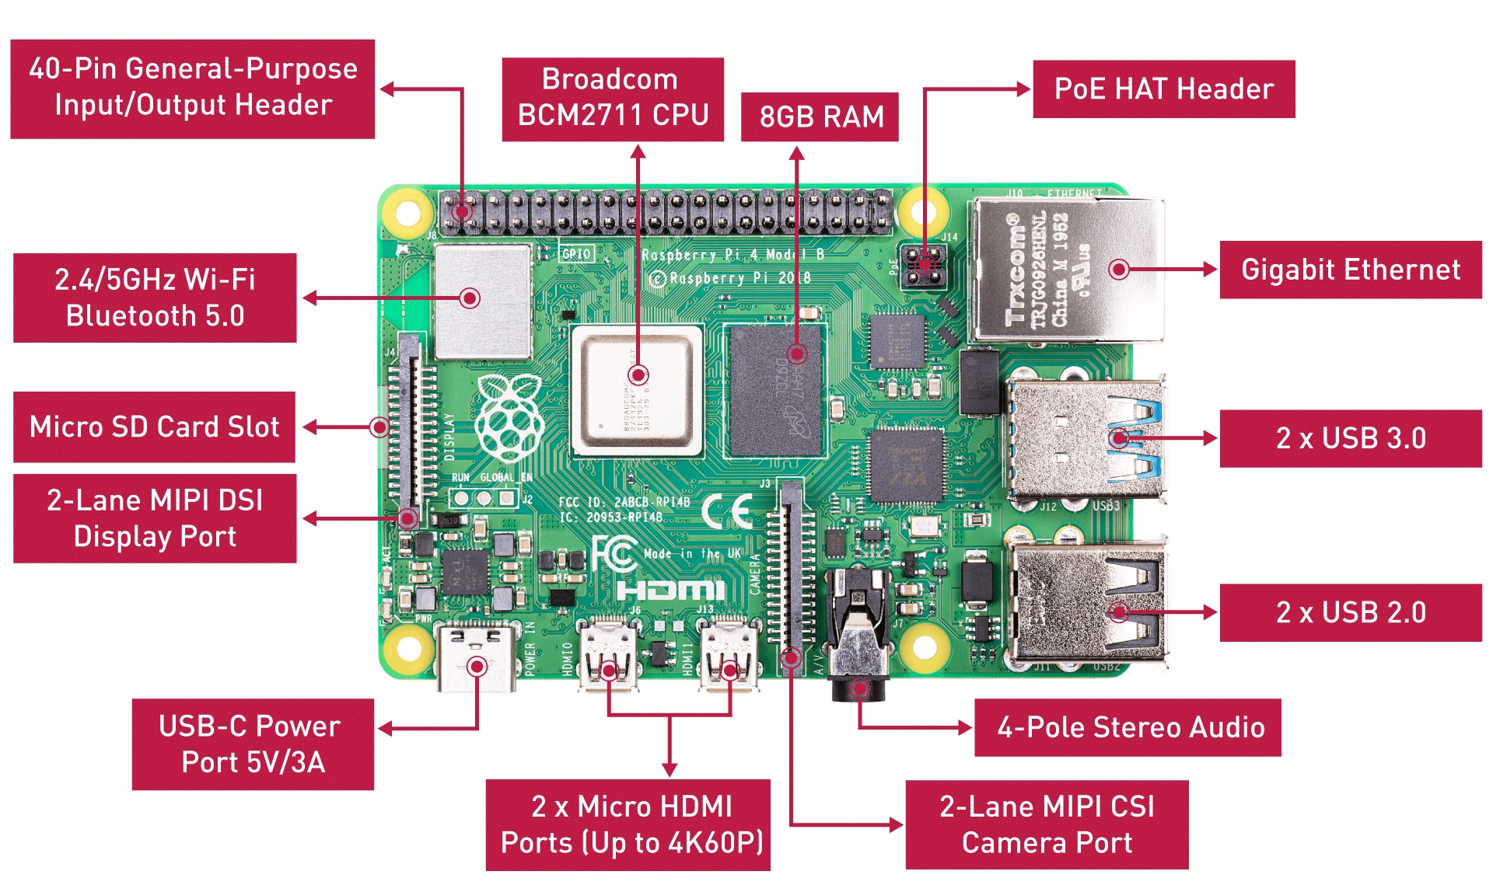

Specifications

Features | Details
CPU | Quad-core Cortex-A72 (ARM v8) 64-bit SoC @ 1.5GHz
RAM | 2GB, 4GB, or 8GB LPDDR4 (depending on model)
GPU | Broadcom VideoCore VI
Connectivity | 2.4GHz and 5.0GHz IEEE 802.11ac Wi-Fi, Bluetooth 5.0
Ethernet | Gigabit Ethernet
USB Ports | 2 × USB 3.0, 2 × USB 2.0
Video Output | 2 × micro-HDMI (up to 4Kp60 supported)
Audio | Via HDMI or 4-pole stereo audio/composite video jack
Storage | microSD card slot (supports high-speed cards); USB boot supported
Power | 5V/3A via USB-C connector
GPIO | 40-pin GPIO header (fully backwards-compatible)
Other interfaces | 2 × MIPI DSI/CSI ports for display and camera

Hardware Requirements

Accessory | Uses
Raspberry Pi 4 Model B | mini-computer ideal for coding, media centers, servers, and automation tasks.
Power Supply (5V/3A USB-C) | Official one is recommended for stability
microSD Card (Class 10 or UHS-I, 16GB or larger) | For storing the OS and files
Micro-HDMI to HDMI Cable | Raspberry Pi 4 has 2 micro-HDMI ports (need at least one to connect to a monitor)
Keyboard & Mouse | For desktop setup or initial setup
Monitor or Display | Needed for GUI use or setup
Case | Protects the board, helps with cable management
Heat Sinks or Cooling Fan | Helps prevent thermal throttling under heavy load
Camera Module or USB Webcam | For projects like surveillance, computer vision, or video calling
GPIO Ribbon Cable & Breadboard | For electronics and prototyping (great for GPIO projects)
Ethernet Cable | If you're not using Wi-Fi and need faster/more stable internet

Software Requirements

Reference

- https://www.seeedstudio.com/blog/2020/05/28/meet-the-brand-new-raspberry-pi-4-8gb-ram/

