STUDY DOCUMENT

VIDEO

Document history:

S. No | Ver.No. | Author | Section(s) Affected | Change(s) made | Approved Date | Approved by
1 | 1.0 | Nithishkumar T | All | Initial

Table of Contents
1 Digital video fundamentals 4
1.1 Pixels 4
1.2 Video Resolution 4
1.3 Frame Rate 4
1.3.1 Common standards 4
1.3.2 common frame rates and their uses 5
1.4 Color Bit-depth 5
1.4.1 RGB Color Model 5
1.4.2 Y'CbCr Color Model 6
1.5 Impact of Video Parameters on Transmission 8
2 Video formats 8
2.1 Codecs 9
2.2 Containers 9
2.3 Frame Types in Digital Video 10
2.4 Video Coding Techniques 10
3 Video Interfaces 12
3.1 HDMI (High-Definition Multimedia Interface) 12
3.2 DisplayPort 12
3.3 CSI-2 (Camera Serial Interface 2) 13
3.4 DSI (Display Serial Interface) 13
4 Cables Used for High-Speed Data Transmission 13
4.1 Coaxial Cables 13
4.2 Shielded Twisted Pair (STP) 14
5 Serializer/Deserializer (SerDes) in Video Transmission 14
5.1 Serializer 14
5.2 Deserializer 15
5.3 Working of Serializer/Deserializer in Video Transmission 15
5.4 Use of SerDes in Video transmission 16
6 Reference Links 17

Digital video fundamentals

A video signal is a sequence of time-varying images, essentially a series of still images called frames. Continuous video illusion is created by changing frames quickly, typically termed as frame rate.

Pixels

- Pixels are the fundamental building blocks of digital video. They are the smallest unit of a digital image and are made up of subpixels that emit red, green, and blue (RGB) light.
- Pixels are arranged in a grid and form a raster image, where each pixel corresponds to a specific position and color value.

Video Resolution

- Resolution refers to the number of pixels displayed in a video frame. It is usually represented as width × height (e.g., 1920 × 1080 for Full HD).
- Higher resolution means more pixels, which leads to sharper, more detailed images. However, it also requires more data to process, increasing the bandwidth needed for transmission.

Frame Rate

- The frame rate of a video signal defines how many consecutive images will be displayed in a finite amount of time, to result in a motion picture perception at the viewer. Usually, the frame rate is expressed in frames per second (FPS).

Common standards
- NTSC (National Television System Committee): 29.97 fps (effectively 30 fps) for video in regions like North America.
- PAL (Phase Alternating Line): 25 fps for video in regions like Europe and parts of Asia.

common frame rates and their uses
- 24 fps: This is the traditional frame rate used in cinema. It provides a "cinematic" look and is widely considered the standard for films. The slight motion blur between frames gives it a characteristic feel that audiences associate with movies.
- 30 fps: Common for television broadcasts in some regions (such as NTSC countries) and online video content. It gives a slightly smoother appearance than 24 fps but can still retain the "film-like" look.
- 60 fps: Often used for high-definition video and sports broadcasts. It produces very smooth motion, making it ideal for fast-moving subjects or action scenes. Some video games and YouTube content are also produced in 60 fps to provide ultra-smooth playback.
- 120 fps or higher: Used for high-frame-rate video and slow-motion shots. These frame rates allow video to be played back in slow motion when captured at higher frame rates, making individual movements or actions appear more detailed and stretched out.

Color Bit-depth
Color bit-depth is a binary number which represents the total number of possible values for each color component. Much like in digital audio, the more bits we have the greater depth possible for the signal. (examples: 10-bit, 12-bit).
We often see color bit-depth referred to as 24-bit True color or 36-bit Deep color. These refer to the sum of bits used for all color components of a single pixel.

RGB Color Model
The color of an individual pixel in the RGB color model is described by indicating how much of each of the red, green, and blue is included. The color is expressed as an RGB triplet (r,g,b), each component of which can vary from zero to a defined maximum value.
If all the components are at zero the result is black; if all are at maximum, the result is the brightest representable white.
To create the color information of an individual pixel in 24-Bit colors, every color is expressed by an 8-bit byte, which can be represented by a decimal number ranging from 0 to 255.
A good example for additive RGB color mixing, is the typical color picker tool used in many PC software to set a custom color tone:
- Yellow: 255; 255; 0
- White: 255; 255; 255
- Red: 255; 0; 0
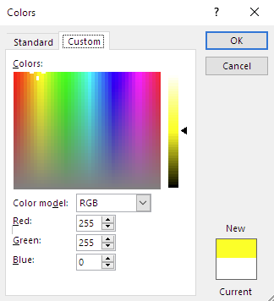
RGB will always express the full color value and can be considered to be a 'raw' or uncompressed type of color format, which requires a lot of bandwidth in transport. By design, it won't natively support color subsampling and needs 3rd party compression algorithms to reduce its bandwidth.

Y'CbCr Color Model
In the Y'CbCr color model, the three colors Red, Green, and Blue are not expressed as an individual value like it is done in RGB. Instead, the information will be encoded into a luminance value (Y) and two chrominance components (Cb, Cr)
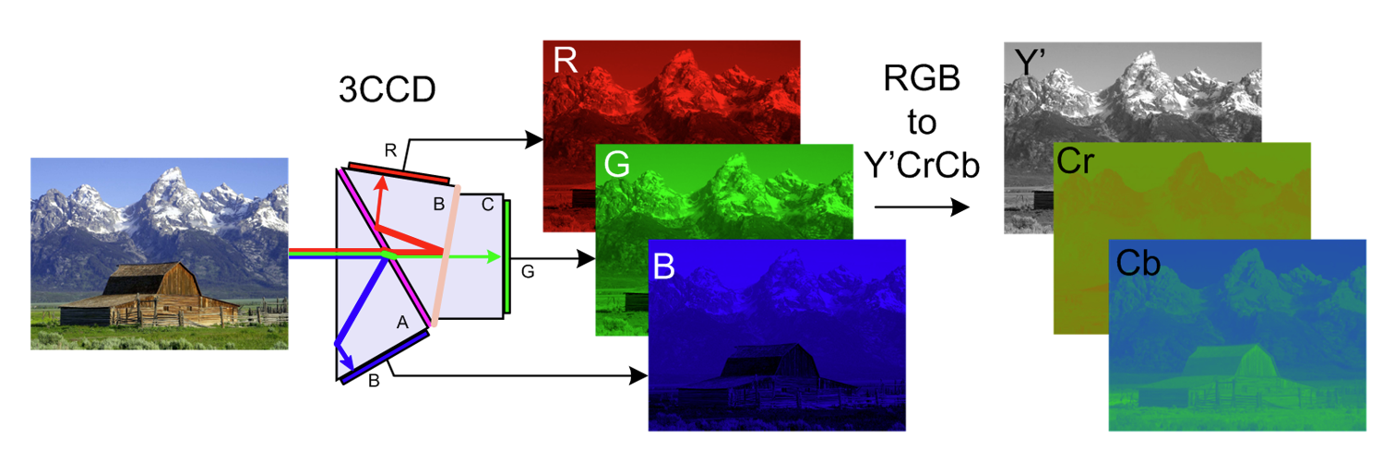
Y' (Luminance or Luma): This represents the brightness or intensity of the color. It is a weighted sum of the RGB components and determines how light or dark the image appears. The Y' channel is the most important in determining the overall visual quality of an image, as the human eye is more sensitive to brightness than color.
Cb (Chrominance Blue): This represents the difference between the blue channel and the luminance (Y') channel. It is also known as the blue chroma component.
Cr (Chrominance Red): This represents the difference between the red channel and the luminance (Y') channel. It is also known as the red chroma component.
Chroma Subsampling specifications are expressed as a three-digit ratio and are applied over a 4 x 2 block of pixels. Some examples are 4:2:0, 4:4:4, and 4:4:2.
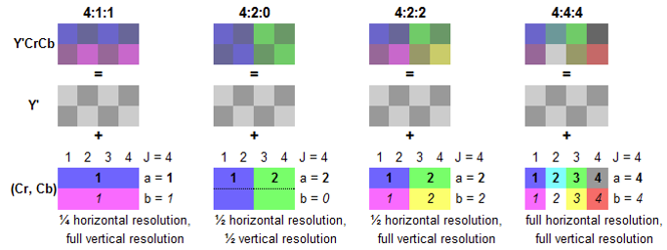

Impact of Video Parameters on Transmission

Parameter | Description | Effect on Transmission
Pixels | Basic unit of image/video | More pixels = more data per frame → higher bandwidth and storage needed
Resolution | Frame dimensions (e.g., 1920×1080) | Higher resolution = more pixels/frame → increases file size and transmission demands
Frame Rate | Frames per second (fps) | Higher fps = more frames/second → increases data rate and affects real-time streaming
Color Space | Representation of color (RGB, YCbCr) | RGB uses more data; YCbCr allows compression (e.g., 4:2:0) → reduces bandwidth requirements

Video formats
- MP4 - most versatile and widely supported format, great for streaming and sharing content across devices and platforms.
- MOV - preferred in professional video production, especially for Apple devices, but comes with large file sizes and limited compatibility outside Apple ecosystems.
- AVI - older format with great quality but large files, making it less practical for modern streaming and sharing.
- WMV - offers great compression for smaller file sizes but suffers from lower compatibility and potential quality loss.
- MKV - perfect for storing high-quality video with multiple audio and subtitle tracks, though it results in large files and has compatibility issues with some devices.
- AVCHD - for high-definition video recording, especially for camcorders, but it has limited compatibility with devices and software.
- WEBM - is ideal for web use with fast loading times, but its mobile compatibility is poor.
Format = codec + Container
Codecs compress the video and audio inside the file.
Containers hold all the contents of the video (video, audio, subtitles) together.

Codecs
A codec is a tool that compresses and decompresses video and audio. When a video is saved, the codec reduces its size to make it easier to store and share. It does this by removing some data (lossy) or keeping everything (lossless).
- Lossy codecs: Reduce file size by removing some data. The video may lose quality. (e.g., H.264, VP9)
- Lossless codecs: Keep all the data, so the video looks perfect but takes up more space. (e.g., ProRes)
Common Codecs:
- H.264/AVC
- H.265/HEVC
- H.262/MPEG-2 Part 2
- M-JPEG
- ProRes
- DNxHD & DNxHR

Containers
A container is like a box that holds everything related to the video file – the video, audio, and sometimes extra info like subtitles. The container makes sure everything plays together correctly.
- MP4 (.mp4): Common and works well for videos on websites (can hold H.264 video and AAC audio).
- MOV (.mov): Often used for editing, works well with high-quality video.
- AVI (.avi): An older format, less efficient.
- MKV (.mkv): Very flexible, can hold lots of things.
Common Containers:
- MP4
- AVI
- MOV
- MXF
- 3DP &3G2
- MTS, M2TS & TS

Frame Types in Digital Video
I-Frames (Intra Frames):
- Encoded without motion compensation, serve as reference frames.
- Used as reference for future predicted P and B frames
P-Frames (Predictive Frames):
- Use motion-compensated prediction from previous reference frames.
- More efficient than I frames in terms of number of bits required for encoding
B-Frames (Bidirectional Frames):
- Use both forward and backward prediction, requiring fewer bits.
- Requires lowest number of bits than I and P

Video Coding Techniques
Intra Frame Coding:
- Reduces spatial redundancy within the frame using transforms like DCT.
Inter Frame Coding:
- Reduces temporal redundancy between frames by exploiting high temporal correlation.
- It relies on the fact that the adjacent pictures in the video sequence have high temporal correlation
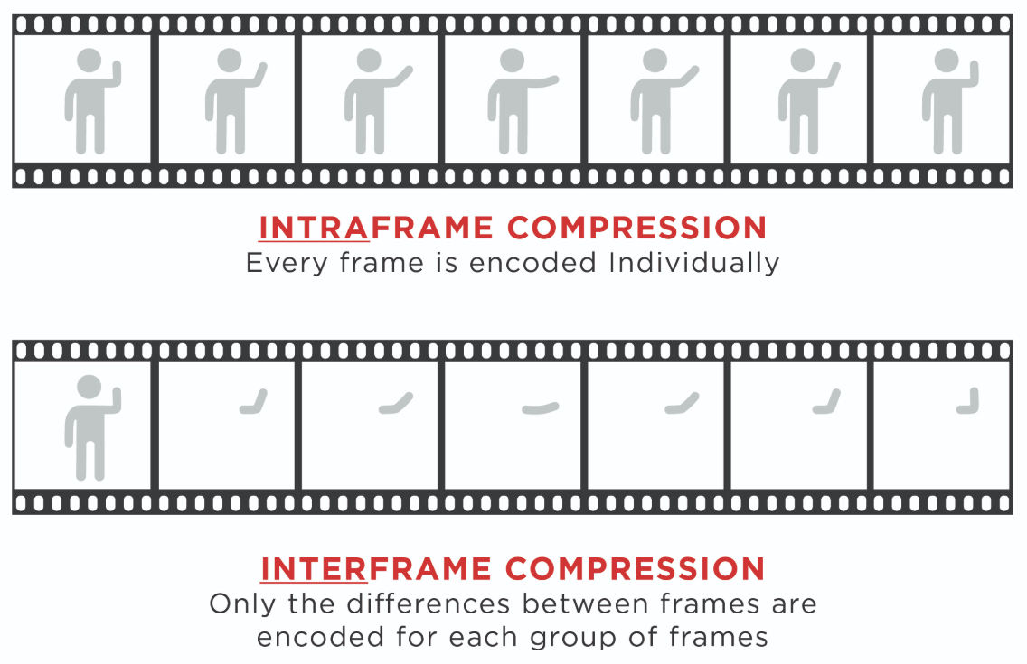
Group of Pictures (GOP):
- Frames between two successive I-frames, facilitating features like random access and varied playback speeds.
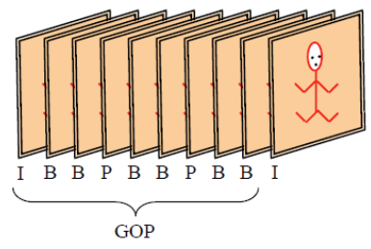

Video Interfaces
Video interfaces define how video signals are transmitted from one device to another, such as from a computer to a display. Some common video interfaces include:

HDMI (High-Definition Multimedia Interface)
- Description: HDMI is a widely-used interface that transmits both video and audio signals. It is commonly used to connect TVs, monitors, and home theater systems.
- Features:
  - Supports high-definition video and multi-channel audio.
  - Versions like HDMI 2.0 and 2.1 support 4K, 8K, and high frame rates (up to 120Hz for gaming).
  - Supports copy protection standards (HDCP).

DisplayPort
- Description: A video interface designed for high-performance applications, often used in computers and professional displays.
- Features:
  - Can support higher resolutions and refresh rates than HDMI, especially for gaming and high-end displays (up to 8K at 60Hz).
  - Can carry audio and data, and supports daisy-chaining multiple monitors from a single port.

CSI-2 (Camera Serial Interface 2)
- Description: A high-speed interface standard used for connecting cameras to processors, commonly used in embedded systems and mobile devices.
- Features:
  - Supports high-speed transmission of video data with low latency.
  - Common in mobile phones, automotive applications, and IoT devices.
  - Uses differential signaling for better noise immunity.

DSI (Display Serial Interface)
- Description: A display interface primarily used for connecting displays (e.g., screens in smartphones and embedded devices) to processors.
- Features:
  - High data transfer rates for display applications.
  - Supports low power consumption and efficient bandwidth management.
  - Often used in conjunction with other interfaces like CSI-2 in embedded systems.

Cables Used for High-Speed Data Transmission
To transmit video signals over long distances, high-speed data cables are necessary. Some commonly used cables include:

Coaxial Cables
- Description: Coaxial cables are commonly used for video and data transmission in older video standards (e.g., cable TV, analog video).
- Features:
  - Includes a central conductor, insulating layer, and shielding to prevent interference.
  - Typically used in long-distance transmission for analog signals, but also used in digital video formats.

Shielded Twisted Pair (STP)
- Description: STP cables are used for data transmission in networks and video applications. They consist of pairs of twisted wires with shielding to prevent electromagnetic interference.
- Features:
  - Typically used in Ethernet and professional AV equipment.
  - Supports high-speed data transmission and is more resistant to noise and interference compared to unshielded twisted pair (UTP) cables.
  - Common in video production setups and for interconnecting equipment like cameras and monitors.

Serializer/Deserializer (SerDes) in Video Transmission
A Serializer and Deserializer (SerDes) is a critical component in video transmission systems, especially when high-speed data transfer is required over a limited number of wires. These devices convert data between parallel and serial formats, enabling high-speed transmission of video signals with minimal hardware requirements.

Serializer
A Serializer is a device or circuit that converts parallel data (where each bit is sent simultaneously on separate channels) into serial data (where the bits are transmitted one by one over a single channel). This is especially useful for reducing the number of transmission lines needed to send large amounts of data, such as high-resolution video.

Deserializer
A Deserializer is the reverse of a serializer. It converts serial data (data sent sequentially over a single line) back into parallel data, allowing it to be used by the receiving system, such as a display or a processor.
Together, these components enable high-speed video transmission with fewer wires, reducing cable complexity, improving signal integrity, and allowing data to travel further without degradation.

Working of Serializer/Deserializer in Video Transmission
Video Source: The source device (like a camera or a video processor) generates video data, often in the form of parallel digital signals. For instance, each pixel in a video frame could have multiple color components (e.g., Red, Green, Blue) transmitted in parallel across different data lines.
Serialization:
- The Serializer takes the parallel video data (often with a wide bit-width, such as 24 bits per pixel or more) and converts it into a high-speed serial data stream.
- This is typically done by clocking the bits of data one by one onto a single transmission line, significantly reducing the number of physical wires needed.
- Serialization can be achieved using different techniques, such as LVDS (Low-Voltage Differential Signaling) or MIPI (Mobile Industry Processor Interface), which are both used for high-speed video transmission.
Transmission:
- The serialized video data is transmitted over a single high-speed line or a small number of differential pairs, depending on the implementation (e.g., MIPI CSI for cameras).
- This serial data can be sent over long distances without significant signal degradation, especially when using differential signaling, which helps eliminate noise.
Deserialization:
- The Deserializer at the receiving end takes the serial data stream and converts it back into parallel data.
- This parallel data can then be processed by the receiving system, such as a display or video processor, where each pixel’s color components can be reconstructed.

Use of SerDes in Video transmission
Bandwidth Optimization:
- Video data, especially high-definition (HD) or ultra-high-definition (UHD) video, can require significant bandwidth. Serial transmission allows this bandwidth to be effectively utilized on fewer physical lines (compared to using parallel lines).
- For instance, HDMI 2.0 or DisplayPort use serializers and deserializers to enable high-definition video transmission over fewer conductors.
Cable Complexity:
- A parallel data bus requires a large number of wires or traces (one for each bit), making the cable or PCB (Printed Circuit Board) complex and bulky.
- Using serializers allows for a single or fewer data lines, which reduces the number of wires and simplifies the design.
Signal Integrity:
- Serial transmission can maintain signal integrity over longer distances. When data is transmitted in parallel, the signals can degrade due to the skew (differences in the arrival times of the signals), especially when data is sent over longer cables.
- Serializing the data ensures that the signal is transmitted in a consistent manner, reducing the risk of errors and data loss.
Reducing Interference:
- By using differential signaling (which is common in serial interfaces like LVDS and MIPI), the risk of electromagnetic interference (EMI) is reduced. This is crucial in environments where high-quality video signals need to be transmitted without degradation.

Reference Links

- https://beta.yourengineer.in/article/what-are-the-fundamentals-of-digital-video-50e1
- https://support.biamp.com/General/Video/Video_Basics
- https://www.techsmith.com/blog/video-file-formats/?srsltid=AfmBOoo7xEMoD89R5wLcq6RfBWJXTWT_6piSJZS3E8dnLDHPOa76pntq&utm_source=chatgpt.com

