***NITHISH KUMAR***

***727721EUIT106***

**COADING CONTEST – 2**

**COADING*:***

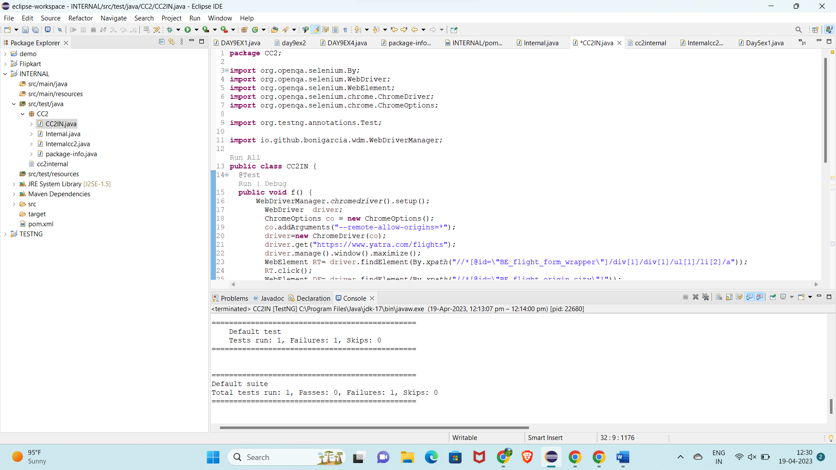

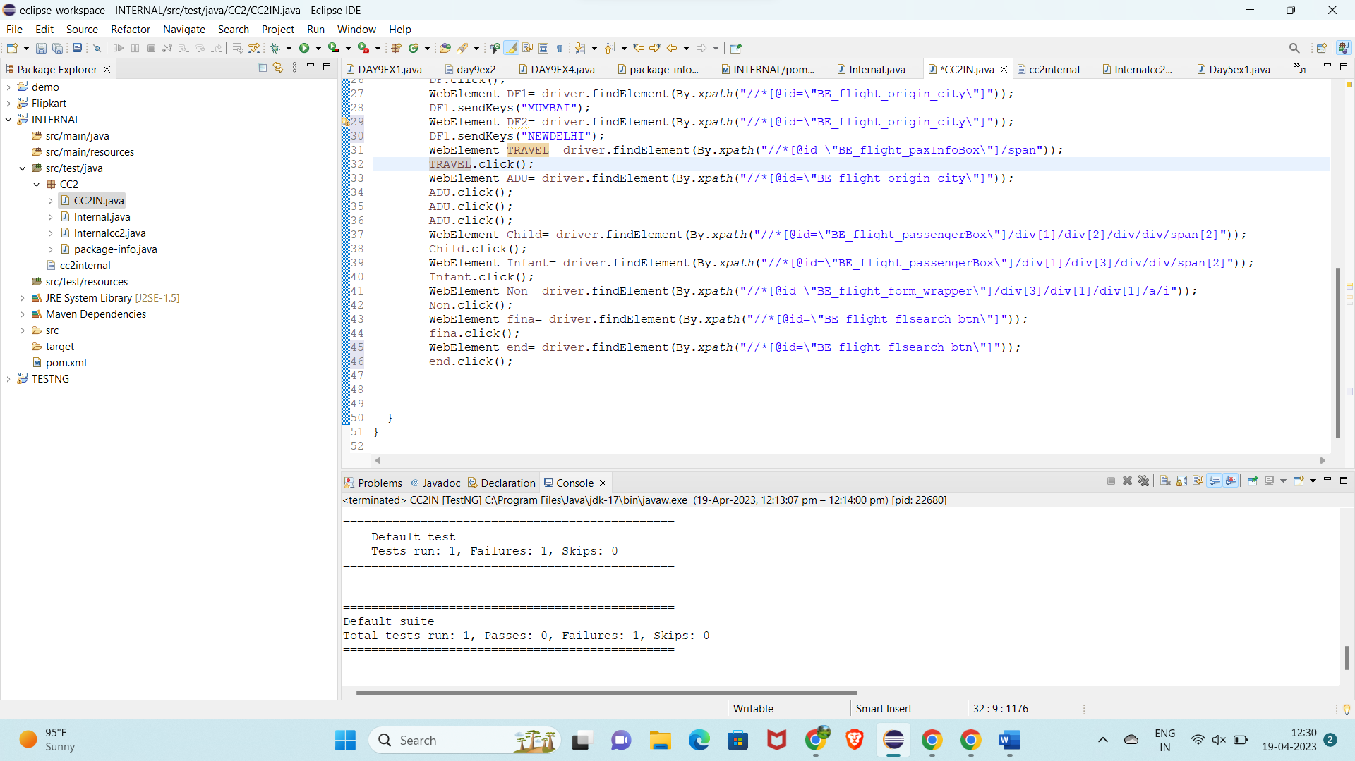

***OUTPUT:***

