

Mini Project Report - 05

Master of Computer Application – General
Semester – III

Sub: Web Technologies

Topic: ATM Interface Design
By
Name:NITHISH N
Reg no.: 2511022250066

Faculty Name: VEERA RAGHAV K

Faculty Signature: _______________

Department of Computer Application
Alliance University
Chandapura - Anekal Main Road, Anekal
Bengaluru - 562 106

June 2026
Employee ID Card

INDEX

Sl. No | Content | Page No.
1 | Introduction | 1
2 | Input Code | 1–3
3 | Output | 4
4 | Conclusion | 4

- INTRODUCTION
The Employee ID Card is a digital representation of an employee's identity within an organization. It contains essential information such as the employee's name, designation, employee ID, contact details, profile photograph, and barcode for identification purposes. This project is developed using HTML and CSS to create a visually appealing and professional ID card design. HTML is used to structure the content, while CSS is used to style the layout, colors, fonts, and overall appearance. The project demonstrates the use of web design techniques to create a simple, attractive, and user-friendly Employee ID Card interface.

- INPUT CODE

<html>
<head>
<title>Employee Id Card</title>
<style>
h1{
text-align: center;
}
.parent{
width: 300px;
height: 500px;
background: linear-gradient(360deg ,red, blue, yellow);
margin-left: 485px;
border: 1px solid black;
border-radius: 10px;
}
/*.c1{
background-color: rgb(227, 227, 68);
width: 300px;
height: 130px;
border-top-left-radius: 10px;
border-top-right-radius: 10px;
}
.c2{
width: 300px;
height: 60px;
margin-top: 310px;
background-color: rgb(15, 15, 59);
border-bottom-left-radius: 10px;
border-bottom-right-radius: 10px;

}*/
.child{
width: 240px;
height: 420px;
background-color: white;
border-radius: 10px;
margin-left: 30px;
margin-top: 40px;
}
.sub{
background-color: rgb(31, 31, 99);
width: 240px;
height: 70px;
border-top-left-radius: 10px;
border-top-right-radius: 10px;
}
h3{
color: white;
text-align: center;
padding-top: 10px;

}
img{
width: 100px;
height: 120px;
margin-top: 20px;
margin-left: 70px;
border-radius: 10px;
border: 1px solid black;
}
h2{
text-align: center;
}
.bar{
width: 150px;
height: 300px;
}
.p1{
width: 140px;
background-color: yellow;
text-align: center;
margin-left: 48px;
margin-top: -15px;
}
.p2{
margin-right: 20px;
margin-top: -10px;
margin-left: 20px;

}
.p3{
margin-left: 20px;
margin-top: -10px;
}
.p4{
margin-left: 20px;
margin-top: -10px;
}
.il{
width: 100px;
height: 50px;
margin-bottom: 150px;
}
.i2{
margin-top: -35px;
border: none;
width: 200px;
height: 100px;
margin-left: 20px;

}
</style>
</head>
<body>
<h1>Employee Id Card</h1>
<div class="parent">
<!-- <div class="c1"></div>
<div class="c2"></div> -->
<div class="child">
<div class="sub">
<h3>Software<br> Company</h3>
</div>
<img class="i1" src="./nithish.jpg" alt="">
<h2>Nithish Reddy</h2>
<p class="p1">Full stack Developer</p>
<p class="p2">ID No : 123-456-789</p>
<p class="p3">Email : @nithish@gmail.com</p>
<p class="p4"> Phone : 9839222232</p>
<img class ="i2" src="./ barcode png_8469148.png" alt="">
</div>
</div>
</body>
</html>

3. OUTPUT

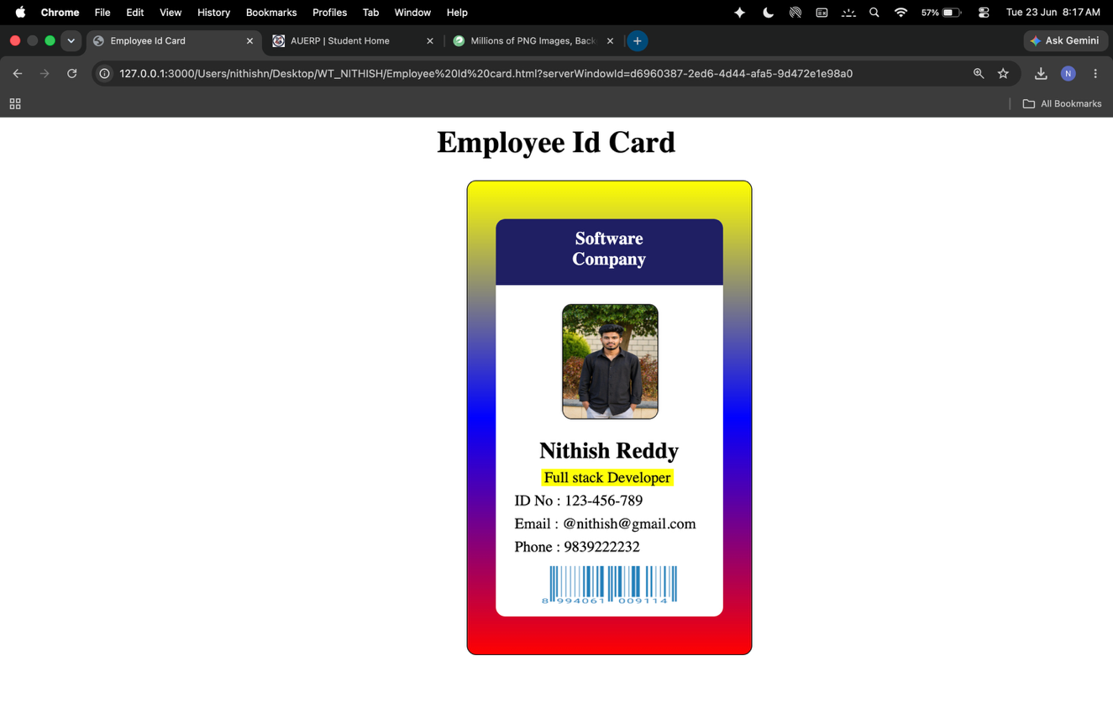

4.CONCLUSION

In conclusion, the Employee ID Card project successfully demonstrates the use of HTML and CSS to create a professional and visually appealing ID card. The project includes essential employee details such as name, designation, employee ID, contact information, profile image, and barcode in a well-organized layout. Through this project, basic web development concepts like page structure, styling, positioning, colors, and responsive design have been effectively implemented. The Employee ID Card provides a simple and efficient way to represent employee information in a digital format

