AI-BASED DYNAMIC PRICING AND REVENUE MANAGEMENT SYSTEM FOR ECO-TOURISM HOSPITALITY

PROJECT REPORT

Submitted by

SRIDHAR V (7376242AL196) THIRUMALAIVASAN N (7376242AL209)

In partial fulfilment for the award of the degree
of

BACHELOR OF TECHNOLOGY
in

ARTIFICIAL INTELLIGENCE AND MACHINE LEARNING


BANNARI AMMAN INSTITUTE OF TECHNOLOGY
(An Autonomous Institution Affiliated to Anna University, Chennai) SATHYAMANGALAM-638401

ANNA UNIVERSITY: CHENNAI 600 025

NOVEMBER 2026

BONAFIDE CERTIFICATE

Certified that this project report “AI-BASED DYNAMIC PRICING AND REVENUE MANAGEMENT SYSTEM FOR ECO-TOURISM
HOSPITALITY” is the bonafide work of “SRIDHAR V (7376242AL196) and THIRUMALAIVASAN N (7376242AL209)” who carried out the project work under my supervision.

SIGNATURE SIGNATURE

Dr. KARTHIKEYAN G SUPERVISOR
Dr. BHARATHI A
HEAD OF THE DEPARTMENT

Assistant Professor Level III Professor & Head

Department of Artificial Intelligence and Machine Learning
Bannari Amman Institute of Technology, Sathyamangalam - 638401
Department of Artificial Intelligence and Machine Learning
Bannari Amman Institute of Technology, Sathyamangalam - 638401

Submitted for Project Viva Voce examination held on ………………

INTERNAL EXAMINER EXTERNAL EXAMINER

DECLARATION

We affirm that the project work titled “AI-BASED DYNAMIC PRICING AND REVENUE MANAGEMENT SYSTEM FOR ECO-TOURISM
HOSPITALITY” being submitted in partial fulfilment for the award of the degree of Bachelor of Technology in Artificial Intelligence and Machine Learning is the record of original work done by us under the guidance of Dr. Karthikeyan G, Assistant Professor Level III, Department of Artificial Intelligence and Machine Learning. It has not formed a part of any other project work(s) submitted for the award of any degree or diploma, either in this or any other University.

SRIDHAR V 7376242AL196
THIRUMALAIVASAN N 7376242AL209

I certify that the declaration made above by the candidates is true.

Dr. KARTHIKEYAN G ASSISTANT PROFESSOR LEVEL III

ACKNOWLEDGEMENT

We would like to enunciate heartfelt thanks to our esteemed Chairman Dr. S.V. Balasubramaniam, and the respected Principal Dr. C. Palanisamy, for providing excellent facilities and support during the course of study in this institute.

We are grateful to Dr. Bharathi A, Head of the Department, Department of Artificial Intelligence and Machine Learning, for her valuable suggestions to carry out the project work successfully.

We wish to express our sincere thanks to Faculty guide Dr. Karthikeyan G, Assistant Professor Level III, Department of Artificial Intelligence and Machine Learning, for his constructive ideas, inspirations, encouragement, excellent guidance, and much needed technical support extended to complete our project work.

We would like to thank our friends, faculty and non-teaching staff who have directly and indirectly contributed to the success of this project.

SRIDHAR V (7376242AL196) THIRUMALAIVASAN N (7376242AL209)

ABSTRACT
Eco-tourism lodges have a small number of rooms and demand that changes with season, weekends, festivals and local events. Many lodges charge fixed or manually adjusted rates, which loses revenue in busy periods and leaves rooms unsold in quiet periods. Revenue management tools designed for large hotels are rarely available to small lodges. The aim of this project was to develop an artificial intelligence based dynamic pricing and revenue management system that forecasts room demand and recommends a nightly price for each date. Real booking records of eco-lodges were not available, so three years of daily bookings for a lodge with twenty rooms were simulated using demand rules for season, weekends, festivals, events and price. A seasonal baseline, a random forest, a gradient boosting model with a monotonic price constraint and a demand curve model fitted by least squares were trained on two years and tested on the third year. A price optimiser then searched prices from 2,000 to 9,000 rupees and selected the price with the highest expected revenue. The system was implemented as a web application with a secured owner dashboard, a what-if simulator, a database and a public price page for guests. The demand curve model gave the best prediction, with a mean absolute error of 1.18 rooms, a root mean squared error of 1.86 rooms and a coefficient of determination of 0.793, compared with 0.205 for the baseline. Recommended prices ranged from 2,900 to 6,300 rupees over one hundred and eighty days and were higher on weekends, festivals and in winter. In a simulation of the test year, dynamic pricing earned about 7.9 percent more revenue than a fixed rate of 3,500 rupees. The results were based on simulated data and showed feasibility. Validation with real booking data was identified as the next step.
Keywords: dynamic pricing, revenue management, eco-tourism, demand forecasting, machine learning, price optimization

TABLE OF CONTENTS
CHAPTER NO. TITLE PAGE NO. ABSTRACT 1
TABLE OF CONTENTS 2
LIST OF TABLES 5
LIST OF FIGURES 6
ABBREVIATIONS AND
NOMENCLATURE 7
- INTRODUCTION 8
  - BACKGROUND OF THE WORK 8
    - ECO-TOURISM LODGES AND
SEASONAL DEMAND 8
    - ROOM PRICING IN SMALL LODGES 9
    - DYNAMIC PRICING AND
REVENUE MANAGEMENT 9
    - STAKEHOLDERS 9
    - ROLE OF DATA AND ARTIFICIAL INTELLIGENCE IN PRICING 9
  - MOTIVATION 10
    - SCOPE OF THE PROPOSED WORK 10
    - OVERVIEW OF THE PROPOSED
WORK 11
    - EXPECTED OUTCOME 11
- LITERATURE SURVEY 13
  - DYNAMIC PRICING AND REVENUE MANAGEMENT IN HOTELS
13
  - DEMAND FORECASTING FOR HOTEL REVENUE MANAGEMENT
14
  - REINFORCEMENT LEARNING AND DATA DRIVEN PRICING
14
  - CUSTOMER PERCEPTION OF DYNAMIC PRICING
15
- OBJECTIVES AND METHODOLOGY 17
  - OBJECTIVES OF THE PROPOSED WORK 17
  - FLOW DIAGRAM OF THE PROPOSED WORK
18
  - SELECTION OF DATA, TECHNIQUES 19

AND TOOLS
    - DATA GENERATION 19
    - FEATURES AND DATA SPLIT 22
    - MODELS COMPARED 22
    - PRICE ELASTICITY AND THE
DEMAND CURVE MODEL 23
    - DERIVATION OF THE OPTIMAL
PRICE 25
    - PRICE OPTIMISER ALGORITHM 26
    - EVALUATION METHODS 27
    - TOOLS AND TECHNOLOGIES 28
    - TESTING METHODS 29
    - PROCEDURE FOR DATA
GENERATION 30
    - PROCEDURE FOR TRAINING AND SELECTION 30
    - THREATS TO VALIDITY 31
- PROPOSED WORK MODULES 32
  - PROPOSED WORK 32
    - SYSTEM ARCHITECTURE 32
    - MODULES 33
    - DATABASE DESIGN 33
    - ROUTES OF THE APPLICATION 34
  - METHODOLOGY OF THE PROPOSED WORK
35
    - DATA AND MODEL PREPARATION 35
    - PRICE RECOMMENDATION 35
    - OWNER DASHBOARD 35
    - CUSTOMER PRICE PAGE 37
    - SECURITY DESIGN 38
    - SETUP AND EXECUTION 38
- RESULTS AND DISCUSSION 39
  - RESULTS 39
    - MODEL COMPARISON 39
    - PREDICTED AND ACTUAL
BOOKINGS 40
    - RECOMMENDED PRICES 41

    - REVENUE SIMULATION 42
    - WHAT-IF SIMULATION 43
    - SYSTEM TESTING 43

5.2
    - COMPARISON WITH RELATED
PUBLISHED WORKS 44
SIGNIFICANCE, STRENGTHS AND
LIMITATIONS OF THE PROPOSED 45
WORK

5.3 COST BENEFIT ANALYSIS 46
CONCLUSIONS AND SUGGESTIONS
6
FOR FUTURE WORK 47
  - CONCLUSION 47
  - SUGGESTIONS FOR FUTURE WORK 47
- REFERENCES 49
- APPENDICES 51
CERTIFICATION 56
WORK CONTRIBUTION 57
PLAGIARISM REPORT 58

LIST OF TABLES

TABLE NO. TABLE NAME PAGE NO.
  - SCOPE OF THE PROPOSED WORK 11
  - SUMMARY OF THE REVIEWED STUDIES 15
  - CHALLENGES IDENTIFIED AND THE PROPOSED SOLUTIONS
16
  - SEASONAL DEMAND FACTOR ASSUMED FOR EACH MONTH
19
  - COLUMNS OF THE GENERATED DATASET
20
AVERAGE ROOMS BOOKED, PRICE AND
  - OCCUPANCY IN EACH MONTH OF THE 21
GENERATED DATASET
VALUES FITTED BY LEAST SQUARES
  - COMPARED WITH THE VALUES USED 24
TO GENERATE THE DATA
  - WORKED EXAMPLE OF THE OPTIMISER FOR 25 DECEMBER 2026
27
  - TOOLS AND TECHNOLOGIES USED 28
  - REASONS FOR THE CHOICE OF THE MAIN TOOLS
29
  - TABLES OF THE DATABASE 34
  - ROUTES OF THE FLASK APPLICATION 34
  - PREDICTION RESULTS ON THE TEST YEAR 2025
39
  - LOWEST AND HIGHEST RECOMMENDED PRICE IN EACH MONTH
41
  - TEST CASES OF THE SYSTEM 43
  - COMPARISON OF THE APPROACH WITH RELATED WORKS
44
  - COST AND BENEFIT OF THE PROPOSED SYSTEM
46
  - BILL OF MATERIALS 51
  - FIRST ROWS OF THE GENERATED DATASET
55
  - SETTINGS OF THE MODELS 55
  - CONTRIBUTION OF EACH STUDENT 57

LIST OF FIGURES

FIGURE NO. FIGURE NAME PAGE NO.
SEASONAL DEMAND PATTERN

1.1
ASSUMED IN THIS WORK 8

  - FLOW DIAGRAM OF THE PROPOSED WORK
18
AVERAGE ROOMS BOOKED AND
  - AVERAGE PRICE IN EACH MONTH OF 21
THE GENERATED DATASET
EXPECTED REVENUE AGAINST PRICE
  - FOR THREE DAY TYPES, WITH THE 25
REVENUE-MAXIMISING PRICE MARKED
  - EXPECTED REVENUE AGAINST PRICE FOR 25 DECEMBER 2026
27
  - ARCHITECTURE OF THE PROPOSED SYSTEM
32
  - TABLES OF THE ECO_PRICING DATABASE
33
  - OWNER LOGIN PAGE 36
  - OWNER DASHBOARD WITH THE FORECAST CHART
36
  - WHAT-IF SIMULATOR RESULT 37
  - CUSTOMER PRICE PAGE 37
  - MYSQL WORKBENCH 38
  - COMPARISON OF THE MODELS ON THE TEST YEAR
40
  - ACTUAL AND PREDICTED AVERAGE BOOKINGS IN EACH MONTH OF 2025
40
  - RECOMMENDED PRICE AND PREDICTED OCCUPANCY FOR 60 DAYS
41
LOWEST AND HIGHEST
  - RECOMMENDED PRICE IN EACH 42
MONTH
  - SIMULATED REVENUE OF 2025 WITH FIXED AND RECOMMENDED PRICES
42

ABBREVIATIONS AND NOMENCLATURE
Abbreviation Meaning
AI ARTIFICIAL INTELLIGENCE
API APPLICATION PROGRAMMING INTERFACE
CDN CONTENT DELIVERY NETWORK
CSV COMMA SEPARATED VALUES
ER ENTITY RELATIONSHIP
HTML HYPERTEXT MARKUP LANGUAGE
JSON JAVASCRIPT OBJECT NOTATION
MAE MEAN ABSOLUTE ERROR
RMSE ROOT MEAN SQUARED ERROR
R2 COEFFICIENT OF DETERMINATION
SQL STRUCTURED QUERY LANGUAGE
UI USER INTERFACE

Symbol Meaning
D EXPECTED DEMAND IN ROOMS
p ROOM PRICE IN RUPEES
m DEMAND MULTIPLIER OF A DAY (EXPONENTIAL OF A WEIGHTED SUM OF FEATURES)
theta WEIGHTS OF THE FEATURES IN THE DEMAND MULTIPLIER x FEATURE VECTOR OF A DAY
CONSTANT THAT SETS THE HIGHEST PRICE GUESTS WOULD
P0 PAY (6,000 RUPEES IN THE GENERATOR)
Pmax PRICE AT WHICH DEMAND FALLS TO ZERO (P0 TIMES M) a DEMAND AT A PRICE OF ZERO (12 TIMES M)
C CAPACITY OF THE LODGE (20 ROOMS)
R REVENUE (PRICE MULTIPLIED BY ROOMS BOOKED) epsilon PRICE ELASTICITY OF DEMAND
y, y-hat, n ACTUAL BOOKINGS, PREDICTED BOOKINGS AND NUMBER OF TEST DAYS

CHAPTER – I INTRODUCTION

Eco-tourism lodges, homestays and farm stays are small hospitality businesses that depend on a limited number of rooms and on guests who travel for nature and local experiences. Their income is determined mainly by how well each room is priced and filled on each night of the year. This project addresses the pricing side of that problem by building an artificial intelligence based system that forecasts room demand and recommends a nightly room price. This chapter explains the background of the work and the motivation for it, and ends with a summary of the challenges and the proposed solution.

BACKGROUND OF THE WORK

Eco-tourism lodges and seasonal demand

An eco-tourism lodge usually has between ten and thirty rooms. A room that is not sold on a given night cannot be stored and sold later, so every empty night is a permanent loss of revenue. Demand for rooms is far from constant. It rises on weekends, during festival holidays and in the cool winter months, and it falls in the monsoon months and on ordinary weekdays. Local events can add further short peaks.
Figure 1.1 shows the seasonal pattern of demand that is assumed in this work, with high demand in the cool winter months and low demand in the monsoon months.
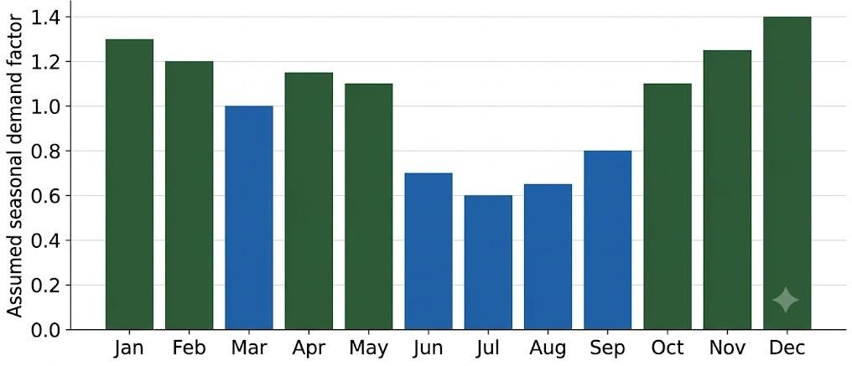
Figure 1.1 Seasonal demand pattern assumed in this work

Room pricing in small lodges
Many small lodges still charge one fixed rate for most of the year, or change the rate by hand when the owner feels that business is slow or busy. A fixed rate that is suitable for an ordinary weekday is too low for a festival weekend, when rooms sell out at the usual price and the lodge earns less than it could. The same rate is too high for a quiet monsoon week, when rooms stay empty. Manual adjustments depend on the experience of the owner and are difficult to repeat or to explain.

Dynamic pricing and revenue management
Dynamic pricing means changing the price of a product according to expected demand. Revenue management is the wider practice of forecasting demand and setting prices and availability so that the revenue from a fixed capacity is as high as possible (Kimes, 1989). Large hotels and airlines use specialized software and dedicated staff for this purpose. The same idea can be applied to a small lodge if a simple and understandable tool is available.

Stakeholders
Three groups are affected by the pricing of a lodge. The owner wants a stable income through the year and needs prices that can be explained and defended. The guest wants a price that is clear, the same for every guest on a given date, and not unreasonable at busy times. The local community, which often supplies staff, food and guides to the lodge, depends on the lodge staying in business through the quiet months. A pricing system has to serve all three groups, which is why the proposed work includes price limits, a what-if tool for the owner and a simple price page for guests.

Role of data and artificial intelligence in pricing
Pricing decisions are based on patterns: how bookings change with the season, the day of the week and the price. A computer can learn such patterns from booking records far more consistently than a person can keep them in mind, and it can then answer the same question for every date in the coming months. Machine learning and statistical models are the tools used to learn these patterns, and an optimiser is the tool

used to turn a learned pattern into a decision. This project uses both, and keeps the decision transparent so that the owner can see why a price was recommended.

MOTIVATION

The motivation for this work came from the gap between the pricing tools available to large hotels and the tools available to small eco-lodges. A small owner needs an answer to a practical question every day: what price should be charged for a given night? The answer should come from the pattern of demand rather than guesswork, remain within sensible limits, and allow the owner to test different prices before applying them.
Small eco-lodges may have limited access to advanced revenue management tools and may depend on fixed prices or manual decisions. These approaches may not adequately reflect changes in booking demand and room availability. Therefore, this work aims to develop an AI-based prototype that predicts demand and recommends suitable nightly prices. An owner dashboard with a what-if simulator allows the owner to compare pricing scenarios and examine their potential revenue impact before making a decision. The proposed approach seeks to make data-driven pricing support more accessible to small eco-tourism businesses.

Scope of the Proposed Work
The scope of the proposed work is a single lodge with twenty rooms and one price per night. The work covers the preparation of booking data, the prediction of daily demand, the recommendation of a revenue-maximising price, a database for bookings and recommendations, an owner dashboard with a what-if simulator, and a public page that shows guests only the nightly price. The system enables the lodge owner to explore different pricing scenarios and understand their potential impact on revenue before selecting a suitable price. It integrates demand prediction with price recommendation to support data-driven decision-making rather than relying entirely on fixed pricing or manual judgement. Real booking validation, automatic retraining and live event feeds lie outside the present scope and are treated as future work.
The inclusions and exclusions are summarised in Table 1.1.

Area | Included | Not included
Lodge | One lodge, twenty rooms, one price  per night | Several lodges, room types and  packages
Data | Simulated daily bookings for 2023 to  2025 | Real booking records
Models | Four demand models compared | Deep learning and reinforcement  learning
Pricing | Daily price between Rs. 2,000 and Rs.  9,000 | Competitor and sales channel  pricing
Application | Owner dashboard, what-if simulator, customer price page and MySQL  storage | Online booking and payment
Events | Festival and event flags | Live event feeds and weather
Table 1.1 Scope of the proposed work

Overview of the proposed work
The proposed work produces a system with two users. The owner logs in to a dashboard, sees the recommended price and predicted occupancy for the coming days, tests other prices with a what-if tool and records bookings. A guest opens a public page, chooses a date and sees only the price per night. Behind these pages, a demand model that was trained on simulated bookings predicts how many rooms will be booked at any price, and an optimiser chooses the price with the highest expected revenue. A database stores the bookings, the recommended prices and the user accounts.

Expected outcome
The expected outcome of the work is a running prototype that an owner can use to see a recommended price for each coming date, to test other prices, and to keep a record of bookings, together with a measured comparison of the models and of recommended prices against a fixed price. The outcome is a demonstration that the method and the system work together, and not a finished product for real use.

Challenges and proposed solution
Four main challenges were identified. First, demand depends on several calendar effects at the same time, so a single average is not enough. Second, real booking records of ecolodges are scarce, so a way of testing the pricing method without them was needed. Third, a pricing model has to show how demand changes when the price changes, because recommending a price depends on that relationship. Fourth, the owner needs a tool that is secure, simple and transparent, while guests should see only the final price.
The proposed solution is a full stack web system. Daily bookings are simulated from stated demand rules, several demand models are trained and compared, a smooth demand curve model is selected, and an optimiser chooses the price with the highest expected revenue for each date. The results are stored in a MySQL database and presented through a secured Flask application with an owner dashboard and a public customer page.

CHAPTER – II LITERATURE SURVEY

This chapter reviews recent studies on dynamic pricing and revenue management in the hotel industry. The survey was carried out on journal articles that deal with hotel room pricing, demand forecasting, machine learning and reinforcement learning methods, and the way customers perceive dynamic prices. Most of the studies are from the last five years. The works are grouped by topic, and a critical summary with the gap that this project addresses is given at the end of the chapter.

DYNAMIC PRICING AND REVENUE MANAGEMENT IN HOTELS

Dynamic pricing and revenue management are important in the hotel industry because room demand and customer preferences can vary over time. Researchers have explored how hotels can adjust prices according to market conditions, demand uncertainty, and property characteristics. The following studies discuss key developments in hotel pricing strategies and their implications for revenue management.
- Kopalle et al. (2023) defined dynamic pricing, discussed what it means for managers and set out directions for future research, which shows that the topic is still developing and that its definition is broader than simple seasonal price changes.
- Talón-Ballestero et al. (2022) described how dynamic pricing in hotels has moved towards open pricing and one-to-one pricing, in which rates follow market conditions and individual customers more closely than before.
- Guizzardi et al. (2022) studied hotel dynamic pricing under stochastic demand together with the effect of the Covid-19 period, which showed that a pricing method has to cope with demand that is uncertain and can change suddenly.
- Gao (2025) examined hotel room prices using a public hotel dataset and statistical methods such as analysis of variance, correlation and multiple linear regression. The study reported that hotel type, rating and location were the main factors behind room prices, and that the number of reviews had an effect through the quality that

guests perceive. This work explains what drives prices but does not itself recommend a price for a future date.

DEMAND FORECASTING FOR HOTEL REVENUE MANAGEMENT
    - Pereira and Cerqueira (2022) compared twenty-two methods for short-term hotel demand forecasting with lead times up to fourteen days. The methods ranged from seasonal naive and exponential smoothing to machine learning models, including a new approach that combines several forecasting models dynamically. Using the daily demand of a four-star hotel in southern Europe, they concluded that machine learning methods were more accurate than the traditional methods.
    - Webb et al. (2022) investigated how the booking window affects the accuracy of hotel revenue management forecasts, and showed that accuracy cannot be judged without considering how far ahead the booking is made.
    - Phumchusri and Suwatanapongched (2023) forecast daily hotel room demand with time series methods applied to transformed data, which shows the value of preparing the data before modelling.
    - Viverit et al. (2023) applied machine learning to cluster hotel booking curves and used the clusters for demand forecasting. These studies concentrate on predicting demand at the usual price and not on how demand responds when the price is changed.

REINFORCEMENT LEARNING AND DATA DRIVEN PRICING

Chen et al. (2023) proposed a reinforcement learning approach for hotel revenue management and supported it with evidence from field experiments. Their work is important because it tested a learning-based pricing method in real operation. Reinforcement learning methods, however, need large volumes of data and a setting in which prices can be varied and observed, which a small lodge usually does not have.

CUSTOMER PERCEPTION OF DYNAMIC PRICING

Bambauer-Sachse and Young (2024) studied the intention of consumers to spread negative word of mouth about dynamic pricing for services and showed that confusion and the perception of unfairness play a role. This finding is important for any practical system, because a price that changes without a clear pattern can harm the reputation of a lodge. It supports the use of price limits and of prices that follow understandable patterns such as weekends and festivals.
The reviewed studies are summarized in Table 2.1.

Study | Focus | Approach | Limitation for this work
Kopalle et al. (2023) | Meaning of dynamic pricing | Conceptual review | No pricing method for a small lodge
Talón-Ballestero et al. (2022) | Evolution of hotel dynamic pricing | Conceptual analysis | No demand model or tool
Guizzardi et al. (2022) | Pricing under stochastic demand  and Covid-19 | Stochastic demand analysis | Not a simple owner tool
Gao (2025) | Factors behind room prices | Statistical analysis of a public dataset | Explains prices, gives no daily  recommendation
Pereira and Cerqueira (2022) | Short-term demand forecasting | Comparison of 22 methods | Forecasts demand, not the price
Webb et al. (2022) | Forecast accuracy and booking  window | Forecast accuracy analysis | Does not recommend prices
Phumchusri and Suwatanapongched  (2023) | Daily room demand | Time series on transformed data | No response to price
Viverit et al. (2023) | Booking curves | Machine learning clustering | No pricing step
Chen et al. (2023) | Hotel revenue management | Reinforcement learning with field experiments | Needs rich data and price experiments
Bambauer-Sachse and Young (2024) | Customer reaction to dynamic prices | Consumer study | Not a pricing method
Table 2.1 Summary of the reviewed studies

Constructive Criticism and Gap Identification

The studies reviewed use several strong approaches, but they leave a gap for small ecolodges. Forecasting studies mostly predict demand at the usual price and do not provide a recommended price. Pricing studies that recommend prices through reinforcement learning need rich data and field testing. Statistical studies such as that of Gao (2025) explain price factors but do not give a daily decision tool. Most of the work addresses city and resort hotels with larger data, and none of the reviewed studies described a light, transparent system for a small eco-lodge that links demand prediction, a price-sensitive model, a price optimiser and an owner tool in one application. In addition, the reviewed studies pay little attention to the data scarcity that small lodges face.

Challenges and Details of the Proposed Solution

The key challenges include limited real eco-lodge data, realistic demand modelling, fair pricing limits, and a simple owner interface. This project aims to develop a transparent dynamic pricing system that predicts daily room demand and recommends revenue-maximizing prices within fixed limits. It uses simulated booking data, a price-responsive demand model, a price-grid optimiser, and a secure web application for owners and guests. The challenges and the matching solutions are summarized in Table 2.2.

Challenge | Proposed solution
Demand changes with season, weekend, festival and event | Calendar features and a model that learns the effect of each
Real eco-lodge booking records are scarce | Simulated bookings from stated demand rules, used to test the whole method
Price must change demand in a believable way | Demand curve model in which demand falls smoothly as price rises
Prices must be fair and safe | Price limits of Rs. 2,000 to Rs. 9,000 and owner review through a what-if tool
Owner data must be protected | Owner login with hashed passwords; guests see only the nightly price

Table 2.2 Challenges identified and the proposed solutions

CHAPTER – III OBJECTIVES AND METHODOLOGY
This chapter states the objectives of the proposed work, explains the flow of the work block by block, and describes the data, the models, the optimiser, the evaluation methods and the tools that were selected. The methodology follows from the gap found in the literature survey: a lodge needs a price-sensitive demand model, a way to turn the model into a price, and a tool that the owner can use with confidence.

OBJECTIVES OF THE PROPOSED WORK

Based on the findings of the literature survey, the following objectives were set. The batch has two members, and the individual contributions reported in the section on individual contribution are based on these objectives.
- To generate a daily booking dataset for a small eco-lodge that reflects season, weekend, festival, event and price effects.
- To prepare the features and to train and compare machine learning and statistical models for predicting daily room demand.
- To select a demand model whose predicted demand falls smoothly as the price rises, so that it can support pricing.
- To develop a price optimiser that recommends the revenue-maximizing nightly price within fixed limits.
- To implement a secured web application with an owner dashboard, a what-if simulator and a database for bookings and recommendations.
- To provide a public customer page that shows only the nightly price, and to evaluate the whole system through simulation and testing.
The objectives follow from the gaps found in Chapter 2. Objectives 1 and 2 respond to the scarcity of real data and the need to compare models. Objective 3 responds to the finding that forecasting studies predict demand at the usual price and say little about how demand reacts to price. Objective 4 turns the demand model into a daily price,

which the reviewed forecasting studies did not do. Objectives 5 and 6 respond to the lack of a simple and secure tool for small lodges and to the need to treat guests fairly by showing them only the price.

FLOW DIAGRAM OF THE PROPOSED WORK

The flow of the proposed work is shown in Figure 3.1. The upper row covers data and model preparation, and the lower row covers the pricing and web application.
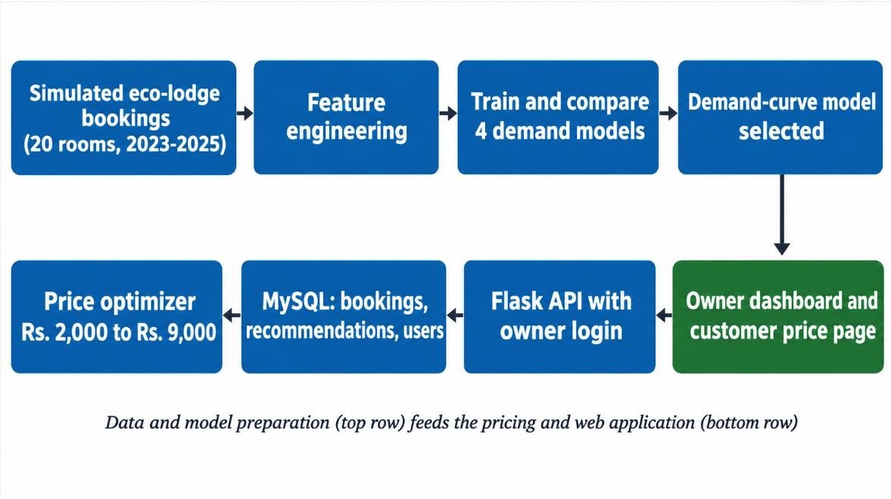
Figure 3.1 Flow diagram of the proposed work
The blocks of the flow diagram are explained below.
- Simulated eco-lodge bookings: daily bookings of a twenty-room lodge for 2023 to 2025 are generated from demand rules, with a fixed random seed so that the data can be reproduced.
- Feature engineering: each date is converted into the day of the week, the month, a weekend flag, a festival flag and an event flag, and the room price is added as a feature.
- Train and compare four demand models: a seasonal baseline, a random forest, a gradient boosting model and a demand curve model are trained on 2023 and 2024 and tested on 2025.
- Demand curve model selected: the model with the best accuracy and a smooth

response to price is saved for use in pricing.
- Price optimiser: for a chosen date, every price from Rs. 2,000 to Rs. 9,000 is tested and the price with the highest expected revenue is selected.
- MySQL database: historical bookings, recommended prices and user accounts are stored in three tables.
- Flask application with owner login: the model, the optimiser and the database are exposed through routes that are protected by a login.
- Owner dashboard and customer price page: the owner sees forecasts, tests prices and records bookings, and a guest sees only the nightly price.
The data move between the blocks as files and database records. The data generator writes a CSV file, the training step reads it and writes a saved model and a results file, and a loading step copies the same data into the database. When the application starts it loads the saved model, so the optimiser, the what-if route and the customer route all use the same demand model.

SELECTION OF DATA, TECHNIQUES AND TOOLS

Data generation
Real booking records of eco-lodges were not available, so the data were simulated. The simulation used a fixed random seed of 42 and covered 1 January 2023 to 31 December 2025, which gives 1,095 days. The rules are assumptions based on general tourism patterns and are not taken from a published dataset.
Each month was given a seasonal factor, as listed in Table 3.1.

Month | Factor | Month | Factor
January | 1.30 | July | 0.60
February | 1.20 | August | 0.65
March | 1.00 | September | 0.80
April | 1.15 | October | 1.10
May | 1.10 | November | 1.25
June | 0.70 | December | 1.40
Table 3.1 Seasonal demand factor assumed for each month

The demand multiplier m of a day is the seasonal factor multiplied by 1.25 on weekends (Friday to Sunday), by 1.30 on festival days and by 1.10 on event days. The expected demand in rooms for a price p is given by Equation 3.1, where P0 is a constant set to 6,000 rupees in the generator.

(3.1)
Historical prices were set from a base rate of Rs. 3,500, raised by 20 percent on weekends and by 10 percent in peak months, and multiplied by a random factor between 0.6 and 2.2, then limited to Rs. 2,000 to Rs. 9,000 and rounded to Rs. 100. This wide variation of price lets the models observe how demand reacts to price over the whole range that the optimisers later searches. The rooms booked on a day were drawn from a Poisson distribution around the expected demand and limited to twenty rooms. The columns of the resulting dataset are listed in Table 3.2.

Column | Description
date | Calendar date from 1 January 2023 to 31 December 2025
dow | Day of the week (0 for Monday to 6 for Sunday)
month | Month number from 1 to 12
is_weekend | 1 for Friday, Saturday and Sunday, otherwise 0
is_festival | 1 for festival days entered in the calendar, otherwise 0
is_event | Pseudo-random flag for local events on about 6 percent of days
price | Room price in rupees charged on that date
bookings | Rooms booked, between 0 and 20
occupancy | Rooms booked divided by 20, in percent
revenue | Price multiplied by bookings

Table 3.2 Columns of the generated dataset
The festival dates were entered by hand and run up to 25 December 2026. The event flag is a repeatable pseudo-random flag and does not come from real event data.
After generation the dataset was checked with summary statistics. Table 3.3 gives the average rooms booked, the average price and the occupancy in each month, and Figure

3.2 shows the average bookings and prices. The average bookings are highest in December, January and November and lowest in June, July and August, which agrees with the seasonal factors of Table 3.1 and shows that the generator behaves as intended. The average price charged does not follow the season strongly, because the historical prices were varied widely on purpose so that the models could learn the effect of price.

Month | Rooms booked per night | Average price (Rs.) | Occupancy (percent)
Jan | 6.1 | 5,786 | 30.4
Feb | 4.8 | 5,731 | 24.0
Mar | 3.7 | 5,032 | 18.7
Apr | 3.7 | 5,804 | 18.4
May | 4.4 | 5,357 | 21.9
Jun | 0.9 | 5,334 | 4.4
Jul | 0.5 | 5,231 | 2.5
Aug | 0.7 | 5,387 | 3.5
Sep | 1.8 | 5,222 | 9.1
Oct | 3.6 | 5,522 | 18.0
Nov | 5.3 | 5,814 | 26.5
Dec | 6.8 | 6,031 | 34.0

Table 3.3 Average rooms booked, price and occupancy in each month of the generated dataset
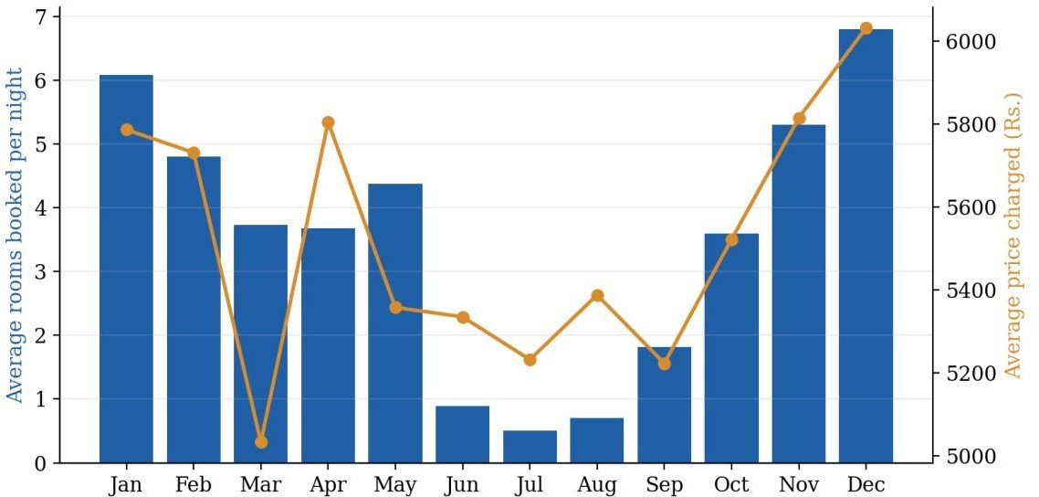
Figure 3.2 Average rooms booked and average price in each month of the generated dataset

Features and data split
The model inputs are the day of the week, the month, the weekend flag, the festival flag, the event flag and the price. The target is the number of rooms booked. The data of 2023 and 2024 (730 days) were used for training, and the data of 2025 (365 days) were kept for testing. The split was made by date because a forecast has to predict the future from the past, and a random split would let information from later dates leak into training.
The reason for using each input is given below.

      - Month: captures the season, which is the largest source of change in demand.
      - Day of the week and weekend flag: capture the higher demand from Friday to Sunday.
      - Festival flag: marks days of festival holidays, when demand is highest.
      - Event flag: marks days with a local event that adds a short peak.
      - Price: lets the model learn how demand falls as the price rises, which the optimiser needs.

Models compared
Four models were compared.

      - Baseline: the average number of rooms booked for each combination of month and weekend flag in the training years. It shows how much the other models add.
      - Random forest: an ensemble of 200 decision trees with at least three samples per leaf, trained with the scikit-learn library. The trees are built on random samples of the data and their predictions are averaged, which reduces overfitting (Breiman, 2001).
      - Gradient boosting: trees built one after another, each correcting the errors of the earlier ones (Friedman, 2001). The scikit-learn histogram-based implementation was used with a monotonic constraint, so that predicted demand can only fall as price rises.

      - Demand curve model: a parametric model fitted by least squares, described Section 3.3.4.
The random forest and the gradient boosting model were fitted to the 730 training rows with the scikit-learn library. The forest uses 200 trees and needs at least three samples in every leaf, which prevents single days from controlling a prediction, and its random state was fixed so that the result can be repeated. The gradient boosting model was given the monotonic constraint on the price input because a price model that lets demand rise with price would mislead the optimiser. The baseline needs no fitting except the calculation of the group averages. All four models predict the same target on the same test rows, so the comparison is fair.
The four models were chosen to cover a range from very simple to flexible. The baseline shows what can be done with seasonal averages alone. The random forest and gradient boosting are standard methods for tabular data and were used in the studies of demand forecasting that were reviewed. The demand curve model was added because pricing needs a model whose response to price is smooth and can be explained.

Price elasticity and the demand curve model
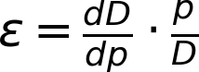
Price elasticity of demand measures how strongly bookings react to a change in price (Equation 3.2). In the demand curve model the expected demand falls in a straight line as the price rises, and the day context changes both the volume of demand and the price at which demand falls to zero.

(3.2)
In Equation 3.1 the term m is the exponential of a weighted sum of the features, m = exp(theta . x), where x contains twelve month indicators, the weekend flag, the festival flag and the event flag. The model therefore has fifteen context values plus the constant P0, which makes sixteen values in all. They were found with the SciPy least squares routine, which adjusts the values until the sum of squared differences between the predicted bookings (capped at twenty rooms) and the actual bookings in the training years is as small as possible.

The fitted values are given in Table 3.4 as multipliers, together with the values used in the generator. The fitted month factors, the weekend factor and the event factor are close to the generator values, which shows that the least squares fit recovers the pattern in the data. The festival factor and P0 differ somewhat because the festival days are few (about fifteen in the training years). The closeness of the two sets of values also shows why the accuracy of this model is helped by its form being similar to the demand rule of the generator, a point that is repeated in the limitations.

Parameter | Fitted value | Value used in the generator
Month factor, Jan | 1.33 | 1.30
Month factor, Feb | 1.26 | 1.20
Month factor, Mar | 1.02 | 1.00
Month factor, Apr | 1.16 | 1.15
Month factor, May | 1.18 | 1.10
Month factor, Jun | 0.70 | 0.70
Month factor, Jul | 0.63 | 0.60
Month factor, Aug | 0.67 | 0.65
Month factor, Sep | 0.83 | 0.80
Month factor, Oct | 1.11 | 1.10
Month factor, Nov | 1.30 | 1.25
Month factor, Dec | 1.44 | 1.40
Weekend factor | 1.24 | 1.25
Festival factor | 1.22 | 1.30
Event factor | 1.11 | 1.10
P0 (rupees) | 5,745 | 6,000

Table 3.4 Values fitted by least squares compared with the values used to generate the data

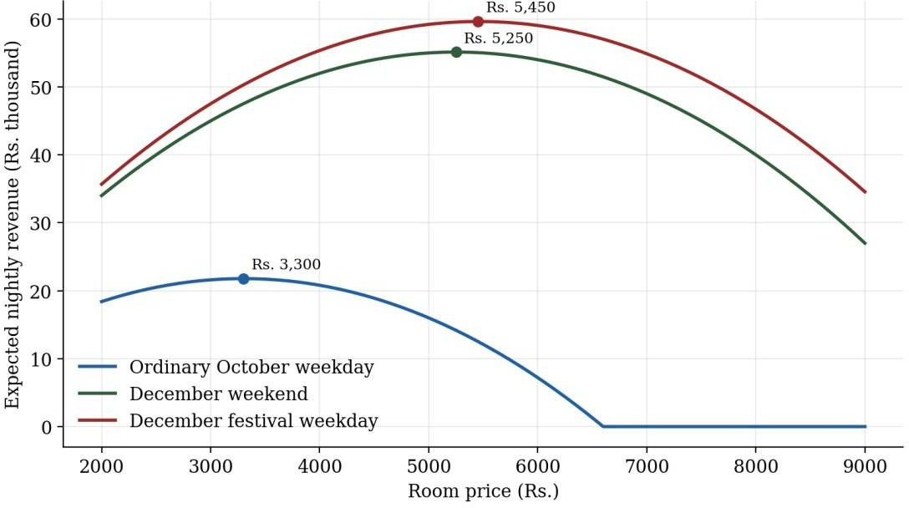

Figure 3.3 Expected revenue against price for three day types, with the revenue maximizing price marked

Figure 3.3 shows the idea behind the optimiser. For each day type the revenue first rises with price and then falls, because fewer rooms are sold at high prices. A busy day has a higher peak at a higher price.

Derivation of the optimal price
With the capacity limit C of twenty rooms, revenue is the price multiplied by the smaller of C and the demand. If the capacity limit is ignored, the demand is a(1 - p/Pmax), where a is 12m and Pmax is P0 times m. Setting the derivative of revenue to zero gives the price in Equation 3.3, which is half of the highest price that guests would pay.

(3.3)
When the demand at this price is more than the capacity, the lodge would sell out, so the price can be raised until demand just equals capacity. The price at which this happens and the resulting optimal price are given in Equation 3.4.

(3.4)
The optimiser does not use these formulas directly. It searches a price grid, which gives

the same answer for this model and would also work for a model that has no closed form. The formulas follow the classical idea that the best price of a limited stock depends on demand and on the capacity that remains (Gallego & van Ryzin, 1994; Talluri & van Ryzin, 2004), and they are used here to explain why prices behave as they do: on quiet days the best price is about half of what guests would pay at most, and on very busy days it is the price that just fills the rooms.

Price optimiser algorithm
The optimiser follows the steps below for each date.

- Find the calendar features of the date (month, weekday, weekend, festival and event flags).
- Build the list of candidate prices from Rs. 2,000 to Rs. 9,000 in steps of Rs. 100, which gives 71 prices.
- Predict the expected bookings of the date at every candidate price with the selected model.
- Limit the predicted bookings to twenty rooms.

- Calculate the revenue as the price multiplied by the limited bookings.

- Select the price with the highest revenue and return it with the predicted occupancy and revenue.
A 60-day forecast therefore needs about 4,300 predictions, which takes a very short time on an ordinary computer. The price limits are fixed for fairness and safety, so the system cannot recommend an extreme price.
A worked example is given in Table 3.5 and Figure 3.4 for 25 December 2026, a Friday and a festival day. At low prices the predicted demand is above the twenty rooms available, so the lodge would sell out cheaply and earn little. As the price rises the number of rooms sold falls but the revenue rises, until the loss of guests outweighs the higher price. The highest revenue in the grid is at Rs. 6,300, with about 13.2 rooms booked and an occupancy of 66 percent, and this is the price that the optimiser returns for that date.

Price (Rs.) | Predicted rooms booked | Occupancy (percent) | Expected revenue (Rs.)
2,000 | 20.0 | 100.0 | 40,000
3,000 | 20.0 | 100.0 | 60,000
4,000 | 18.0 | 90.0 | 72,036
5,000 | 15.9 | 79.6 | 79,600
6,000 | 13.8 | 69.2 | 82,988
6,300 (selected) | 13.2 | 66.0 | 83,189
7,000 | 11.7 | 58.7 | 82,198
8,000 | 9.7 | 48.3 | 77,230
9,000 | 7.6 | 37.8 | 68,085

Table 3.5 Worked example of the optimiser for 25 December 2026
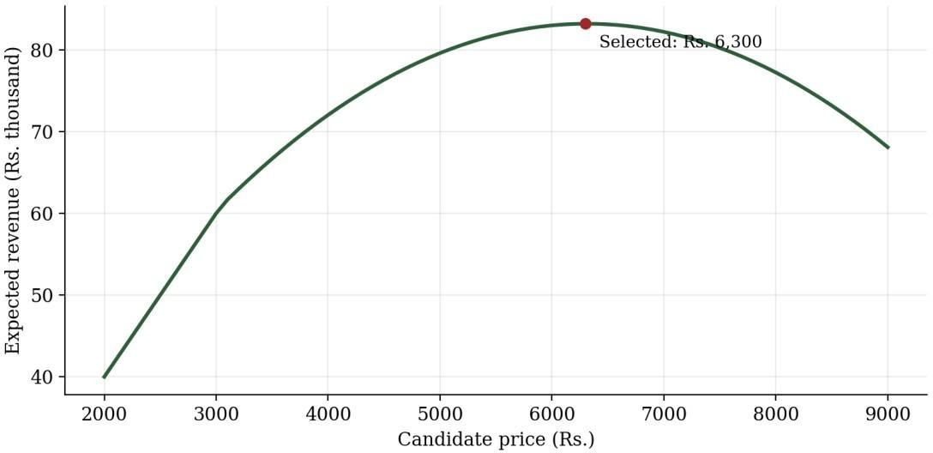
Figure 3.4 Expected revenue against price for 25 December 2026

Evaluation methods
The models were compared on the test year 2025 with three measures, given in Equations 3.5 and 3.6, where y is the actual and the hatted y is the predicted number of rooms booked on each of the n test days. The mean absolute error is the average error in rooms, the root mean squared error penalizes large errors more, and the coefficient of determination R2 shows how much of the variation in bookings the model explains.

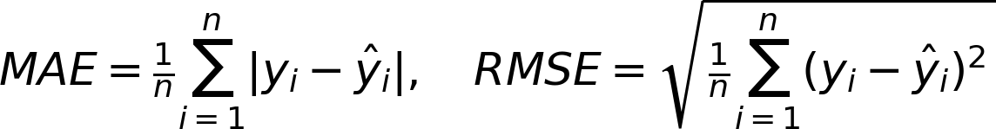
(3.5)

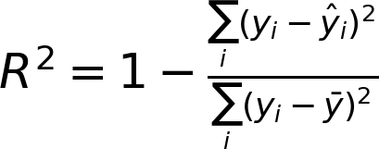
(3.6)
For

revenue, the year 2025 was simulated twice, once with a fixed rate of Rs. 3,500 and once with the recommended prices. The revenue of both was calculated with the demand rule of the generator, so that the comparison measures the pricing method.

Tools and technologies
The tools were selected because they are free, widely used and well documented.
They are listed in Table 3.6.

Tool | Purpose
Python | Programming language for data, models and the web application
pandas and NumPy | Data preparation and numerical work
SciPy | Least squares fitting of the demand curve model
scikit-learn | Random forest, gradient boosting and error measures
Flask | Web framework for the routes and the pages
MySQL and MySQL Workbench | Database and its management
HTML, CSS, JavaScript and Chart.js | Browser pages and the forecast chart
Git, GitHub and Visual Studio Code | Version control and code editing
AI assistant (Claude) | Support for code and documentation; the team ran, tested and reviewed all outputs

Table 3.6 Tools and technologies used

Table 3.7 gives the reason for the main choices.

Choice | Alternative considered | Reason for the choice
Flask | A larger framework with built-in administration | Flask is small and easy to explain,  and the project needs only a few routes
MySQL | A file-based database | MySQL is a widely used server database and supports generated  columns and constraints
scikit-learn | Writing the tree algorithms by hand | Tested implementations with a  common interface for fitting and prediction
SciPy least squares | A general optimiser from another library | Direct fitting of a nonlinear formula with a squared error objective
Chart.js | Drawing the chart on the server | Drawing in the browser keeps the server simple and the chart  interactive

Table 3.7 Reasons for the choice of the main tools

Testing methods
The system was tested at three levels. The data and models were checked by comparing predictions with actual bookings on the unseen year. The routes were tested for access control, for valid and invalid input and for the contents of each response. The database was checked by saving bookings through the dashboard and reading them back with SQL queries in MySQL Workbench. The test cases are listed in Chapter 5. Several checks were also built into the design. The prices are limited to Rs. 2,000 to Rs. 9,000 both in the optimiser and in the booking route. Responses use standard status codes, with 401 for a request that needs a login and 400 for invalid input. Database statements use placeholders instead of joining text, which is the usual protection against SQL injection. The random seed of the generator and the random states of the models are fixed so that every result can be repeated, and the same data and model are used by the dashboard, the what-if route and the customer page so that a price is the same wherever it is shown. These checks help ensure that the system remains consistent,

secure, and reliable throughout the pricing and booking workflow. Together, these measures improve reproducibility, prevent inconsistent pricing, and support dependable system operation.

Procedure for data generation
The generator follows the steps below, and every step uses the fixed random seed of 42.
- Create the list of dates from 1 January 2023 to 31 December 2025.

- Add the day of the week, the month, the weekend flag, the festival flag and the event flag to each date.
- Calculate the demand multiplier m of each day from the seasonal factor and the weekend, festival and event factors.
- Draw the price of each day from the base rate with the weekend and peak month uplifts and the random factor, and limit it to Rs. 2,000 to Rs. 9,000.
- Calculate the expected demand of each day from the price and the demand multiplier.
- Draw the rooms booked from a Poisson distribution around the expected demand and limit them to twenty.
- Calculate the occupancy and the revenue of each day.

- Save the table as a CSV file.

Procedure for training and selection
The training script follows the steps below.

- Read the CSV file and split it by date into the training years 2023 and 2024 and the test year 2025.
- Calculate the baseline averages for each month and weekend flag from the training years.
- Fit the random forest to the training rows.

- Fit the gradient boosting model with the monotonic constraint on price.

- Fit the demand curve model by least squares.

- Predict the bookings of the test year with every model and limit the demand curve predictions to twenty rooms.
- Calculate the mean absolute error, the root mean squared error and R2 of every model.
- Save the demand curve model with joblib and write the results to a file.

- Simulate the year 2025 with the fixed rate and with the recommended prices and save the revenue comparison.

Threats to validity

The methodology has limits that affect how far the results can be trusted. The data are simulated from assumed rules, so the models learn those rules and not the behavior of real guests. The demand curve model has a form similar to the generating rule, which favors it in the comparison. The revenue simulation uses the same rule that created the data, so it measures the pricing method under that rule only. The lodge is a single property with one room type and one price per night, and the data contain no cancellations, no competitors and no effect of earlier bookings on later demand. The festival and event flags are simplified. These limits do not stop the work from showing that the system functions end to end, but they mean that the numerical results should be read as a feasibility check and that validation on real booking data is needed before any real use.

CHAPTER – IV PROPOSED WORK MODULES
This chapter describes the proposed system. It first presents the architecture, the modules, the database design and the routes, and then explains the methodology with which each module was implemented. The system was developed as a full stack web application so that the owner of a lodge can use the demand model and the optimiser through a browser.

PROPOSED WORK

System architecture
The system has four layers. The data and model layer consist of Python scripts that generate the data and train the models. The storage layer is a MySQL database. The application layer is a Flask program that loads the trained model, applies the login checks and exposes the routes. The presentation layer consists of browser pages for the owner and the guest. The structure is shown in Figure 4.1.

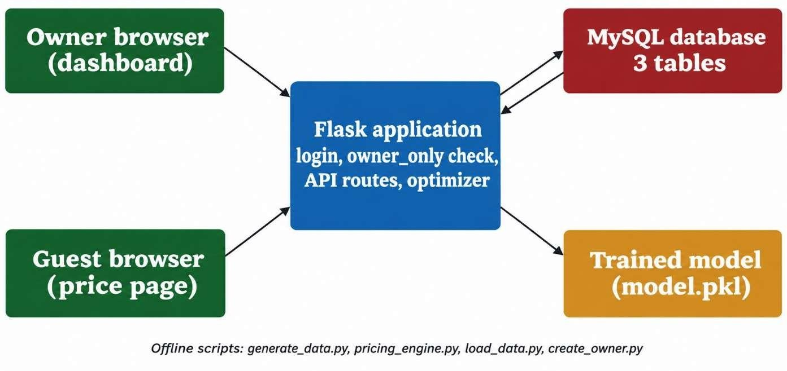

Figure 4.1 Architecture of the proposed system

Modules
The system was divided into the following modules.
      - Data management module: generates the simulated bookings and loads them into the database.
      - Demand prediction module: trains the four models, compares them on 2025 and saves the selected model and the results.
      - Dynamic pricing module: runs the optimiser and returns the recommended price, occupancy and revenue for a date.
      - Revenue analysis module: simulates 2025 with a fixed rate and with the recommended prices and reports the difference.
      - Owner dashboard module: shows the revenue comparison, the 60-day forecast chart, the what-if simulator, the booking form and the model table.
      - Customer price module: returns only the nightly price for a date chosen by a guest.
      - Security module: provides the login, password hashing, session handling and owner-only protection.
      - Event integration module: planned for future work and not implemented in this version.

Database design
Three tables were created in the eco_pricing database, as shown in Figure 4.2 and described in Table 4.1. The revenue column of the booking table is a generated column, so it always equals the rooms booked multiplied by the price. A check constraint keeps the rooms booked between 0 and 20.
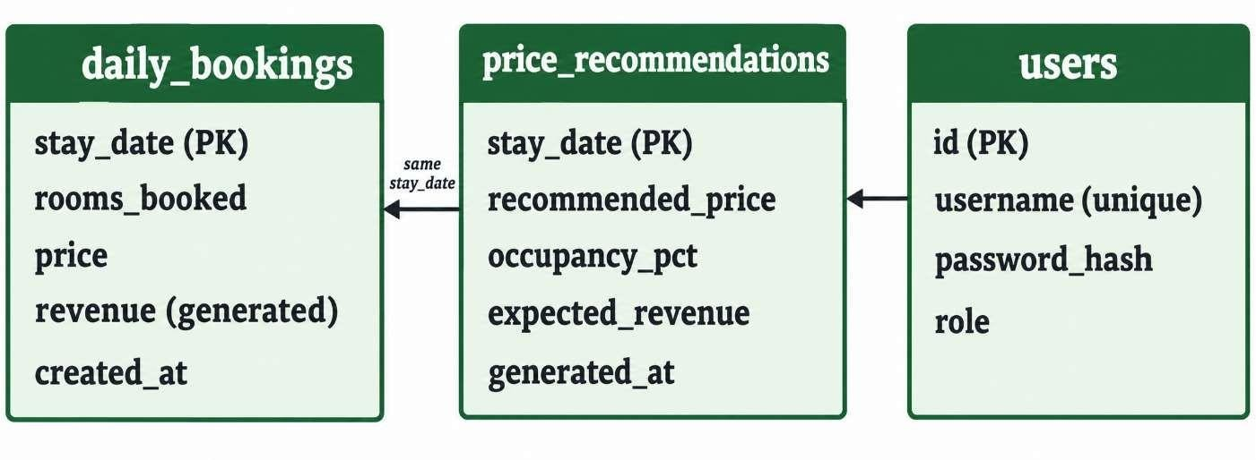
Figure 4.2 Tables of the eco_pricing database

Table | Main columns | Purpose
daily_bookings | stay_date, rooms_booked, price, revenue | History of bookings and  bookings entered by the owner
price_recommendations | stay_date, recommended_price, occupancy_pct,  expected_revenue | Prices recommended by the optimiser
users | id, username, password_hash, role | Owner accounts with hashed passwords

Table 4.1 Tables of the database

Routes of the application
The routes are listed in Table 4.2. A route marked owner is available only after login. A request to an owner page without a login is redirected to the login page, and a request to an owner API route receives a 401 response with the message that a login is required.

Route | Access | Purpose
/ | Owner | Dashboard page
/login and /logout | Public | Start and end a session
/book | Public | Customer price page
/api/public-price | Public | Price per night for a date within the next 180 days
/api/forecast | Owner | Recommended price and occupancy for a date range; also saved to the database
/api/whatif | Owner | Predicted bookings, occupancy and revenue for a date and a price
/api/results | Owner | Model comparison and revenue simulation
/api/bookings | Owner | List recent bookings or save a booking

Table 4.2 Routes of the Flask application

METHODOLOGY OF THE PROPOSED WORK

Data and model preparation
The data generator is run first and writes the dataset to a CSV file. The training script reads the file, splits it by date, trains the four models and writes the selected demand curve model and a results file. A separate script loads the same dataset into the booking table. The three scripts are run in the order generate, train and load, and the generator always gives the same data because of its fixed random seed. This sequence ensures that model training and database loading use a consistent dataset. The saved model can then be loaded by the application to generate demand predictions without retraining it for every request.

Price recommendation
When the dashboard asks for a forecast, the application builds the calendar features for the requested dates, runs the optimiser for each date and returns the price, occupancy and revenue. The same result is stored in the recommendation table, using an insert that updates an existing date instead of adding a duplicate. The what-if route predicts the bookings for one date and one price chosen by the owner, caps them at twenty rooms and reports the occupancy and revenue. This allows the owner to compare the recommended price with alternative prices before making a decision. The defined price range also prevents the optimiser from recommending prices outside the system's permitted limits.

Owner dashboard
After logging in (Figure 4.3), the owner sees the revenue of the 2025 simulation with the recommended prices against the fixed rate, a chart of the recommended price and predicted occupancy for the next 60 days (Figure 4.4), the what-if simulator (Figure 4.5), a form for saving a booking and a table of recent bookings. The chart is drawn in the browser with Chart.js. These components provide the owner with a single interface for reviewing forecasts, exploring pricing scenarios, and managing booking records.
The dashboard presents simulated results to support decision-making; they should not be interpreted as verified revenue from a real eco-lodge.

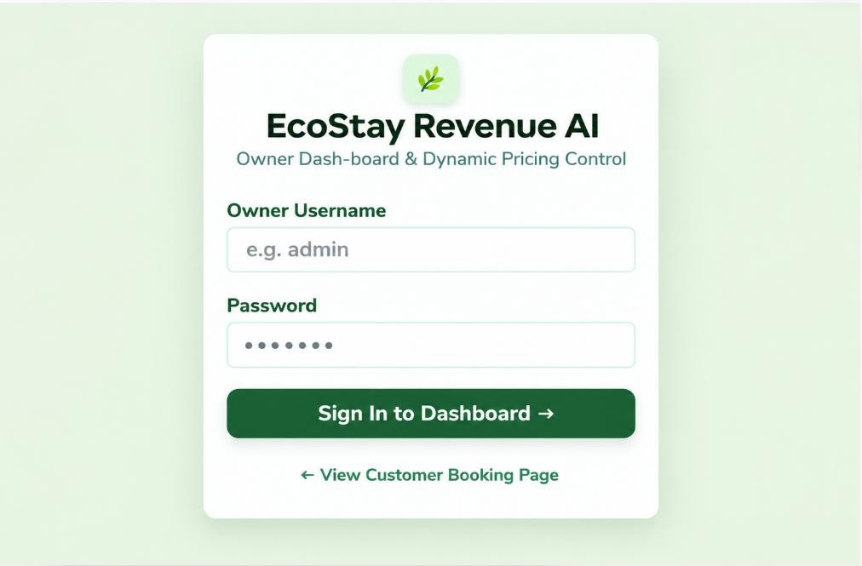

Figure 4.3 Owner login page

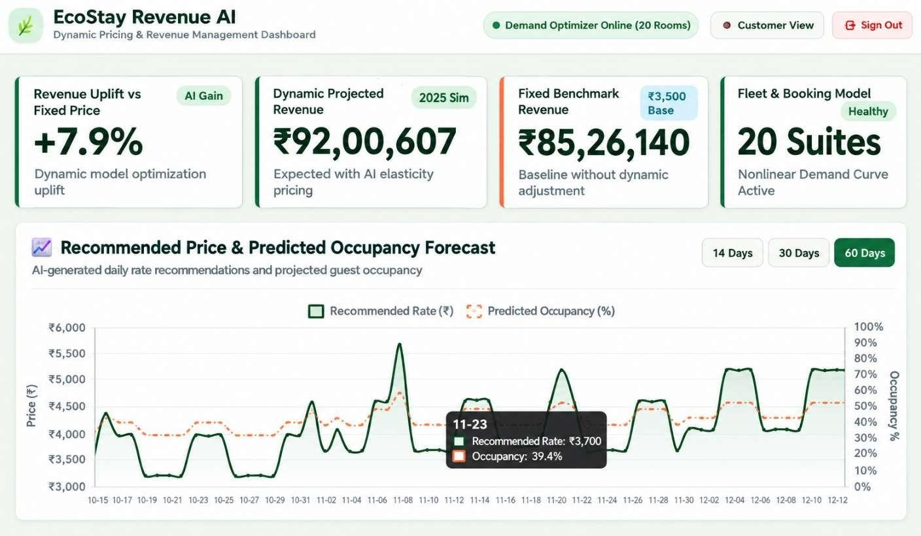

Figure 4.4 Owner dashboard with the forecast chart

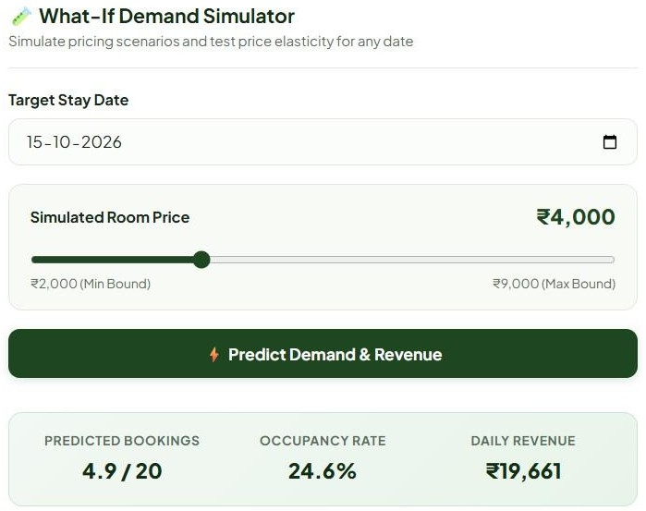
Figure 4.5 What-if simulator result

Customer price page
The customer page (Figure 4.6) has a date picker. When a date is chosen, the page asks the public price route, which accepts dates from today up to 180 days ahead and returns only the date and the price per room per night. No occupancy, revenue or booking data is sent to guests.
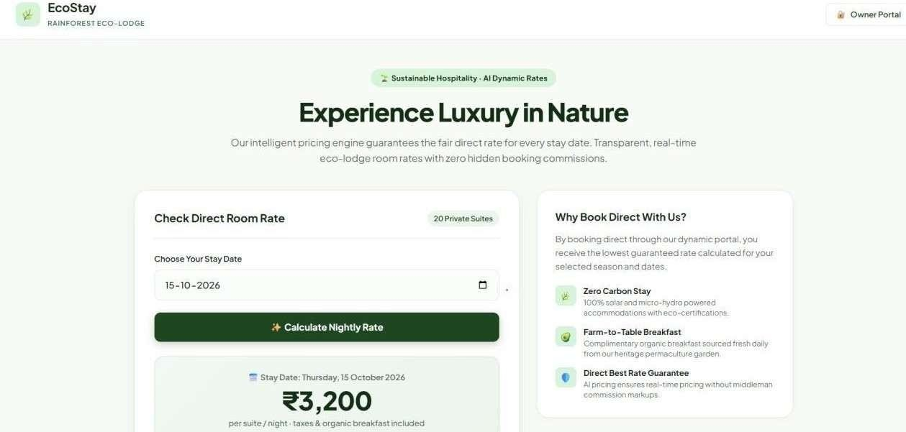

Figure 4.6 Customer price page

Security design
Passwords are never stored as text. The owner account is created by a script that stores a salted hash made with the Werkzeug library. When the owner logs in, the typed password is compared with the hash, and on success the server stores the role in a signed session cookie that is marked HttpOnly and SameSite so that scripts and most cross-site requests cannot use it. Every owner route is wrapped by a check of the role in the session. All database statements use placeholders instead of text joining, which prevents SQL injection. The booking route checks that the rooms are between 0 and 20 and the price is between Rs. 2,000 and Rs. 9,000. The database password and the secret key for the session are kept in an environment file that is excluded from version control. These security measures reduce unauthorized access, protect sensitive information, maintain data integrity, and support safe operation of the application.

    - Setup and execution

The database is created by running the schema script in MySQL Workbench. The packages are installed from the requirements file, the environment file is created, and the scripts for data, training, loading and the owner account are run once. The application is then started and opened in a browser on the local computer.
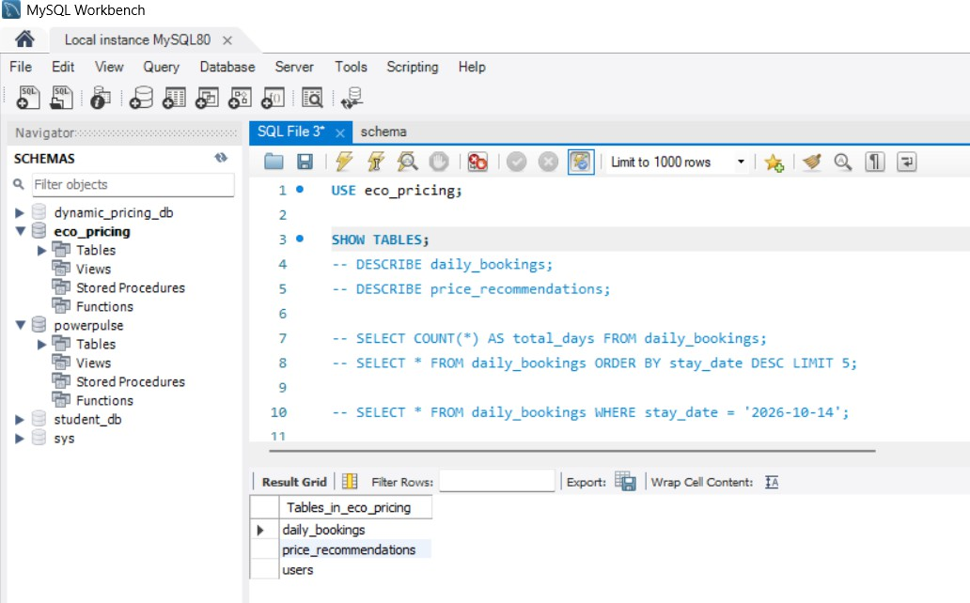

Figure 4.7 MySQL Workbench

CHAPTER – V RESULTS AND DISCUSSION
This chapter presents the results of the model comparison, the recommended prices, the revenue simulation and the system tests. The results are arranged in the order of the methodology. All results are based on simulated booking data, so they show how well the method and the system work under the stated demand rules and do not describe the behavior of real guests.

RESULTS

Model Comparison

The four models were scored on the 2025 test year. The results are given in Table 5.1 and Figure 5.1. The three learned models were far more accurate than the seasonal baseline, and the demand curve model gave the lowest errors and the highest R2. The comparison was conducted using evaluation metrics to assess prediction accuracy on data not used during training. Lower error values indicate that the predicted demand is closer to the observed booking values. The higher R² value indicates that the model explains a greater proportion of the variation in demand. The seasonal baseline provides a reference for evaluating whether machine learning improves prediction performance. The demand curve model was selected because it combined better predictive performance with a demand response that supports price optimisation. This selection forms the basis for the revenue simulation and pricing analysis presented in the following sections.

Model | MAE  (rooms) | RMSE  (rooms) | R2
Baseline (month and weekend average) | 2.77 | 3.64 | 0.205
Random forest | 1.38 | 2.10 | 0.736
Gradient boosting (monotonic in price) | 1.51 | 2.04 | 0.750
Demand curve (used for pricing) | 1.18 | 1.86 | 0.793

Table 5.1 Prediction results on the test year 2025

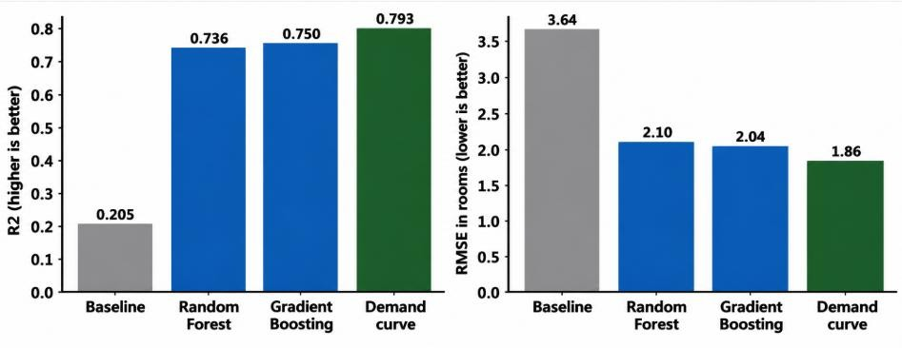
Figure 5.1 Comparison of the models on the test year

The R2 of 0.793 is well below 1 because the bookings in the data contain random Poisson variation, so even a model that knew the exact demand rule could not predict every day. Part of the remaining error is therefore unavoidable.

Predicted and Actual Bookings

Figure 5.2 compares the monthly average of the actual bookings of 2025 with the bookings predicted by the demand curve model. The predicted values follow the seasonal pattern closely, with high demand in the winter months and low demand in the monsoon months.
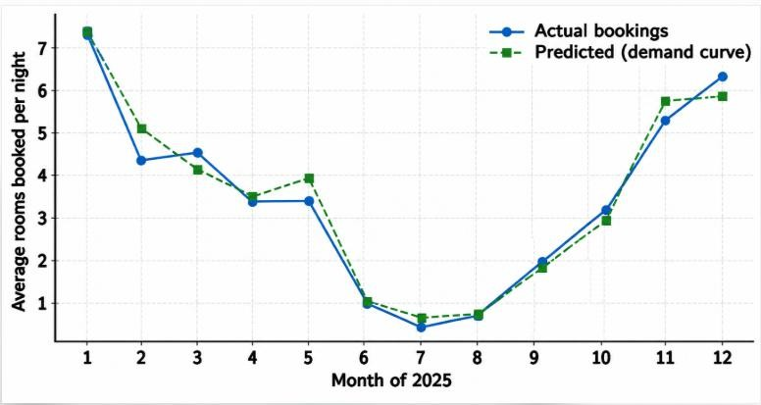
Figure 5.2 Actual and predicted average bookings in each month of 2025

Recommended Prices

Figure 5.3 shows the recommended price and predicted occupancy for the 60 days from 15 October 2026. The price rises on weekends and around festivals and falls on quiet days, and the predicted occupancy follows the same pattern. Over the 180 days from 1 October 2026 the recommended prices took 16 different values between Rs. 2,900 and Rs. 6,300.
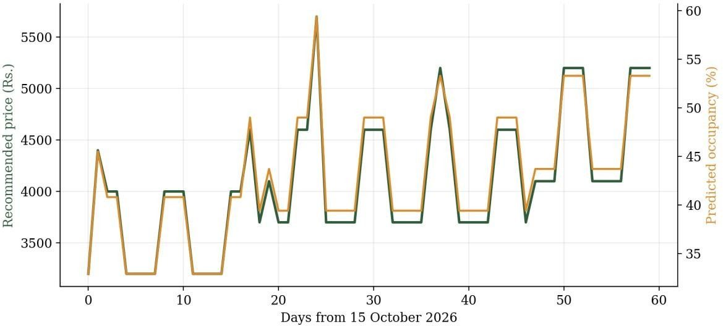
Figure 5.3 Recommended price and predicted occupancy for 60 days

The lowest and highest price of each month are given in Table 5.2 and Figure 5.4. The prices were highest in December and November, which have the strongest seasonal factors and contain Diwali and Christmas, and lowest in March.

Month | Lowest price (Rs.) | Highest price (Rs.)
October | 3,200 | 4,400
November | 3,700 | 5,700
December | 4,100 | 6,300
January | 3,800 | 5,300
February | 3,600 | 4,500
March | 2,900 | 3,600

Table 5.2 Lowest and highest recommended price in each month

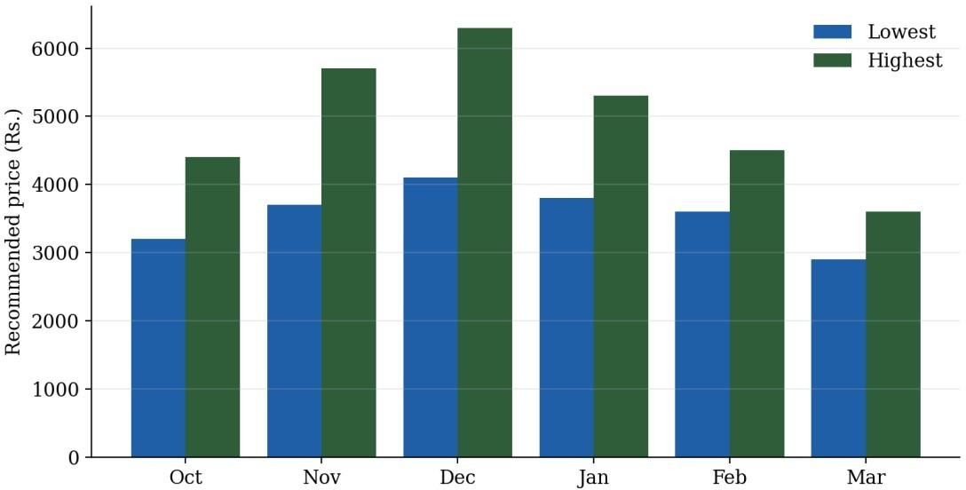
Figure 5.4 Lowest and highest recommended price in each month

Examples of single dates are Rs. 3,200 for an ordinary October weekday with about 33 percent predicted occupancy, Rs. 5,700 for Diwali on 8 November 2026 with about 59 percent, and Rs. 6,300 for 25 December 2026 with about 66 percent.

Revenue Simulation

In the simulation of 2025, a fixed rate of Rs. 3,500 gave a revenue of about Rs.
85.3 lakh and the recommended prices gave about Rs. 92.0 lakh, which is a gain of about Rs. 6.7 lakh or 7.9 percent (Figure 5.5). The revenue was calculated with the demand rule of the generator. On ordinary days the fixed rate is already close to the best price under that rule, so the gain comes mostly from higher prices on busy days and lower prices on slow days.
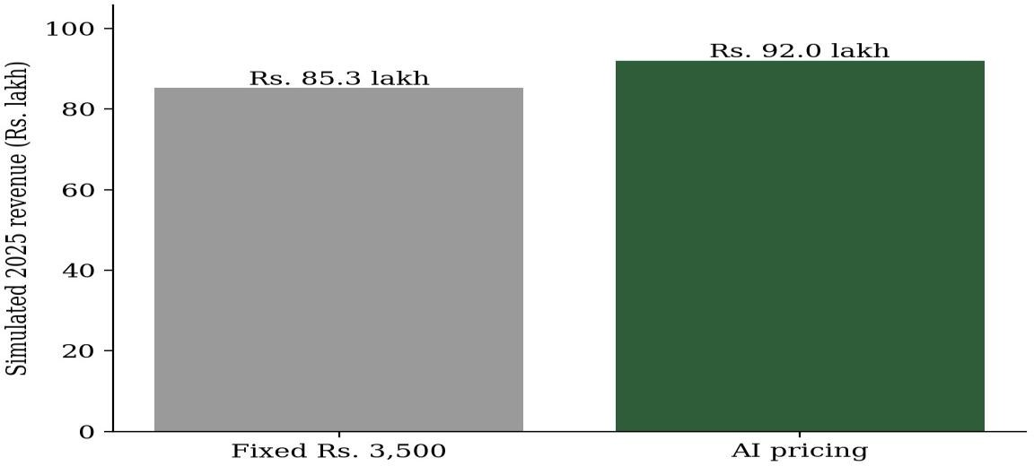
Figure 5.5 Simulated revenue of 2025 with fixed and recommended prices

What-if Simulation

The what-if simulator lets the owner compare prices before using them. For 25 December 2026 at a price of Rs. 6,000 it predicted about 13.8 rooms booked, an occupancy of about 69 percent and a revenue of about Rs. 82,987. Trying other prices for the same date shows the owner how revenue changes as occupancy falls.

System testing

The test cases are listed in Table 5.3. Tests T1 to T6 were run automatically against the application. Tests T7 to T11 are performed through the web interface with the database running. These tests verify core functionality, input validation, database connectivity, and expected system behaviour.

ID | Test | Expected result
T1 | Open the dashboard while logged out | Redirect to the login page
T2 | Call the results route while logged out | Status 401 with a login required message
T3 | Request the public price for a date within 180 days | Only the date and price per night are returned
T4 | Request the public price for a past date | Status 400 with a message to choose a date within 180 days
T5 | Open the customer page | The page loads without a login
T6 | Open the login page | The login form loads
T7 | Log in with the correct password | The dashboard opens
T8 | Log in with a wrong password | The message Invalid username or password
T9 | Save a booking of 12 rooms at Rs. 4,000 | The booking appears in the table and in the database
T10 | Save a booking of 25 rooms | Status 400 with the message rooms 0-20, price 2000-9000
T11 | Open the dashboard and check the recommendation table | Rows for the forecast dates are stored
Table 5.3 Test cases of the system

Comparison with related published works

The studies reviewed in Chapter 2 used different data and different measures, so their numbers cannot be compared directly with those of this project. A comparison of the approach is given in Table 5.4. Pereira and Cerqueira (2022) found that machine learning methods were more accurate than traditional methods for hotel demand forecasting, and the same pattern was seen here, where the learned models reached an R2 of 0.736 to 0.793 against 0.205 for the seasonal baseline. Gao (2025) identified the factors that influence room prices by statistical analysis, while this work goes a step further by predicting demand and recommending a price. Chen et al. (2023) tested a reinforcement learning method in field experiments, which is stronger evidence than the simulation used here, but the method needs much more data and experimentation than a small lodge can provide. The comparison highlights that this project focuses on a practical, integrated pricing system rather than demand forecasting alone. Unlike approaches requiring extensive field data or complex experimentation, the proposed prototype demonstrates demand prediction and price optimisation using simulated booking data.

Aspect | Related works | This project
Data | Real hotel data (Pereira and Cerqueira,  2022; Gao, 2025) | Simulated eco-lodge data
Output | Forecasts or price factors | Daily recommended price
Method | Machine learning, statistics, reinforcement learning (Chen et al.,  2023) | Demand curve model with a price optimiser
Evidence | Real series and field experiments | Test-year error and revenue  simulation
User tool | Not described in the studies | Owner dashboard and customer  price page

Table 5.4 Comparison of the approach with related works

SIGNIFICANCE, STRENGTHS AND LIMITATIONS OF THE PROPOSED WORK
The work is significant because it connects demand prediction, a price-sensitive model, an optimiser and a user tool for a type of business that usually has no revenue management software. Its main strengths are the following.
- The prices are explainable, because each recommendation follows from the demand curve and the capacity limit.
- The owner remains in control through the what-if simulator and the price limits.
- The system is cheap to run, because every component is open source.
- The owner and guest sides are separated, and business data stay behind a login.
- The results are reproducible because of the fixed random seed.
The limitations are listed below and were kept in view when the results were interpreted.
- The data are simulated, so the accuracy and the revenue gain describe the method and not real guests.
- The demand curve has a form similar to the demand rule of the generator, which helps its fit, so the accuracy and the gain are probably higher than they would be on real bookings.
- The model is trained from the CSV file and is not retrained automatically from the bookings saved in the database.
- The festival dates are entered by hand up to December 2026, and the event flag is not real event data.
- Guests can view prices but cannot book rooms, and the owner cannot yet override a recommended price.
- The application has no encrypted connection or limit on login attempts and runs in debug mode, so it is a prototype and not ready for live use.
- The system has not been evaluated with live bookings or compared with actual pricing decisions from an operating eco-lodge.
- The revenue improvement depends on the assumptions used in the simulation.

5.3 COST BENEFIT ANALYSIS

The cost and benefit of the system are summarized in Table 5.5. The system needs no paid software, and the benefit is the simulated revenue gain for a lodge of twenty rooms. The main costs involve development time, data preparation, testing, and routine maintenance. Open-source tools help avoid recurring software licence fees. The simulated revenue gain provides an estimate of the system's potential financial benefit. Actual cost savings and profitability must be assessed through testing with real booking data. The benefit was not measured on a real lodge. The system may also reduce manual effort by helping owners make pricing decisions more consistently. However, maintenance and future improvements may require additional time and resources. Therefore, the estimated benefits should be validated before practical adoption. The system's long-term value will depend on its accuracy, usability, and ability to adapt to changing demand. Further testing can help determine whether the potential revenue improvement justifies the implementation and maintenance effort.

Item | Amount | Remark
Software and tools | Rs. 0 | All tools are open source
Hardware | Existing computer | No additional equipment
Hosting | Rs. 0 for local use | A cloud server would be needed  only for deployment
Revenue at a fixed rate of  Rs. 3,500 | About Rs. 85.3 lakh a year | 2025 simulation
Revenue with recommended  prices | About Rs. 92.0 lakh a year | 2025 simulation
Simulated gain | About Rs. 6.7 lakh a year (7.9 percent) | Not measured on a real lodge
Table 5.5 Cost and benefit of the proposed system

CHAPTER – VI
CONCLUSIONS AND SUGGESTIONS FOR FUTURE WORK

This chapter gives the consolidated findings of the project and the points that could extend it. Eco-lodges need a way to set room prices from the pattern of demand, and this project built and tested such a system with simulated data.

CONCLUSION

A full stack system was built that forecasts the demand of a twenty-room eco-lodge and recommends a nightly price for each date. Three years of daily bookings were simulated, four demand models were compared on an unseen test year, and a demand curve model was selected. It gave a mean absolute error of 1.18 rooms, a root mean squared error of 1.86 rooms and an R2 of 0.793, against an R2 of 0.205 for a seasonal baseline. An optimiser that searched prices from Rs. 2,000 to Rs. 9,000 produced 16 different recommended prices between Rs. 2,900 and Rs. 6,300 over 180 days, higher on weekends, festivals and in winter. In a simulation of the test year, the recommended prices earned about 7.9 percent more revenue than a fixed rate of Rs. 3,500. The system also provides a secured owner dashboard with a what-if simulator, a MySQL database and a public price page for guests.
These findings show that the method and the system work together under the stated assumptions. They should not be taken as a measure of what a real lodge would earn, because the data were simulated and the demand curve is similar in form to the rules that produced the data.

SUGGESTIONS FOR FUTURE WORK

The following points were not considered in this version and are important for fine tuning the work.
    - Validate and retrain the models on real booking data from partner lodges and on public hotel booking datasets such as that of Antonio et al. (2019), and report the results with real measures.

    - Retrain the model automatically from the bookings stored in the database.
    - Add local events and weather as demand signals, with a festival calendar that updates itself.
    - Let the owner override a recommended price, check room availability and offer an actual booking flow for guests.
    - Limit price changes between neighbouring days and include guest satisfaction in the objective, so that pricing stays fair.
    - Add an encrypted connection, a limit on login attempts and a production server before any real use, and consider token based authentication if other applications use the interface.

REFERENCES
- Kimes, S. E. (1989). Yield management: A tool for capacity-constrained service firms. Journal of Operations Management, 8(4), 348-363.
- Gallego, G., & van Ryzin, G. (1994). Optimal dynamic pricing of inventories with stochastic demand over finite horizons. Management Science, 40(8), 999-1020.
- Breiman, L. (2001). Random forests. Machine Learning, 45(1), 5-32.
- Friedman, J. H. (2001). Greedy function approximation: A gradient boosting machine. The Annals of Statistics, 29(5), 1189-1232.
- Talluri, K. T., & van Ryzin, G. J. (2004). The theory and practice of revenue management. Springer.
- Antonio, N., de Almeida, A., & Nunes, L. (2019). Hotel booking demand datasets. Data in Brief, 22, 41-49.
- Guizzardi, A., Ballestra, L. V., & D'Innocenzo, E. (2022). Hotel dynamic pricing, stochastic demand and Covid-19. Annals of Tourism Research, 97, 103495. https://doi.org/10.1016/j.annals.2022.103495
- Pereira, L. N., & Cerqueira, V. (2022). Forecasting hotel demand for revenue management using machine learning regression methods. Current Issues in Tourism, 25(17), 2733-2750. https://doi.org/10.1080/13683500.2021.1999397
- Talon-Ballestero, P., Nieto-Garcia, M., & Gonzalez-Serrano, L. (2022). The wheel of dynamic pricing: Towards open pricing and one-to-one pricing in hotel revenue management. International Journal of Hospitality Management, 102, 103184. https://doi.org/10.1016/j.ijhm.2022.103184
- Webb, T., Schwartz, Z., Xiang, Z., et al. (2022). Hotel revenue management forecasting accuracy: The hidden impact of booking windows. Journal of Hospitality and Tourism Insights, 5(5), 950-965. https://doi.org/10.1108/JHTI-052021-0124
- Chen, J., Xu, Y., Yu, P., et al. (2023). A reinforcement learning approach for hotel revenue management with evidence from field experiments. Journal of Operations Management, 69(7), 1176-1201. https://doi.org/10.1002/joom.1246

- Kopalle, P. K., Pauwels, K., Akella, L. Y., et al. (2023). Dynamic pricing: Definition, implications for managers, and future research directions. Journal of Retailing, 99(4), 580-593. https://doi.org/10.1016/j.jretai.2023.11.003
- Phumchusri, N., & Suwatanapongched, P. (2023). Forecasting hotel daily room demand with transformed data using time series methods. Journal of Revenue and Pricing Management, 22(1), 44-56. https://doi.org/10.1057/s41272-021-00363-6
- Viverit, L., Heo, C. Y., Pereira, L. N., et al. (2023). Application of machine learning to cluster hotel booking curves for hotel demand forecasting. International Journal of Hospitality Management, 111, 103455.
https://doi.org/10.1016/j.ijhm.2023.103455
- Bambauer-Sachse, S., & Young, A. (2024). Consumers' intentions to spread negative word of mouth about dynamic pricing for services: Role of confusion and unfairness perceptions. Journal of Service Research, 27(3), 364-380.
https://doi.org/10.1177/10946705231190871
- Gao, J. (2025). Optimizing hotel revenue management through dynamic pricing algorithms and data analysis. Journal of Computational Methods in Sciences and Engineering, 25(2), 1200-1209. https://doi.org/10.1177/14727978241298467

APPENDICES
I BILL OF MATERIALS

Item | Specification | Cost
Computer | Laptop or desktop with at least 4 GB memory, already available | Rs. 0
Python and packages | Python 3.10 to 3.12; flask, pandas, numpy, scipy, scikit-learn, joblib, mysql-connector-python, python-  dotenv | Rs. 0
Database | MySQL Server and MySQL Workbench (community editions) | Rs. 0
Browser libraries | Chart.js loaded from a content delivery network | Rs. 0
Version control | Git and a public GitHub repository | Rs. 0
Table A.1 Bill of materials

II CODING
Demand curve model (curve_model.py):
import numpy as np
from scipy.optimize import least_squares ROOMS = 20

def _x(X):
M = np.zeros((len(X), 15))
M[np.arange(len(X)), X["month"].to_numpy() - 1] = 1
M[:, 12], M[:, 13], M[:, 14] = (
X["is_weekend"], X["is_festival"], X["is_event"]
)
return M

class CurveModel: def fit(self, X, y):
A, p, y = (
_x(X), X["price"].to_numpy(float), np.asarray(y, float)

)

def resid(w):
m = np.exp(A @ w[:15]) return (
np.minimum( ROOMS,
12 * m * np.clip(
1 - p / (w[15] * m), 0, 1
)
) - y
)

self.w = least_squares(
resid, np.r_[np.zeros(15), 6000.]
).x
return self

def predict(self, X):
m = np.exp(_x(X) @ self.w[:15]) p = X["price"].to_numpy(float) return 12 * m * np.clip(
1 - p / (self.w[15] * m), 0, 1
)

Price optimiser (pricing_engine.py):
GRID = np.arange(2000, 9001, 100)
def recommend(model, cal): out = []
for _, r in cal.iterrows(): X = pd.DataFrame({
f: [r[f]] * len(GRID)
for f in FEATURES[:-1]
})
X["price"] = GRID
b = np.minimum(ROOMS, model.predict(X))

rev = GRID * b i = rev.argmax() out.append(dict(
date=str(r.date.date()), price=int(GRID[i]),
occupancy=round(b[i] / ROOMS * 100, 1), revenue=int(rev[i])
))
return out

Owner-only access check (app.py):
def owner_only(f): @wraps(f)
def wrap(*a, **k):
if session.get("role") != "owner":
if request.path.startswith("/api/"): return jsonify(error="login
required"), 401
return redirect(url_for("login")) return f(*a, **k)
return wrap

Database schema (schema.sql):
CREATE DATABASE IF NOT EXISTS
eco_pricing;

USE eco_pricing;

CREATE TABLE IF NOT EXISTS
daily_bookings (
stay_date DATE PRIMARY KEY, rooms_booked INT NOT NULL
CHECK (rooms_booked BETWEEN 0 AND
20),
price INT NOT NULL,
revenue INT GENERATED ALWAYS AS
(rooms_booked * price) STORED, created_at TIMESTAMP DEFAULT

CURRENT_TIMESTAMP
);

CREATE TABLE IF NOT EXISTS
price_recommendations (
stay_date DATE PRIMARY KEY, recommended_price INT NOT NULL, occupancy_pct DECIMAL(5,1) NOT NULL, expected_revenue INT NOT NULL, generated_at TIMESTAMP DEFAULT
CURRENT_TIMESTAMP
ON UPDATE CURRENT_TIMESTAMP
);

CREATE TABLE IF NOT EXISTS users ( id INT AUTO_INCREMENT PRIMARY
KEY,
username VARCHAR(50) NOT NULL UNIQUE,
password_hash VARCHAR(255) NOT NULL, role VARCHAR(20) NOT NULL DEFAULT
'owner'
);

III STANDARD TABLES AND GRAPHS NOT MENTIONED IN THE REPORT
Table A.2 gives the first rows of the generated dataset, and Table A.3 gives the settings of the models.

Date | Month | Weekend | Festival | Price (Rs.) | Bookings | Revenue (Rs.)
2023-01-01 | 1 | 1 | 0 | 8500 | 3 | 25500
2023-01-02 | 1 | 0 | 0 | 5000 | 1 | 5000
2023-01-03 | 1 | 0 | 0 | 7600 | 2 | 15200
2023-01-04 | 1 | 0 | 0 | 6600 | 1 | 6600
2023-01-05 | 1 | 0 | 0 | 2900 | 9 | 26100
2023-01-06 | 1 | 1 | 0 | 9000 | 1 | 9000
2023-01-07 | 1 | 1 | 0 | 8400 | 2 | 16800
2023-01-08 | 1 | 1 | 0 | 8600 | 2 | 17200

Table A.2 First rows of the generated dataset

Model | Settings
Baseline | Mean bookings for each month and weekend flag in 2023 and 2024
Random forest | 200 trees, at least 3 samples per leaf, random state 1
Gradient boosting | Histogram based regressor, demand non-increasing in price, random state 1
Demand curve | Least squares from zero context values and P0 of 6,000 rupees, bookings capped at 20 rooms

Table A.3 Settings of the models

IV CERTIFICATION




V WORK CONTRIBUTION
The contribution of each student was based on the objectives stated in Section 3.1. The batch worked jointly on integration, testing and documentation, and discussed every part with the project guide.

S.No | Project  Objective | Sridhar V  (7376242AL196) | Thirumalaivasan N  (7376242AL209)
1 | Booking dataset | Domain study, literature  survey and booking factor analysis | Domain study, literature  survey and booking factor analysis
2 | Features and model  comparison | Feature selection and algorithm study | Demand prediction design and model  comparison
3 | Price-sensitive  demand model | Model evaluation and  comparison | Demand curve modelling  and mathematical analysis
4 | Price optimiser | Optimisation logic and pricing objectives | Optimiser  implementation and algorithm analysis
5 | Secured web application | System workflow and model integration planning | Flask backend, database  and security implementation
6 | Customer page and evaluation | Customer page testing and revenue simulation | Customer page testing and documentation

Table A.4 Contribution of each student

VI PLAGIARISM REPORT


