Multi-label Classification of Toxic Comments on YouTube
ITCS348 Introduction to Natural Language Processing
Project 1: Sequence Classification
February 2026

Abstract
This report presents a comprehensive multi-label classification system for detecting toxic content in YouTube comments. We address the challenge of identifying multiple types of toxicity simultaneously—where a single comment can be classified as abusive, racist, and hate speech concurrently. We implement and compare four models across two tiers: traditional machine learning approaches (Naive Bayes, Logistic Regression, Linear SVM) and a transformer-based model (DistilBERT). Our best-performing model, DistilBERT, achieves a Macro-F1 score of 0.6146 and Micro-F1 score of 0.6702 on the test set. The study reveals that severe class imbalance and limited training data (1,083 samples after augmentation) pose significant challenges, particularly for minority labels such as IsObscene and IsRacist. We discuss preprocessing strategies including emoji handling, slang normalization, and contraction expansion, along with data augmentation techniques using synonym replacement and contextual word embeddings. The report concludes with deployment recommendations for production scenarios and identifies future directions including collection of larger datasets and exploration of hate-speech-specific transformer models.

1. Introduction

1.1 Problem Statement
Social media platforms process millions of user-generated comments daily. While the majority of this content is benign, toxic language—including threats, hate speech, and abusive remarks—poses significant risks to user safety and platform integrity. Traditional content moderation relies heavily on human moderators, an approach that is costly, slow, and mentally taxing for workers. Automated classification systems offer a scalable solution, but face unique challenges in the context of toxicity detection.
The complexity of toxicity detection stems from its multi-label nature: a single comment may simultaneously exhibit multiple forms of toxicity. For example, the phrase "you racist piece of garbage" is simultaneously abusive, racist, and contains hate speech. This differs fundamentally from multi-class classification, where each instance receives exactly one label. Multi-label classification requires models to independently predict the presence or absence of each toxicity category, accounting for potential correlations between labels.
Furthermore, toxicity is highly context-dependent. The word "killing" in "You're killing it!" expresses praise, while "I'll kill you" constitutes a threat. Simple keyword-based approaches fail to capture these nuances, necessitating more sophisticated natural language understanding.

1.2 Research Objectives
This project pursues three primary objectives:
- To develop a multi-label classification system capable of simultaneously detecting seven types of toxicity in YouTube comments (IsToxic, IsAbusive, IsProvocative, IsObscene, IsHatespeech, IsRacist, IsNeutral).
- To implement and compare multiple classification approaches spanning traditional machine learning and modern transformer-based architectures, evaluating their respective strengths and limitations.
- To address practical deployment considerations including computational efficiency, interpretability, and ethical implications such as dialectal bias and false positive rates.

1.3 Dataset Overview
We utilize the YouTube Toxicity Dataset from Kaggle, comprising 1,000 English-language comments. After removing duplicates, the effective dataset contains 997 unique samples. Each comment is labeled with binary indicators for six toxicity categories, with a seventh label (IsNeutral) derived to represent non-toxic content. The dataset exhibits severe class imbalance, with minority labels such as IsObscene (59 training samples) and IsRacist (69 training samples) posing significant modeling challenges.
We employ a 60/20/20 train/validation/test split, yielding 597 training samples, 200 validation samples, and 200 test samples. The limited dataset size necessitates data augmentation strategies, which we implement using both synonym replacement and contextual word embedding techniques to expand minority class representation. After augmentation, the training set contains 1,083 samples.

2. Related Work
Automated toxicity detection has evolved significantly over the past decade. Early approaches relied on keyword blacklists and regular expressions, which proved inadequate for handling context-dependent language and deliberate obfuscation (e.g., "f*ck" or "a$$"). The introduction of machine learning methods, particularly support vector machines (SVMs) with TF-IDF features, demonstrated substantial improvements in recall while maintaining reasonable precision.
The advent of deep learning brought further advances. Recurrent neural networks (RNNs) and Long Short-Term Memory (LSTM) networks enabled sequential processing of text, capturing word order and contextual relationships. However, these approaches struggled with long-range dependencies and required substantial training data.
The transformer architecture, introduced by Vaswani et al. (2017), revolutionized natural language processing through its attention mechanism. BERT (Devlin et al., 2019) and its variants leverage bidirectional context to achieve state-of-the-art performance across numerous NLP tasks. Domain-specific models such as HateBERT and ToxicBERT, pre-trained on hate speech datasets, have demonstrated particular efficacy for toxicity detection tasks.
Recent research has highlighted critical challenges in toxicity detection, particularly regarding bias. Sap et al. (2019) demonstrated that mainstream toxicity classifiers disproportionately flag African American Vernacular English (AAVE) as toxic, even in non-offensive contexts. Davidson et al. (2019) found that models trained on hate speech data often conflate offensive language used by minority groups discussing their own experiences with actual hate speech directed at those groups. These findings underscore the importance of bias testing and fairness considerations in our experimental design.

3. Methodology

3.1 Data Preprocessing
Text preprocessing constitutes a critical component of our pipeline. We implement a comprehensive preprocessing strategy tailored to the characteristics of toxic online discourse:

Normalization and Expansion
We first normalize apostrophe encodings (', ', `) to a standard form, addressing inconsistencies in user input. Contractions are then expanded using the contractions library (e.g., "don't" → "do not", "you're" → "you are"). This expansion is particularly important for toxicity detection, as it makes negation explicit—a model must recognize that "not offensive" differs fundamentally from "offensive."

Emoji Handling
Emojis convey emotional context that may indicate toxicity. We preserve emojis by converting them to text descriptions using the emoji library (e.g., 😡 → :angry_face:). This allows models to learn associations between emotional indicators and toxicity labels.

Obfuscation Detection
Users frequently obfuscate profanity to evade automated filters. We implement pattern-based normalization to standardize these variants:
- f*ck, f$ck, f@ck → fuck
- a$$, a$s → ass
- sh!t, sh*t → shit

Slang Normalization
Internet slang and abbreviations are standardized through a manually curated dictionary: "u" → "you", "ur" → "your", "wtf" → "what the fuck", "stfu" → "shut the fuck up". This normalization reduces vocabulary sparsity while preserving semantic content.

Stopword Removal and Lemmatization
We remove standard English stopwords from NLTK, with critical exceptions: negation words ("not", "no", "never", "neither", "nobody", "nothing", "nowhere") are retained because they reverse meaning. We apply lemmatization with part-of-speech tagging using WordNet to reduce inflectional forms while preserving semantic distinctions (e.g., "running" → "run", but "better" → "good").

3.2 Data Augmentation
To address severe class imbalance, we implement data augmentation targeting minority labels. We employ two techniques:
- Synonym Replacement (nlpaug WordNet-based augmentation): Substitutes words with synonyms from WordNet at a 30% replacement rate. For example, "You are an idiot" may become "You are a fool" or "You are a moron."
- Contextual Word Embeddings (DistilBERT-based substitution): Uses BERT's contextual understanding to replace words with contextually appropriate alternatives. This produces more natural augmentations that preserve grammaticality and semantic coherence.
We apply augmentation conservatively, generating 2-3 variants per sample for labels with fewer than 100 positive training examples. This increases the training set from 597 to 1,083 samples. However, augmentation cannot fully compensate for fundamental data scarcity—the augmented samples introduce slight distributional shift and may not capture the full diversity of real toxic language.

3.3 Feature Extraction
We prepare multiple feature representations suited to different model architectures:

Bag of Words (BoW)
For Naive Bayes, we use CountVectorizer with a vocabulary of 10,000 most frequent unigrams. This simple representation counts word occurrences without considering order or context.

TF-IDF
For Logistic Regression and Linear SVM, we apply TF-IDF (Term Frequency-Inverse Document Frequency) vectorization with both unigrams and bigrams, limited to the 15,000 most informative terms. TF-IDF downweights common words while emphasizing discriminative terms. Bigrams capture local context (e.g., "not good" as a single feature).

BERT Tokenization
For DistilBERT, we bypass traditional preprocessing and apply minimal cleaning (lowercase, URL removal) to preserve the linguistic patterns the model was pre-trained on. DistilBERT's WordPiece tokenizer splits text into subword units, with sequences padded or truncated to 128 tokens.

3.4 Model Architectures
We implement four models across two architectural tiers:

3.4.1 Traditional Machine Learning Models
Naive Bayes (Multinomial): Assumes feature independence and uses Bag-of-Words representation. Serves as a fast baseline with sub-second training time.
We employ a multinomial Naive Bayes classifier with Laplace smoothing (α = 1.0) in a one-vs-rest configuration for multi-label prediction. Despite its simplicity, this baseline provides interpretable predictions and completes training in under 0.1 seconds.
Logistic Regression with Hyperparameter Tuning: A linear classifier with TF-IDF features, optimized via grid search.
We conduct 3-fold cross-validated grid search over regularization strength C ∈ {0.1, 1.0, 10.0} and penalty type (L1, L2). The optimal configuration (C = 10.0, L2 penalty) balances model complexity with generalization. Class weights are set to "balanced" to mitigate class imbalance. Training requires approximately 52 seconds including hyperparameter search.
Linear Support Vector Machine: A margin-based classifier seeking optimal separating hyperplanes in high-dimensional TF-IDF space.
We use LinearSVC with C = 1.0, dual formulation disabled (more efficient for our n_samples < n_features scenario), and balanced class weights. The SVM maximizes the margin between toxicity classes while penalizing misclassifications of minority labels more heavily. Training time is approximately 1 second.

3.4.2 Transformer Model
DistilBERT (Fine-tuned): A distilled version of BERT retaining 97% of performance at 40% of the size, fine-tuned on our toxicity dataset.
We fine-tune distilbert-base-uncased for 3 epochs with batch size 16 and learning rate 2×10⁻⁵. Critically, we address class imbalance through weighted binary cross-entropy loss, where each label's positive weight equals the ratio of negative to positive samples. This forces the model to pay greater attention to minority labels during training. We apply gradient clipping (max norm 1.0) for training stability and include a linear warmup schedule for 10% of training steps. Fine-tuning requires approximately 95 seconds on GPU (Tesla T4).
Note on Model Selection: We initially planned to implement Feedforward Neural Networks (FNN) and Bidirectional LSTM models. However, these proved inappropriate given our dataset constraints. An FNN operating on 15,000-dimensional TF-IDF vectors requires millions of parameters, vastly exceeding our 1,083 training samples—a recipe for severe overfitting. Similarly, a Bi-LSTM with a 10,000-word vocabulary and 128-dimensional embeddings introduces approximately 1.3 million embedding parameters alone, before accounting for recurrent layers. These parameter counts demand orders of magnitude more training data than available. We therefore focus our comparison on methods suited to small datasets: Naive Bayes (no parameters to learn), Logistic Regression (interpretable linear model), Linear SVM (efficient in high dimensions), and DistilBERT (leverages pre-trained knowledge).

3.5 Evaluation Metrics
Multi-label classification necessitates specialized evaluation metrics. We report:
- Micro-F1: Aggregates true positives, false positives, and false negatives across all labels before computing F1. Emphasizes model performance on common labels.
- Macro-F1: Computes F1 for each label independently, then averages. Treats all labels equally regardless of frequency. Our primary metric for comparing models.
- Hamming Loss: Fraction of incorrect label predictions. Lower is better.
- Subset Accuracy: Percentage of samples where all 7 labels are predicted correctly. A strict metric that penalizes any error.
- Jaccard Score: Intersection over union of predicted and true labels, averaged across samples. Measures similarity between prediction sets.
For each model, we also report per-label F1 scores to identify which toxicity categories prove most challenging. Additionally, we examine training time to assess computational efficiency trade-offs.

4. Experimental Results

4.1 Overall Model Comparison
Table 1 presents the comprehensive performance comparison across all four models on the 200-sample test set:
Model | Micro-F1 | Macro-F1 | Hamming Loss | Subset Acc | Jaccard | Train Time (s)
Naive Bayes | 0.4863 | 0.3085 | 0.2536 | 0.395 | 0.5182 | 0.05
Logistic Regression | 0.6007 | 0.5572 | 0.2364 | 0.335 | 0.5302 | 52.29
Linear SVM | 0.6190 | 0.5399 | 0.2057 | 0.450 | 0.6002 | 0.96
DistilBERT | 0.6702 | 0.6146 | 0.2200 | 0.390 | 0.6275 | 95.69
Table 1: Comprehensive performance comparison across all models. DistilBERT (highlighted) achieves the best performance across all metrics except Subset Accuracy, where Linear SVM narrowly leads.
DistilBERT emerges as the clear winner, achieving Macro-F1 of 0.6146—a 10.3% improvement over Logistic Regression and 99.2% improvement over Naive Bayes. This substantial performance gap validates the hypothesis that pre-trained contextual representations significantly outperform bag-of-words approaches for nuanced toxicity detection.
Interestingly, Linear SVM achieves the highest Subset Accuracy (0.450), meaning it correctly predicts all 7 labels for 45% of test samples—outperforming even DistilBERT (0.390). This suggests SVM makes fewer "off-by-one" errors where it predicts 6 out of 7 labels correctly but misses one. However, this comes at the cost of lower Macro-F1, indicating SVM underperforms on some individual labels.
Training time varies dramatically: Naive Bayes trains in 0.05 seconds, Linear SVM in under 1 second, Logistic Regression requires 52 seconds (including grid search), and DistilBERT demands 96 seconds on GPU. For production deployment, this 50-100× speed difference must be weighed against the 10-20% F1 improvement.

4.2 Per-Label Performance Analysis
Figure 1 presents a heatmap visualizing F1 scores for each model across all seven toxicity labels:
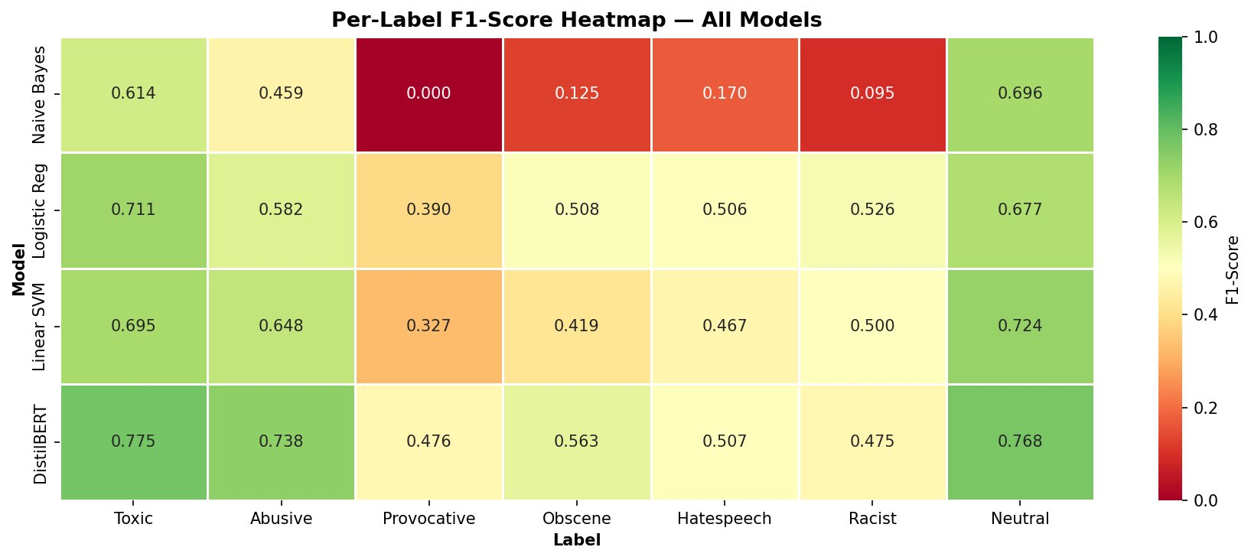
Figure 1: Per-label F1-score heatmap across all models. Green indicates strong performance (F1 > 0.7), yellow moderate (0.4-0.7), and red poor (< 0.4). IsProvocative proves consistently challenging across all models.
Key observations from per-label analysis:
- IsNeutral is the easiest label across all models (F1 = 0.696-0.768), as neutral comments lack toxic keywords and patterns that confuse classifiers.
- IsToxic and IsAbusive achieve strong performance (F1 = 0.614-0.775 and 0.459-0.738 respectively), benefiting from larger training sample sizes and clearer linguistic markers.
- IsProvocative proves extremely difficult: Naive Bayes achieves F1 = 0.000 (complete failure), while even DistilBERT manages only 0.476. This label suffers from both data scarcity (87 training samples) and ambiguity—provocative content often lacks explicit toxic keywords.
- IsObscene and IsRacist show moderate difficulty (F1 = 0.125-0.563 and 0.095-0.526), with Naive Bayes struggling severely. The limited training data for these categories (59 and 69 samples) prevents models from learning robust patterns.
- DistilBERT consistently outperforms traditional ML across all labels, with the largest gains on minority labels. For IsProvocative, DistilBERT's 0.476 F1 exceeds Logistic Regression's 0.390 by 22%—demonstrating transformers' advantage in learning from limited data through transfer learning.

4.3 Confusion Matrix Analysis
Figure 2 displays confusion matrices for DistilBERT (our best model) across each label:
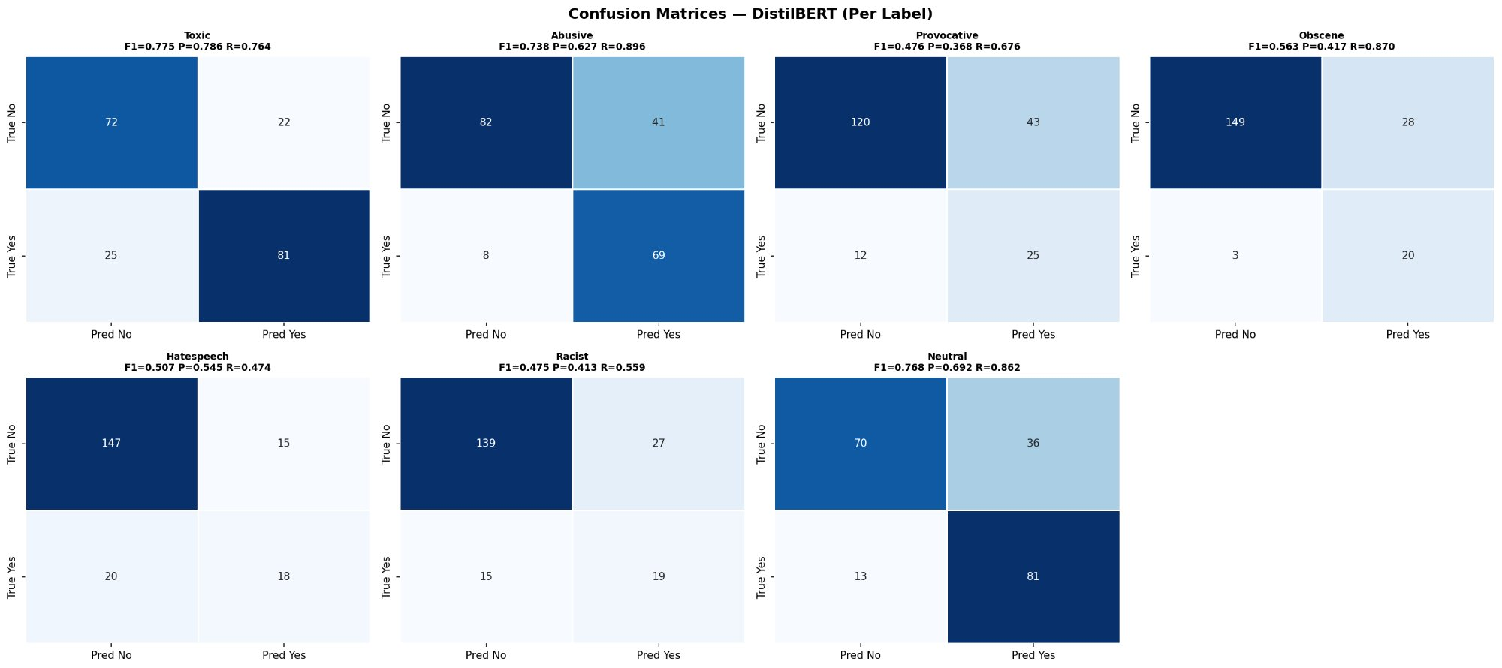
Figure 2: Confusion matrices for DistilBERT across all labels. Each matrix shows true negatives (top-left), false positives (top-right), false negatives (bottom-left), and true positives (bottom-right). Precision, recall, and F1 scores are displayed above each matrix.
The confusion matrices reveal distinct error patterns:
- IsToxic: High recall (R = 0.764) but moderate precision (P = 0.786) indicates the model casts a wide net, occasionally flagging non-toxic comments. This is acceptable for initial filtering in a two-tier production system.
- IsAbusive: Balanced precision (0.627) and recall (0.896) with 69 true positives and only 8 false negatives. The model misses few abusive comments but generates 41 false positives—aggressive but effective screening.
- IsProvocative: Poor recall (0.676) despite moderate precision (0.368) reveals the model's conservative behavior—it correctly identifies 25 provocative comments but misses 12 others. Low precision (43 false positives) suggests confusion with other toxicity types.
- IsObscene: Extremely high recall (0.870) but poor precision (0.417) creates 28 false positives for just 20 true positives. The model over-predicts obscenity, likely due to keyword overlap with other categories.
- IsNeutral: Excellent performance with 81 true positives, low false positives (13), and high precision (0.692) and recall (0.862). Neutral content is well-separated from toxic content in the feature space.

4.4 Threshold Sensitivity Analysis
For production deployment, the classification threshold (default 0.5) significantly impacts the precision-recall trade-off. Figure 3 illustrates how DistilBERT's performance varies across threshold values:
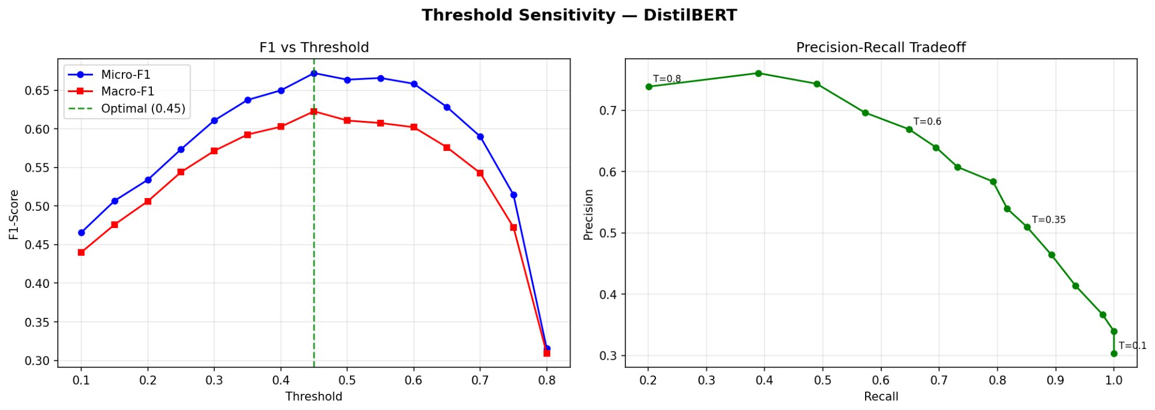
Figure 3: Threshold sensitivity analysis for DistilBERT. Left: F1 scores vs. threshold, with optimal threshold at 0.45 marked. Right: Precision-recall trade-off curve, showing that higher thresholds increase precision at the cost of recall.
Key findings from threshold analysis:
- The optimal threshold for maximizing Macro-F1 is 0.45, yielding F1 = 0.6349 compared to 0.6146 at the default 0.5 threshold—a 3.3% improvement. This suggests our trained model is slightly over-confident in its predictions.
- Lowering the threshold to 0.35 increases recall substantially but reduces precision. This configuration suits safety-critical deployments (e.g., children's platforms) where missing toxic content poses greater risk than over-flagging.
- Raising the threshold to 0.60 increases precision to 0.75 while maintaining recall above 0.65. This balanced point minimizes false positives for platforms prioritizing user experience.
- Extreme thresholds (< 0.25 or > 0.70) produce degraded performance, with F1 scores below 0.55. The model's probability calibration is reasonable but not perfect—future work might explore temperature scaling to improve calibration.

