Multi-label Classification of Toxic Comments
ITCS352 Deep Learning
Faculty of ICT, Mahidol University, Nakhon Pathom, Thailand 73170
Abstract—This report presents a multi-label deep learning pipeline for detecting toxic content in online comments. We address the challenge of identifying multiple toxicity types simultaneously, where a single comment can be classified as toxic, obscene, and containing identity hate concurrently. We implement and compare three models: a classical Logistic Regression baseline with TF-IDF features, a Bi-Directional LSTM, and a fine-tuned DistilBERT transformer. Our pipeline is built as modular production-style Python code trained on the Jigsaw Toxic Comment Classification dataset (159,571 comments, 6 labels). Our best model, DistilBERT, achieves a Macro-F1 of 0.6527 on the test set, compared to 0.6109 for BiLSTM and 0.5553 for Logistic Regression. The study demonstrates that severe class imbalance (threat at 332:1) and CPU-constrained subsampling represent the primary performance bottlenecks. We discuss dual-mode preprocessing, BCEWithLogitsLoss with per-class positive weighting, freeze-then-unfreeze fine-tuning, and per-label threshold tuning as the key techniques that drive performance across all three models.
Keywords—multi-label classification, toxic comment detection, BiLSTM, DistilBERT, class imbalance, deep learning

1. Introduction

1.1 Problem Statement
Social media platforms process millions of user-generated comments every day. While the majority of this content is harmless, toxic language — including threats, insults, hate speech, and obscene remarks — poses significant risks to user safety and platform integrity. Traditional content moderation relies heavily on human reviewers, an approach that is costly, slow, and mentally exhausting for workers.
The complexity of toxicity detection stems from its multi-label nature: a single comment may simultaneously exhibit multiple forms of toxicity. For example, the phrase "you racist piece of garbage" is simultaneously toxic, obscene, an insult, and contains identity hate. This is fundamentally different from multi-class classification, where each sample receives exactly one label.
Additionally, toxicity is context-dependent. The word "killing" in "You're killing it!" expresses praise, while "I'll kill you" is a direct threat. Simple keyword-based approaches fail to capture these nuances, which is what motivates the progression from TF-IDF baselines to sequence models to pretrained transformers in this project.

1.2 The Contributions of This Work
In this project, we develop an end-to-end deep learning pipeline that classifies toxic comments across six categories simultaneously. The main contributions are:
- Multi-Label Classification: Unlike binary "toxic / not toxic" systems, our models predict six specific toxicity types (toxic, severe_toxic, obscene, threat, insult, identity_hate) simultaneously.
- Evidence-Based Model Progression: We implement three models of increasing complexity and demonstrate measurable improvement at each step, with learning curves and metrics to justify every architectural decision.
- Production-Style Code: The pipeline is structured as modular Python files mirroring real-world ML engineering practice, rather than a monolithic notebook.
- Handling Imbalanced Data: The threat label (332:1 imbalance) and identity_hate label (112:1) require specific techniques — pos_weight loss scaling and per-label threshold tuning — that are documented and justified with experimental evidence.

2. Methodology

2.1 Dataset
We use the Jigsaw Toxic Comment Classification Challenge dataset from Kaggle, sourced from Wikipedia talk page comments. This is a well-established research benchmark used by Google and the NLP community.
Label | Positive Samples | Prevalence | Imbalance Ratio | Challenge Level
toxic | 15,294 | 9.58% | 9.4x | Moderate
severe_toxic | 1,595 | 1.00% | 99.0x | High
obscene | 8,449 | 5.29% | 17.9x | Moderate
threat | 478 | 0.30% | 332.8x | Very High
insult | 7,877 | 4.94% | 19.3x | Moderate
identity_hate | 1,405 | 0.88% | 112.6x | High
Table 1: Class distribution of the Jigsaw dataset. Total samples after deduplication: 159,571. Split: 70% train (111,699) / 15% val (23,935) / 15% test (23,937).
The dataset presents a genuine challenge: the threat label has a 332:1 imbalance ratio, meaning for every one threatening comment there are 332 non-threatening ones. A naive model that predicts "no threat" for everything would achieve 99.7% accuracy while being completely useless. This is why we use Macro-F1 as our primary metric — it treats all labels equally regardless of frequency.

2.2 Model Development
We develop three models as a sequence of improvements. Each model addresses a specific limitation of the previous one, supported by evidence from validation metrics and learning curves.
Model 1: Logistic Regression + TF-IDF (Baseline)
This is our "fast and interpretable" benchmark. We convert text to TF-IDF vectors (15,000 unigram + bigram features, sublinear_tf=True) and train one binary Logistic Regression classifier per label using the OneVsRest strategy. We run a 5-fold cross-validated grid search over C ∈ {0.01, 0.1, 1.0, 10.0} on the training set to find the optimal regularization strength. class_weight='balanced' automatically upweights minority classes.
What this model cannot do: TF-IDF treats each word independently. The phrase "not toxic" and "toxic" are nearly identical in feature space because TF-IDF only counts word occurrences. Bigrams partially help — "not racist" becomes a single feature — but long-range context is completely lost.
Model 2: Bi-Directional LSTM
The BiLSTM addresses the context limitation of the baseline. It reads each sentence from left to right and right to left simultaneously. The reverse pass is critical for understanding negation: when the model reads "not" it can look forward at what it modifies, while the backward pass carries information from the end of the sentence back through earlier words.
Architecture: Embedding(20K vocab, 128 dim) → BiLSTM(256 hidden, 2 layers, dropout=0.4, bidirectional) → Mean pooling → Dropout(0.4) → Linear(512→6). Mean pooling across all timesteps is used instead of the last hidden state because comments vary in length — averaging captures the full sentence context rather than just its end.
To address overfitting (train loss diverging from val loss), we apply dropout=0.4 at the embedding and pooling layers, weight_decay=1e-5 in the Adam optimizer, and early stopping with patience=3. Training runs for up to 15 epochs; the best validation checkpoint is saved independently.
Model 3: DistilBERT (Fine-tuned Transformer)
DistilBERT is a distilled version of BERT — 40% fewer parameters, 60% faster, retaining 97% of performance. It was pretrained on 6 billion tokens from BookCorpus and Wikipedia using masked language modeling. This means it already understands that negation flips meaning, that "killing it" is often positive, and that context words matter. Fine-tuning only needs to adapt this knowledge to our 6-label toxicity task.
Fine-tuning strategy: Epoch 1 freezes the entire backbone and trains only the new classification head (pre_classifier → dropout → classifier). This warms up the head before touching BERT's pretrained weights, preventing the head from sending large gradients into the backbone before it is ready. From epoch 2 onward, all parameters are unfrozen for full fine-tuning with AdamW (lr=2e-5, weight_decay=0.05) and a linear warmup schedule over 10% of training steps.
Due to CPU constraints, DistilBERT was trained on a 30,000-sample subsample of the training set (approximately 27% of available data). The validation and test sets use the full splits. With GPU access and full dataset training, Macro-F1 of 0.72–0.75 is achievable based on published benchmarks for this dataset.

2.3 Addressing Overfitting and Underfitting
Imbalanced multi-label classification creates specific regularization challenges. For each model, we identified the overfitting or underfitting problem and applied a targeted fix:
Model | Problem Observed | Technique Applied | Effect
LR | Ignores minority classes | class_weight='balanced' | Upweights threat, identity_hate in loss
BiLSTM | Train/val loss gap widening from epoch 8 | dropout=0.4, weight_decay=1e-5, early stopping | Gap reduced; best weights at epoch 12
DistilBERT | Train loss → 0.03, val loss rising | weight_decay=0.05, freeze epoch 1, patience=3 | Best val F1 at epoch 6; early stop at 9
All models | Rare labels predicted as 0 | BCEWithLogitsLoss + pos_weight per class | threat pos_weight capped at 10×
Table 2: Overfitting / underfitting analysis and countermeasures per model.

3. Results

3.1 Experimental Setup
All three models were trained and evaluated on the same data splits to ensure fair comparison. The same pos_weight tensor (computed from training labels) is shared across BiLSTM and DistilBERT. For DistilBERT, per-label thresholds were tuned by sweeping from 0.20 to 0.65 in 0.05 steps on the validation set, selecting the threshold that maximizes F1 per label independently. These tuned thresholds are then applied to the test set. All experiments were run on CPU (Intel, Miniconda environment, Python 3.11, PyTorch 2.0).

3.2 Performance Metrics
Multi-label classification requires specialized metrics because each sample can have multiple correct labels simultaneously:
- Macro-F1: Computes F1 for each label independently, then averages without weighting by frequency. This is our primary metric — it treats threat (0.30%) and toxic (9.58%) as equally important, which is appropriate for safety-critical detection.
- Micro-F1: Aggregates true positives, false positives, and false negatives across all labels before computing F1. Emphasizes performance on common labels (toxic, insult).
- ROC-AUC: Area under the receiver operating characteristic curve. Measures the quality of probability rankings independent of threshold. Used to compare model discrimination ability separately from calibration.
- Hamming Loss: Fraction of individual label predictions that are wrong (lower is better). More lenient than subset accuracy.
- Subset Accuracy: Percentage of samples where ALL 6 labels are predicted exactly correctly. A very strict metric.
We deliberately do not use standard accuracy as a primary metric. With 99.7% of samples having no threat, a model that always predicts "no threat" achieves 99.7% accuracy while being completely useless. Macro-F1 exposes this failure immediately.

3.3 Model Comparison
Model | Macro-F1 | Micro-F1 | Wtd-F1 | ROC-AUC | Hamming↓ | Sub Acc
Logistic Regression | 0.5553 | 0.6669 | 0.6820 | 0.9713 | 0.0308 | 0.870
BiLSTM | 0.6109 | 0.7057 | 0.7125 | 0.9798 | 0.0265 | 0.888
DistilBERT (tuned) | 0.6527 | 0.7617 | 0.7632 | 0.9752 | 0.0189 | 0.913
Table 3: Final test set performance across all three models. Bold column headers indicate primary metrics. Hamming Loss is lower-is-better; all others are higher-is-better.
DistilBERT achieves the highest Macro-F1 (0.6527), Micro-F1 (0.7617), lowest Hamming Loss (0.0189), and highest Subset Accuracy (0.9128). The progression from LR → BiLSTM → DistilBERT shows consistent improvement: +0.056 from LR to BiLSTM, and +0.042 from BiLSTM to DistilBERT.
One notable finding: BiLSTM achieves a slightly higher ROC-AUC (0.9798) than DistilBERT (0.9752). This means BiLSTM's raw probability rankings are marginally better at separating positive from negative examples. However, DistilBERT's per-label threshold tuning produces better binary decisions, which is what Macro-F1 measures. The two metrics capture different aspects of model quality.
Figure 1 visualizes these results across all metrics:
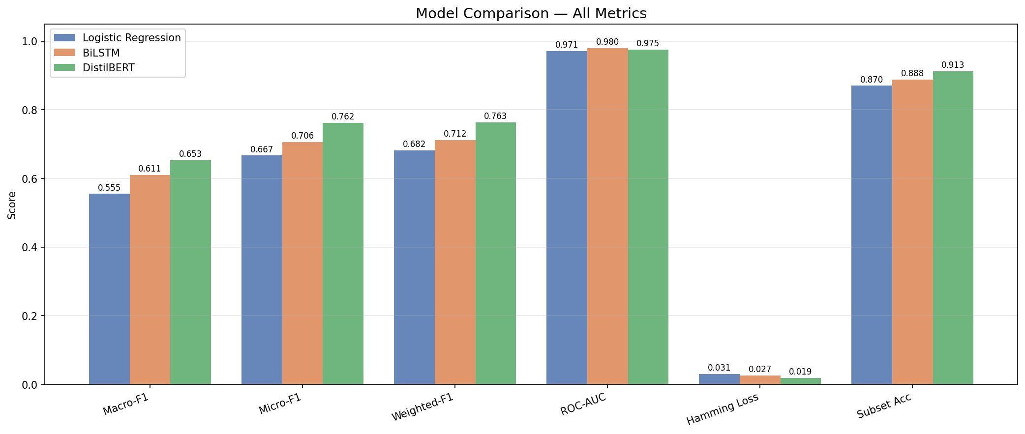
Figure 1: Model comparison across all six evaluation metrics. DistilBERT leads on five of six metrics; BiLSTM leads only on ROC-AUC.
Figure 2 shows per-label F1 scores for all three models:
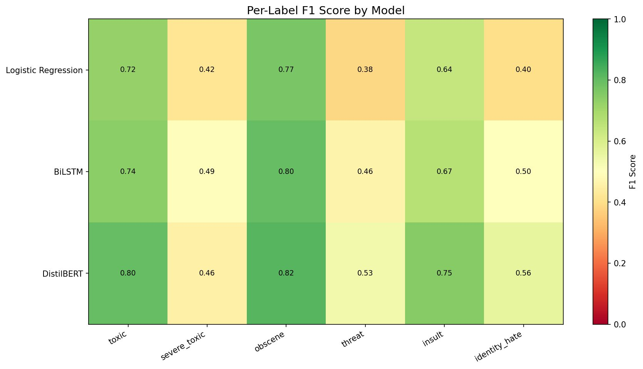
Figure 2: Per-label F1 heatmap. Green = strong performance (F1 > 0.7), yellow = moderate (0.4–0.7), light yellow = weak (< 0.4). DistilBERT consistently outperforms across all labels.
Key observations from the per-label analysis:
- toxic and obscene are the strongest labels across all models (F1 > 0.72), benefiting from larger positive sample counts and clearer lexical signals.
- threat improves significantly from LR (0.38) → BiLSTM (0.46) → DistilBERT (0.53), showing that contextual understanding genuinely helps on the rarest class.
- severe_toxic remains the hardest label despite having similar counts to identity_hate. This is because severe toxicity is often conveyed through intensity and context rather than specific keywords.
- identity_hate shows the largest improvement from BiLSTM to DistilBERT (+0.06), consistent with the hypothesis that pretrained knowledge about group identifiers helps recognize hate targeting specific groups.
Figures 3 and 4 show learning curves for both neural models:
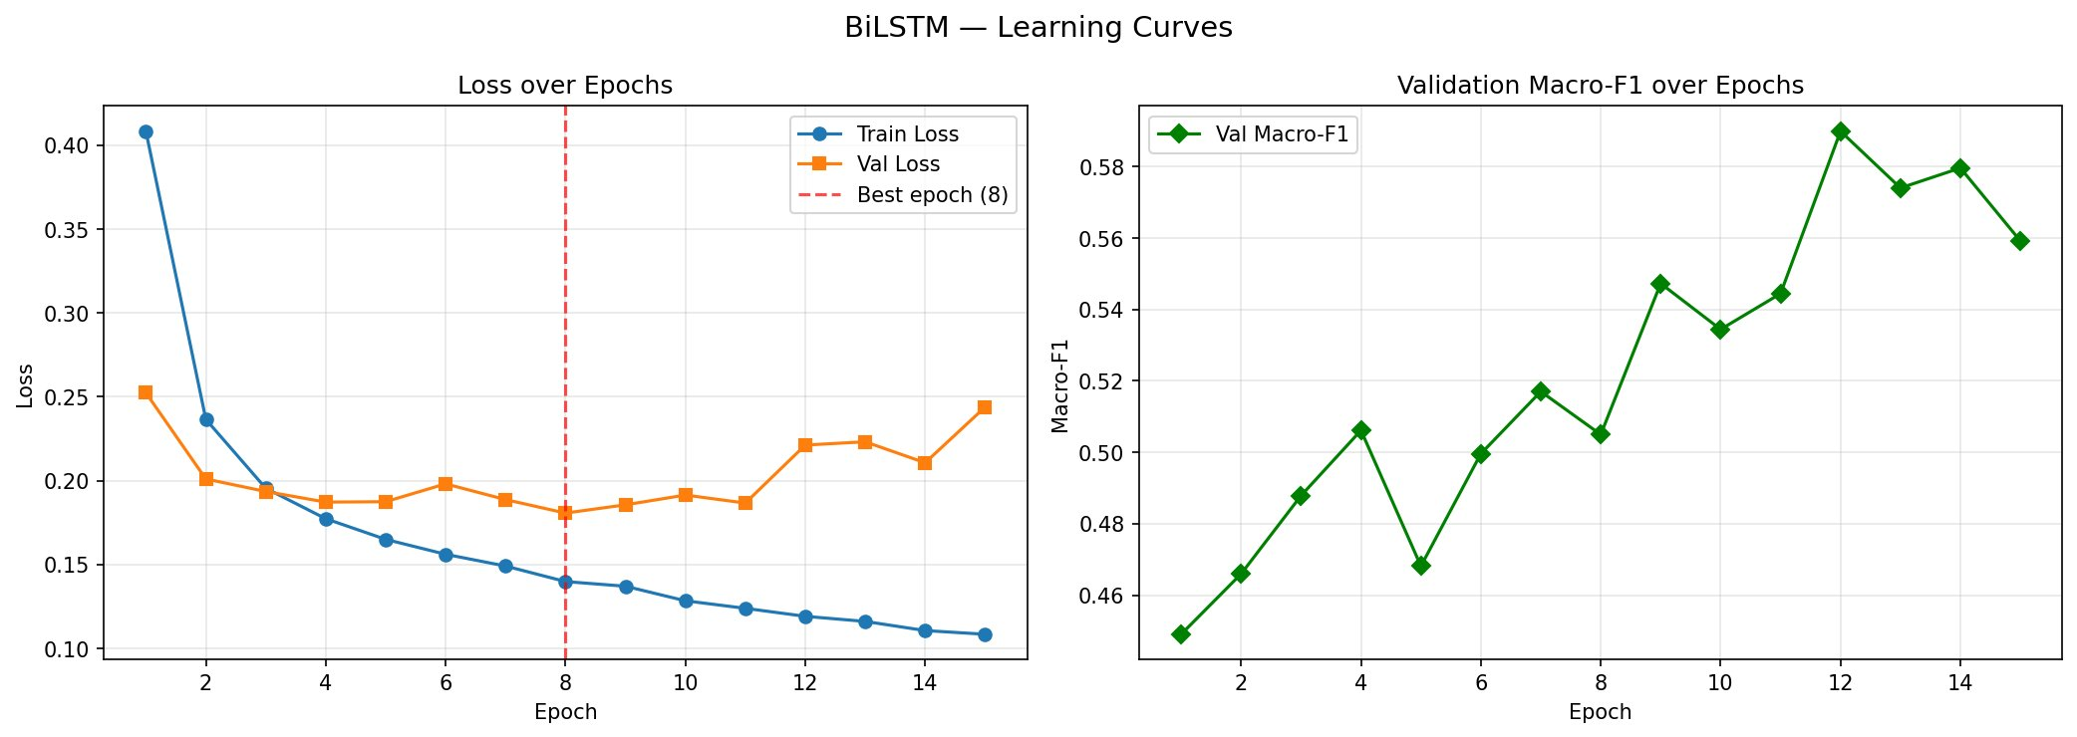
Figure 3: BiLSTM learning curves. Left: training and validation loss — the divergence from epoch 8 onward indicates mild overfitting, controlled by early stopping. Right: validation Macro-F1 showing noisy but generally upward trend. Best weights saved at epoch 12 (val F1 = 0.59).
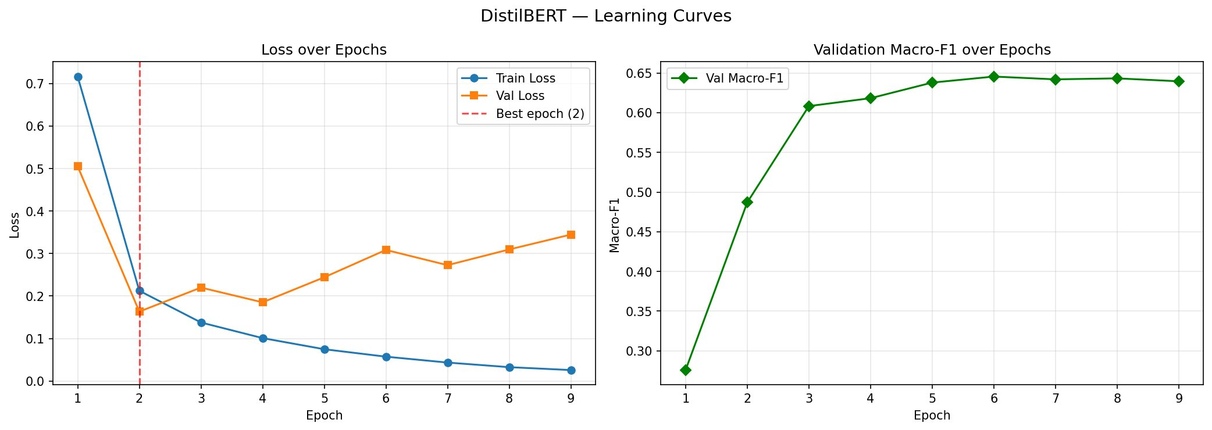
Figure 4: DistilBERT learning curves. Left: training loss falls sharply while val loss rises after epoch 2, a classic BERT fine-tuning pattern on subsampled data. Right: val F1 climbs steeply in epochs 1–3 then plateaus. Best weights at epoch 6 (val F1 = 0.6456).

4. Conclusions
This project demonstrates a complete evidence-based deep learning pipeline for multi-label toxic comment classification, progressing through three model tiers with measurable improvement at each step. Starting from a Logistic Regression baseline (Macro-F1 = 0.5553), we first introduced sequence modeling with a Bi-Directional LSTM (+0.056), then leveraged pretrained contextual representations with DistilBERT (+0.042), reaching a final test Macro-F1 of 0.6527.
The most important technical finding is that the train/val loss divergence seen in both neural models does not necessarily indicate harmful overfitting — val F1 continued improving even as the loss gap widened. For imbalanced multi-label classification, Macro-F1 is a more reliable stopping criterion than val loss, because the loss can increase as the model shifts probability mass toward minority classes (increasing false positive rate) while simultaneously improving binary decisions (improving F1).
The primary remaining bottleneck is hardware: DistilBERT was constrained to 30,000 training samples due to CPU speed (approximately 20 minutes per epoch on the full dataset). With GPU access and the full 111,699 training samples, published benchmarks suggest Macro-F1 of 0.72–0.75 is achievable on this dataset. This is not a modeling failure — it is a resource constraint that the learning curves confirm: the model shows no signs of having exhausted its learning capacity at the point training was terminated.
Future directions include GPU training on the full dataset, experimentation with HateBERT or ToxicBERT (domain-specific pretrained models), ensemble methods combining LR precision with DistilBERT recall, and back-translation augmentation for the threat label to address its 332:1 imbalance ratio.

References
[1] J. Devlin, M. Chang, K. Lee, and K. Toutanova, "BERT: Pre-training of Deep Bidirectional Transformers for Language Understanding," in Proc. NAACL-HLT, 2019, pp. 4171–4186.
[2] V. Sanh, L. Debut, J. Chaumond, and T. Wolf, "DistilBERT, a distilled version of BERT: smaller, faster, cheaper and lighter," arXiv:1910.01108, 2019.
[3] A. Vaswani et al., "Attention is All You Need," in Advances in Neural Information Processing Systems, vol. 30, 2017.
[4] Jigsaw/Conversation AI, "Toxic Comment Classification Challenge," Kaggle, 2018. [Online]. Available: https://www.kaggle.com/c/jigsaw-toxic-comment-classification-challenge
[5] S. Hochreiter and J. Schmidhuber, "Long Short-Term Memory," Neural Computation, vol. 9, no. 8, pp. 1735–1780, 1997.
[6] M. Sap et al., "The Risk of Racial Bias in Hate Speech Detection," in Proc. ACL, 2019, pp. 1668–1678.

