Credit Score Classification: Project Report

1. Introduction
The goal of this project is to predict a customer's credit score (Poor, Standard or Good) from financial and personal attributes, so that credit assessment can be automated, consistent and faster. The data has 100,000 labeled training rows (12,500 customers, 8 monthly records each) and 50,000 unlabeled test rows.

2. Data cleaning
The raw data contained stray characters (for example trailing underscores), placeholder strings, numbers stored as text, impossible values (negative ages, extreme counts of accounts or loans) and missing values. Junk and impossible values were converted to missing, numeric columns were converted to numbers, and Credit_History_Age was converted to months. Missing values were then filled using the same customer's other months (mode for categorical and fixed attributes, median for varying amounts). Any remaining gaps were filled with training-set statistics.

3. Feature engineering
New features: loan count, one flag per loan type, debt-to-income, EMI-to-salary, investment-to-salary and balance-to-salary ratios. Identifier columns (ID, Customer_ID, Name, SSN) and Month were dropped. Credit_Mix was encoded as an ordered value (Bad < Standard < Good); Occupation, Payment_of_Min_Amount and Payment_Behaviour were one-hot encoded. The target was encoded as Poor=0, Standard=1, Good=2.

4. Exploratory data analysis
Median values of key features by credit score class:
Credit_Score | Interest_Rate | Outstanding_Debt | Delay_from_due_date | Num_of_Delayed_Payment | Credit_History_Months | Credit_Utilization_Ratio
Poor | 21.0000 | 1945.3500 | 27.0000 | 17.0000 | 161.0000 | 32.0100
Standard | 13.0000 | 1001.6100 | 18.0000 | 14.0000 | 227.0000 | 32.3300
Good | 7.0000 | 736.4700 | 10.0000 | 8.0000 | 288.0000 | 32.7400
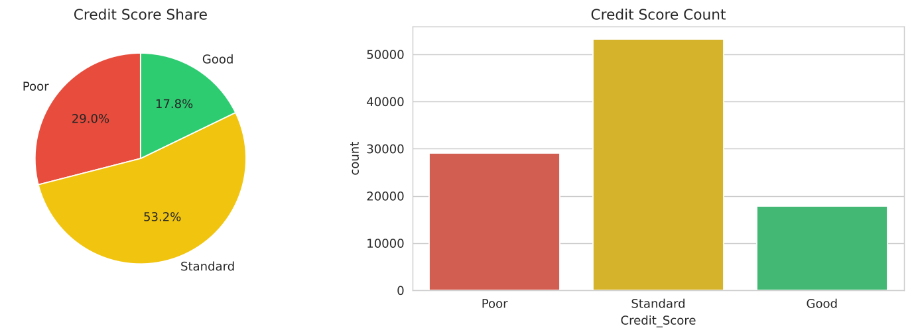
Figure 1: Target distribution.
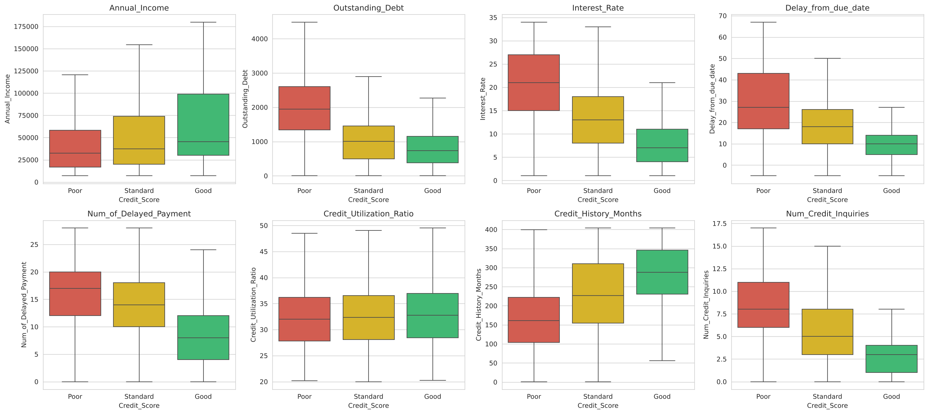
Figure 2: Key numeric features by credit score.
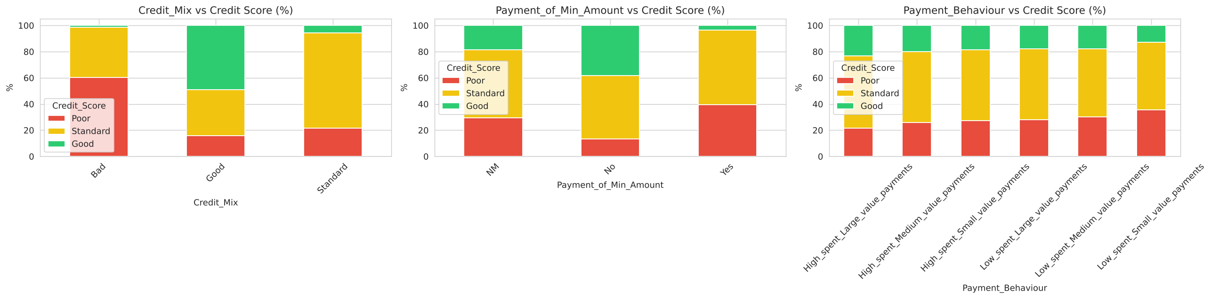
Figure 3: Categorical features versus credit score.
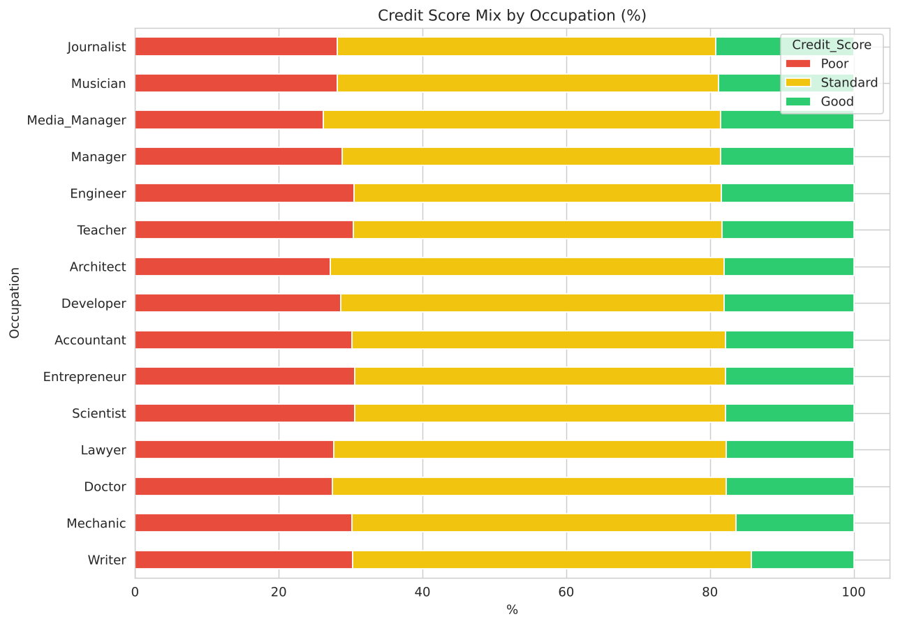
Figure 4: Credit score mix by occupation.
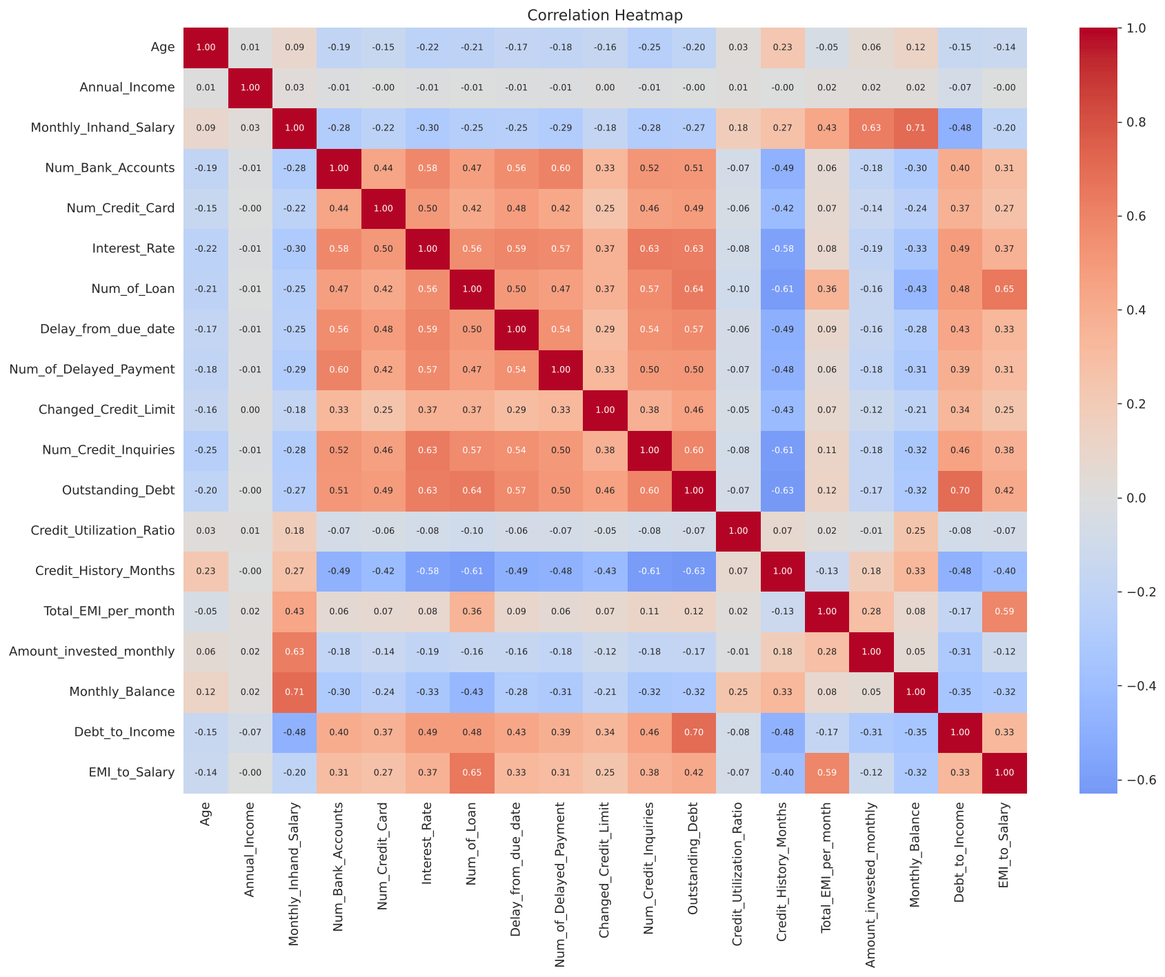
Figure 5: Correlation heatmap.
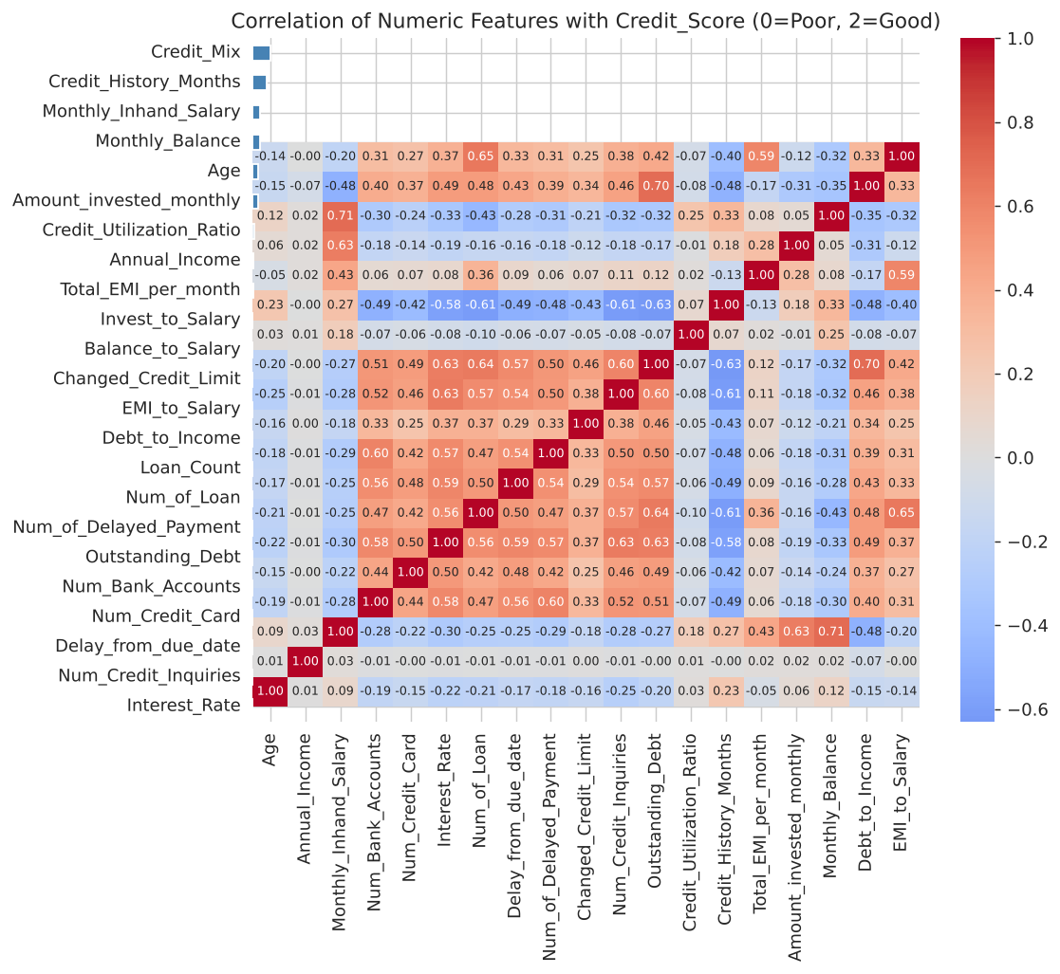
Figure 6: Correlation of features with the credit score.

5. Methodology
train.csv was split 80/20 by customer (StratifiedGroupKFold on Customer_ID) so that no customer appears in both the training and validation sets; a random row split would leak a customer's near-identical monthly records and inflate scores. Three models were trained: Logistic Regression (baseline, with standard scaling inside a pipeline), Random Forest and XGBoost. The tree models need no scaling. Because the classes are imbalanced, the best model was chosen by macro F1.

6. Model comparison
Results on the held-out validation set:
Model | Accuracy | Macro F1 | Weighted F1 | Poor F1 | Standard F1 | Good F1
Random Forest | 0.7010 | 0.6783 | 0.7022 | 0.6818 | 0.7448 | 0.6084
XGBoost | 0.6956 | 0.6698 | 0.6952 | 0.6757 | 0.7399 | 0.5936
Logistic Regression | 0.6632 | 0.6330 | 0.6597 | 0.5920 | 0.7214 | 0.5857
Best model: Random Forest (accuracy 0.7010, macro F1 0.6783).
Training versus validation accuracy (a large gap indicates overfitting):
Model | Train accuracy | Validation accuracy | Validation macro F1 | Train time (s) | Gap
Logistic Regression | 0.6636 | 0.6632 | 0.6330 | 0.5000 | 0.0004
Random Forest | 0.9638 | 0.7010 | 0.6783 | 25.2000 | 0.2628
XGBoost | 0.8658 | 0.6956 | 0.6698 | 6.0000 | 0.1702
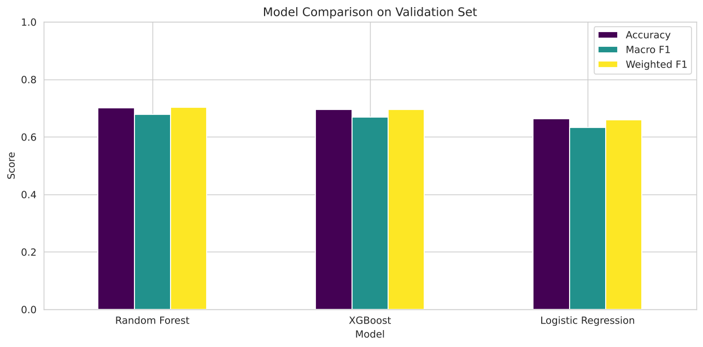
Figure 7: Model comparison.
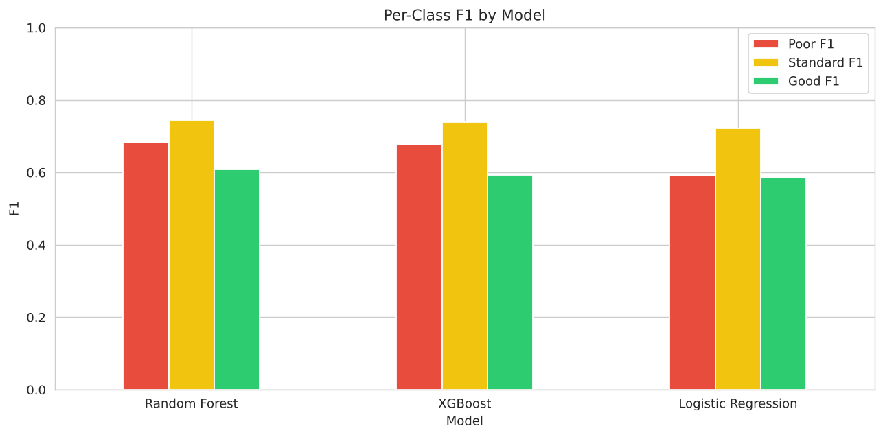
Figure 8: Per-class F1.
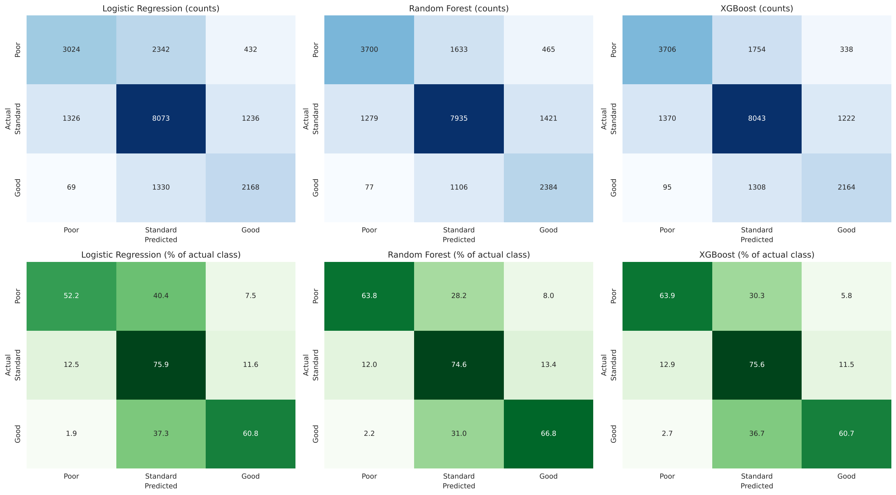
Figure 9: Confusion matrices.

7. Feature importance
The five most important features by permutation importance (Random Forest) were: Interest_Rate, Credit_Mix, Outstanding_Debt, Delay_from_due_date, Payment_of_Min_Amount_Yes. With one-hot columns combined, the top factors by average built-in importance were: Credit_Mix, Payment_of_Min_Amount, Occupation, Outstanding_Debt, Interest_Rate.
Feature | Importance
Interest_Rate | 0.0681
Credit_Mix | 0.0589
Outstanding_Debt | 0.0385
Delay_from_due_date | 0.0345
Payment_of_Min_Amount_Yes | 0.0166
Changed_Credit_Limit | 0.0142
Num_Credit_Card | 0.0140
Credit_History_Months | 0.0099
Loan_Count | 0.0073
Num_Credit_Inquiries | 0.0065
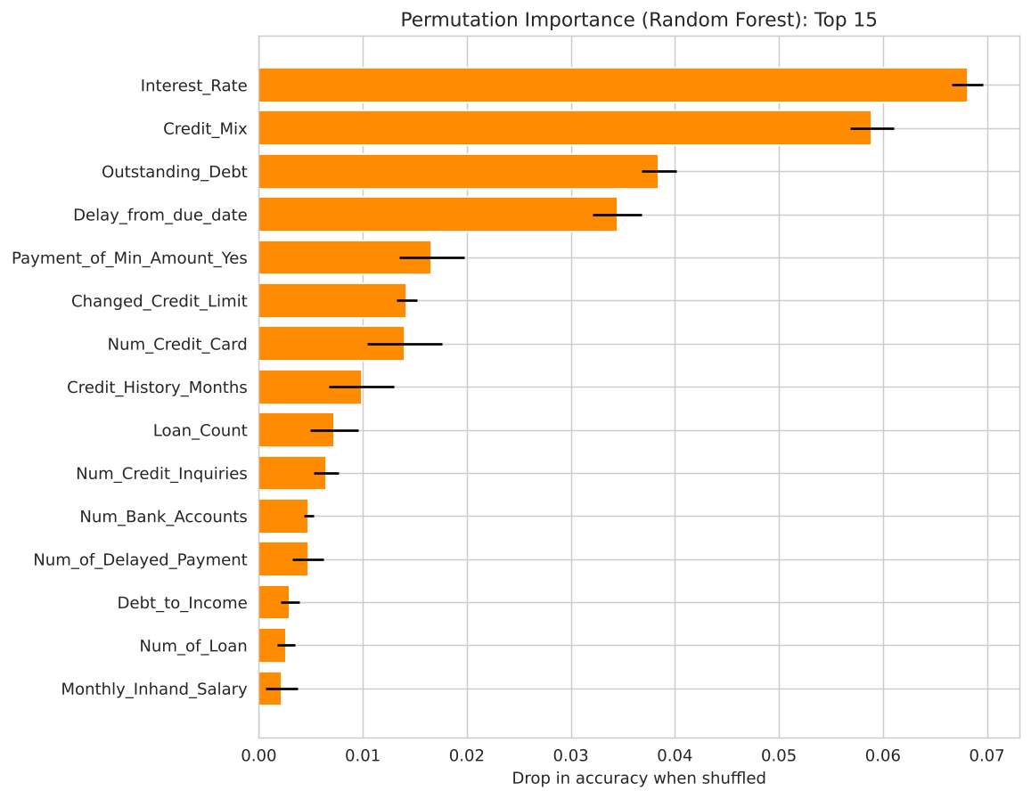
Figure 10: Permutation importance.
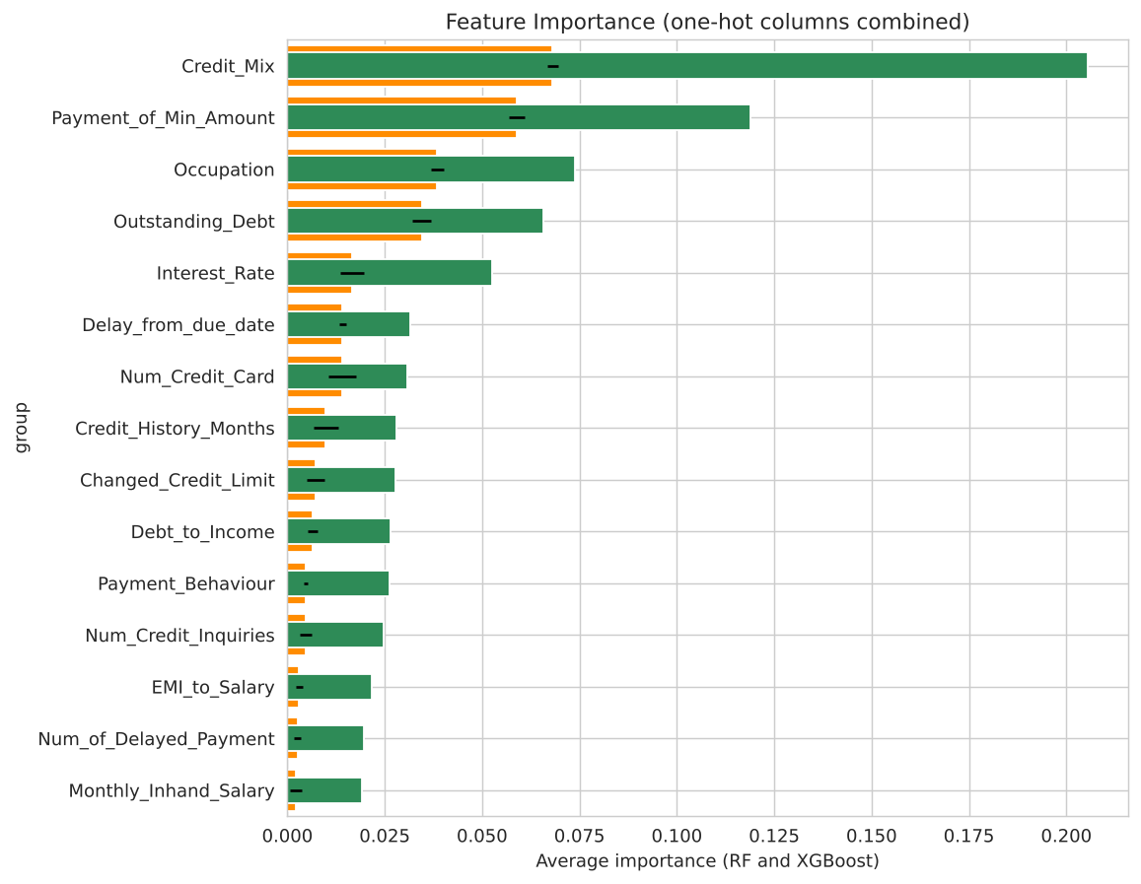
Figure 11: Grouped feature importance.
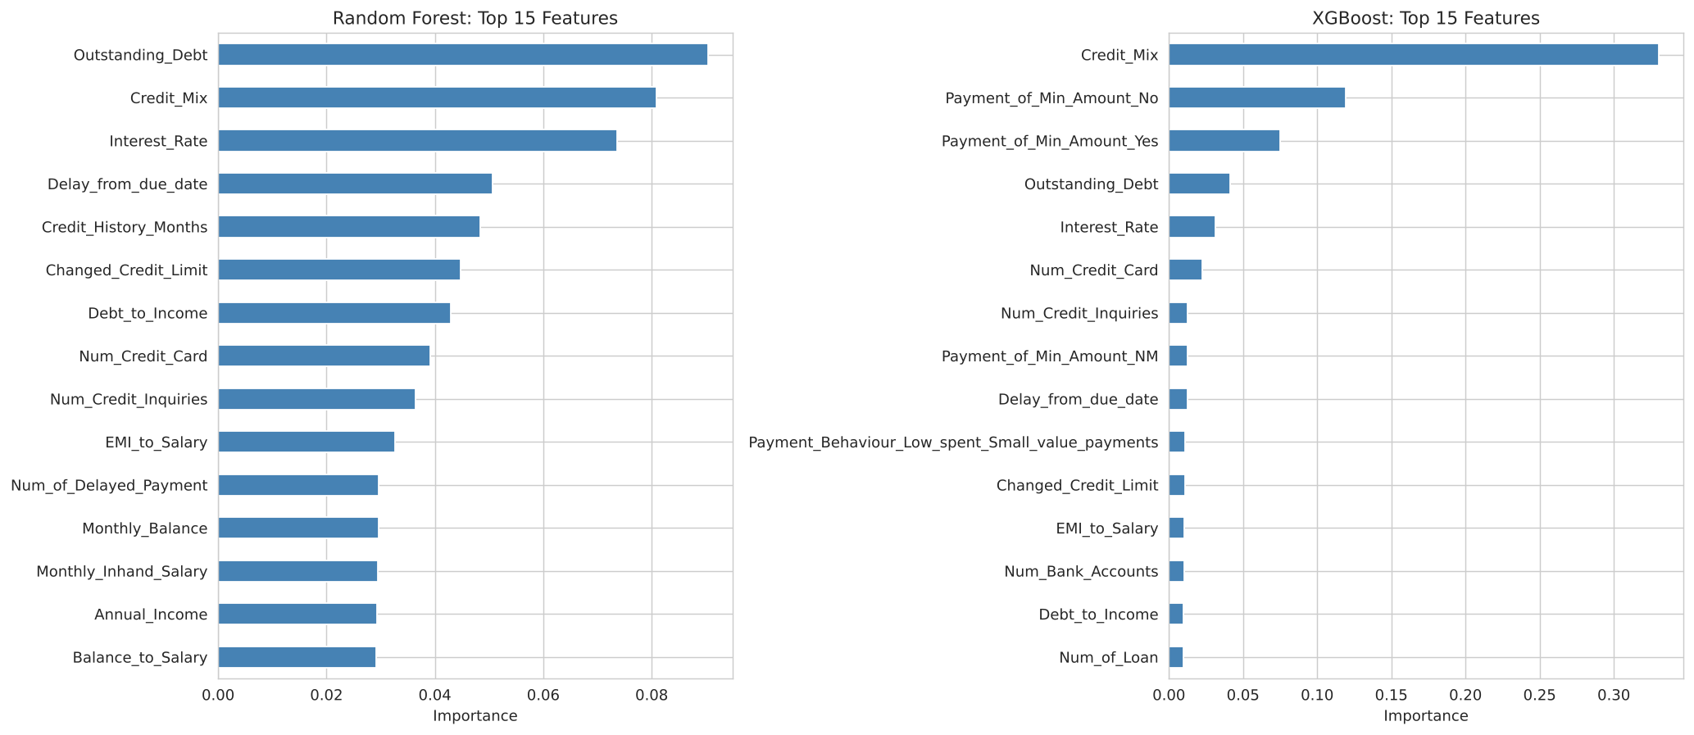
Figure 12: Built-in importance (Random Forest and XGBoost).

8. Predictions on test.csv
The best model was retrained on all of train.csv and used to predict the 50,000 test rows (outputs/predictions.csv). Predicted class shares:
index | Train (actual) | Test (predicted)
Poor | 0.2900 | 0.3030
Standard | 0.5320 | 0.5090
Good | 0.1780 | 0.1880
test.csv has no Credit_Score column, so accuracy cannot be measured on it. All reported metrics come from the customer-grouped validation split of train.csv.
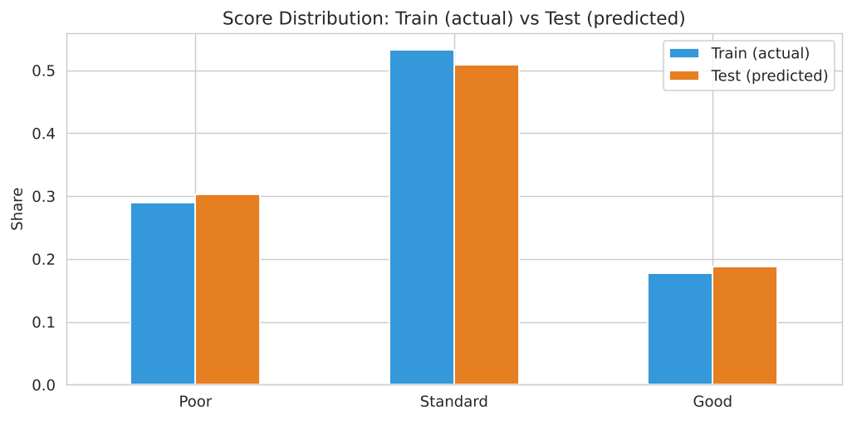
Figure 13: Train (actual) versus test (predicted) distribution.

9. Limitations and future work
No labels exist for test.csv; hyperparameters were not extensively tuned; the data is partly synthetic and heavily noisy; the Standard class is the largest and hardest to separate. Future work: hyperparameter search, class weighting, additional models (LightGBM), and probability calibration.

10. Conclusion
Random Forest performed best on the validation set (accuracy 0.7010, macro F1 0.6783). The most influential factors were Interest_Rate, Credit_Mix, Outstanding_Debt, which links back to the patterns seen in the EDA.

