VLSI DESIGN LAB
HALF ADDER - ANALOG DESIGN USING CADENCE
Schematic of XOR Gate (Sum):
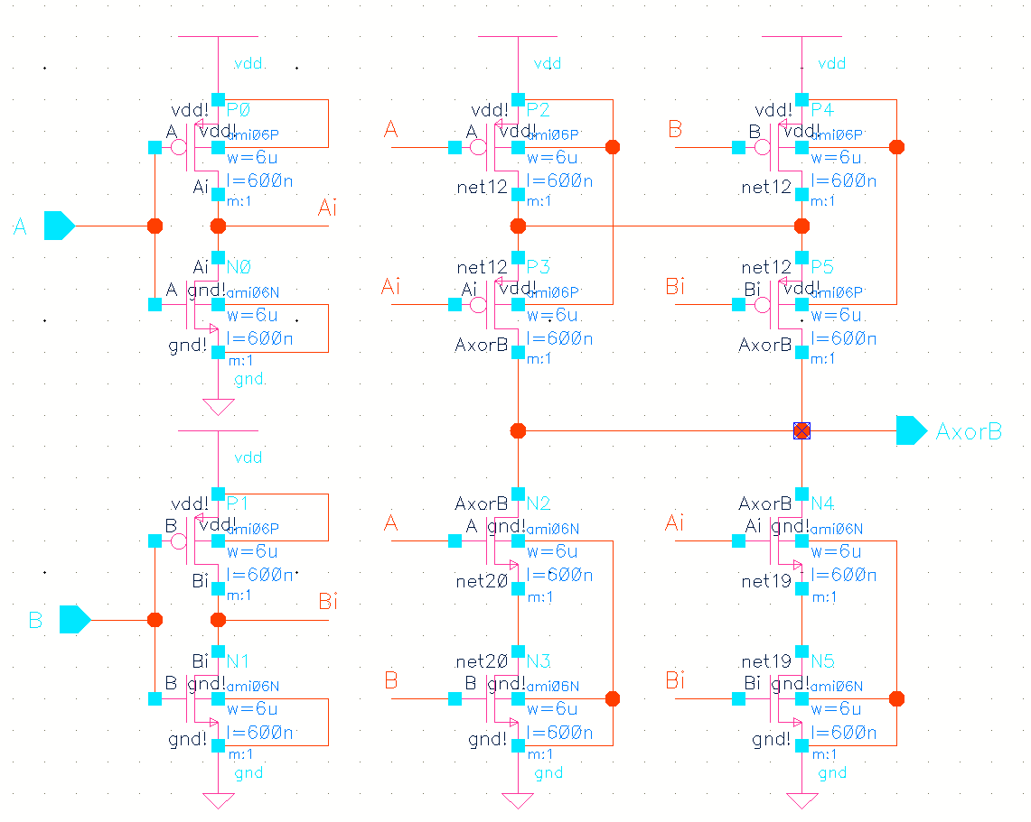
Schematic of NAND Gate (Carry):
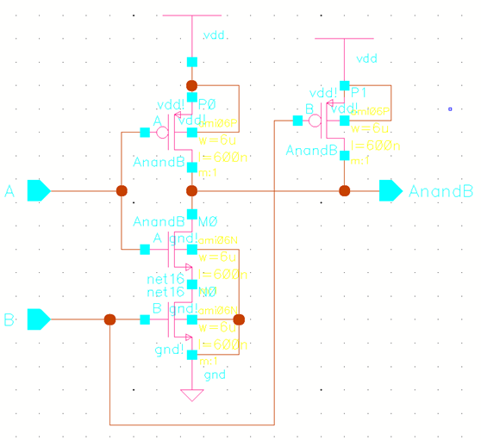
Output:


