VLSI DESIGN LAB
MULTIPLEXERS AND COUNTERS
A. 4:1 Multiplexer
Program:
module mux4_1(out, a, b, c, d, s0, s1);
input a, b, c, d, s0, s1;
output reg out;

always @(*)
begin
case ({s0, s1})
2'b00: out = a;
2'b01: out = b;
2'b10: out = c;
2'b11: out = d;
endcase
end
endmodule
Test Bench:
`timescale 1ns/1ps
module mux4_1_tb;
reg a, b, c, d, s0, s1;
wire out;

mux4_1 uut(out, a, b, c, d, s0, s1);

initial
begin
a = 1; b = 0; c = 0; d = 0; s0 = 0; s1 = 0;
#200 a = 0; b = 1; s0 = 0; s1 = 1;
#100 b = 0; c = 1; s0 = 1; s1 = 0;
#100 c = 0; d = 1; s0 = 1; s1 = 1;
#600 $finish;
end
endmodule
Output:
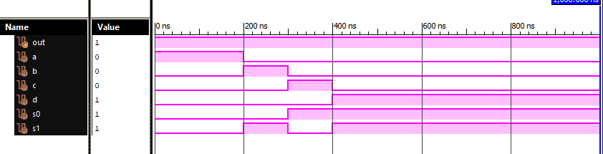
B. 8:1 Multiplexer
Program:
module mux8_1(out, a, b, c, d0, d1, d2, d3, d4, d5, d6, d7);
input a, b, c; /* select lines (a is MSB) */
input d0, d1, d2, d3, d4, d5, d6, d7;
output reg out;

always @(*)
begin
case ({a, b, c})
3'b000: out = d0;
3'b001: out = d1;
3'b010: out = d2;
3'b011: out = d3;
3'b100: out = d4;
3'b101: out = d5;
3'b110: out = d6;
3'b111: out = d7;
endcase
end
endmodule
Test Bench:
`timescale 1ns/1ps
module mux8_1_tb;
reg a, b, c, d0, d1, d2, d3, d4, d5, d6, d7;
wire out;

mux8_1 uut(out, a, b, c, d0, d1, d2, d3, d4, d5, d6, d7);

initial
begin
{a, b, c} = 3'b000;
{d0, d1, d2, d3, d4, d5, d6, d7} = 8'b10000000;
#200 {a, b, c} = 3'b001; {d0, d1, d2, d3, d4, d5, d6, d7} = 8'b01000000;
#100 {a, b, c} = 3'b010; {d0, d1, d2, d3, d4, d5, d6, d7} = 8'b00100000;
#100 {a, b, c} = 3'b011; {d0, d1, d2, d3, d4, d5, d6, d7} = 8'b00010000;
#100 {a, b, c} = 3'b100; {d0, d1, d2, d3, d4, d5, d6, d7} = 8'b00001000;
#100 {a, b, c} = 3'b101; {d0, d1, d2, d3, d4, d5, d6, d7} = 8'b00000100;
#100 {a, b, c} = 3'b110; {d0, d1, d2, d3, d4, d5, d6, d7} = 8'b00000010;
#100 {a, b, c} = 3'b111; {d0, d1, d2, d3, d4, d5, d6, d7} = 8'b00000001;
#200 $finish;
end
endmodule
Output:
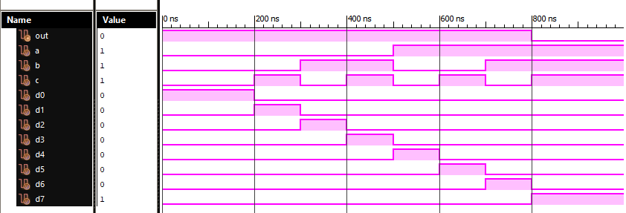
C. 4-Bit Up Counter
Program:
module up_counter(clk, rst, q);
input clk, rst;
output reg [3:0] q;

always @(posedge clk or posedge rst)
begin
if (rst)
q <= 4'b0000;
else
q <= q + 1;
end
endmodule
Test Bench:
`timescale 1ns/1ps
module up_counter_tb;
parameter T = 20;
reg clk, rst;
wire [3:0] q;

up_counter uut(clk, rst, q);

initial clk = 0;
always #(T/2) clk = ~clk;

initial
begin
rst = 1;
#20 rst = 0;
#70 rst = 1;
#10 rst = 0;
#310 $finish;
end
endmodule
Output:
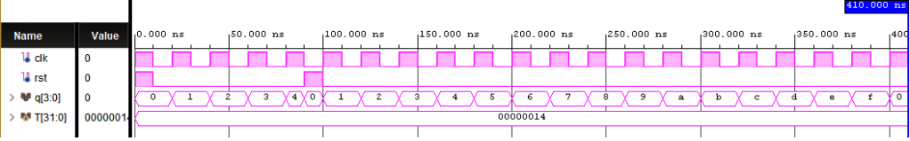
D. 3-Bit Up/Down Counter
Program:
module updown_counter(q, mod, clk, rst);
output reg [2:0] q;
input mod, clk, rst;

always @(posedge clk or posedge rst)
begin
if (rst)
q <= 3'b000;
else if (mod)
q <= q + 1; /* mod = 1 : up counting */
else
q <= q - 1; /* mod = 0 : down counting */
end
endmodule
Test Bench:
`timescale 1ns/1ps
module updown_counter_tb;
reg mod, clk, rst;
wire [2:0] q;

updown_counter uut(q, mod, clk, rst);

initial clk = 0;
always #10 clk = ~clk;

initial
begin
rst = 1; mod = 0;
#20 rst = 0;
#160 mod = 1;
#70 $finish;
end
endmodule
Output:


