VLSI DESIGN LAB
FPGA KIT EXPERIMENT - ADDERS
A. Half Adder
Program:
module half_adder(i0, i1, s, c);
input i0, i1;
output s, c;

assign s = i0 ^ i1; /* Sum */
assign c = i0 & i1; /* Carry */
endmodule
Output:
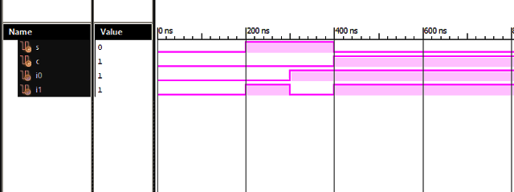
B. Full Adder
Program:
module full_adder(Data_in_A, Data_in_B, Data_in_C,
Data_out_Sum, Data_out_Carry);
input Data_in_A, Data_in_B, Data_in_C;
output Data_out_Sum, Data_out_Carry;

assign Data_out_Sum = Data_in_A ^ Data_in_B ^ Data_in_C;
assign Data_out_Carry = (Data_in_A & Data_in_B) |
(Data_in_B & Data_in_C) |
(Data_in_A & Data_in_C);
endmodule
Output:
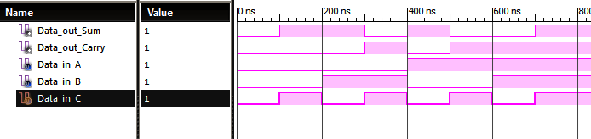
C. Parallel Adder (4-bit)
Program:
/* 4-bit parallel (ripple carry) adder built from four full adders */
module parallel_adder(sum, carry, a, b, c);
output [3:0] sum;
output carry;
input [3:0] a, b;
input c; /* carry input */
wire c1, c2, c3;

full_adder fa0(a[0], b[0], c, sum[0], c1);
full_adder fa1(a[1], b[1], c1, sum[1], c2);
full_adder fa2(a[2], b[2], c2, sum[2], c3);
full_adder fa3(a[3], b[3], c3, sum[3], carry);
endmodule
Output:
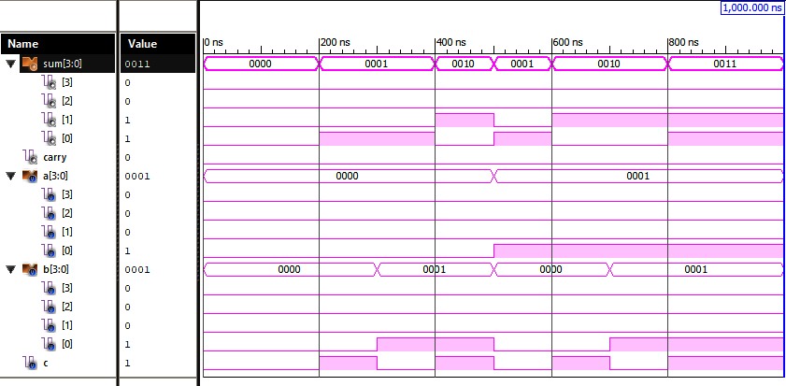
D. Implementation on FPGA Kit


