**AGRICULTURAL MACHINERY IN SOUTH TAMILNADU AMONG FARMERS**

*Dr.T.Chandrakumar, Ph.D., Assistant Professor at the Department of Computer Application*

*Nithiyasri K V, Shibani K R, Shobika R*

**ABSTRACT:**

Economic growth in India purely depends on the Indian agricultural sector. Agricultural machinery plays an important role in the improvement of agricultural production and productivity in developing countries[1]. The research focuses on identifying which agricultural machinery is mostly used by the farmers in South Tamilnadu. In this paper, we have taken farmer names and mobile numbers into consideration by collecting the real details through surveys. This paper contains the details of five districts such as Dindigul, Madurai, Theni, Ramnad, and Virudhunagar in which we have predicted which machinery is suitable for that region. The research paper deals with the relation between the farmer’s mobile number and the agricultural machinery. To get efficient results, we have applied linear regression and built a model by testing and training the datasets in all five data frames. Prediction of each data frame reveals the efficient working of the particular machinery in that particular area due to the different geographical features.

**Keywords:** Mechanization, Mechanization strategy, Farm power, Types of machinery, South Tamilnadu

**INTRODUCTION:**

Agriculture is the practice of cultivating plants and livestock which is the key development in human civilization where the Indian economy directly depends on it. In particular, Tamil Nadu agriculture is the most overriding sector in the economy of the state as it contributes about 17% to the total GDP and provides employment to over 60% of the population. Above 50% of the population in South Tamil Nadu are involved in agricultural activities. There are many types of equipment used in agriculture, from hand tools to tractors and many kinds of farm machinery that they used to tow or operate. The use of modern agricultural machines instead of primitive tools, machinery, equipment, and facilities is called agricultural mechanization. Agricultural mechanization is generally used for increasing the productivity of land and labor [2].

The Indian farmers gradually responded to farm mechanization technology especially after the Green revolution in the 1960s. To usher in the Second Green Revolution and to increase agricultural production, the Agricultural Engineering Department is implementing various programs for soil & water conservation, water management, groundwater recharge, and farm mechanization in a massive way. The economic reforms of the 1990s have deprioritized the agricultural sector and also diverted attention away from scholarly concerns about agrarian transformation. Some of the reform rhetoric can be shown openly to confront the interests of the mass of agricultural producers. [12]To maximize the use of the newly developed agricultural machinery in agriculture and to improve the farm power availability, training programs on operation and maintenance of the agricultural machinery/implements are imparted to rural youth. Agricultural machinery is widely used by farmers to make farming faster. This research paper contains different types of agricultural machinery which shall be explained in the upcoming topics. We have the details of farmer name, phone number, and their respective machinery which they use in their farming in the various districts like Dindigul, Madurai, Ramnad, Theni, and Virudhunagar. Each district has different types of crop farming based on their soil. Likewise, the agricultural machinery which has been used also differs. To find which machinery is useful and efficient to use in that district, we have built algorithms to predict it. Nowadays, farmers in SouthIndia are adopting agricultural mechanization at a faster rate in comparison to the past. Although the sale of tractors cannot be considered as the only measure of farm mechanization, to a great extent it reflects the farm mechanization level of the country[3].

**LITERATURE**

The Indian agricultural equipment market is experiencing rapid growth with expected strong potential for future growth as well.[4].Public agricultural extension systems often fail due to inadequate consultation of farmers about their information needs and poor understanding of their information search strategies[10]. Let's take each dataset, where we clean the data by splitting the farmer name and mobile number into individual columns. After that, we fill all the blank spaces in mobile number and machinery columns into valid numerical columns. To get numerical and graphical results, we assigned our suitable number in the machinery column which contains a name where we have replaced every data of machinery name into a number that is unique and distinct in the dataset.

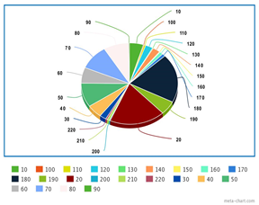

**DINDIGUL**

In Dindigul datasets, it consists of 3 columns namely farmer name, mobile no, and implement name(machine name). This dataset contains 22 different types of implement names in numeric form. The dataset contains a maximum number of type 180 of machinery where it contains less number of values in type 130 of machines. From this dataset, we assume that 180 types of machines are popular among Dindigul District.

**Figure1 Pie Chart of Dindigul dataset**

**MADURAI**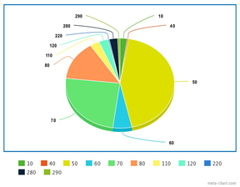

In Madurai datasets, it consists of 3 columns namely farmer name, mobile no, and implement name(machine name). This dataset contains 11 different types of implement names in numeric form. The dataset contains a maximum number of type 50 machinery whereas it contains less number of values in type 40 machines. From this dataset, we assume that 50 types of machines are popular among Madurai District.

**Figure 2 Pie Chart of Madurai dataset**

**RAMNAD**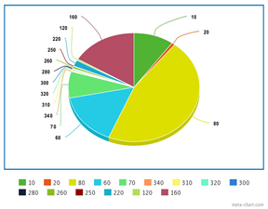

In Ramnad datasets, it consists of 3 columns namely farmer name, mobile no, and implements name(machine name). This dataset contains 15 different types of implement names in numeric form. The dataset contains a maximum number of type 80 machinery whereas it contains less number of values in type 280 machines. From this dataset, we assume that type 80 machines are popular among Ramnad District.

**Figure 3 Pie Chart of Ramnad dataset**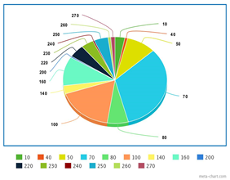

**THENI**

In Theni datasets, it consists of 3 columns namely farmer name, mobile no, and implements name(machine name). This dataset contains 16 different types of implement names in numeric form. The dataset contains a maximum number of type 70 machinery whereas it contains less number of values in type 240 machines. From this dataset, we assume that type 70 machines are popular among the Theni District

.

**Figure 4 Pie Chart of Theni dataset**

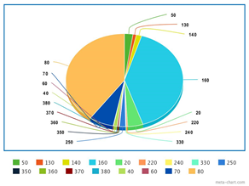

**VIRUDHUNAGAR**

In Virudhunagar datasets, it consists of 3 columns namely farmer name, mobile no, and implements name(machine name). This dataset contains 18 different types of implement names in numeric form. . The dataset contains a maximum number of type 80 machinery whereas it contains less number of values in type 330 machines. From this dataset, we assume that type 80 machines are popular among Virudhunagar District.

**Figure 5 Pie Chart of Virudhunagar dataset**

**METHODS/MODELS:**

Regression may be a statistical procedure that is employed to seek out the strength and estimate the connection between the variable and experimental variable. In regression terminology, the variable which is being predicted is called the dependent variable. Regression analysis may be Supervised Learning. In linear regression which is used for Prediction. There are two types of linear regression. They are simple linear regression which involves one variable and Multiple linear regression which involves quite one variable. In Logistic Regression which is used for Classification. Regression analysis needs some features on which analysis is to be made. It has n features and m rows of training data.

**LINEAR REGRESSION**

Linear regression is a statistical method for modeling relationships between a dependent variable with a given set of independent variables. In Linear regression, The relationship between X and Y is linear and non-deterministic where Y is distributed normally at each value of X. The observations are independent. The dependent variables Y are also called outputs, or responses. The independent variables X are also called inputs, or predictors.

In this research, we have analyzed and studied the data using linear regression by two ways of approaches which are statistical formula-based regression and another one is inbuilt linear regression function in python. For the statistical formula method, initially, we get the mean of the column values, mobile number, and implement name which is stored in variables ma and mb respectively. after that, we initiate numerator and denominator zero. By using a for loop, we find the numerator and denominator respectively. Values of m and c are found and printed then we use the y=mx+c formula and we represent them in a scatter plot

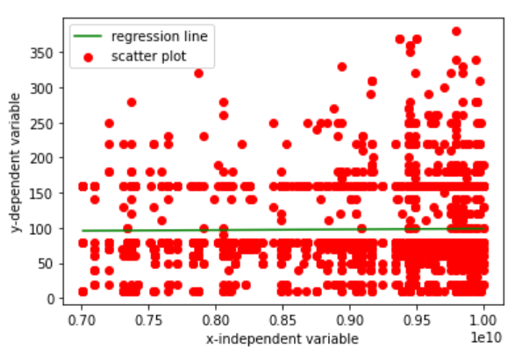 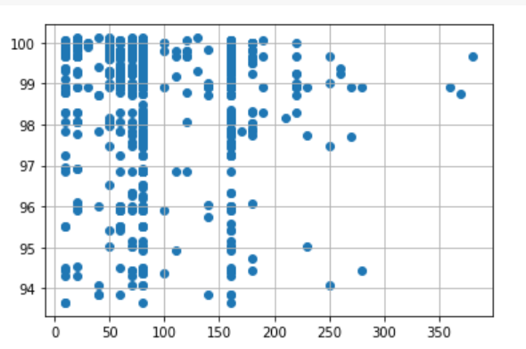

**Figure 6 Scatter plot using Linear regression Figure 7 Scatter plot using linear regression with statistical formula by model selection**

From the sklearn library, the class Linear regression is imported and initialized to an object called a model. Data fitting is an important process in which we fit the data to get accurate results. Then, we predict the value of x_test data using the predict function and store it in prediction which is then compared with the y_test values. Finally, the result is visualized as a scatter plot.

**DATA COLLECTION AND ANALYSIS:**

This section deals with the machinery used in the data set since the data set used is larger and real the machinery is mentioned in numerical value. Agricultural workers, draught animals, tractors, power tillers, diesel engines, electric motors are used as sources of farm power in Indian agriculture.[5]Initially, the given dataset contained two categorical column values *(Farmers name and implementation name -machinery name)* and one column value (*Phone number).* To predict the outcome, we have changed one categorical column value *(implementation name -machinery name)* into numeric column values *(10-380)* by assigning our convenient numbers manually. The dataset consists of two independent variables *(Farmer name and phone number)* and one dependent variable *(implementation name -machinery name).*In the Asia-Pacific region, India has remained one of the primary nations which fuelled the growth of the market for tractors, power tillers, and agricultural equipment[6]

**RAMNAD**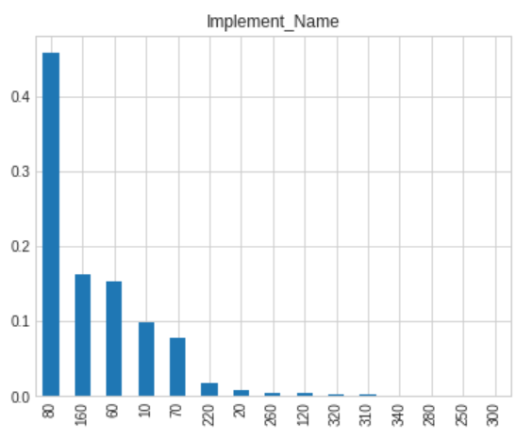

The above graph represents the machinery used by the Ramnad district farmers. This graph shows us the most used machinery and least used machinery for agricultural purposes easily. Type 80 machinery is the most used machinery with nearly 50% of the population. More number of the farmers in Ramnad use the tractor as the main machinery in their agricultural area.

**Figure 8 Bar Chart of Ramnad dataset**

**MADURAI**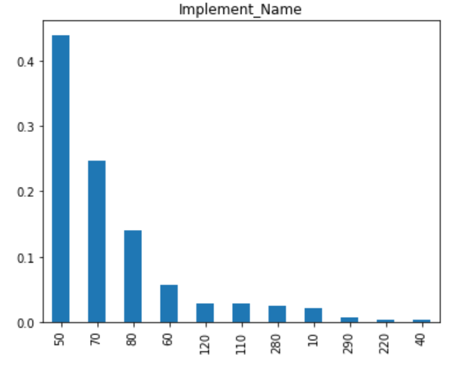

The above graph represents the machinery used by the Madurai district farmers. This graph shows us the most used machinery and least used machinery for agricultural purposes easily. Type 50 machinery is the most used machinery with nearly 50% of the population followed by type 70.power tiller and Rotavator are mostly used in Madurai districts.

**Figure 9 Bar Chart of Madurai dataset** 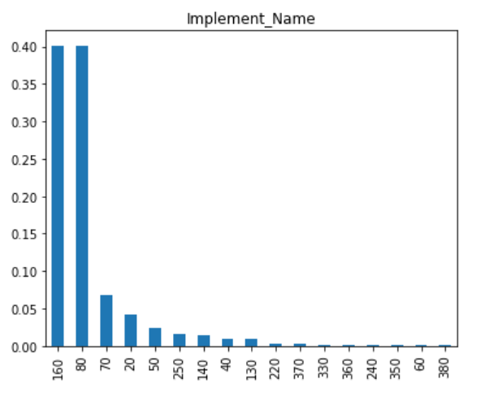

**VIRUDHUNAGAR**

The above graph represents the machinery used by the Virudhunagar district farmers. This graph shows us the most used machinery and least used machinery for agricultural purposes easily. Type 160 and 80 machinery is the most used machinery. Type 160 and type 80 are tractors with different properties and ranges.

**Figure 10 Bar Chart of Virudhunagar dataset**

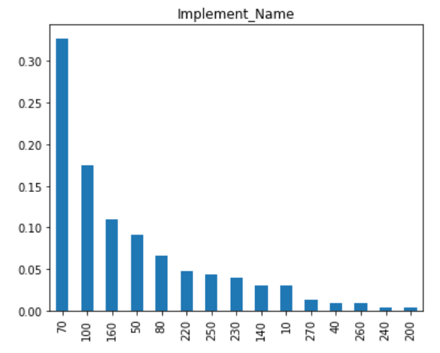

**THENI**

The above graph represents the machinery used by the Theni district farmers. This graph shows us the most used machinery and least used machinery for agricultural purposes easily. Type 70 machinery is the most used machinery with more than 30% of the population. More number of the farmers in Theni use Rotavator is the main machinery in their agricultural area.

**Figure 11 Bar Chart of Theni dataset**

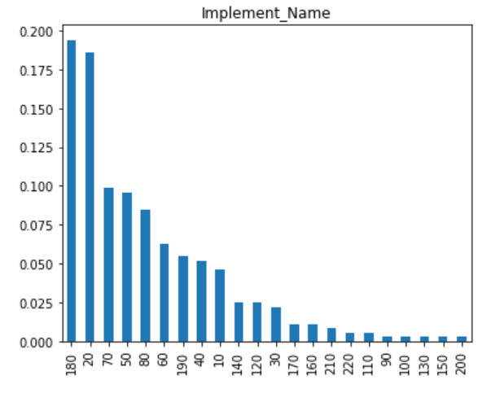

**DINDIGUL**

The above graph represents the machinery used by the Dindigul district farmers. This graph shows us the most used machinery and least used machinery for agricultural purposes easily. Type 180 machinery is the most used machinery. Chaff cutter - CHAFF CUTTER(Operated by engine/electric motor below 3 HP and by Power Tiller and Tractor of below 20 BHP) is the most used machinery by the farmers in Dindigul District and this district has used many types of machinery.

**Figure 12 Bar Chart of Dindigul dataset**

**RESULTS AND DISCUSSION:**

Farm mechanization increased agricultural production and profitability on account of timeliness of operation, the better quality of work done, and the more efficient utilization of inputs[7]. Tractor use in agriculture has been mainly for power requiring operations like tillage, sowing, intercultural, threshing, and transport; the use in field operations being about 35 to 40 percent and the rest in transport.[8]

**LINE CHART USING MATPLOT**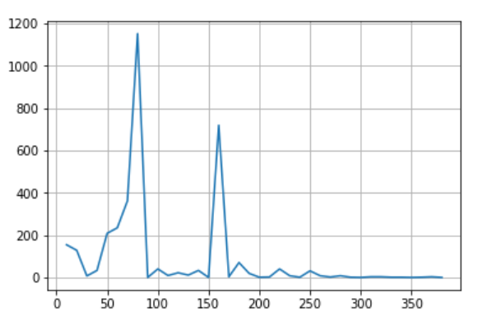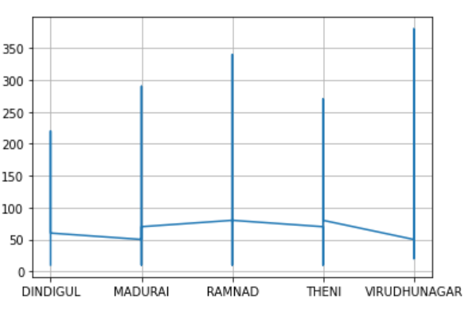

**Figure 13 & Figure 14 Line chart showing the machinery mostly used by the farmers all over 5 districts.**

This line chart speaks about the usage of machinery in south Tamilnadu. The most commonly used machinery is type 80 which is Tractor 2WD(above 40-70 PTO HP) followed by type 160 Tractor 2WD(above 20-40 PTO HP). The selection of tractors is hypothetically a tough job since there are various kinds of tractors, the selection process is done regarding the land and many other factors. The tractor is a highly versatile piece of machinery for multi-use both for land reclamation and for carrying out various crop cultivation and also employed for carrying out various operations connected with raising the crops by attaching suitable implements and to provide the necessary energy for performing various crop production operations involved in the production of crops.[11]

**HISTOGRAM USING MATPLOT**

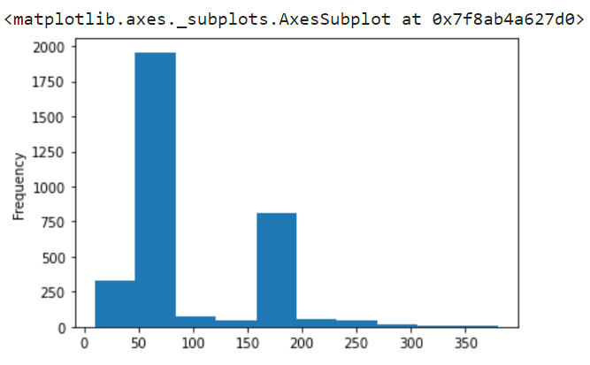

This histogram represents the given combined dataset where we can see an increase in the range 50 to 80 and 160 to 190. To be specific, we find maximum no of farmers uses 80 and 160 type of machinery uniformly in various districts

**Figure 18 Histogram graph for machinery**

**SCATTER PLOT**

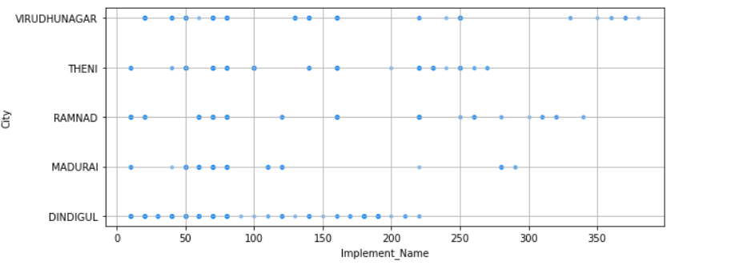

**Figure 17 Scatter plot for representation of machinery**

In this scatter plot, we observe a clear picture of how data is scattered over the various districts. With the above diagrammatic results, common machinery among the various districts has been found and also the difference in it. Based upon correlating the dots, we can get the desired results.Type 70(Rotavator(6 feet)),80(Tractor(Above 40-70 PTO HP)),220(cultivator) are the most commonly used machinery.

**SCATTER PLOT USING MATPLOT**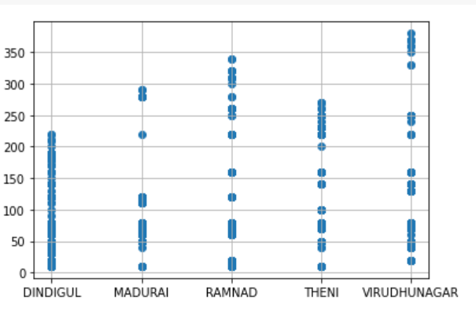

The scatter plot speaks about the machinery used by the 5 districts. Here Dindigul district has not even used the machinery which is above type 250 but in virudhunagar district it has a scatter over all the ranges. Mostly, Virudhunagar is the only district that has used the machinery above type 350. Madurai district has mostly used machinery ranging between 40 to 90.

**Figure 19 Scatter plot showing the machinery used with their respective districts.**

**BAR GRAPH USING PANDAS**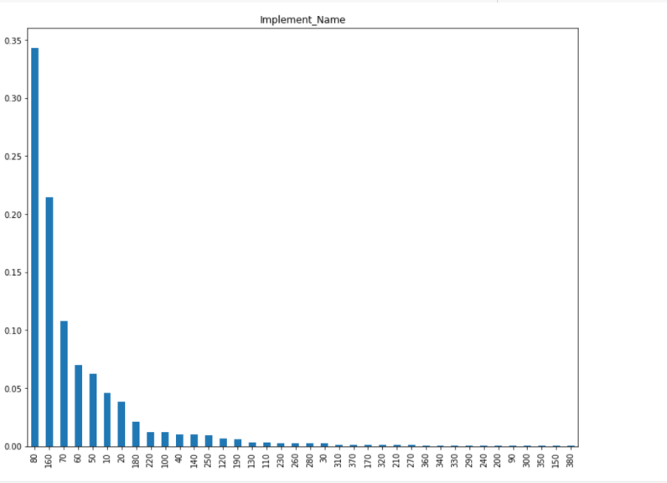

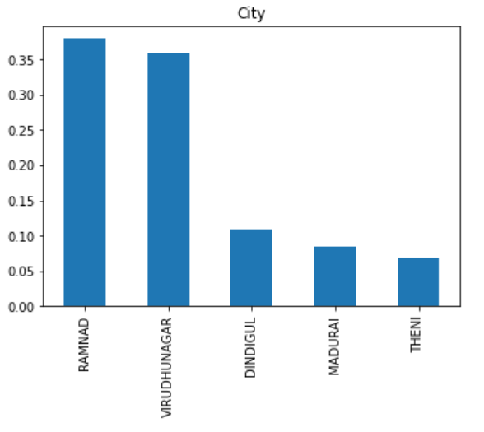

**Figure 15 Bar Chart for the City as Figure 16 Bar Chart for machineries x-axis & population as the y-axis**

The two bar graph speaks about the population of the farmers in each district and the machinery used by farmers in their district. The first graph shows the population of farmers and Ramnad is the district with the highest population among the 5 districts followed by Virudhunagar district. Theni district has the least population among the others.

The second graph shows the machinery which is mostly used and least used over all other machinery. Type 80(i.e).Tractor 2WD(above 40-70 PTO HP) is mostly used over every district then followed by type 160 (i.e)Tractor 2WD(above 20-40 PTO HP). The least used machinery is more because it has been rarely used by the district.

**CONCLUSION:**

Agricultural mechanization implies the use of various power sources and improved farm tools and equipment, intending to reduce the laboring of the human beings and draught animals, enhance the cropping intensity and timelines of efficiency of utilization of various crop inputs[13]Thereby to increase crop production, machinery plays a vital role. In this research paper, we conclude, maximum data collection has been done in districts Ramnad and Virudhunagar. Different types of machinery are used by the farmers in the 5 given districts and as per the result, the tractor(type 80) is the most commonly used machine among all the districts. Among the five districts, the Dindigul district has many types of machinery used by the farmers and Madurai is the district where different types of machinery used are less. The most used machinery is Tractor which is of various types like it differs in ranges. The selection of tractors is the most important process as they should be selected based upon the agricultural land. Technological innovations have had an intense effect on the agriculture sector which acts as the backbone of farm mechanization and has played a pivotal role in bringing a green revolution in the country[8].

**ACKNOWLEDGEMENT:**

**REFERENCES:**

[1]Mehta, C. R., Chandel, N. S., & Senthilkumar, T. (2014). Status, challenges, and strategies for farm mechanization in India. *Agricultural Mechanization in Asia, Africa, and Latin America*, *45*(4), 43-50

[2]Işık, A., & Adalı, E. (2016). A comparative study for the agricultural tractor selection problem. *Decision Science Letters*, *5*(4), 569-580.

[3]Singh, G. (2006). Agricultural machinery industry in India (Manufacturing, marketing, and mechanization promotion). *Status of Farm Mechanization in India*, 154-174.

[4]Mehta, C. R., Chandel, N. S., & Senthilkumar, T. (2014). Status, challenges, and strategies for farm mechanization in India. *Agricultural Mechanization in Asia, Africa, and Latin America*, *45*(4), 43-50.

[5]Mehta, C. R., Chandel, N. S., Senthilkumar, T., & Singh, K. K. (2014). Trends of agricultural mechanization in India. *Economic and Social Commission for Asia and the Pacific (ESCAP) Policy Brief*, *2*.

[6]Mehta, C. R., Chandel, N. S., & Senthilkumar, T. (2014). Status, challenges, and strategies for farm mechanization in India. *Agricultural Mechanization in Asia, Africa, and Latin America*, *45*(4), 43-50.

[7]Verma, S. R. (2006). Impact of agricultural mechanization on production, productivity, cropping intensity income generation, and employment of labor. *Status of farm mechanization in India*, 133-153.

[8]Singh, S. P., Singh, R. S., & Singh, S. (2009). Tractor production and sales in India. *Agricultural Engineering Today*, *33*(1), 20-32

[9]Bector, V., Singh, S., Sharda, A., & Bansal, A. (2008). Status & recent trends of tractor power in Indian Agriculture. *Agricultural Engineering Today*, *32*(1), 16-26.

[10]Babu, S. C., Glendenning, C. J., Okyere, K. A., & Govindarajan, S. K. (2012). *Farmers' information needs and search behaviors: A case study in Tamil Nadu, India* (No. 1007-2016-79468).

[11]Mandal, S. K., & Maity, A. (2013). Current trends of Indian tractor industry: A critical review. *Applied Science Report*, *3*(2), 132-139.

[12]Harriss-White, B., & Janakarajan, S. (1997). From the green revolution to the rural industrial revolution in South India. *Economic and Political Weekly*, 1469-1477.

[13]Verma, S. R. (2006). Impact of agricultural mechanization on production, productivity, cropping intensity income generation, and employment of labor. *Status of farm mechanization in India*, 133-153.