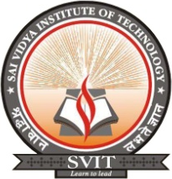
DEPARTMENT OF Computer SCIENCE & ENGINEERING

SAI VIDYA INSTITUTE OF TECHNOLOGY
(Affiliated to VTU, Belgaum, Approved by AICTE, New Delhi and Govt. of Karnataka)
Rajanukunte, Bangalore-560064

Weekly Project Status Report for the week 01/03/2021 to 08/05/2021

Project Title: Smart Attendance System
Name of Internal Guide: Dr. Sunil G L
Name of External Guide, if any: N.A
Name of the company, if applicable: N.A

Sl. No | USN | NAME | Work Status | Student’s Signature
1 | 1VA17CS047 | Satwik Ram K | - Implemented Home Page using Html CSS and JS  - Implemented Admin in Django  - Added Django Rest Frameworks interface  - Implemented 3 API – College adding, Otp verification via Email and Student Register  - Implemented Django Rest API to take students Live Camera image from browser  - Implemented Data Augmentation to increase the size of the image  - Connected PostgreSQL Database and stored data in Database.  - Started training first version of object detection model. | 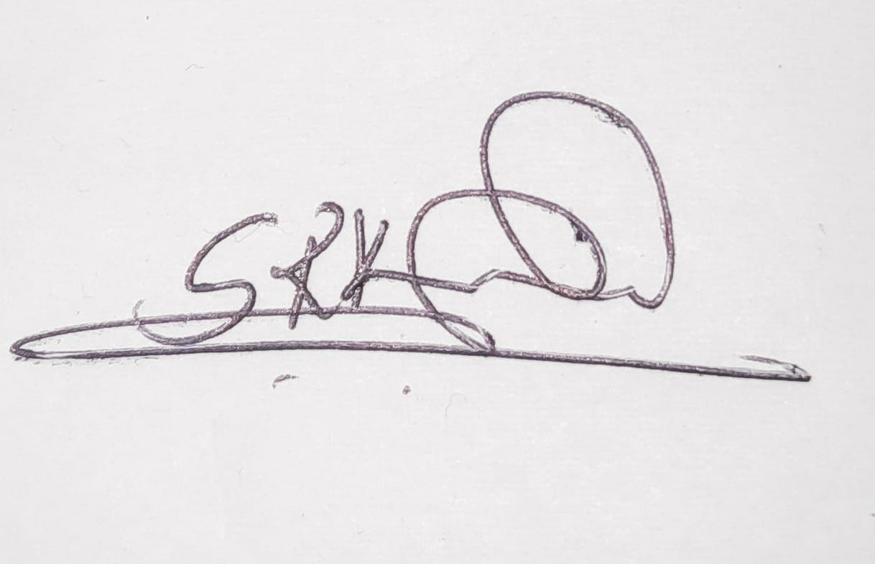 Satwik Ram
2 | 1VA17CS028 | Pavan Kumar N |  |  Pavan

Remark of Guide: Work done is satisfactory / Not Satisfactory
If not satisfactory, please specify the reasons:

Guide Project Coordinator HOD

