## Day 08 – Cloud Server Setup: Docker, Nginx & Web Deployment

## Objective
Deploy a real web server on the cloud, manage it via SSH, configure network access, and extract service logs — simulating real-world DevOps production tasks.

---

## Cloud Provider
- AWS EC2 (Free Tier)
*(Ubuntu 24.04 LTS)*
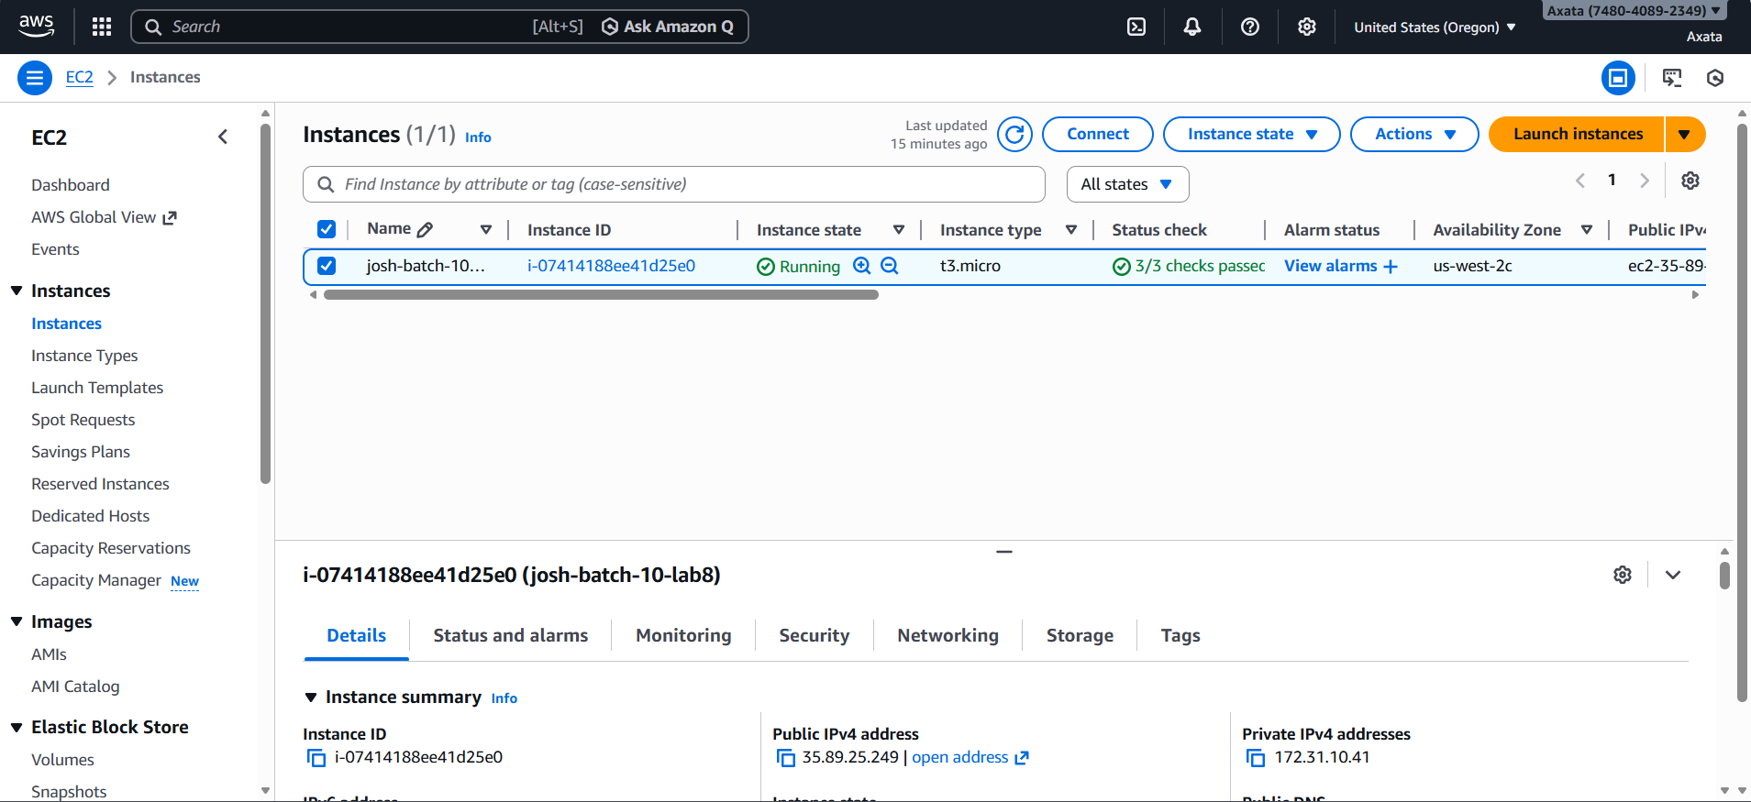
---

## Commands Used

- Connect to EC2 via SSH
chmod 400 devops-key.pem
ssh -i lab-8-practice-key.pem ubuntu@35.89.25.249
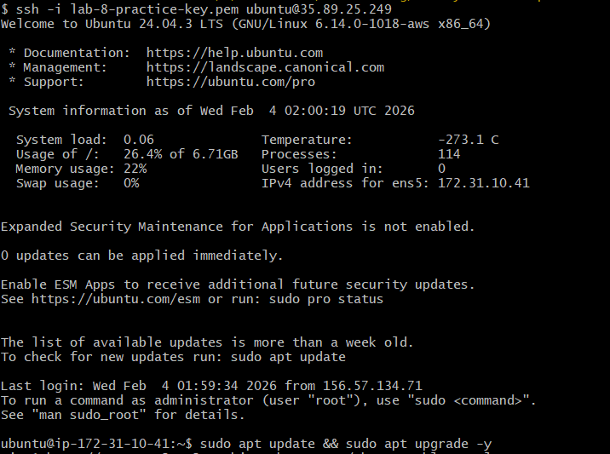

- Update System Packages
sudo apt update && sudo apt upgrade -y

- Install Nginx
sudo apt install nginx –y
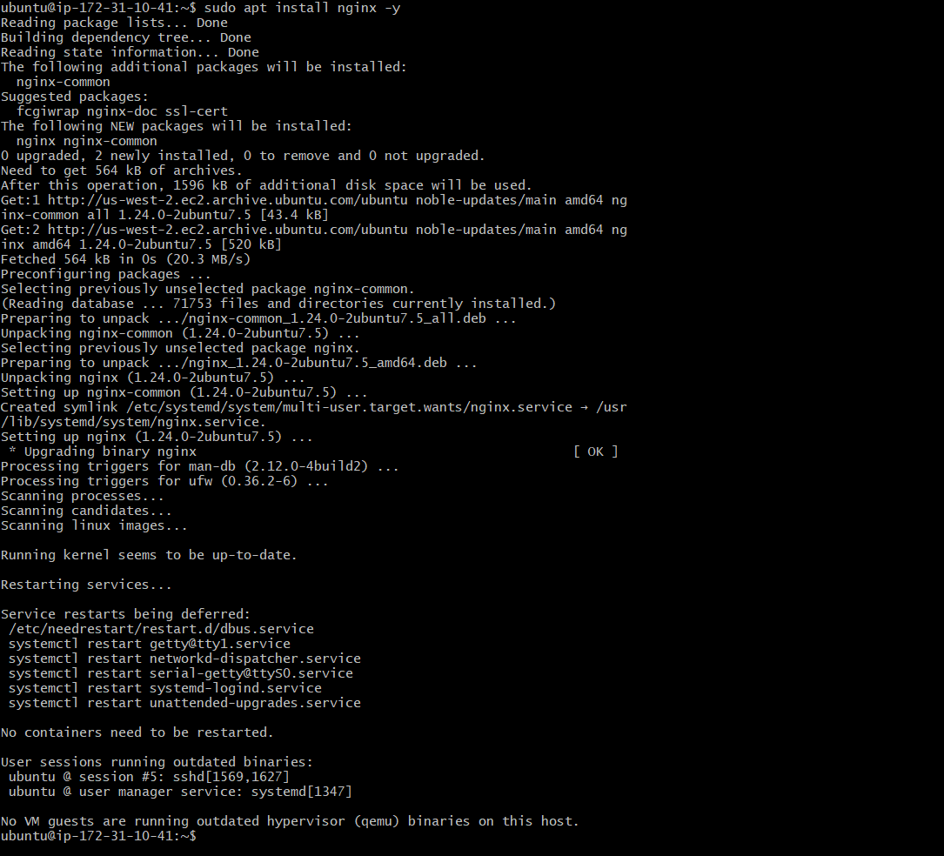

- Verify Nginx Status
systemctl status nginx
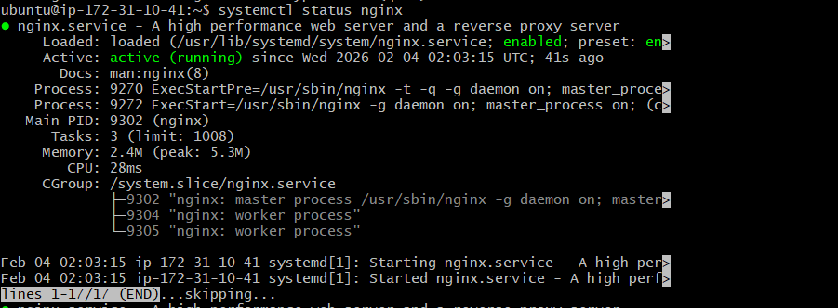

- Enable Nginx on Boot
sudo systemctl enable nginx

- Check Open Port
sudo ss -tulpn | grep nginx

## Security Group Configuration

Inbound rules configured:
- SSH → Port 22 (My IP)
- HTTP → Port 80 (0.0.0.0/0)

## Verification:

http:// 35.89.25.249

## Result:
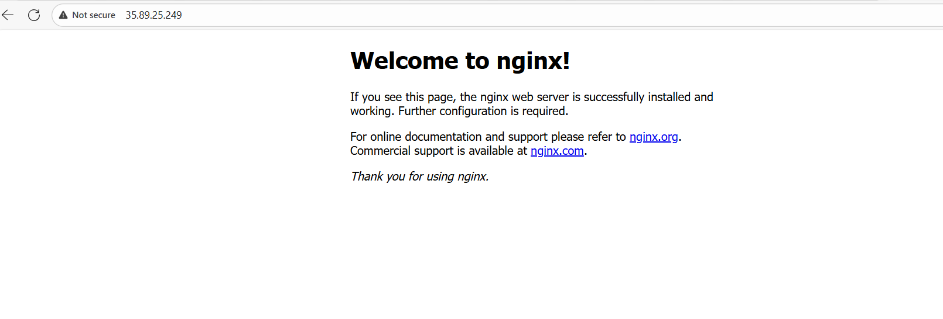

## Nginx Log Management
- View Logs
sudo cat /var/log/nginx/access.log
sudo cat /var/log/nginx/error.log

- Save Logs to File
sudo cat /var/log/nginx/access.log > ~/nginx-logs.txt

- Verify Log File
ls -lh nginx-logs.txt
cat nginx-logs.txt

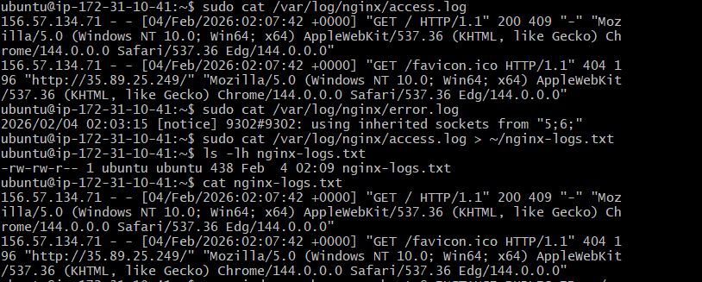

- Download Logs to Local Machine
scp -i devops-key.pem ubuntu@35.89.25.249:~/nginx-logs.txt
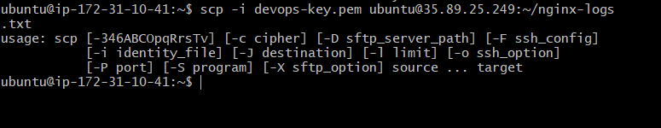

## Challenges Faced

- Nginx page not accessible initially
  - Root cause: HTTP (port 80) not allowed in Security Group
  - Fix: Added inbound rule for port 80

- Permission denied while accessing logs
  - Fix: Used sudo to read logs from /var/log/nginx

## What I Learned

- How to provision and access a cloud VM using SSH
- Installing and managing services using systemctl
- Importance of security groups/firewall rules in cloud networking
- Practical log extraction and transfer using scp
- How production servers expose services securely over the internet

