## Day 09 Challenge – User & Group Management

## Users & Groups Created

Users:

- tokyo
- berlin
- professor
- nairobi

Groups:

- developers
- admins
- project-team

## Group Assignments

- developers: tokyo, berlin
- admins: berlin, professor
- project-team: nairobi, tokyo

Verification commands:
- groups tokyo
- groups berlin
- groups professor
- groups Nairobi

Output:
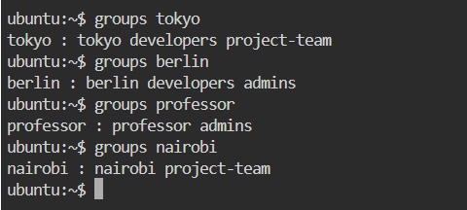

## Directories Created:

Directory | Group Owner | Permissions
/opt/dev-project | developers | 775 (rwxrwxr-x)
/opt/team-workspace | project-team | 775 (rwxrwxr-x)

Verification:
- ls -ld /opt/dev-project
- ls -ld /opt/team-workspace

Output:
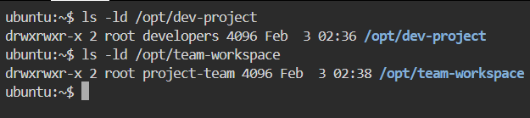

## Commands Used

Task 1: Create Users
sudo useradd -m tokyo
sudo passwd tokyo
sudo useradd -m berlin
sudo passwd berlin
sudo useradd -m professor
sudo passwd professor

Verification:
cat /etc/passwd | grep -E 'tokyo|berlin|professor'
ls -l /home

Output:
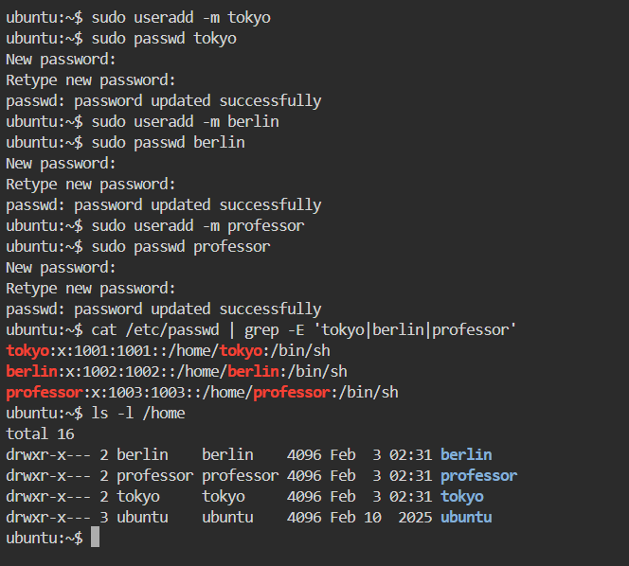

Task 2: Create Groups
sudo groupadd developers
sudo groupadd admins

Verification:
cat /etc/group | grep -E 'developers|admins'

Output:
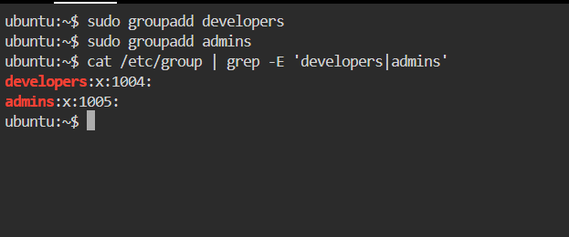

Task 3: Assign Users to Groups
sudo usermod -aG developers tokyo
sudo usermod -aG developers,admins berlin
sudo usermod -aG admins professor

Verification:
groups tokyo
groups berlin
groups professor

Output:
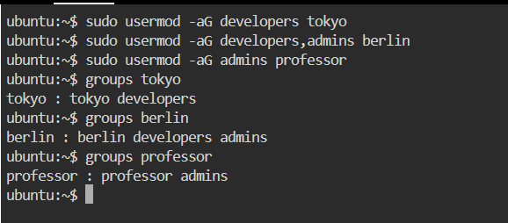

Task 4: Shared Directory (/opt/dev-project)
sudo mkdir -p /opt/dev-project
sudo chgrp developers /opt/dev-project
sudo chmod 775 /opt/dev-project

Testing access:
sudo -u tokyo touch /opt/dev-project/tokyo.txt
sudo -u berlin touch /opt/dev-project/berlin.txt
ls -l /opt/dev-project

Output:
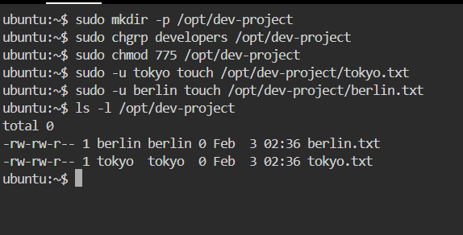

Task 5: Team Workspace
sudo useradd -m nairobi
sudo passwd nairobi
sudo groupadd project-team
sudo usermod -aG project-team nairobi
sudo usermod -aG project-team tokyo
sudo mkdir -p /opt/team-workspace
sudo chgrp project-team /opt/team-workspace
sudo chmod 775 /opt/team-workspace

Testing:
sudo -u nairobi touch /opt/team-workspace/nairobi.txt
ls -l /opt/team-workspace

Output:
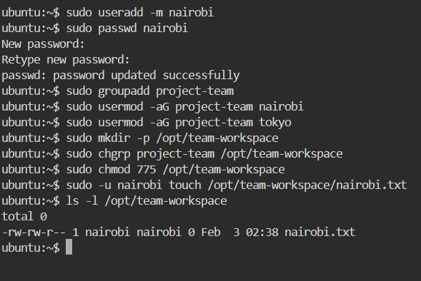

## What I Learned

- Group-based permissions are the cleanest way to manage shared access without using chmod 777.
- The usermod -aG command is critical—missing -a can remove existing group memberships.
- Testing access with sudo -u username is an effective way to validate permissions without switching users.

