## Day 10 Challenge – Linux File Permissions & File Operations

Task 1: Create Files

Files Created
- devops.txt (empty file)
- notes.txt (file with content)
- script.sh (shell script)

Commands Used
touch devops.txt
echo "Linux file permissions practice" > notes.txt
vim script.sh

Content of script.sh:
echo "Hello DevOps"

Verification
ls –l

Output:
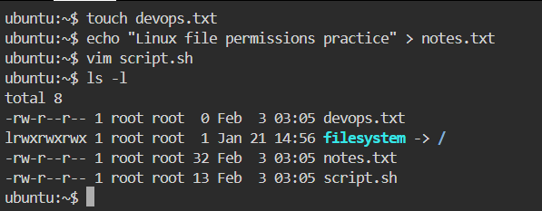

Task 2: Read Files

Commands Used
cat notes.txt
vim -R script.sh
head -n 5 /etc/passwd
tail -n 5 /etc/passwd

Observations

- cat displays full file content
- vim -R opens file in read-only mode
- head and tail help inspect large system files quickly

Output:
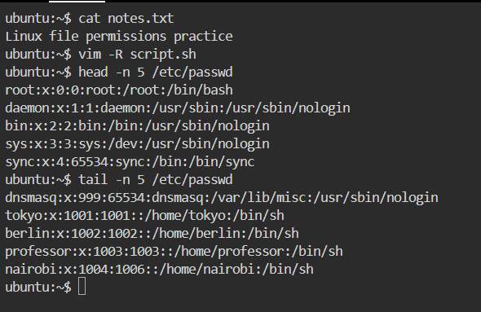

Task 3: Understand Permissions

Permission Format:
rwxrwxrwx
│ │ │
│ │ └── Others
│ └──── Group
└────── Owner

Permission Value
Read (r) 4
Write (w) 2
Execute(x) 1

Current Permissions:
ls -l devops.txt notes.txt script.sh

Output:
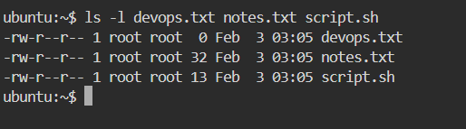

Access Explanation:

- Owner: read & write
- Group: read only
- Others: read only
- No execute permission for any file

Task 4: Modify Permissions

1. Make script.sh Executable
chmod +x script.sh
./script.sh

Output:
Hello

2. Make devops.txt Read-Only for All
chmod a-w devops.txt

Permissions:
-r--r--r-- devops.txt

3. Set notes.txt to 640
chmod 640 notes.txt

Permissions:
-rw-r----- notes.txt

4. Create Directory project/ with 755
mkdir project
chmod 755 project

Permissions:
drwxr-xr-x project/

Output:
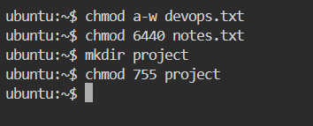

Task 5: Test Permissions
1. Writing to Read-Only File
echo "test" >> devops.txt

Error:
Permission denied

2. Executing Without Execute Permission
chmod -x script.sh
./script.sh

Error:
Permission denied
Output:
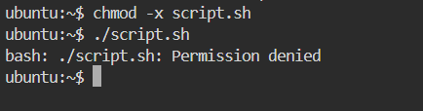

## Commands Used (Summary)
- touch
- echo
- cat
- vim
- vim -R
- ls -l
- head
- tail
- chmod
- mkdir

## What I Learned

- Linux permissions control who can read, write, or execute files and directories
- Numeric and symbolic chmod both achieve the same goal in different ways
- Execute permission is mandatory to run scripts, even if read access exists

