### Day 13 – Linux Volume Management (LVM)

## Goal
Learn LVM to manage storage flexibly – create, extend, and mount volumes.
---

## Commands Used and Steps

1. Switch to root user
sudo –i

2. Create a virtual disk
dd if=/dev/zero of=/tmp/disk1.img bs=1M count=1024
losetup -fP /tmp/disk1.img
losetup -a
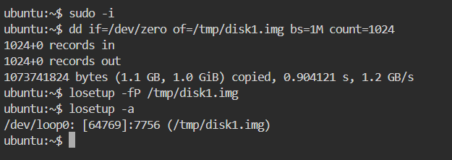

3. Check current storage
lsblk
pvs
vgs
lvs
df -h
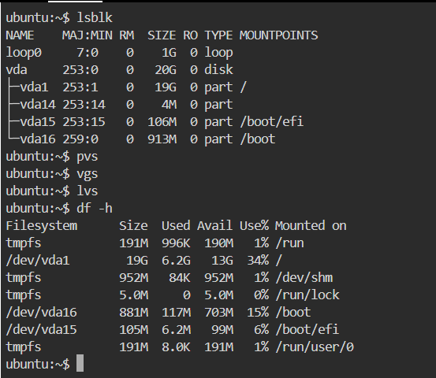

4. Create Physical Volume
pvcreate /dev/loop0
pvs
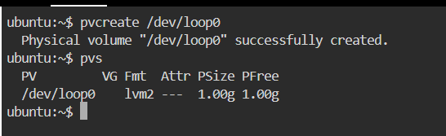

5. Create Volume Group
vgcreate devops-vg /dev/loop0
vgs
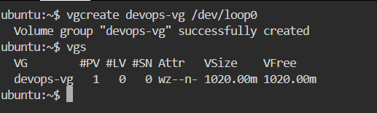

6. Create Logical Volume
lvcreate -L 500M -n app-data devops-vg
lvs
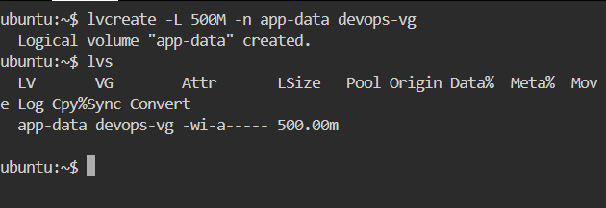

7. Format and Mount Logical Volume
mkfs.ext4 /dev/devops-vg/app-data
mkdir -p /mnt/app-data
mount /dev/devops-vg/app-data /mnt/app-data
df -h /mnt/app-data
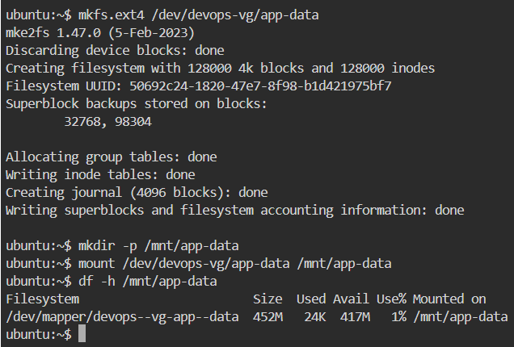

8. Extend the Logical Volume
lvextend -L +200M /dev/devops-vg/app-data
resize2fs /dev/devops-vg/app-data
df -h /mnt/app-data
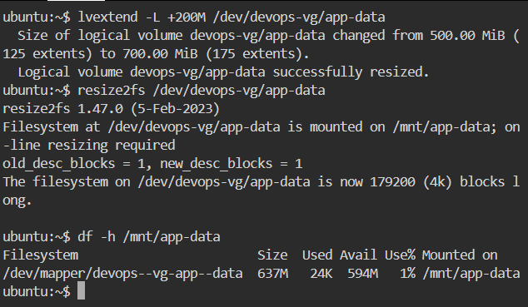

## What I Learned
- Physical Volumes (PV), Volume Groups (VG), Logical Volumes (LV) form the core of LVM, enabling flexible storage management.
- Mounting and extending volumes can be done without downtime, allowing dynamic storage adjustments.
- Commands like pvs, vgs, lvs, and df -h are essential to monitor LVM structure and usage.

