### Day 14 – Networking Fundamentals & Hands-on Checks

## Quick Concepts

### OSI vs TCP/IP

- OSI (L1–L7): Physical, Data Link, Network, Transport, Session, Presentation, Application — conceptual model for troubleshooting.
- **L1 – Physical**
Responsible for physical transmission of bits (cables, NICs, voltage, signals).

- **L2 – Data Link**
Handles MAC addressing, framing, and error detection on the local network (Ethernet, ARP).

- **L3 – Network**
Responsible for logical addressing and routing packets between networks (IP, ICMP).

- **L4 – Transport**
Ensures end-to-end communication, reliability, and flow control (TCP reliability, UDP speed).

- **L5 – Session**
Manages session setup, maintenance, and teardown between applications.

- **L6 – Presentation**
Handles data formatting, encryption, and compression (TLS/SSL, encoding).

- **L7 – Application**
Provides network services to user applications (HTTP, HTTPS, DNS, FTP, SMTP).
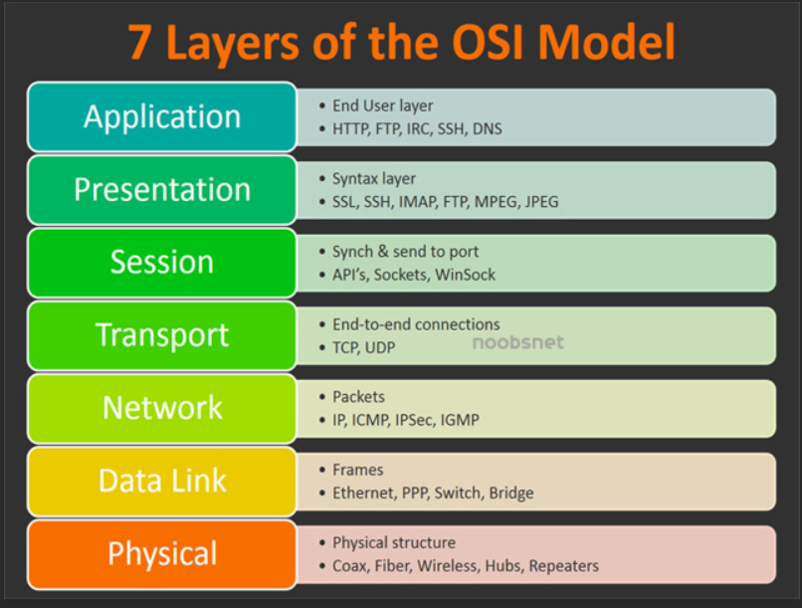

- TCP/IP: Network Access (Link), Internet, Transport, Application — practical model used by real networks.

- **Link Layer**
Combines OSI L1–L2; responsible for local network delivery (Ethernet, ARP).

- **Internet Layer**
Equivalent to OSI L3; handles IP addressing and routing between networks.

- **Transport Layer**
Same as OSI L4; manages ports, connections, reliability, and data flow (TCP/UDP).

- **Application Layer**
Combines OSI L5–L7; where application protocols operate (HTTP, HTTPS, DNS).
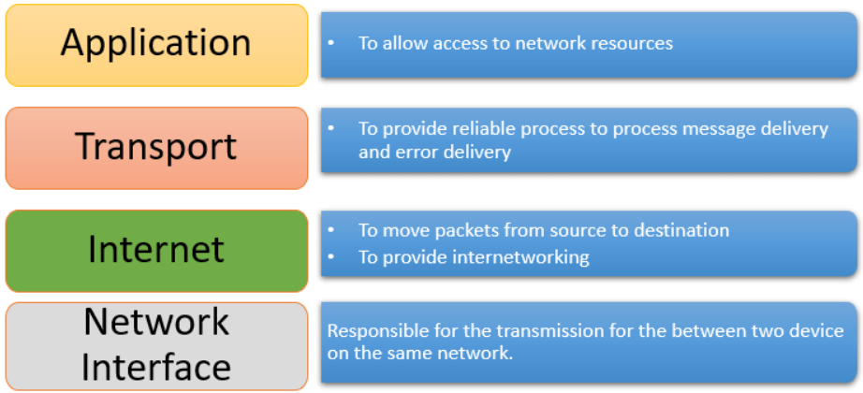

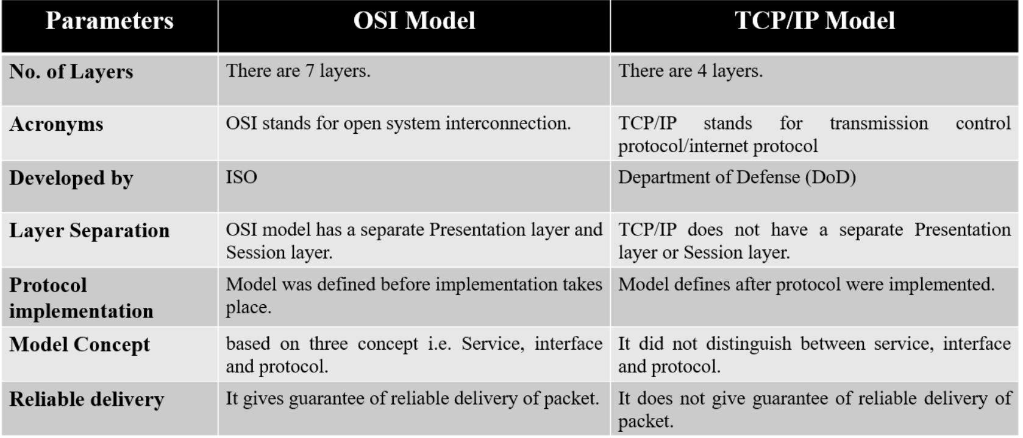

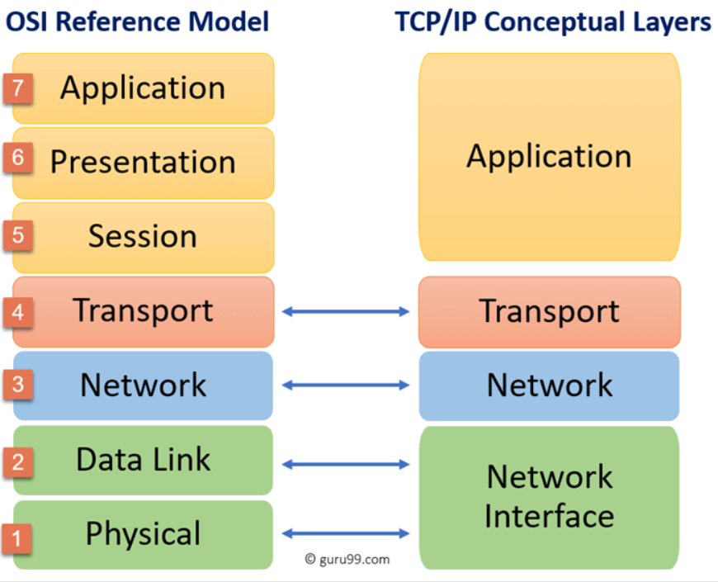
### Where protocols sit:

- **IP** → Network (OSI L3) / Internet (TCP/IP)
- **TCP / UDP** → Transport (OSI L4)
- **HTTP / HTTPS** → Application (OSI L7)
- **DNS** → Application (OSI L7), usually over UDP/TCP 53

### Hands-on Checklist

**Target host:** `google.com`

- Identity: ipconfig
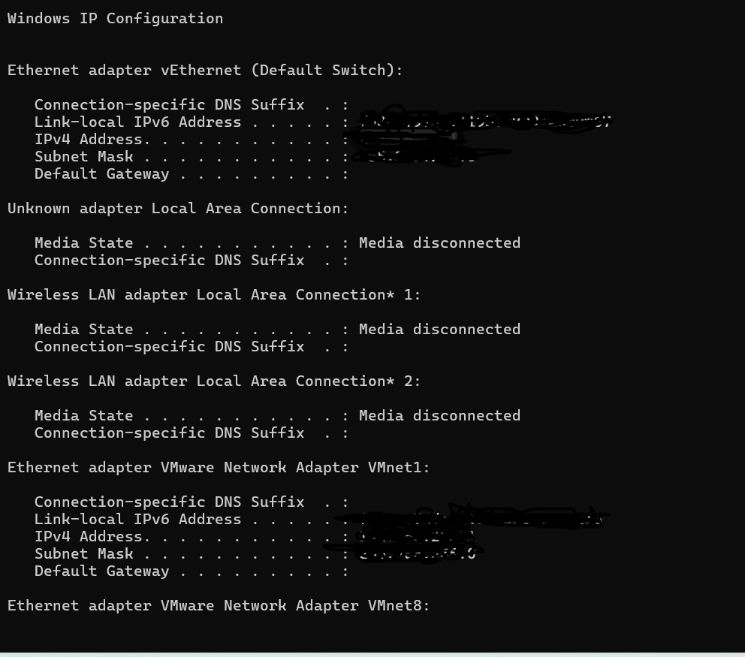

- Reachability: ping google.com
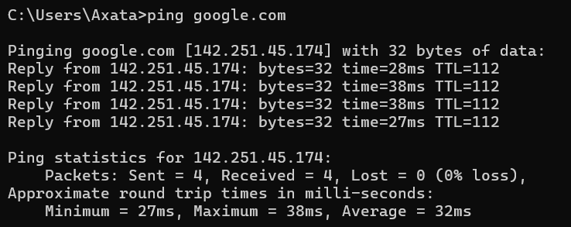
Observation: Reachable, ~15–25 ms latency, 0% packet loss.

- Path: traceroute google.com
On Windows the traceroute command is tracert
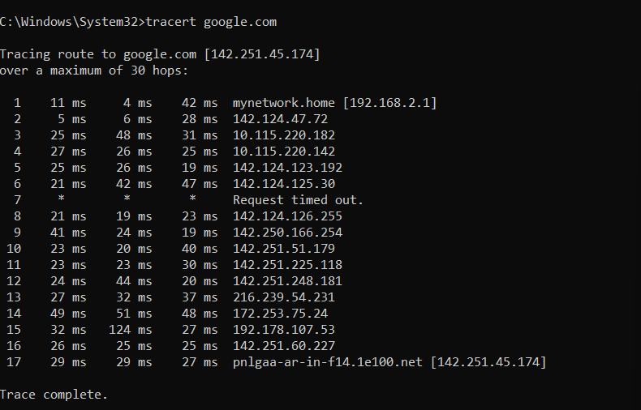

- Ports: ss -tulpn (or netstat -tulpn)
On Windows the traceroute command is netstat -ano
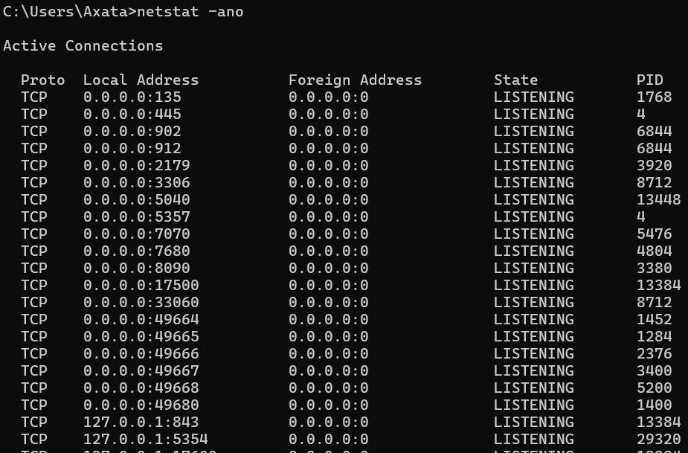
- Name resolution: dig google.com or nslookup google.com
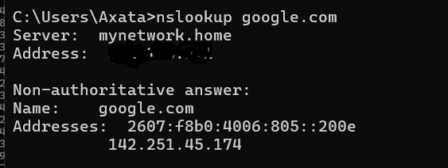

- HTTP check: curl -I https://google.com
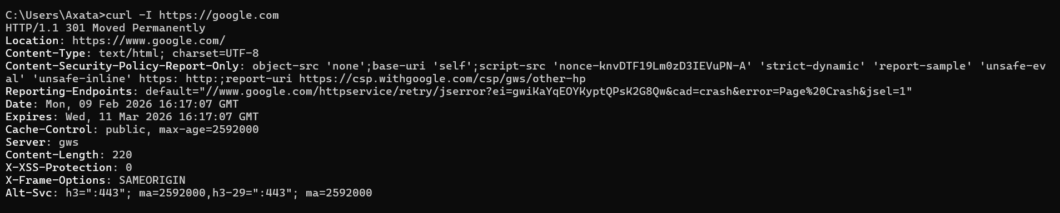
Observation: HTTP status 200 OK or 301 Moved Permanently

- Connections snapshot: netstat -an | head —count
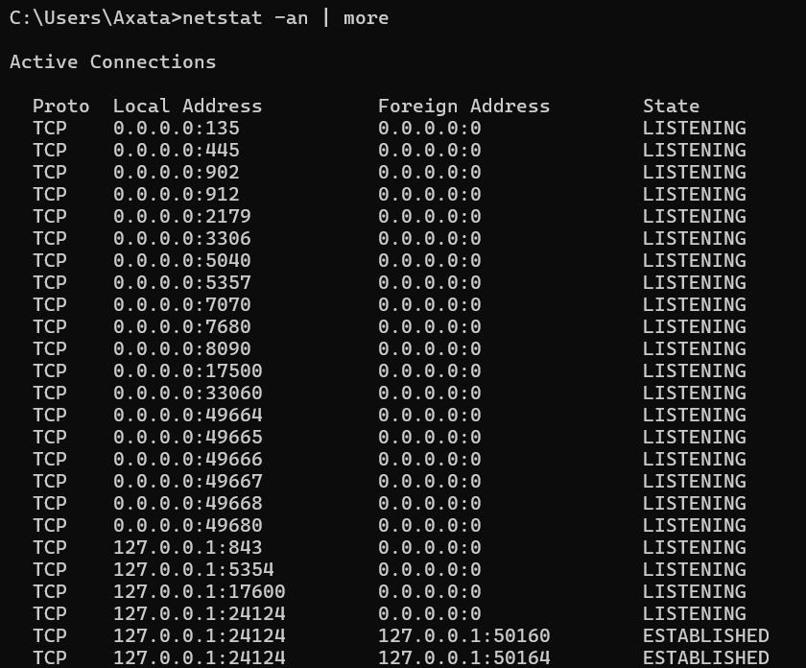

### Mini Task: Port Probe & Interpret

Selected port: SSH on 22

nc -zv localhost 22

Result: Port reachable.

If not reachable: Next check would be service status (systemctl status ssh) or firewall rules.

Reflection

- Fastest signal when something is broken: ping (quick reachability check).
- If DNS fails: Inspect Application layer (DNS) → resolver config (/etc/resolv.conf).
- If HTTP 500 occurs: Inspect Application layer first, then backend service logs.

Two follow-up checks in a real incident

- Verify firewall/security group rules for blocked ports.
- Check service health and logs on the target host.

