### Day 15 – Networking Concepts: DNS, IP, Subnets & Ports

## Task 1: DNS – How Names Become IPs
What happens when you type google.com in a browser:
When you type google.com, your computer first checks its DNS cache. If not found, it queries a recursive DNS resolver, which looks up the domain's authoritative nameserver to return the corresponding IP address. Your browser then connects to this IP to fetch the website.
DNS Record Types:
Record Type | Description
A | Maps a domain to an IPv4 address
AAAA | Maps a domain to an IPv6 address
CNAME | Alias for another domain name
MX | Specifies mail servers for the domain
NS | Specifies authoritative name servers for the domain

Command Output:
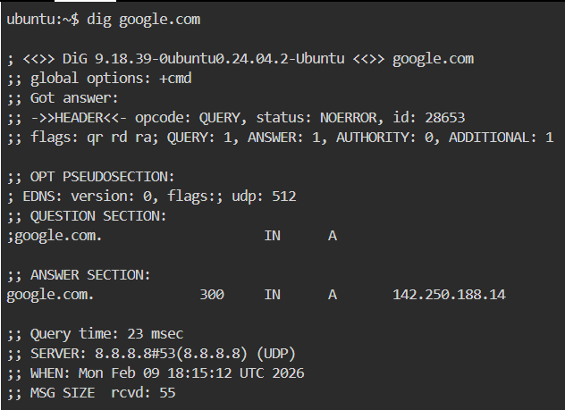
Example Output Snippet:
;; ANSWER SECTION:
google.com. 300 IN A 142.250.72.14

A record: 142.250.72.14
TTL (Time to Live): 300 seconds

## Task 2: IP Addressing
What is an IPv4 address:
IPv4 addresses are 32-bit numbers written in dotted decimal format (e.g., 192.168.1.10). They identify devices on a network.
Public vs Private IPs:
Public IP: Accessible from the internet (e.g., 142.250.72.14)
Private IP: Used internally in networks (e.g., 192.168.1.10)

Private IP Ranges:
- 10.0.0.0 – 10.255.255.255
- 172.16.0.0 – 172.31.255.255
- 192.168.0.0 – 192.168.255.255
Command Output:
ip addr show
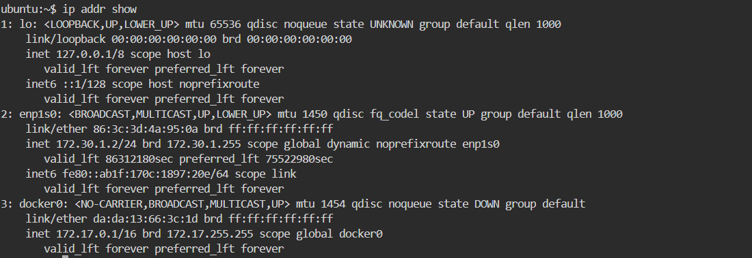
Example Output Snippet (Private IPs Identified):
- 172.30.1.2 (enp1s0)
- 172.17.0.1 (docker0)

## Task 3: CIDR & Subnetting
CIDR Notation:
/24 in 192.168.1.0/24 means the first 24 bits are network bits, leaving 8 bits for hosts.
Usable Hosts Calculation:
/24 → 2⁸ – 2 = 254 hosts
/16 → 2¹⁶ – 2 = 65,534 hosts
/28 → 2⁴ – 2 = 14 hosts
Why subnet:
Subnetting divides large networks into smaller, manageable networks to improve efficiency, security, and reduce broadcast traffic.
CIDR Table:
CIDR | Subnet Mask | Total IPs | Usable Hosts
/24 | 255.255.255.0 | 256 | 254
/16 | 255.255.0.0 | 65,536 | 65,534
/28 | 255.255.255.240 | 16 | 14

## Task 4: Ports – The Doors to Services
What is a port:
A port is a logical endpoint for network communication. Ports allow multiple services to run on a single IP address.
Port | Service
22 | S
80 | HTTP
443 | HTTPS
53 | DNS
3306 | MySQL
6379 | Redis
27017 | MongoDB

Command Output:
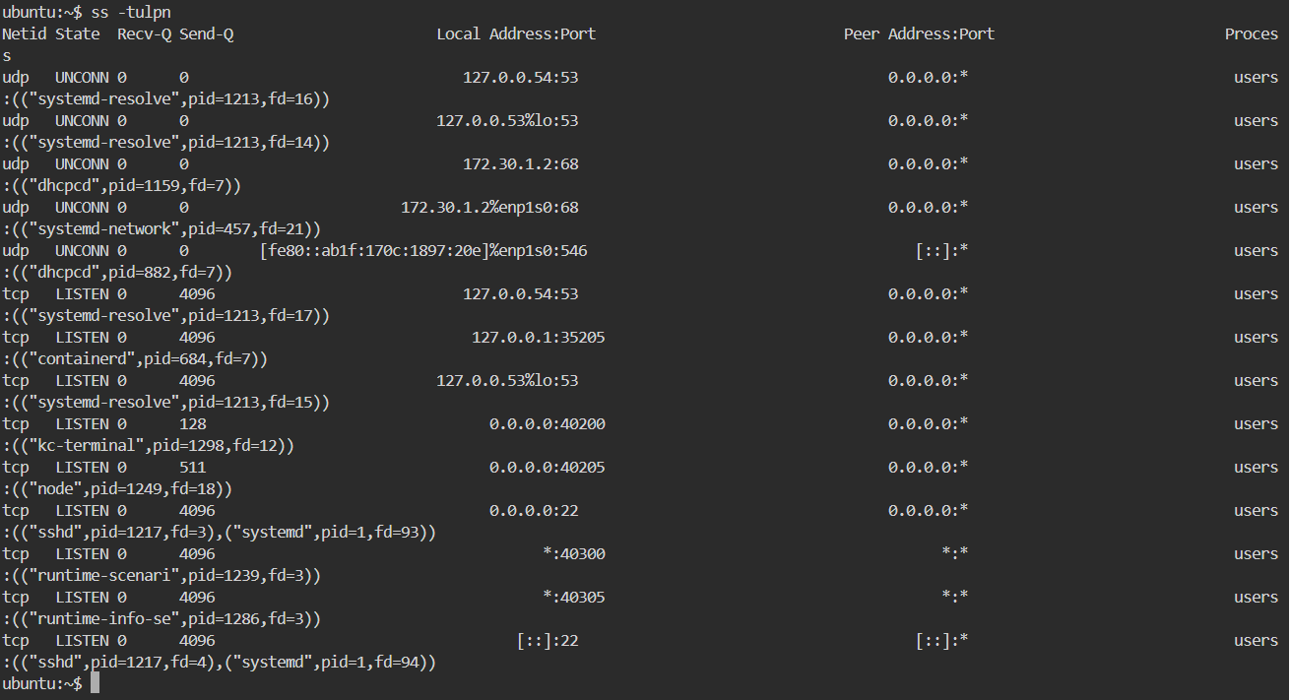
Example Output Snippet:
tcp LISTEN 0 4096 0.0.0.0:22 0.0.0.0:* users:(("sshd",pid=1217,fd=3),("systemd",pid=1,fd=93))
tcp LISTEN 0 4096 [::]:22 [::]:* users:(("sshd",pid=1217,fd=4),("systemd",pid=1,fd=94))
22 → SSH

## Task 5: Putting It Together
- You run curl http://myapp.com:8080 — what networking concepts from today are involved?
- curl http://myapp.com:8080
- DNS resolves myapp.com to IP
- TCP/IP establishes connection on port 8080
- HTTP protocol communicates with the server
- App can't reach 10.0.1.50:3306
- Check network connectivity (ping/traceroute)
- Verify firewall rules and port availability
- Ensure MySQL service is running on the server
## What I Learned
- DNS translates human-friendly domain names into machine-friendly IP addresses.
- Subnetting helps manage IP allocation efficiently and enhances network security.
- Ports are essential for directing traffic to the correct services on a host.

