### Day 16 – Shell Scripting Basics

## Overview
Today I started my shell scripting journey by learning the fundamentals required to write basic Bash scripts. I practiced using shebangs, variables, user input, conditions, and combined everything into a practical script.
## Task 1: Your First Script
Script: hello.sh
#!/bin/bash
echo "Hello, DevOps!"
Commands Used:
- chmod +x hello.sh
- ./hello.sh
Output:
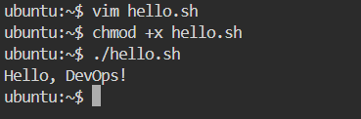
What happens if the shebang is removed?
  - The shebang (#!/bin/bash) tells the OS which interpreter to use
  - Without it:
    - Script may fail with Exec format error
    - Or it may run only if explicitly executed using bash hello.sh
  - Shebang ensures portability and correct execution

## Task 2: Variables
Script: variables.sh
#!/bin/bash
NAME="Axata"
ROLE="DevOps Engineer"
echo "Hello, I am $NAME and I am a $ROLE"
Output:
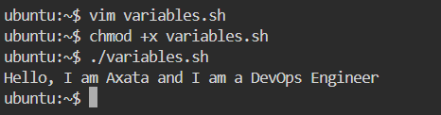
Single Quotes vs Double Quotes
- echo 'Hello $NAME'
- echo "Hello $NAME"
Difference:
- Single quotes → variables are NOT expanded
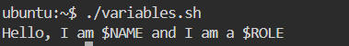
- Double quotes → variables ARE expanded
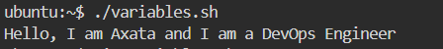

## Task 3: User Input with read
Script: greet.sh
#!/bin/bash
read -p "Enter your name: " NAME
read -p "Enter your favourite tool: " TOOL
echo "Hello $NAME, your favourite tool is $TOOL"
Sample Output:
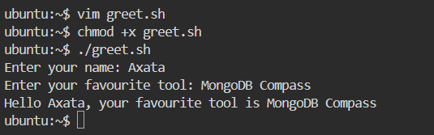
## Task 4: If-Else Conditions
Script 1: check_number.sh
#!/bin/bash
read -p "Enter a number: " NUM
if [ "$NUM" -gt 0 ]; then
echo "Number is positive"
elif [ "$NUM" -lt 0 ]; then
echo "Number is negative"
else
echo "Number is zero"
fi

Script 2: file_check.sh
#!/bin/bash
read -p "Enter filename: " FILE
if [ -f "$FILE" ]; then
echo "File exists"
else
echo "File does not exist"
fi

Output:
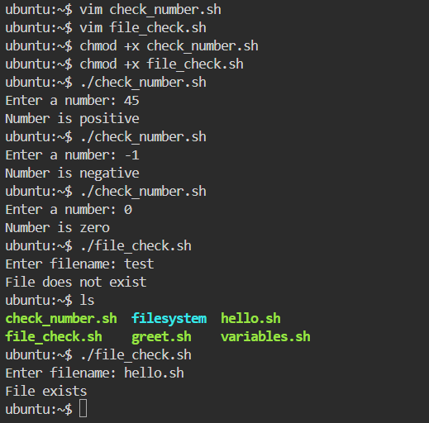

Task 5: Combine It All
Script: server_check.sh
#!/bin/bash
SERVICE="nginx"
read -p "Do you want to check the status of $SERVICE? (y/n): " CHOICE
if [ "$CHOICE" = "y" ]; then
systemctl is-active --quiet $SERVICE
if [ $? -eq 0 ]; then
echo "$SERVICE is running"
else
echo "$SERVICE is not running"
fi
elif [ "$CHOICE" = "n" ]; then
echo "Skipped."
else
echo "Invalid choice"
fi

Output:
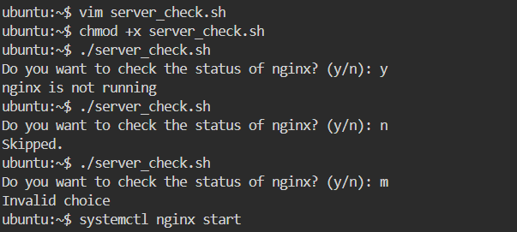

## What I Learned (Key Takeaways)
- Shebang is critical for telling Linux which interpreter should execute the script
- Variables and quotes behave differently — double quotes allow expansion
- Conditional logic + user input makes scripts interactive and powerful

