### Day 17 – Shell Scripting: Loops, Arguments & Error Handling

## Task 1: For Loop
Script: for_loop.sh
#!/bin/bash
fruits=("Apple" "Banana" "Mango" "Orange" "Grapes")
for fruit in "${fruits[@]}"; do
echo "Fruit: $fruit"
done
Output:
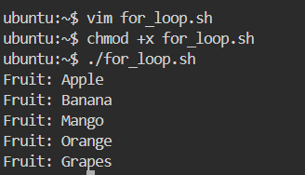
Script: count.sh
#!/bin/bash
for i in {1..10}; do
echo $i
done
Output:
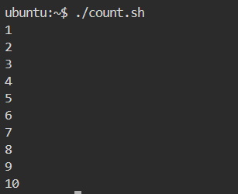
## Task 2: While Loop
Script: countdown.sh
#!/bin/bash
read -p "Enter a number: " num
while [ $num -ge 0 ]; do
echo $num
num=$((num - 1))
done
echo "Done!"
Output:
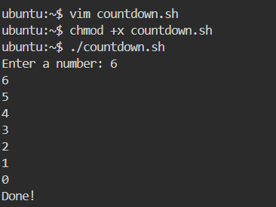

## Task 3: Command-Line Arguments
Script: greet.sh
#!/bin/bash
if [ $# -eq 0 ]; then
echo "Usage: ./greet.sh <name>"
exit 1
fi
echo "Hello, $1!"
Output:
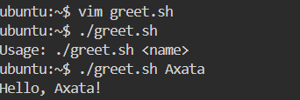
Script: args_demo.sh
#!/bin/bash
echo "Script name: $0"
echo "Total arguments: $#"
echo "All arguments: $@"
Output:
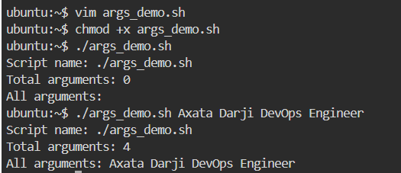
## Task 4: Install Packages via Script
Script: install_packages.sh
#!/bin/bash
set -e
if [ "$EUID" -ne 0 ]; then
echo "Please run this script as root"
exit 1
fi
packages=("nginx" "curl" "wget")
for pkg in "${packages[@]}"; do
if dpkg -s "$pkg" &> /dev/null; then
echo "$pkg is already installed"
else
echo "Installing $pkg..."
apt update -y && apt install -y "$pkg"
echo "$pkg installed successfully"
fi
done
Output:
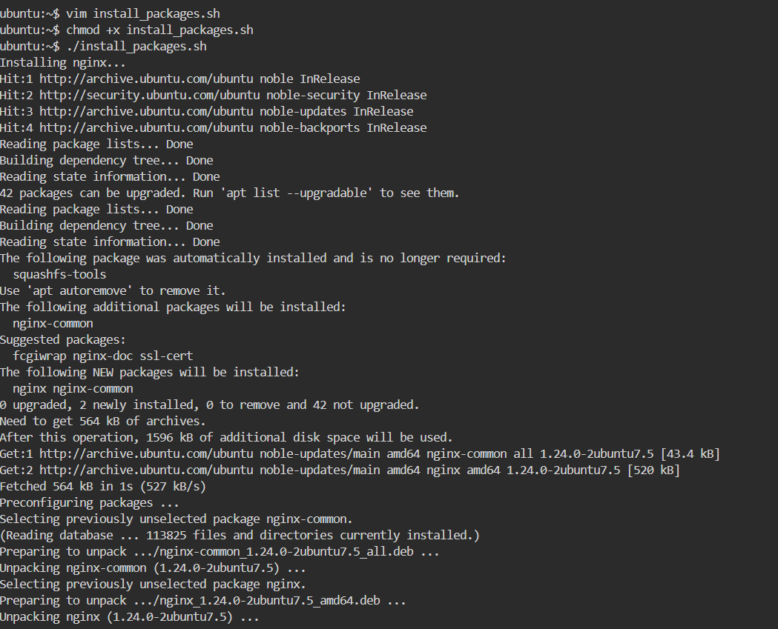
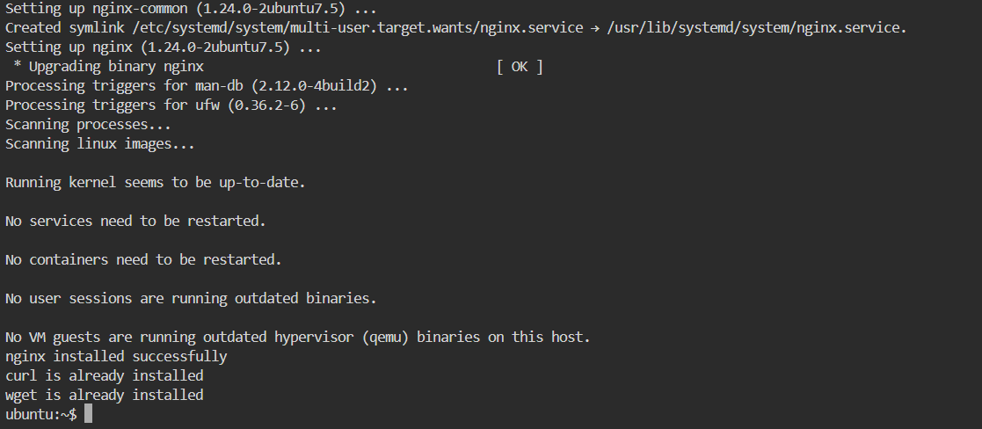

## Task 5: Error Handling
Script: safe_script.sh
#!/bin/bash
set -e
mkdir /tmp/devops-test || echo "Directory already exists"
cd /tmp/devops-test || echo "Failed to enter directory"
touch testfile.txt || echo "Failed to create file"
echo "Script completed successfully"
Output:
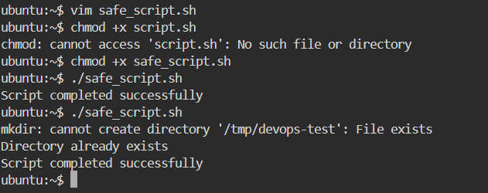
## What I Learned
- Loops (for and while) help automate repetitive tasks efficiently.
- Command-line arguments allow scripts to accept dynamic input.
- Error handling using set -e, ||, and root checks makes scripts safer and more reliable.

