### Day 18 – Shell Scripting: Functions & Slightly Advanced Concepts

🎯 Goal
Learn to write clean, reusable, and safe Bash scripts using functions, strict mode, and real-world system monitoring patterns.

## Task 1: Basic Functions
File: functions.sh
#!/bin/bash
greet() {
echo "Hello, $1!"
}
add() {
echo "Sum: $(($1 + $2))"
}
# Function calls
greet "Axata"
add 10 20
Output:
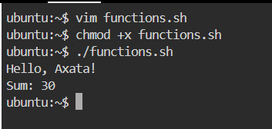

## Task 2: Functions with Return Values (System Checks)
File: disk_check.sh
#!/bin/bash
check_disk() {
echo "Disk Usage:"
df -h /
}
check_memory() {
echo "Memory Usage:"
free -h
}
main() {
check_disk
echo "-------------------"
check_memory
}
Main
Output:
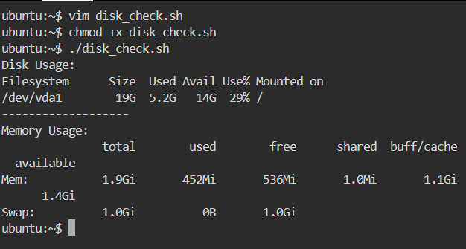
## Task 3: Strict Mode — set -euo pipefail
File: strict_demo.sh
#!/bin/bash
set -euo pipefail
echo "=== Strict Mode Demo ==="
echo
echo "Demonstrating set -u (undefined variables)"
if [[ -z "${MY_VAR:-}" ]]; then
echo "MY_VAR is undefined → handled safely using \${VAR:-}"
else
echo "MY_VAR value: $MY_VAR"
fi
echo
echo "Demonstrating set -e (command failure)"
if ls /this/path/does/not/exist >/dev/null 2>&1; then
echo "Command succeeded"
else
echo "Command failed → detected safely using if"
fi
echo
echo "Demonstrating set -o pipefail (pipeline failure)"
if echo "hello" | grep "hello" | grep "world" >/dev/null; then
echo "Pipeline succeeded"
else
echo "Pipeline failed → one command in the pipeline failed"
fi
echo
echo "Script completed without crashing"
Output:
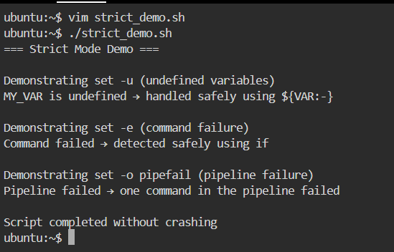
Explanation :
- set -e → Exit immediately if any command fails
- set -u → Exit if an undefined variable is used
- set -o pipefail → Fail the script if any command in a pipeline fails

## Task 4: Local Variables
File: local_demo.sh
#!/bin/bash
demo_local() {
local MESSAGE="I am local"
echo "Inside function: $MESSAGE"
}
demo_global() {
MESSAGE="I am global"
}
demo_local
echo "Outside function: ${MESSAGE:-Not Accessible}"
demo_global
echo "After global function: $MESSAGE"
Output:
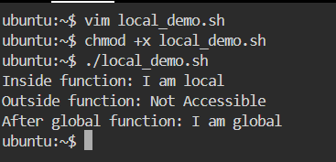
## Task 5: Build Script — System Info Reporter
File: system_info.sh
#!/bin/bash
set -euo pipefail
print_header() {
echo "=============================="
echo "$1"
echo "=============================="
}
system_info() {
print_header "System Information"
hostname
uname -a
}
uptime_info() {
print_header "Uptime"
uptime
}
disk_usage() {
print_header "Top 5 Disk Usage"
du -h / 2>/dev/null | sort -hr | head -5
}
memory_usage() {
print_header "Memory Usage"
free -h
}
cpu_processes() {
print_header "Top 5 CPU Consuming Processes"
ps -eo pid,comm,%cpu --sort=-%cpu | head -6
}
main() {
system_info
uptime_info
disk_usage
memory_usage
cpu_processes
}
Main
Output:
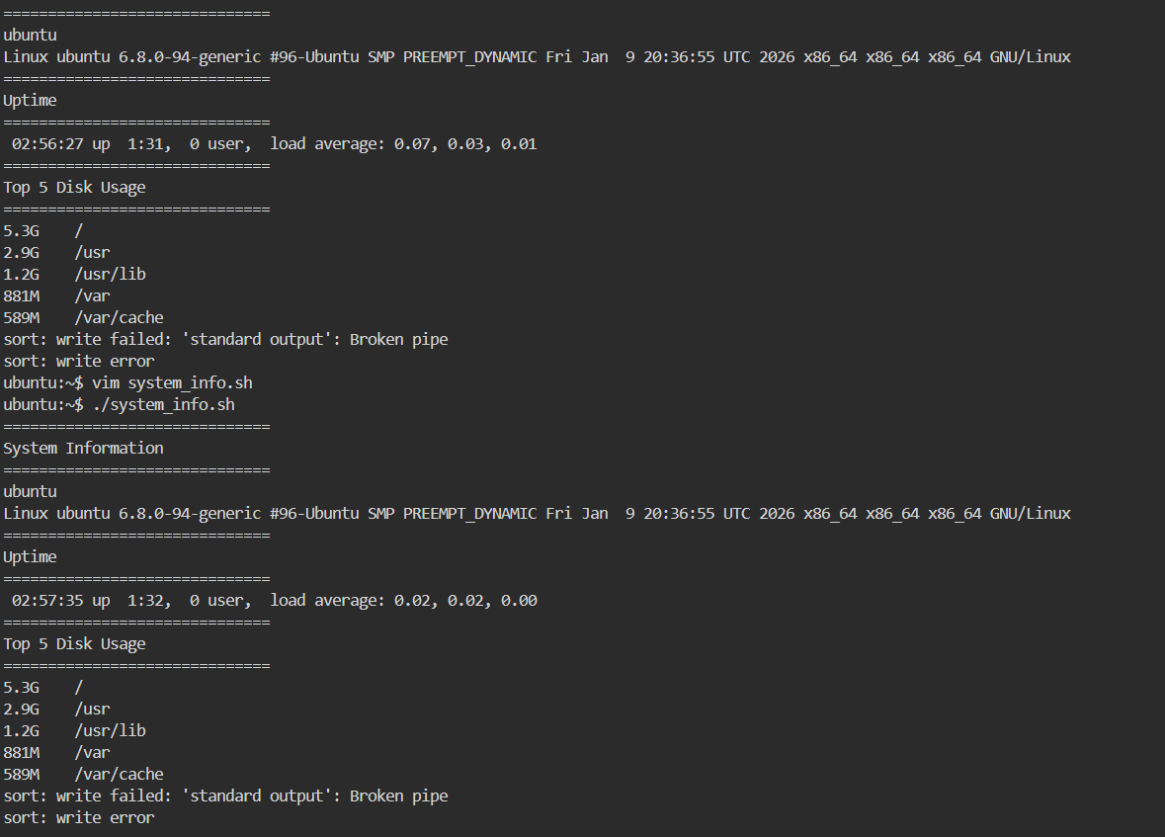
## What I Learned (Key Takeaways)
- Functions make shell scripts reusable, readable, and professional
- set -euo pipefail is critical for safe automation and CI/CD pipelines
- Local variables prevent bugs caused by accidental variable overwrites

