### Day 22 – Introduction to Git: Your First Repository## Quick Reference Table

##Task 1: Install & Configure Git
🔹 Verify installation
git --version
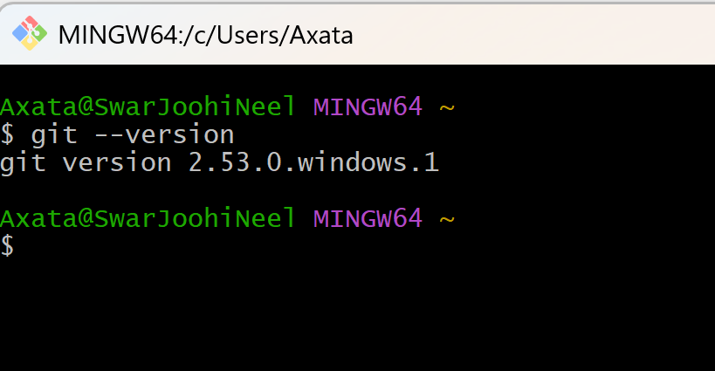
🔹 Set identity
git config --global user.name "Axata"
git config --global user.email "staraxu@gmail.com"
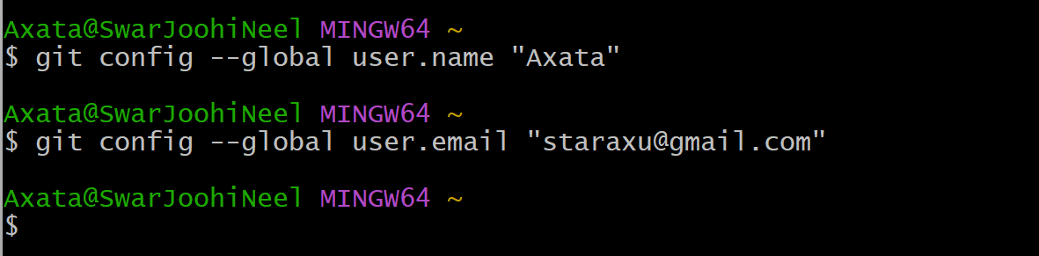
🔹 Verify configuration
git config --list
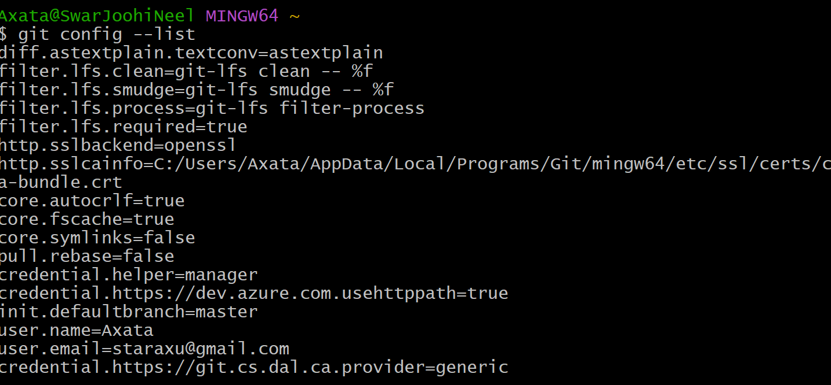

## Task 2: Create Your Git Project
🔹 Create project folder
mkdir devops-git-practice
cd devops-git-practice
🔹 Initialize Git repository
git init
🔹 Check repository status
git status
🔹 Explore hidden .git folder
ls –a
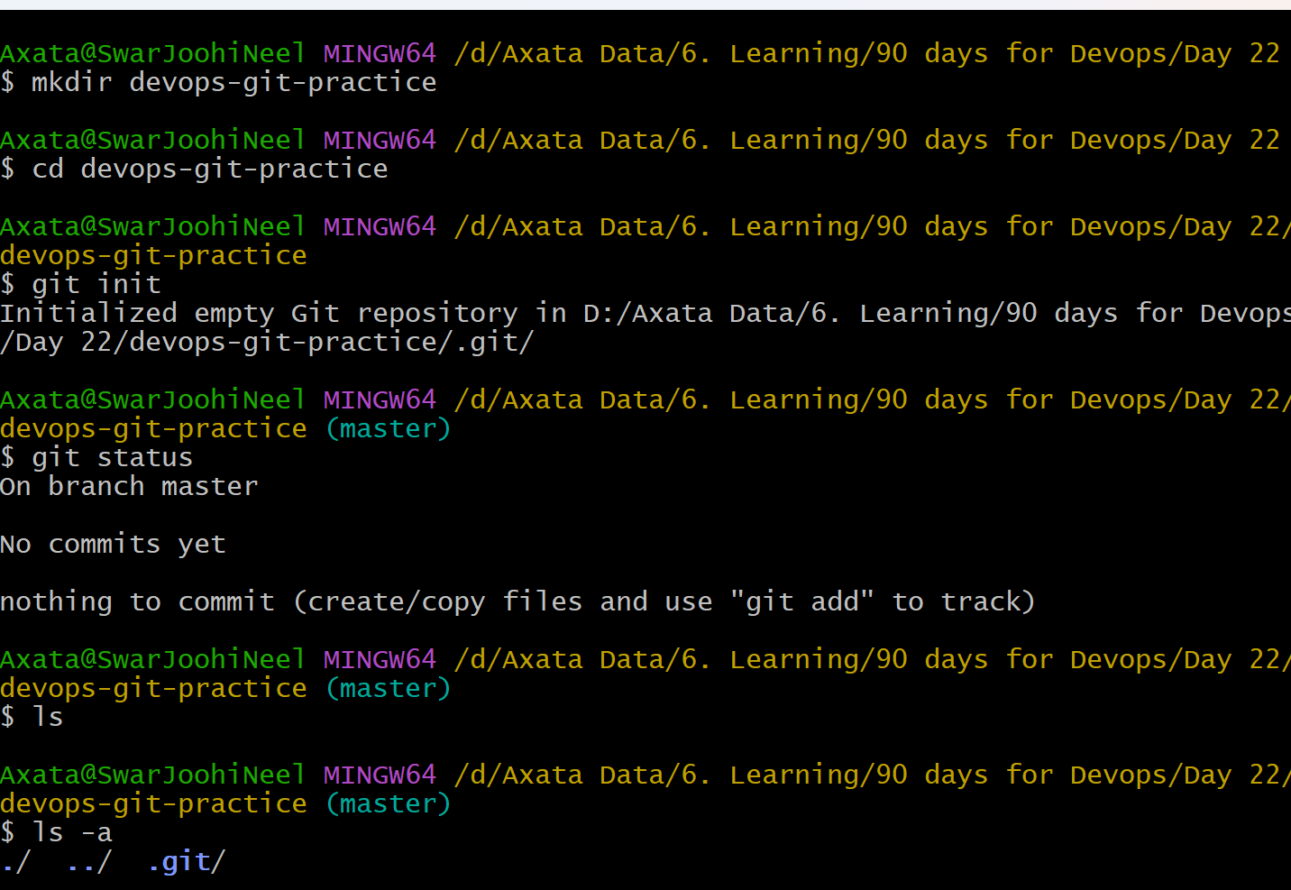

## Task 3: Create git-commands.md
Create file:
touch git-commands.md
File Content:
# Git Commands Reference
## Setup & Config

### git config
Sets user identity
Example:
git config --global user.name "Axata"

---

## Basic Workflow

### git init
Creates a new repository
Example:
git init

### git add
Stages files for commit
Example:
git add git-commands.md

### git commit
Saves snapshot of staged files
Example:
git commit -m "Add git commands file"

---

## Viewing Changes

### git status
Shows file state
Example:
git status

### git log
Shows commit history
Example:
git log

## Task 4: Stage & Commit
🔹 Stage file
git add git-commands.md
🔹 Check staged files
git status
🔹 Commit
git commit -m "Initial commit: add git commands reference"
🔹 View history
git log
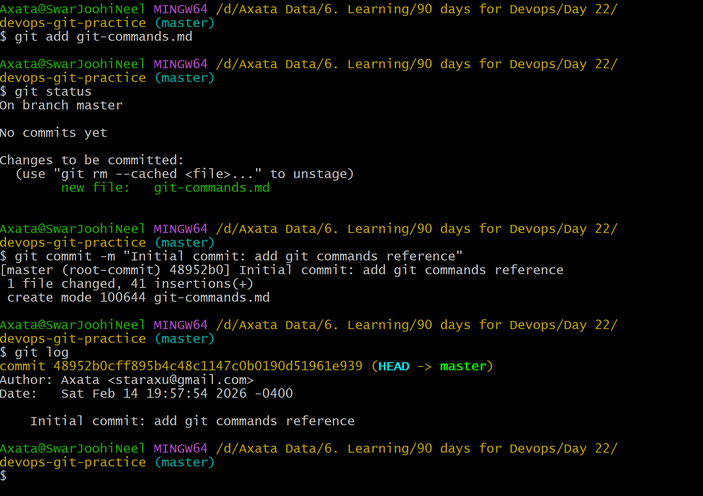

## Task 5: Build Commit History
🔹 See changes
git diff
🔹 Stage & commit again
git add .
git commit -m "Add viewing and restore commands"
🔹 Compact history view
git log
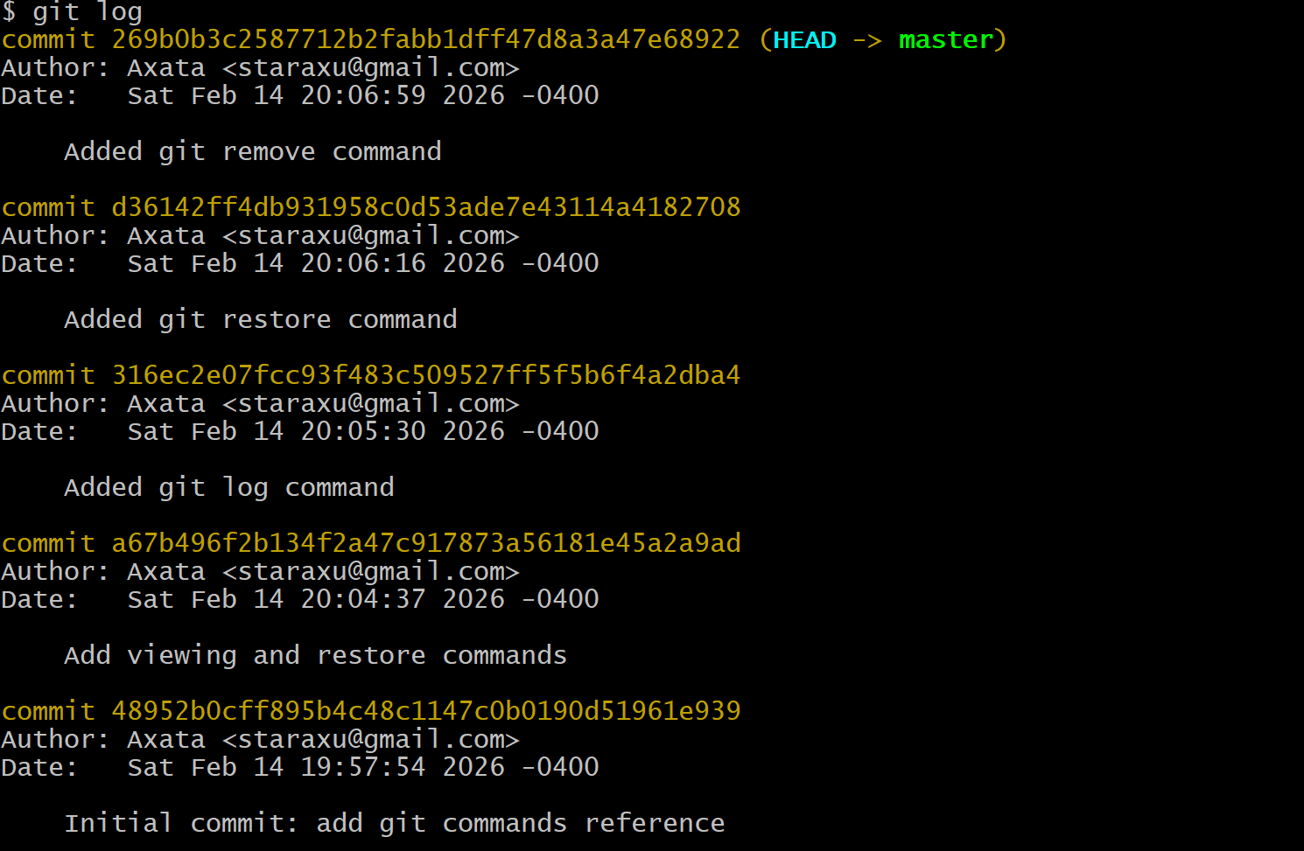

## Task 6: Create day-22-notes.md
Git Workflow:
Working Directory → Staging Area → Repository
edit git add git commit
Create file:
touch day-22-notes.md
Content:
# Day 22 Notes
## 1. Difference between git add and git commit
git add moves changes to the staging area.
git commit permanently saves those staged changes to the repository.

## 2. What does the staging area do?
The staging area lets you prepare and review changes before committing.
It allows selective commits instead of committing everything.

## 3. What information does git log show?
It shows commit history including:
- commit ID
- author
- date
- commit message

## 4. What is the .git folder?
.git stores all repository history, commits, and configuration.
Deleting it removes version control and history.

## 5. Working directory vs staging vs repository
Working directory → files you edit
Staging area → files ready to commit
Repository → saved history of commits

