### Day 26 – GitHub CLI: Manage GitHub from Your Terminal
## Task:1 Install and Authenticate
1. Install the GitHub CLI on your machine
Enter command in command prompt:
winget install GitHub.cli
2. Authenticate with your GitHub account
gh auth login
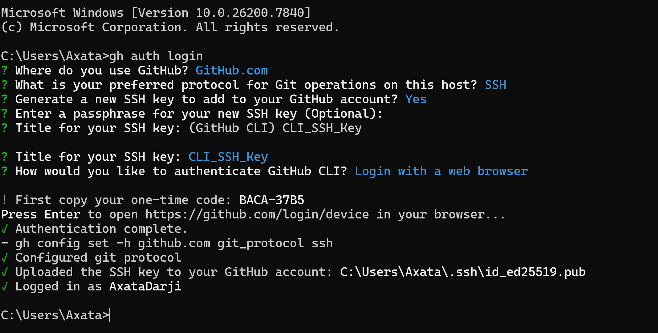
3. Verify you're logged in and check which account is active
gh auth status
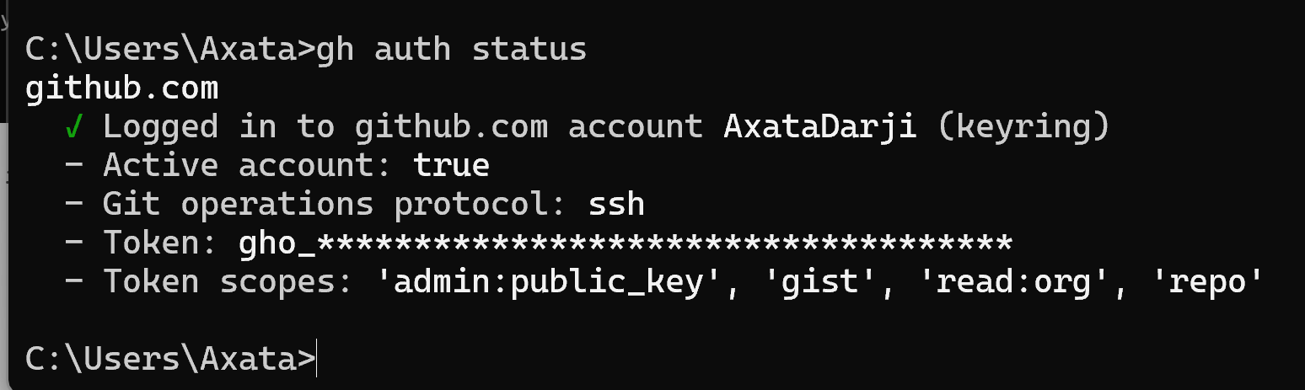
4. What authentication methods does gh support?
gh supports:
- Browser-based OAuth (recommended)
→ Opens browser for secure login
- Personal Access Token (PAT)
→ Used for automation & CI
- SSH authentication
→ Uses existing SSH keys
- GitHub Enterprise authentication
→ Supports enterprise servers
## Task:2 Working with Repositories
- Create a new GitHub repo directly from the terminal — make it public with a README
gh repo create my-test-repo --public --clone --add-readme

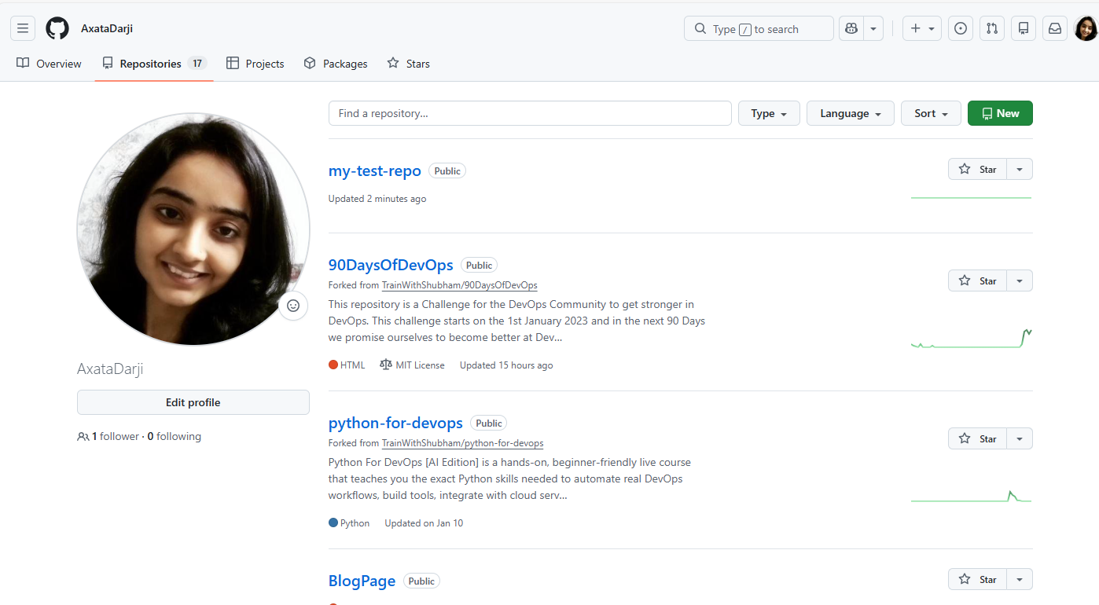
- Clone a repo using gh instead of git clone
gh repo clone TrainWithShubham/python-for-devops
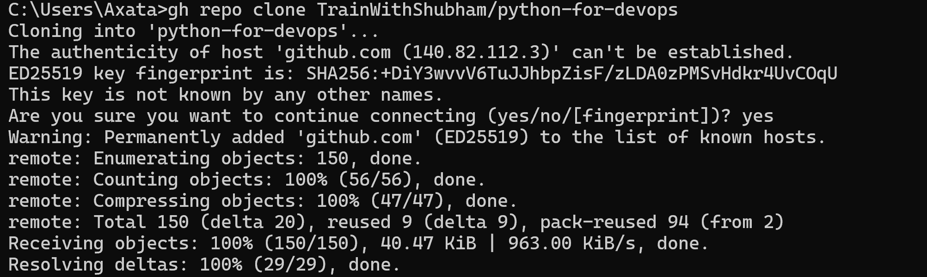

- View details of one of your repos from the terminal
gh repo view my-test-repo
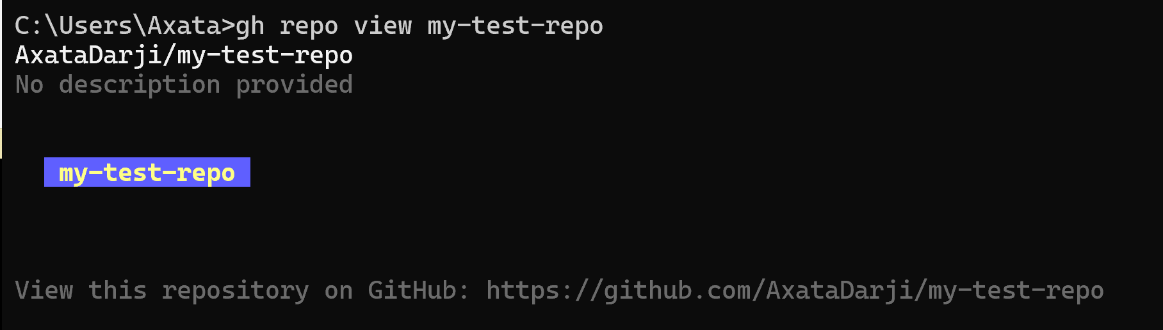

- List all your repositories
gh repo list
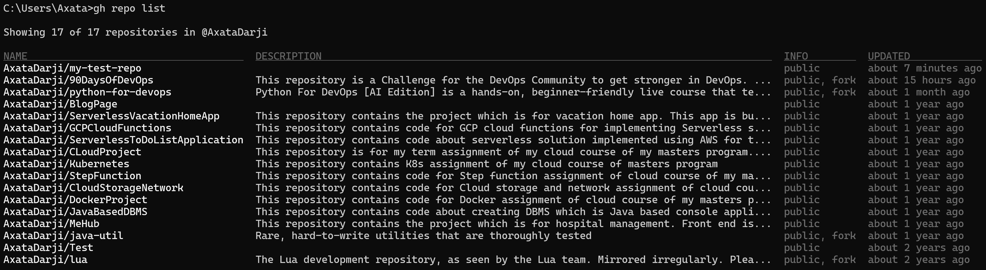

- Open a repo in your browser directly from the terminal
gh repo view –web
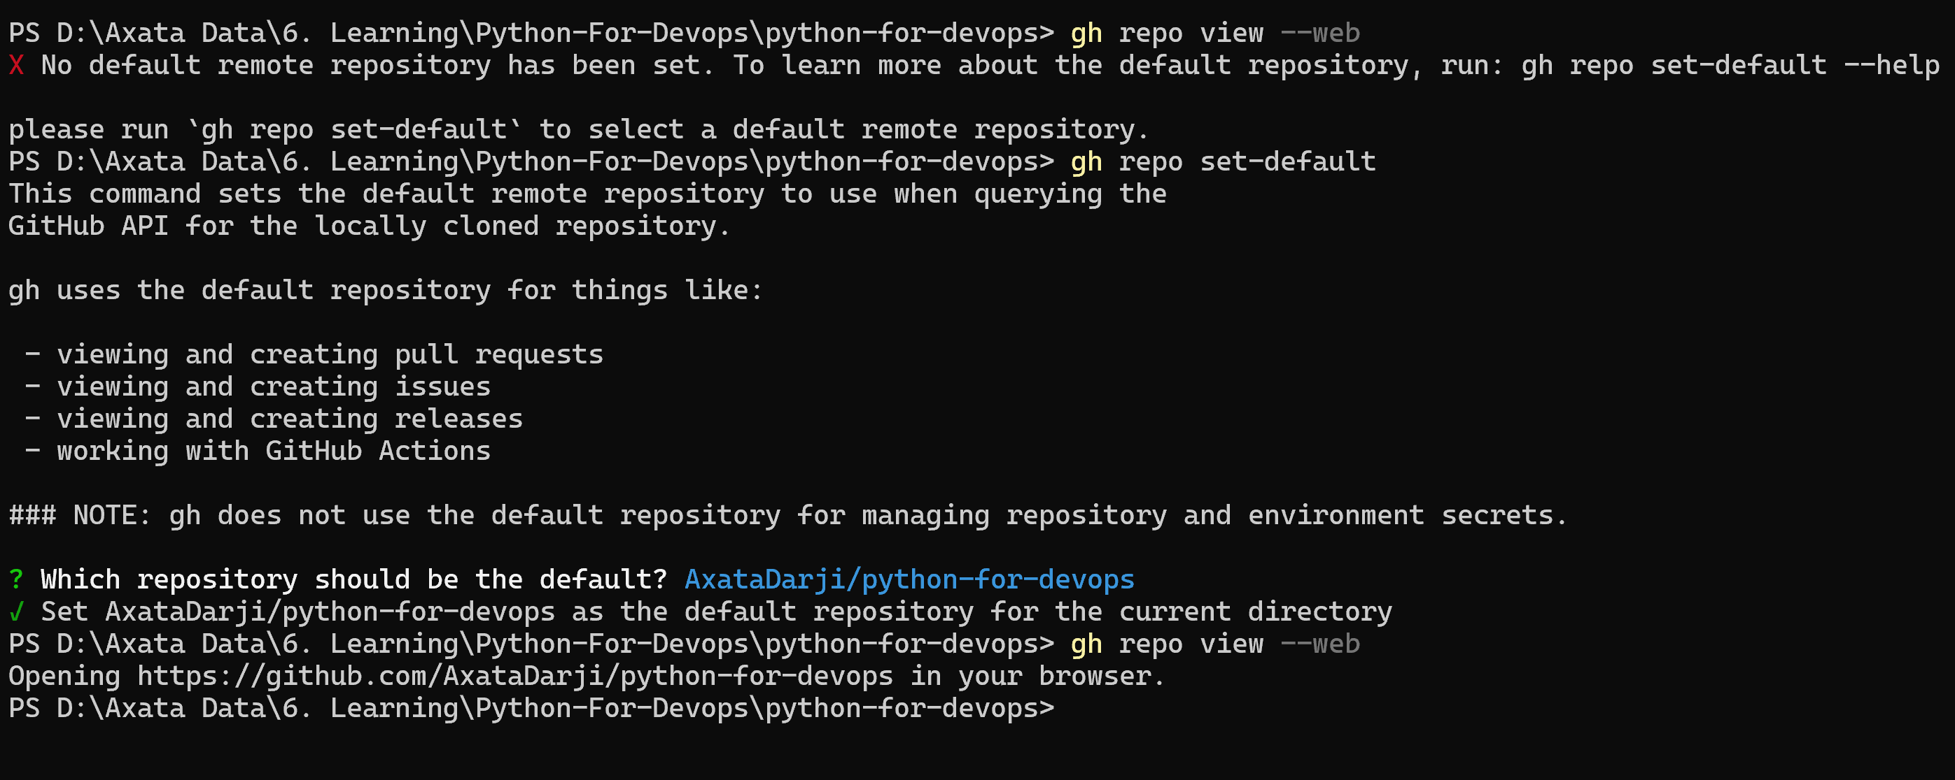

- Delete the test repo you created (be careful!)
gh auth refresh -h github.com -s delete_repo
gh repo delete my-test-repo –-yes
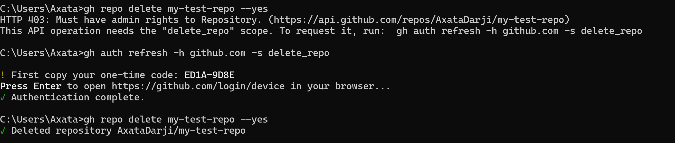

##Task:3 Issues
- Create an issue on one of your repos from the terminal — give it a title, body, and a label
gh issue create --title "Bug in login flow" --body "Users cannot login after update" --label bug
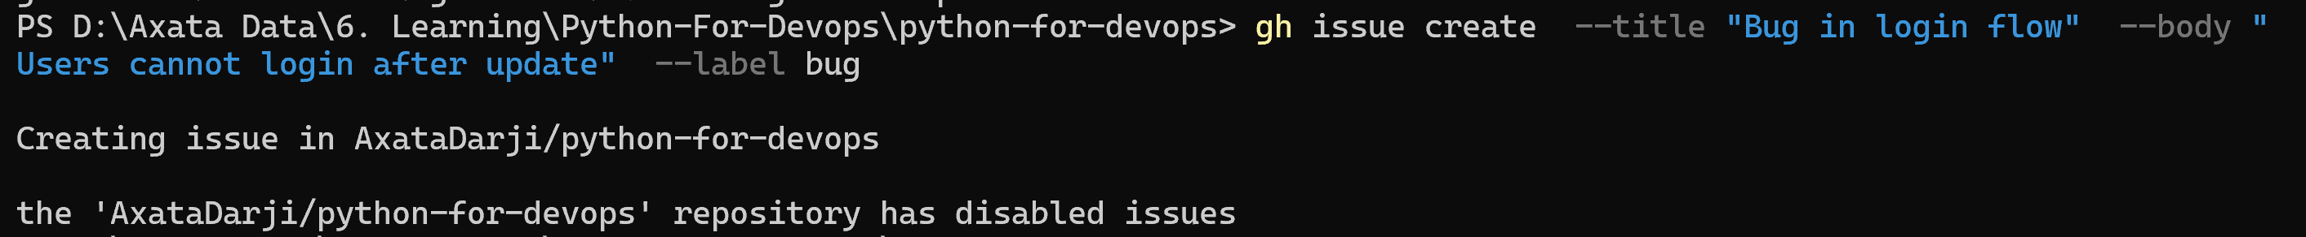

- List all open issues on that repo
gh issue list

- View a specific issue by its number
gh issue view 1

- Close an issue from the terminal
gh issue close 1

- How could you use gh issue in a script or automation?
gh issue can be scripted to:
- Auto-create issues from monitoring alerts
- Create bug tickets from CI failures
- Generate weekly backlog items
- Track incidents automatically
## Task:4 Pull Requests
- Create a branch, make a change, push it, and create a pull request entirely from the terminal
git checkout -b feature-update
echo "update" >> file.txt
git add .
git commit -am "update file"
git push origin feature-update

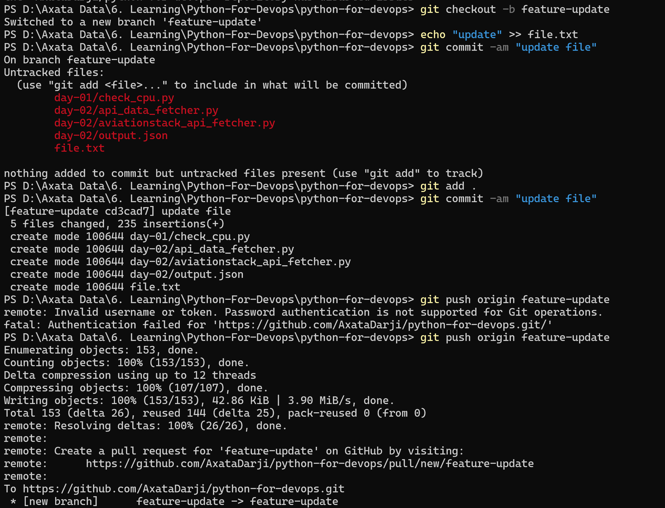

- List all open PRs on a repo
Create a PR:
gh pr create –fill
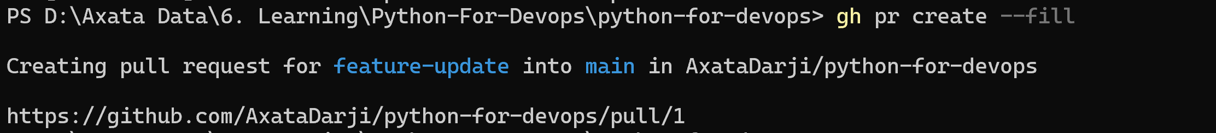

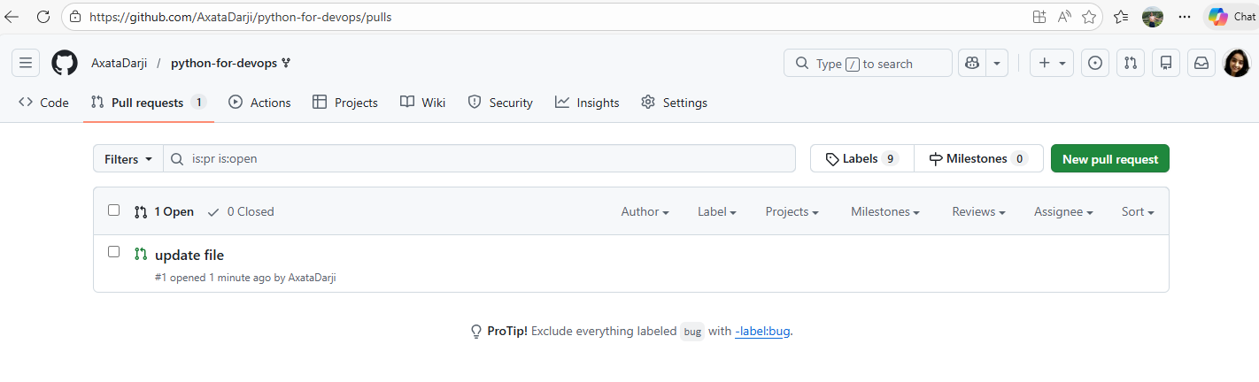

To List open PRs
gh pr list
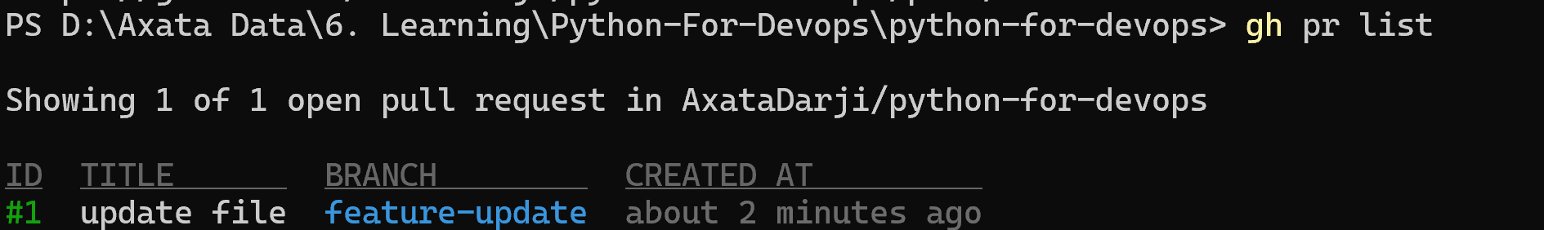

- View the details of your PR — check its status, reviewers, and checks
gh pr view 1
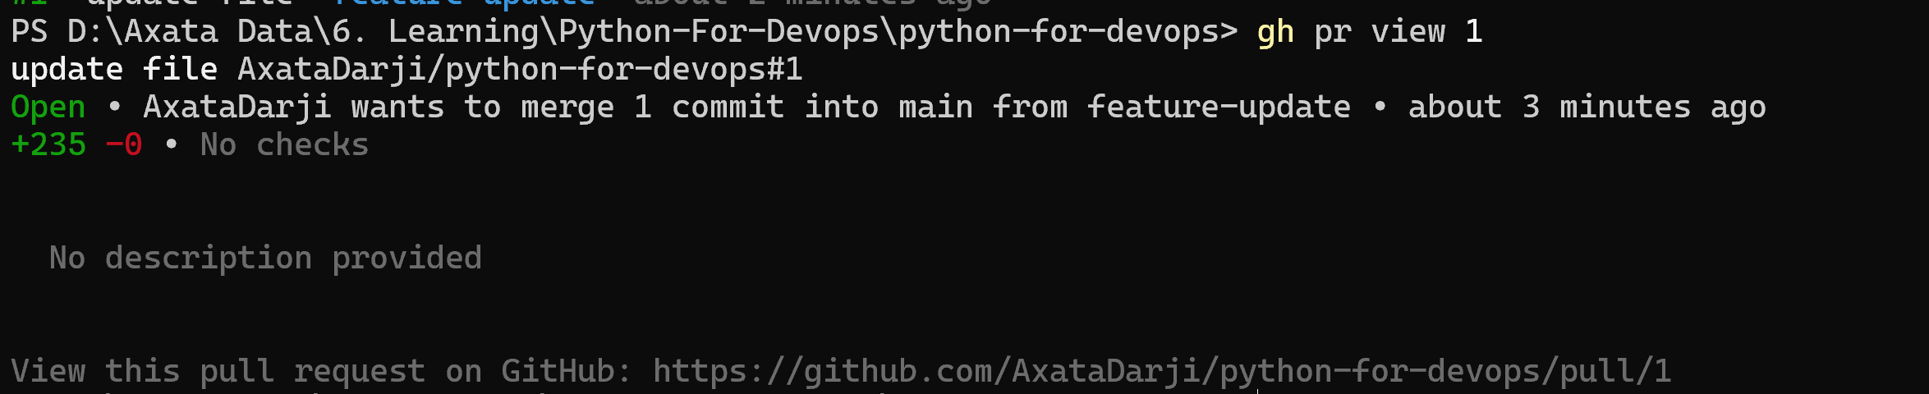

- Merge your PR from the terminal
gh pr merge 1 –merge
- Answer in your notes:
- What merge methods does gh pr merge support?
gh pr merge --merge # merge commit
gh pr merge --squash # squash commits
gh pr merge --rebase # rebase & merge
- How would you review someone else's PR using gh?
gh pr checkout 15 # checkout PR locally
gh pr review 15 --approve
gh pr review 15 --comment -b "Looks good"
gh pr review 15 --request-changes -b "Please fix formatting"

## Task : 5 GitHub Actions & Workflows (Preview)
- List the workflow runs on any public repo that uses GitHub Actions
gh run list
- View the status of a specific workflow run
gh run view <run-id> --log
- Answer in your notes: How could gh run and gh workflow be useful in a CI/CD pipeline?
gh run & gh workflow help:
- Monitor pipeline status from terminal
- Auto-fail deployments if checks fail
- Trigger workflows manually
- Fetch logs for debugging
- Integrate pipeline status into scripts

## Task 6: Useful gh Tricks
Explore and try these — add the ones you find useful to your git-commands.md:
- gh api — make raw GitHub API calls from the terminal
gh api repos/:owner/:repo/issues
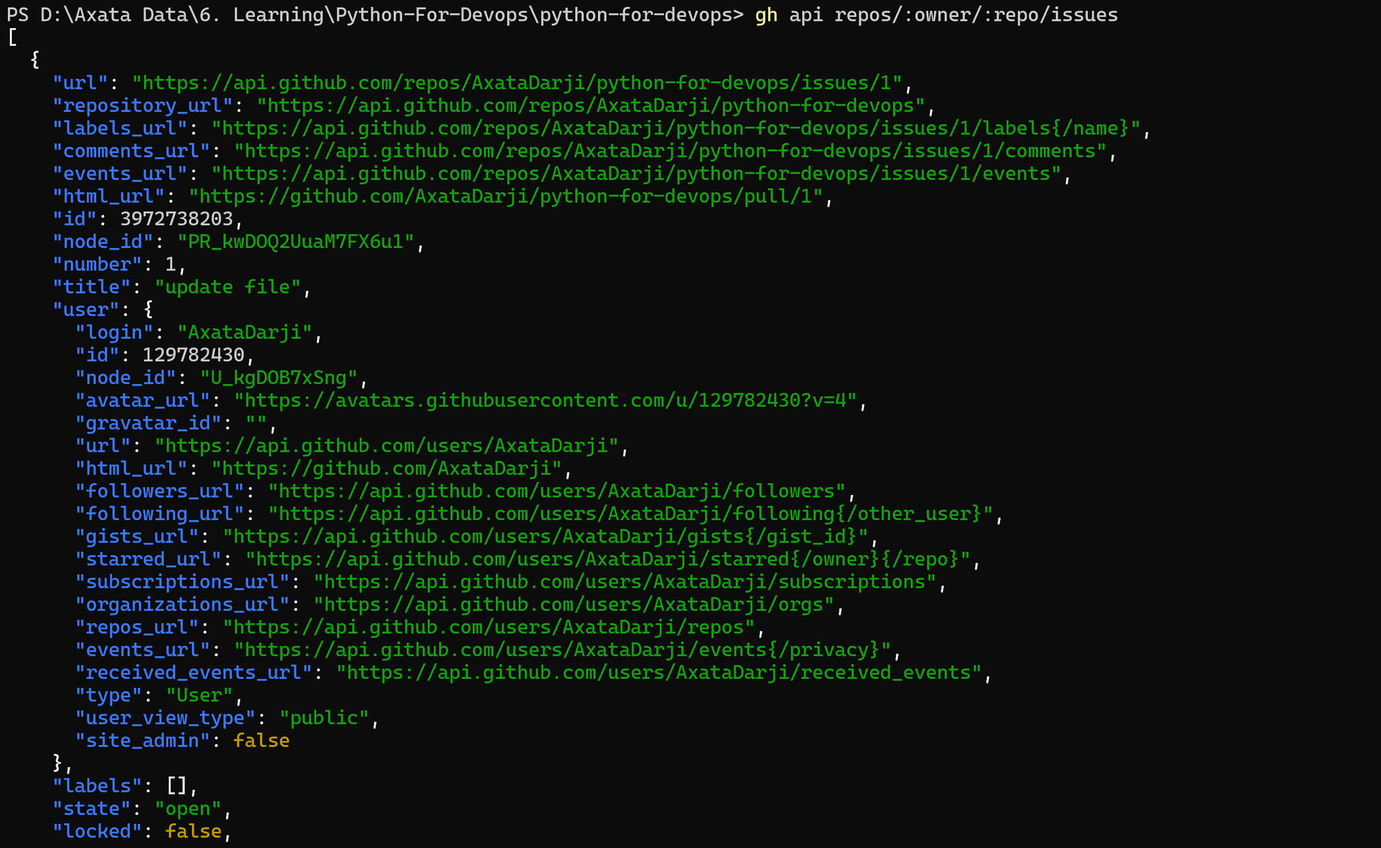
- gh gist — create and manage GitHub Gists
gh gist create notes.txt

- gh release — create and manage releases
gh release create v1.0 --notes "First release"

- gh alias — create shortcuts for commands you use often
gh alias set prs "pr list"
gh prs
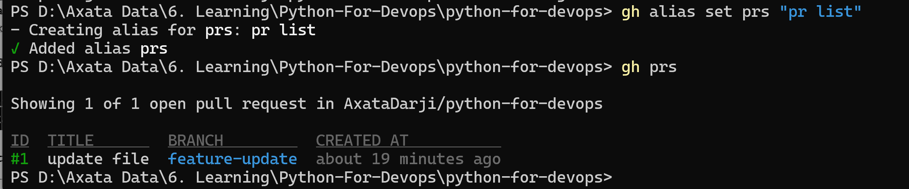

- gh search repos — search GitHub repos from the terminal
gh search repos terraform aws
