### Day 29 – Introduction to Docker

## Task 1: What is Docker?
- What is a Container?
A **container** is a lightweight, portable package that includes:
- application code
- runtime
- libraries
- dependencies
- system tools
Containers ensure software runs the same everywhere.
Why Do We Need Containers?
Before containers:
- apps worked on one machine but failed on another
- dependency conflicts were common
- environment setup was time-consuming
Containers solve this by packaging everything together.
- Containers vs Virtual Machines
Feature | Containers | Virtual Machines
OS | Share host OS | Each VM has full OS
Size | MBs | GBs
Startup Time | Seconds | Minutes
Performance | Near native | Overhead from hypervisor
Isolation | Process-level | Full OS isolation
Use Case | Microservices, CI/CD | Running different OS

Containers are lightweight and fast.
VMs provide stronger isolation.
- Docker Architecture

Docker uses a **client-server architecture**:
**Docker Client**
- Command line interface (`docker run`, `docker build`)
- Sends requests to the daemon
**Docker Daemon**
- Builds images
- Runs containers
- Manages networks & volumes
**Docker Images**
- Read-only templates used to create containers
**Docker Containers**
- Running instances of images
**Docker Registry (Docker Hub)**
- Stores and distributes images

- Architecture in Simple Words
When you run:
docker run nginx
✔ Docker client sends request
✔ Docker daemon checks local images
✔ If not found → pulls from Docker Hub
✔ Creates container from image
✔ Container starts running

## Task 2: Install Docker
- Verify the installation:
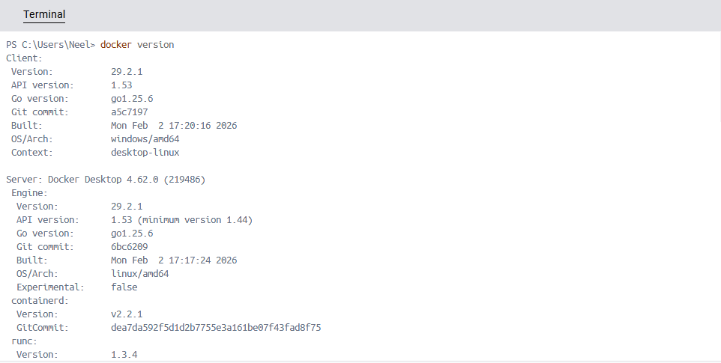
- Run the hello-world container
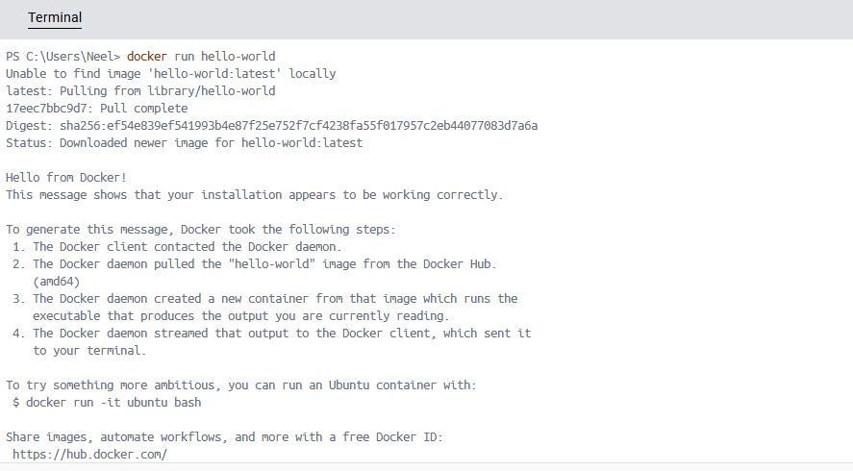
What happened?
Docker contacted Docker Hub
Downloaded hello-world image
Created container
Ran it and printed a message
## Task 3: Run Real Containers
- Run an Nginx container and access it in your browser
docker run -d -p 8080:80 nginx
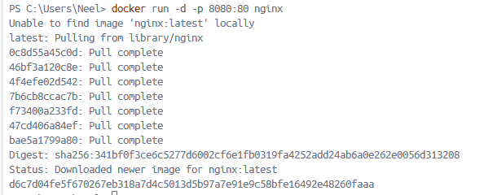
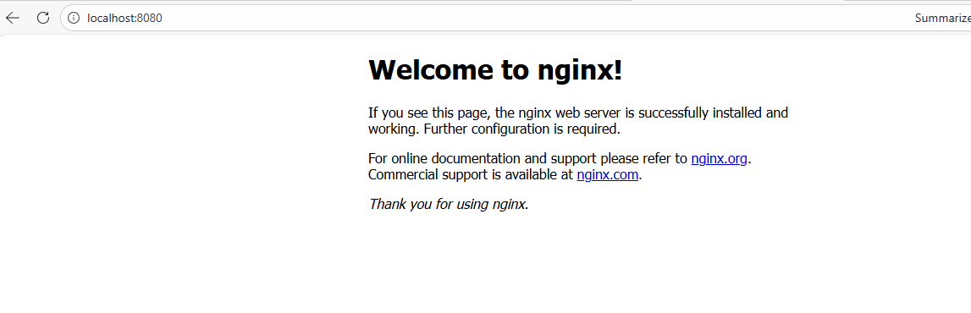
- Run an Ubuntu container in interactive mode — explore it like a mini Linux machine
docker run -it ubuntu bash
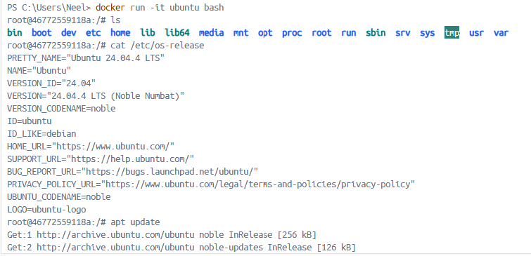
- List all running containers
docker ps
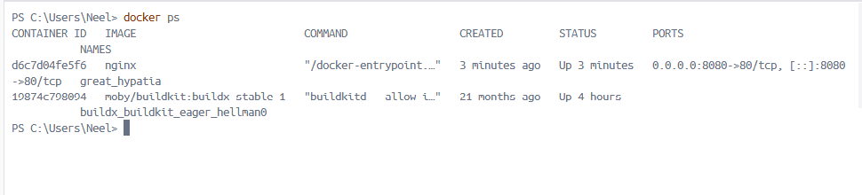
- List all containers (including stopped ones)
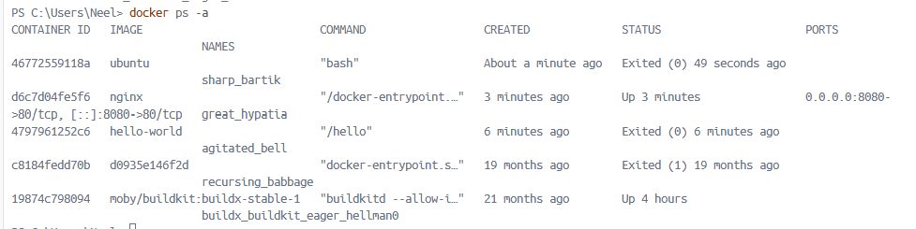
- Stop and remove a container
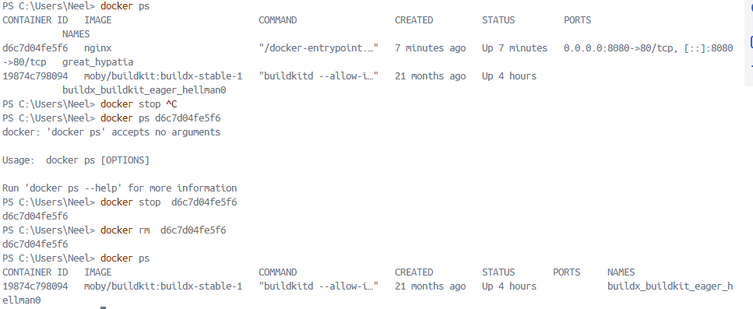
## Task 4: Explore
- Run a container in detached mode — what's different?
Docker run –d nginx
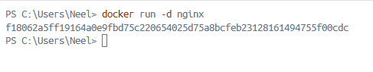
- Give a container a custom name
docker run -d --name my-nginx nginx
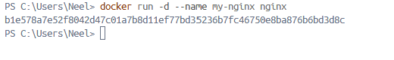
- Map a port from the container to your host
docker run -d -p 9090:80 nginx
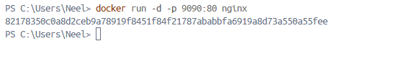
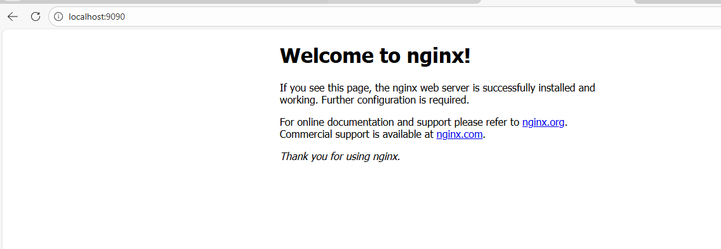
- Check logs of a running container
docker logs my-nginx
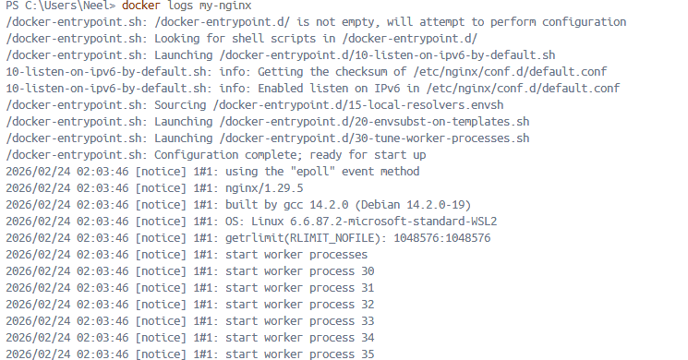
- Run a command inside a running container
docker exec -it my-nginx bash


