### Day 30 – Docker Images & Container Lifecycle
##Task 1: Docker Images
- Pull the nginx, ubuntu, and alpine images from Docker Hub
docker pull nginx
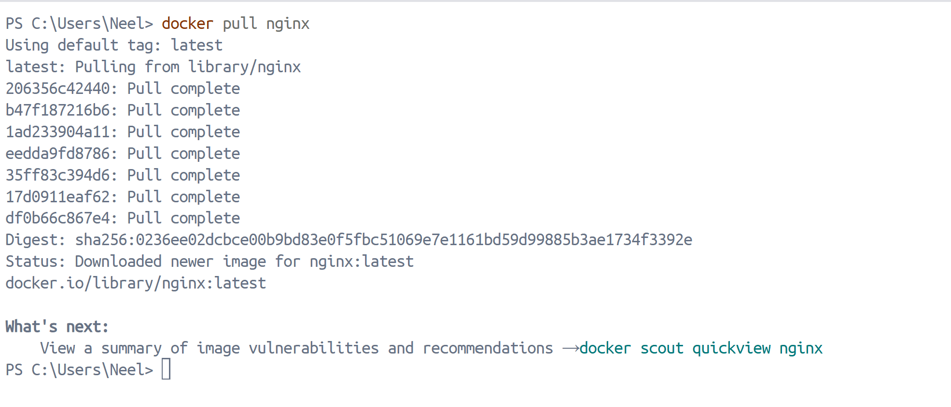
docker pull Ubuntu
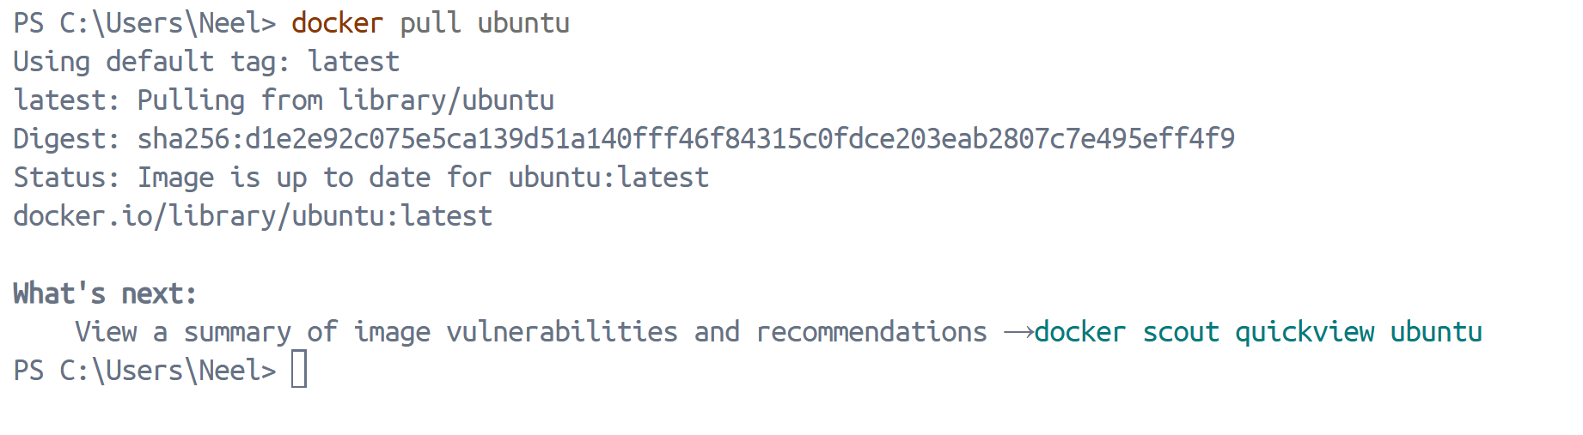
docker pull alpine
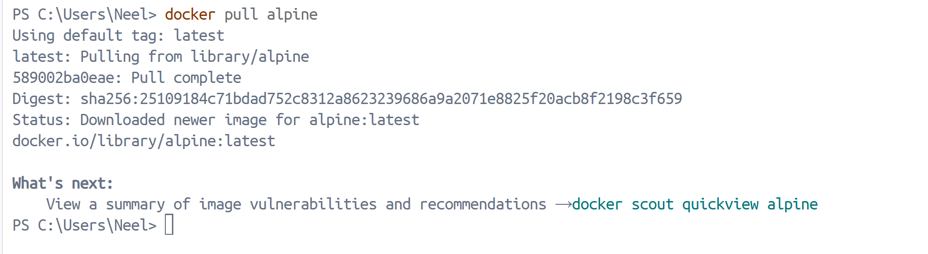
- List all images on your machine — note the sizes
docker images
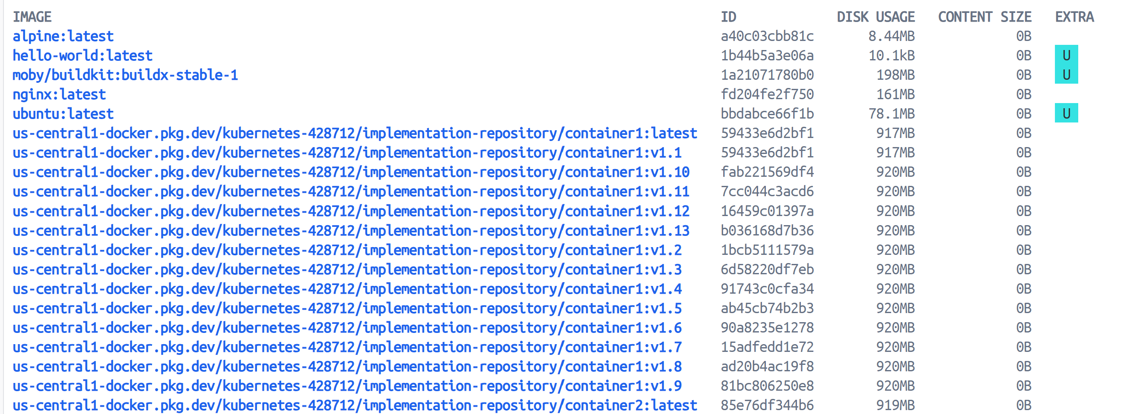
- Compare ubuntu vs alpine — why is one much smaller?
- Alpine is built for minimalism
- Uses musl libc instead of glibc
- No unnecessary packages
- Designed for containers

- Ubuntu includes:
- Full package ecosystem
- More libraries
- Larger base filesystem
- Alpine is ideal for production containers when you need smaller attack surface and faster pulls.
- Inspect an image — what information can you see?
docker inspect nginx
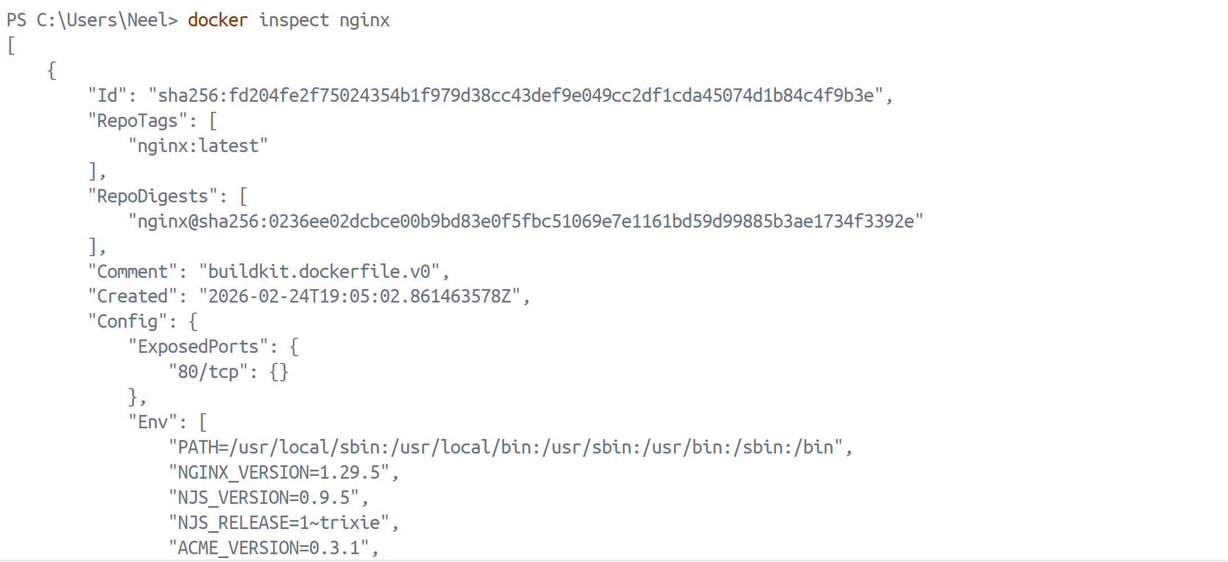
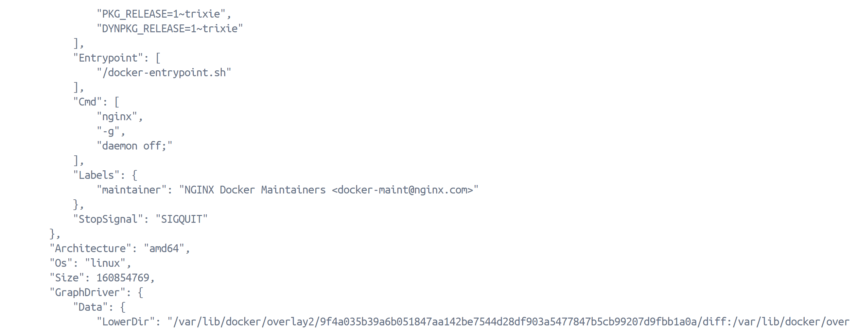
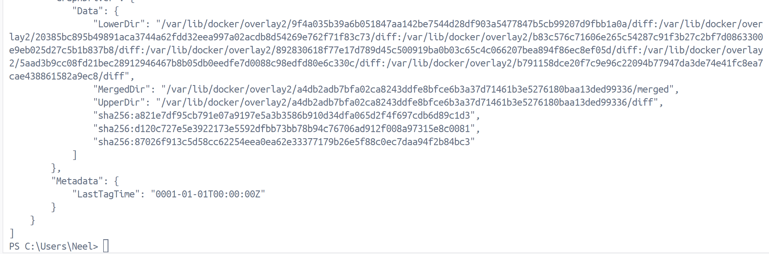
Information available:

- Image ID
- Created date
- OS/Architecture
- Environment variables
- Entrypoint
- Layers
- Metadata

- Remove an image you no longer need
docker rmi Ubuntu:latest
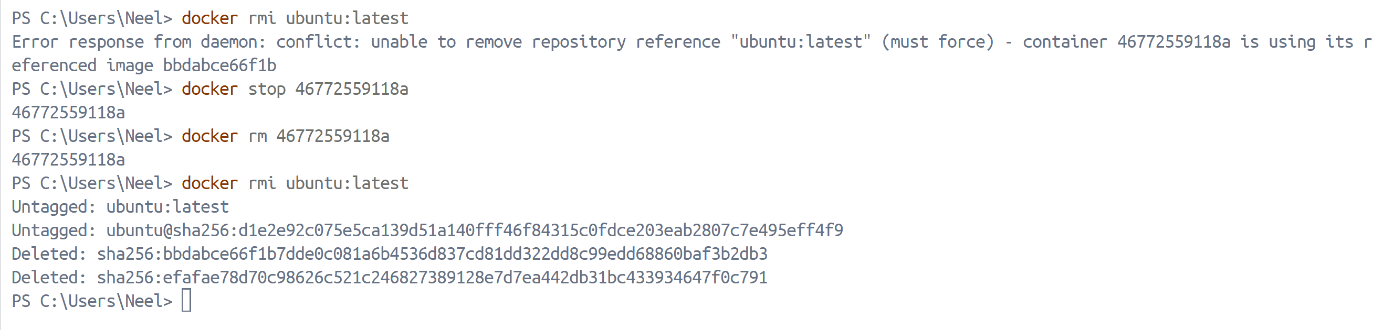
##Task 2: Image Layers
- Run docker image history nginx — what do you see?
docker image history nginx
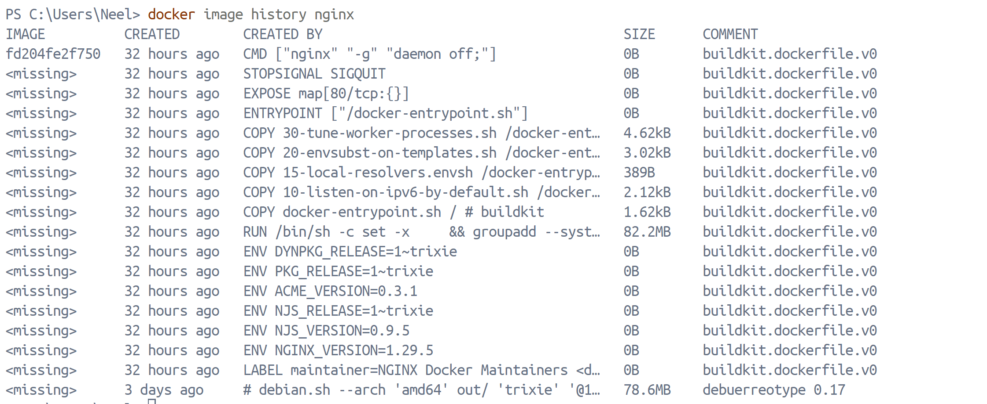
- Each line is a layer. Note how some layers show sizes and some show 0B
- What are layers and why does Docker use them?
Docker images are built in layers.
Each:
- RUN
- COPY
- ADD
- ENV
- CMD
Creates a new layer.

Why Docker Uses Layers
- Faster builds (layer caching)
- Reuse unchanged layers
- Efficient storage
- Faster pulls

If one layer changes, only that layer rebuilds.

## Task 3: Container Lifecycle
- Create a container (without starting it)
docker create --name mycontainer Ubuntu
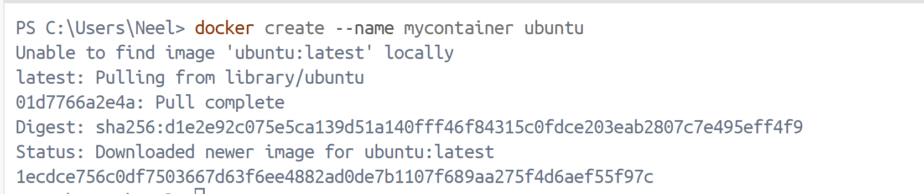
- Start the container
docker start mycontainer
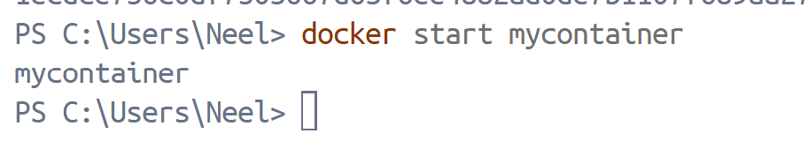
- Pause it and check status
docker pause mycontainer
- Unpause it
docker unpause mycontainer
- Stop it
docker stop mycontainer

- Restart it
docker restart mycontainer
- Kill it
docker kill mycontainer
- Remove it
docker rm mycontainer

## Task 4: Working with Running Containers
- Run an Nginx container in detached mode
docker run -d -p 8080:80 --name mynginx nginx
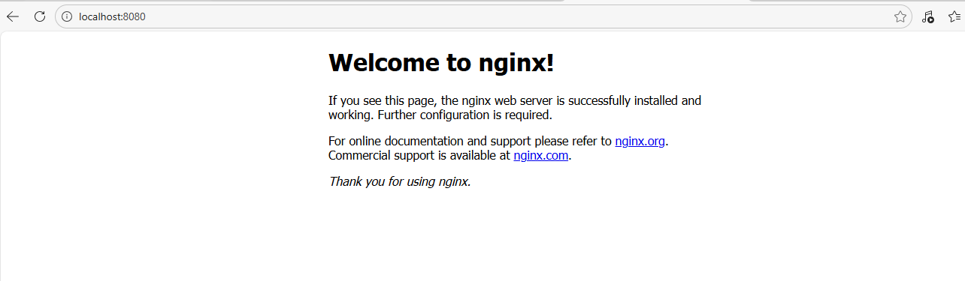
- View its logs
docker logs mynginx
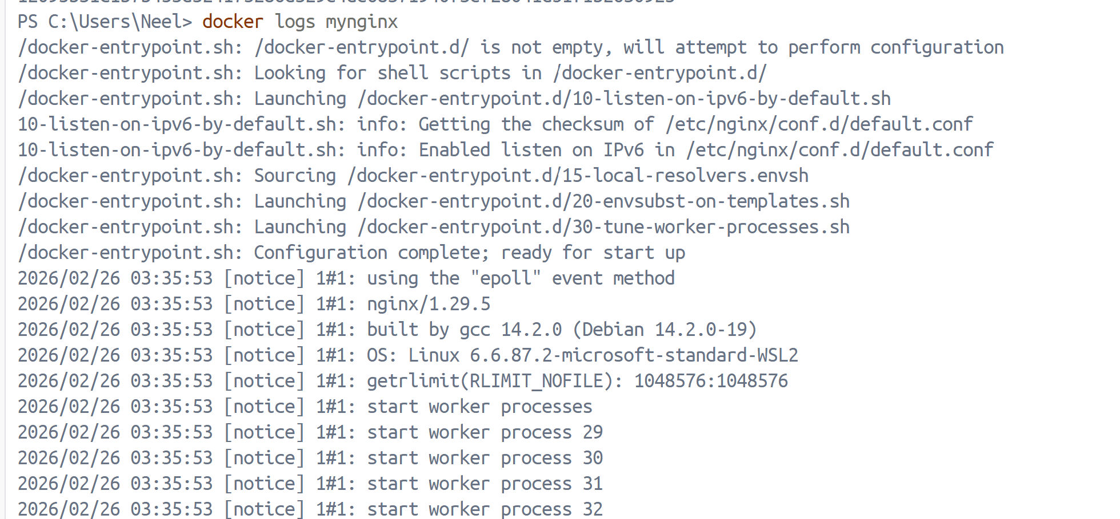
- View real-time logs (follow mode)
docker logs -f mynginx
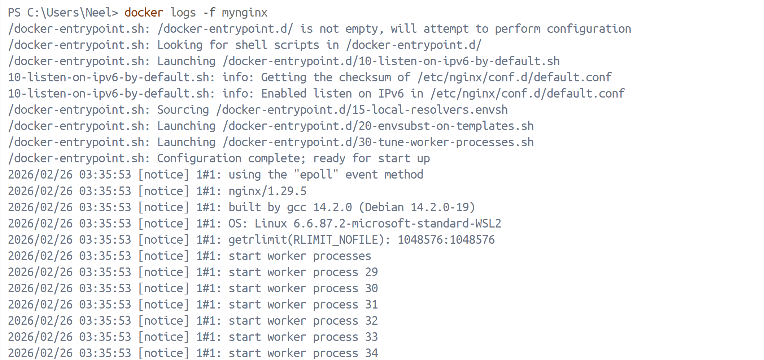
- Exec into the container and look around the filesystem
docker exec -it mynginx /bin/bash
- Run a single command inside the container without entering it
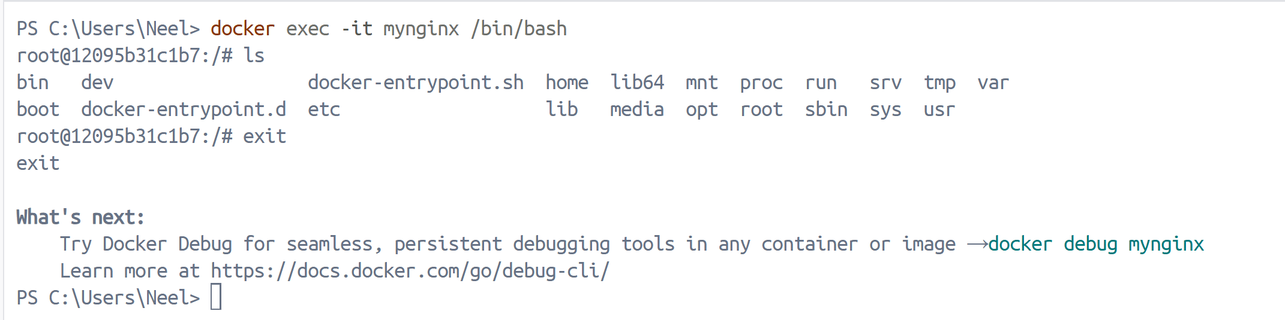
- Inspect the container — find its IP address, port mappings, and mounts
docker inspect mynginx
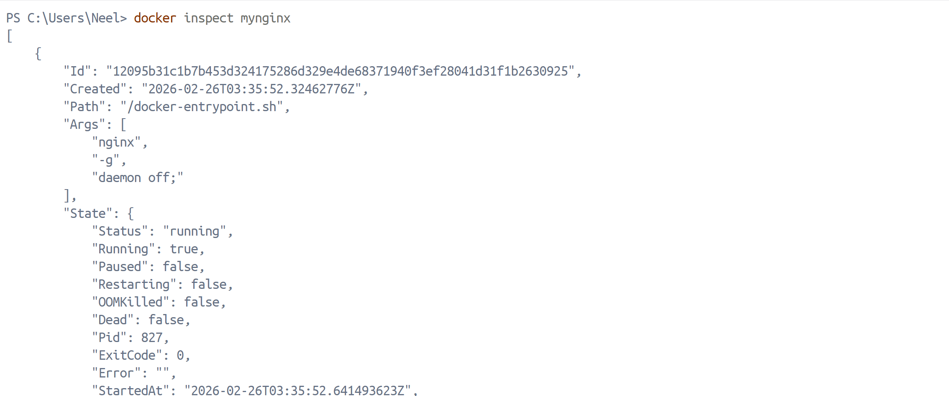
## Task 5: Cleanup
- Stop all running containers in one command
docker stop $(docker ps -q)
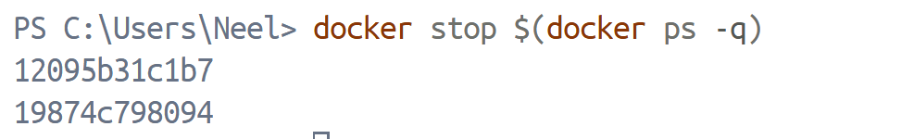
- Remove all stopped containers in one command
docker rm $(docker ps -aq)
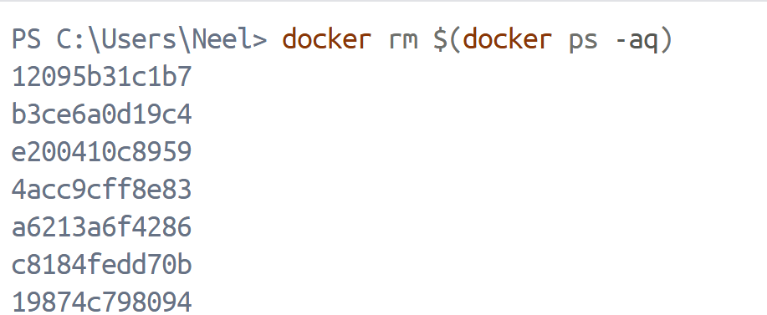
- Remove unused images
docker image prune –a
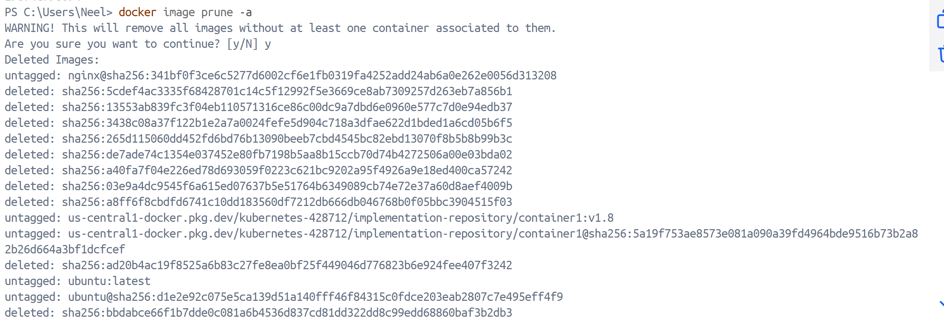
- Check how much disk space Docker is using
docker system df
