### Day 31 – Dockerfile: Build Your Own Images
##Task 1: Docker Images
- Create a folder called my-first-image
- Inside it, create a Dockerfile that:
- Uses ubuntu as the base image
- Installs curl
- Sets a default command to print "Hello from my custom image!"
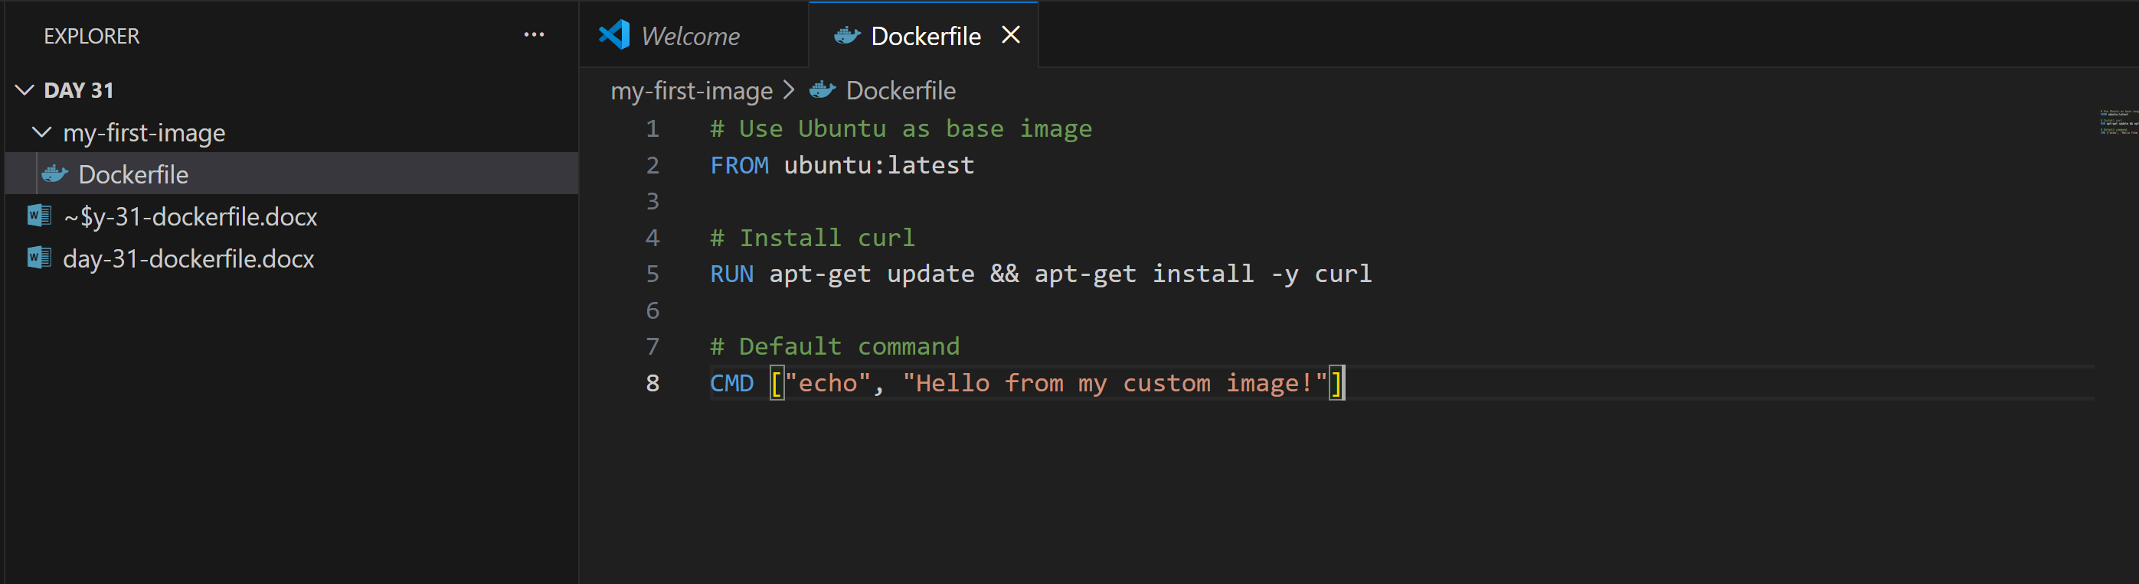
- Build the image and tag it my-ubuntu:v1
docker build -t my-ubuntu:v1 .
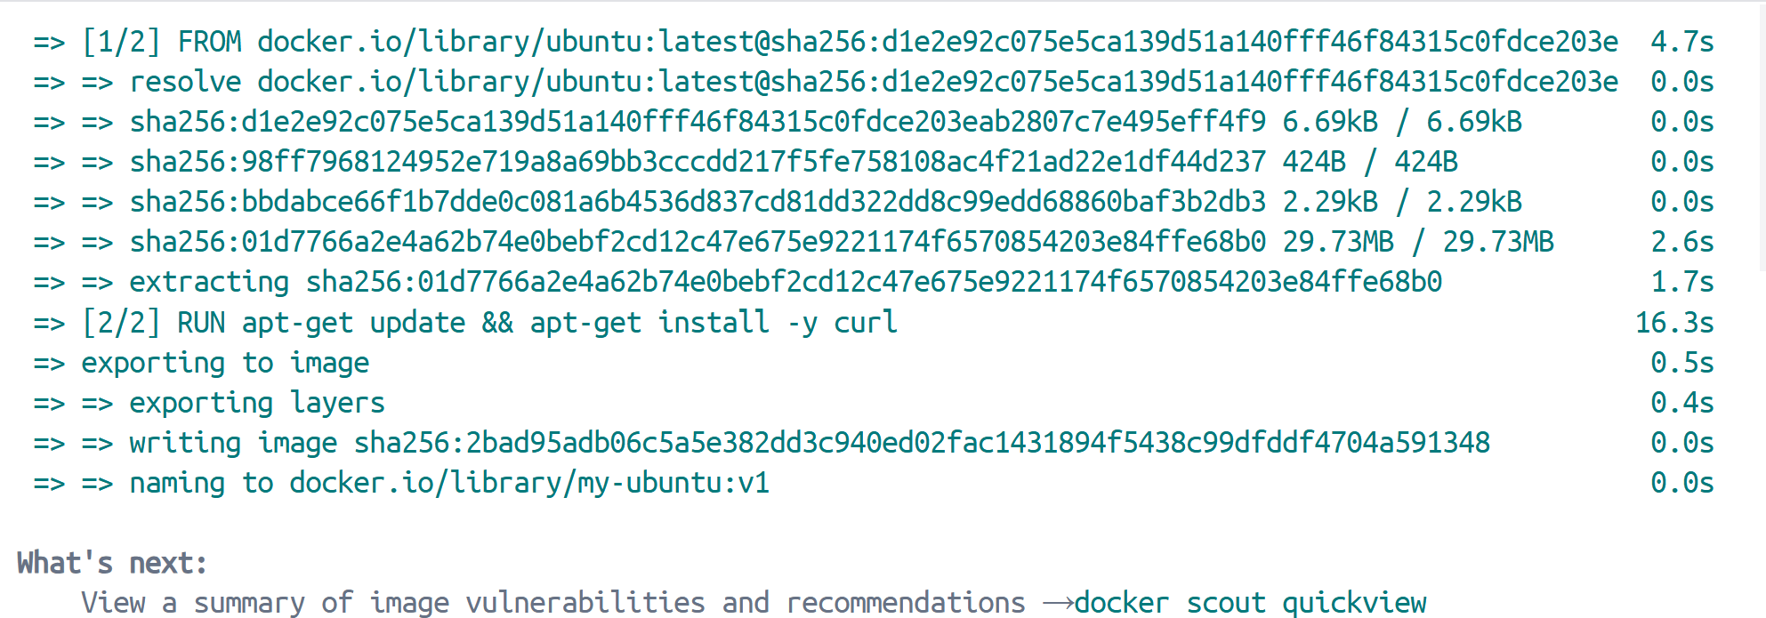
- Run a container from your image
docker run my-ubuntu:v1

## Task 2: Dockerfile Instructions
Create a new Dockerfile that uses all of these instructions:
- FROM — base image
- RUN — execute commands during build
- COPY — copy files from host to image
- WORKDIR — set working directory
- EXPOSE — document the port
- CMD — default command
Build and run it. Understand what each line does.
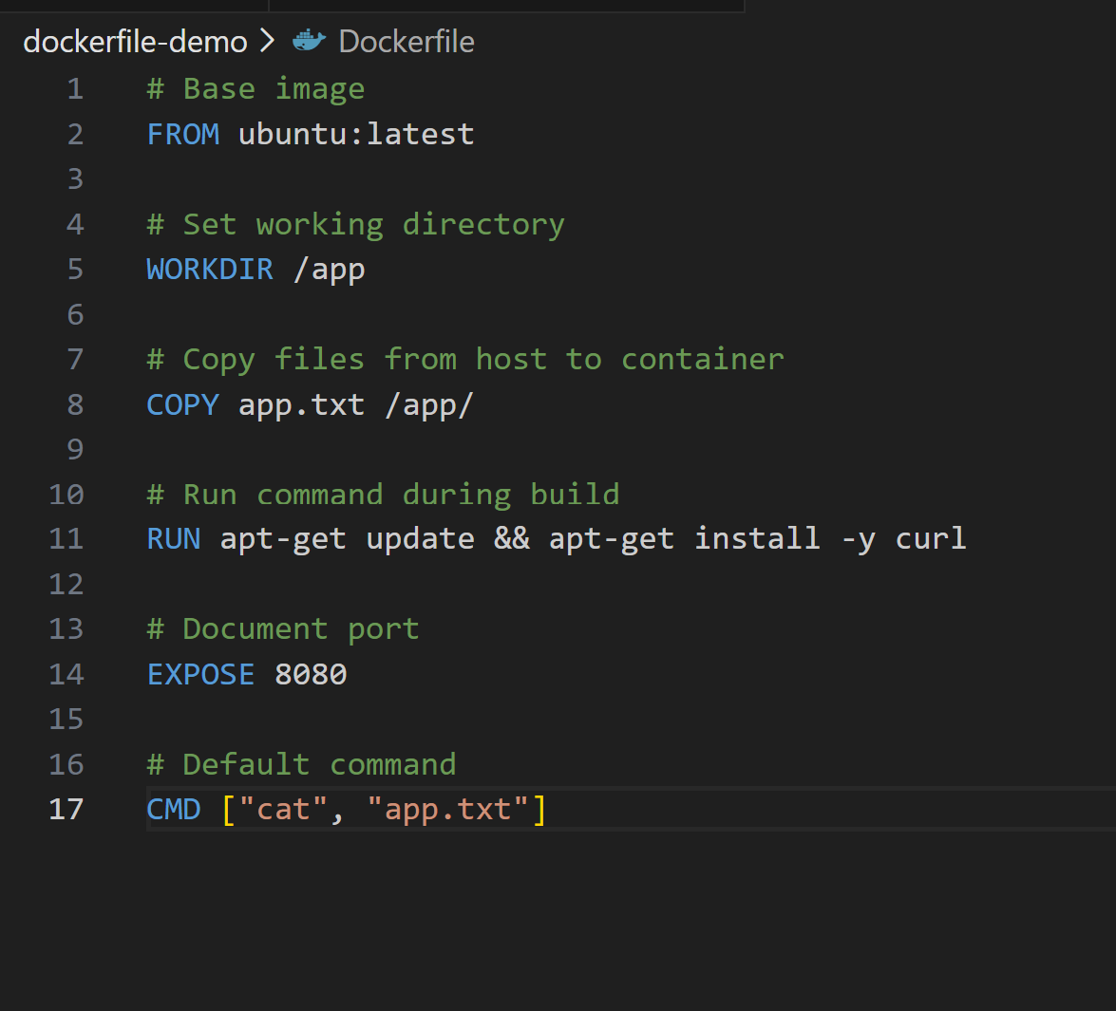
What each instruction Does:
| Instruction | Purpose |
| ----------- | ---------------------------------- |
| FROM | Defines base image |
| RUN | Executes commands during build |
| COPY | Copies files from host → container |
| WORKDIR | Sets working directory |
| EXPOSE | Documents container port |
| CMD | Default runtime command |

Building the image
docker build -t docker-demo:v1 .
Run the container
docker run docker-demo:v1
## Task 3: CMD vs ENTRYPOINT
- Create an image with CMD ["echo", "hello"] — run it, then run it with a custom command. What happens?
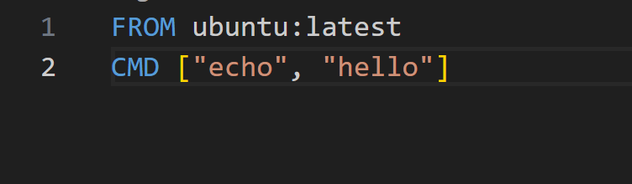

docker build -t cmd-image .
docker run cmd-image
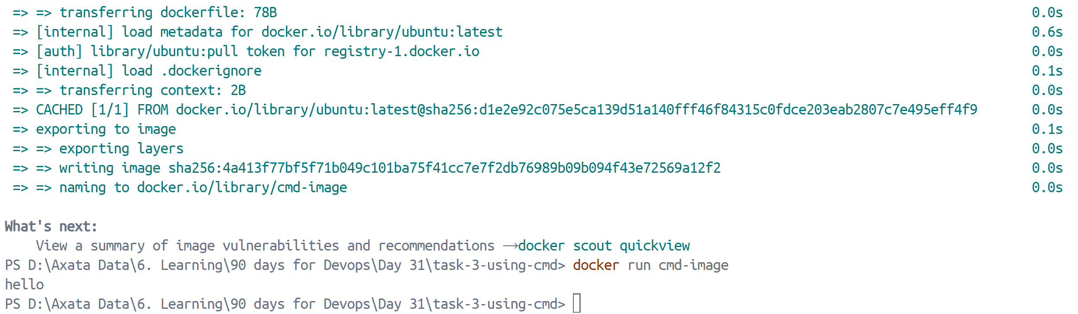
docker run cmd-image ls
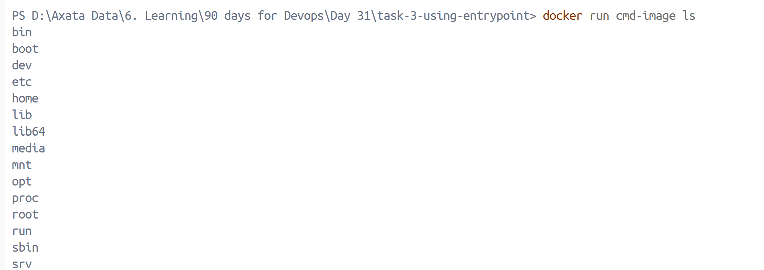
CMD gets overridden. ls runs instead.
- Create an image with ENTRYPOINT ["echo"] — run it, then run it with additional arguments. What happens?
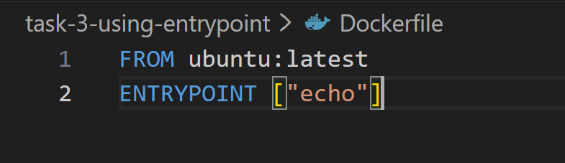

docker build -t entrypoint-image .
docker run entrypoint-image hello
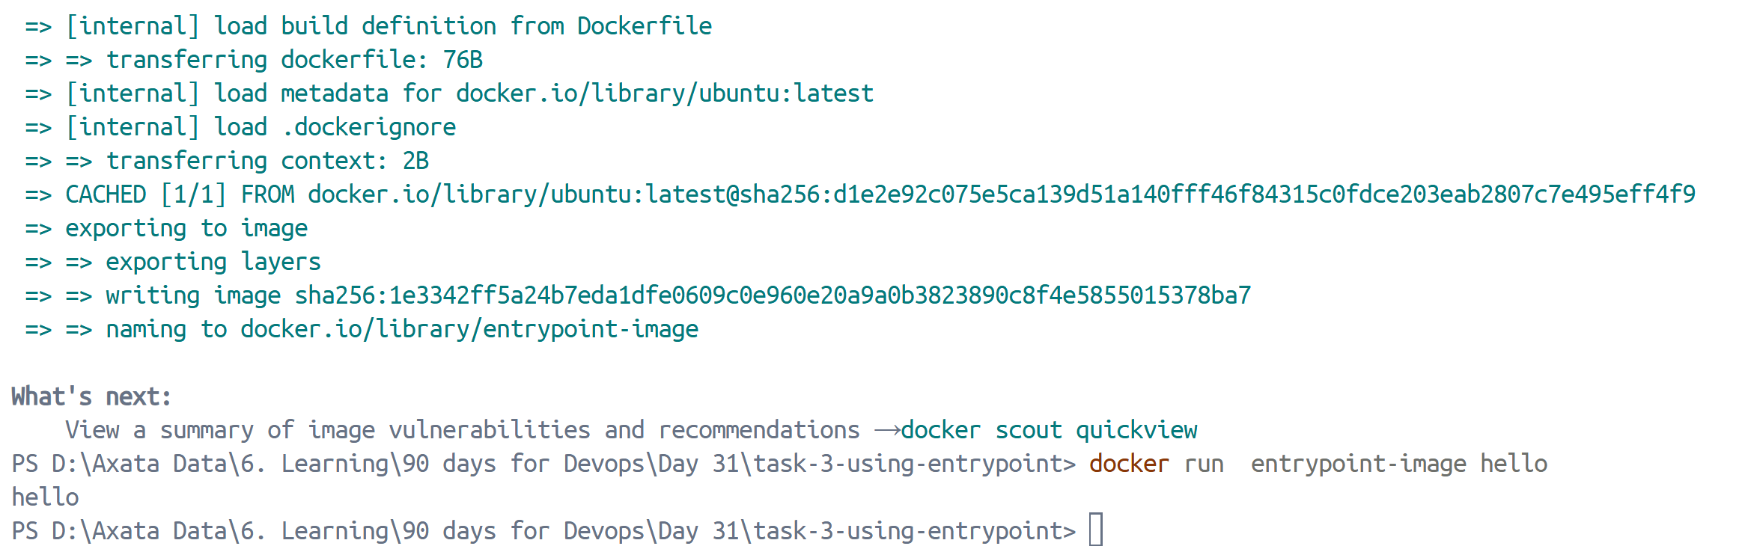
docker run entrypoint-image world
ENTRYPOINT does NOT get overridden.
Arguments are appended.

- Write in your notes: When would you use CMD vs ENTRYPOINT?
| Use Case | Use |
| -------------------------------------------- | ---------- |
| Default command that users can override | CMD |
| Force container to behave like an executable | ENTRYPOINT |
| CLI tools | ENTRYPOINT |
| Flexible dev images | CMD |

## Task 4: Build a Simple Web App Image
- Create a small static HTML file (index.html) with any content
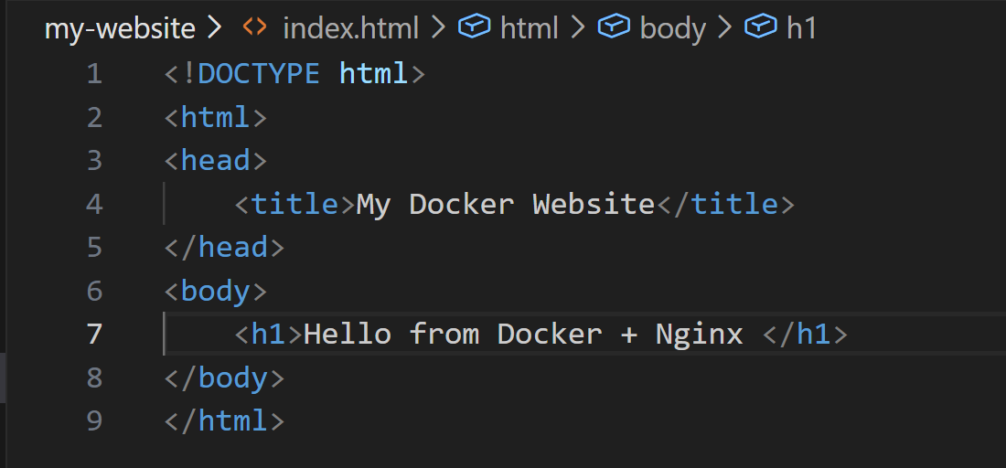
- Write a Dockerfile that:
- Uses nginx:alpine as base
- Copies your index.html to the Nginx web directory
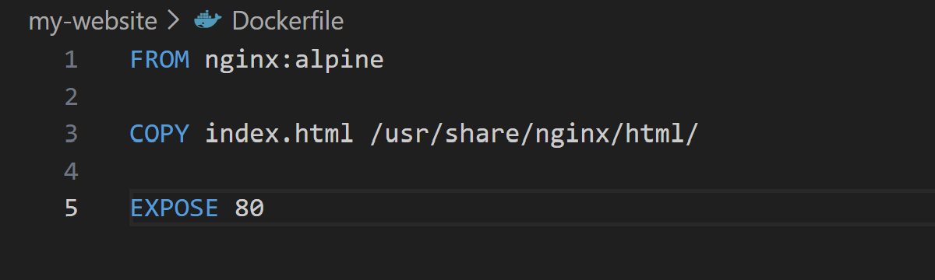
- Build and tag it my-website:v1
docker build -t my-website:v1 .
- Run it with port mapping and access it in your browser
docker run -p 8080:80 my-website:v1
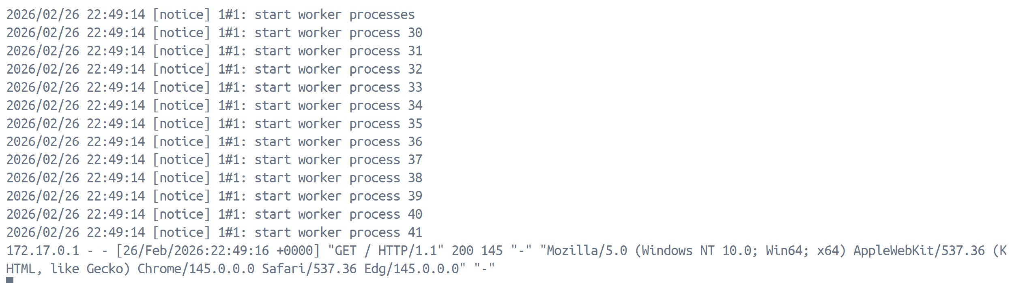
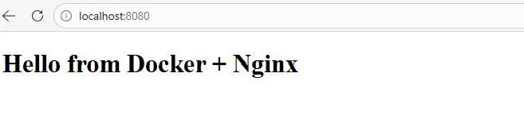
## Task 5: .dockerignore
- Create a .dockerignore file in one of your project folders
- Add entries for: node_modules, .git, *.md, .env
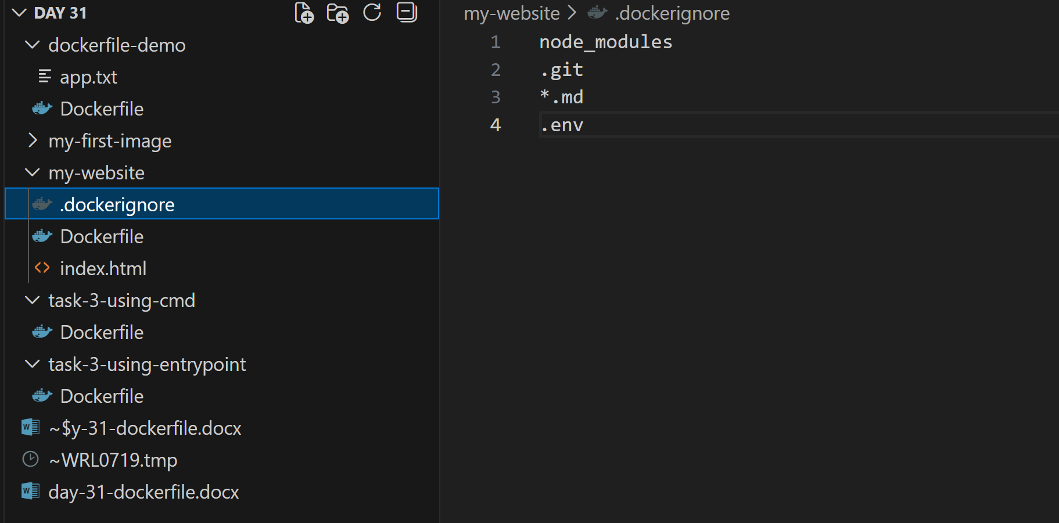
- Build the image — verify that ignored files are not included
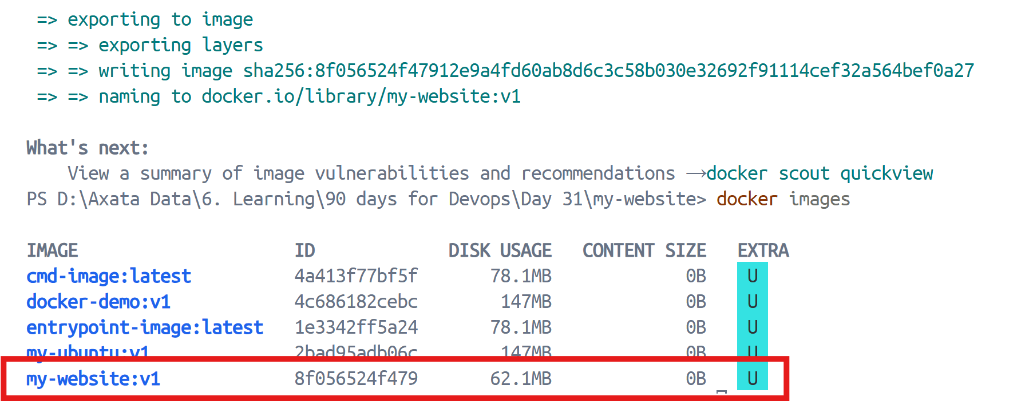
## Task 6: Build Optimization
- Build an image, then change one line and rebuild — notice how Docker uses cache
Docker reuses unchanged layers.
- Reorder your Dockerfile so that frequently changing lines come last
- Write in your notes: Why does layer order matter for build speed?
Docker builds images layer by layer.
If a layer changes:
- All layers after it rebuild.
Best Practice:
Put:
- Dependencies first
- Frequently changing code last
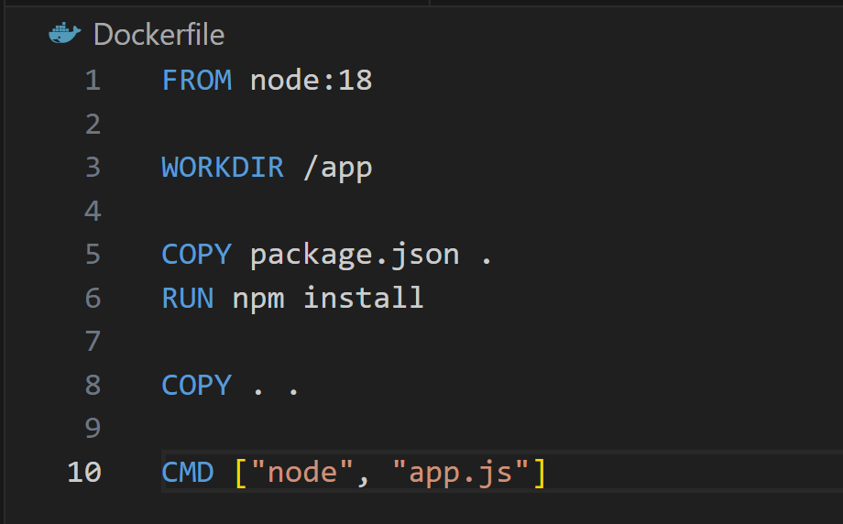

If app.js changes → only last layer rebuilds
If package.json changes → npm install runs again

