### Day 32 – Docker Volumes & Networking
## Task 1: The Problem
- Run a Postgres or MySQL container
docker run --name my-postgres -e POSTGRES_PASSWORD=admin -d postgres

- Create some data inside it (a table, a few rows — anything)
Enter Container
docker exec -it my-postgres bash
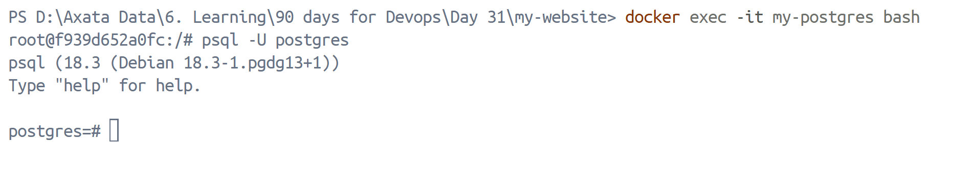
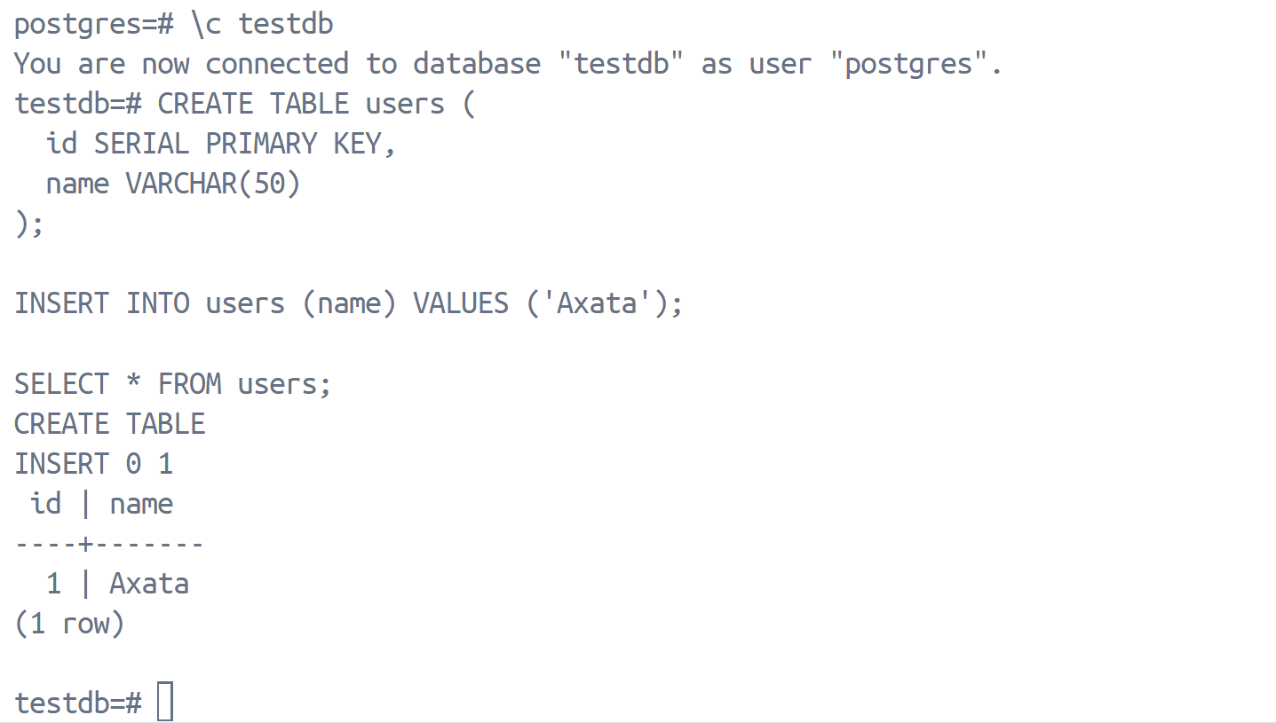
- Stop and remove the container
docker stop my-postgres
docker rm my-postgres
- Run a new one — is your data still there?
docker run --name my-postgres -e POSTGRES_PASSWORD=admin -d postgres
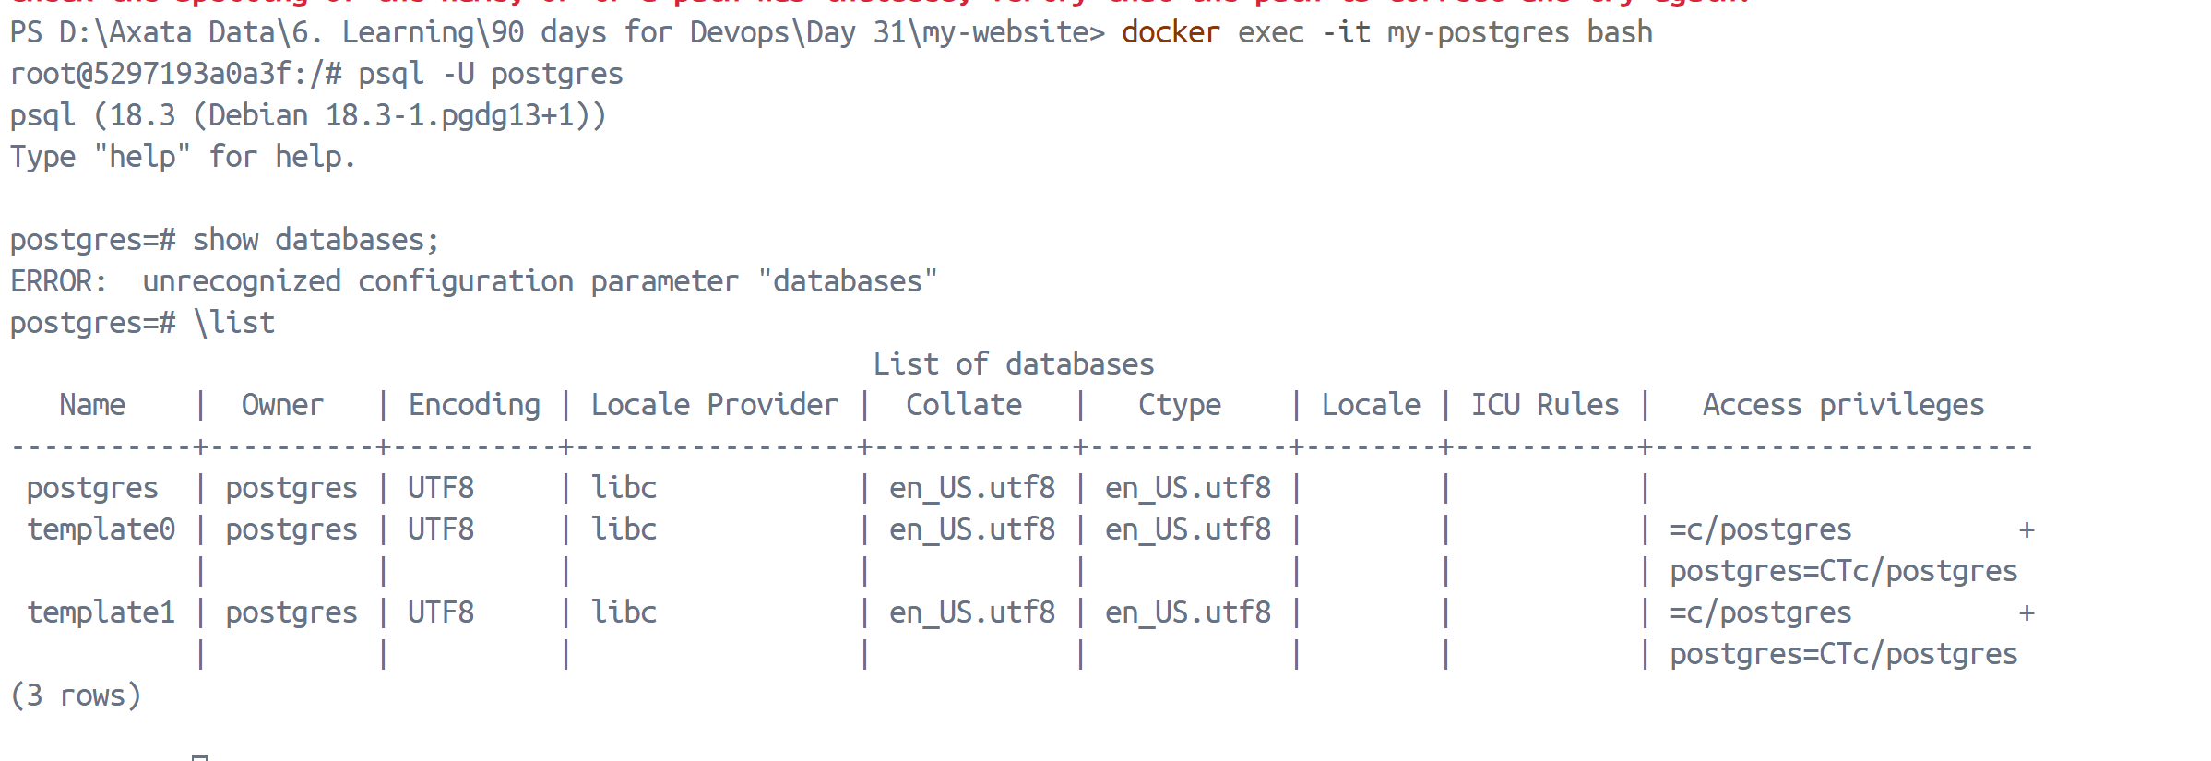
Result:
The database and table were gone.

Why?
Because container storage is ephemeral.
When the container is removed, its writable layer is deleted.
## Task 2: Named Volumes
- Create a named volume
docker volume create pgdata
docker volume ls
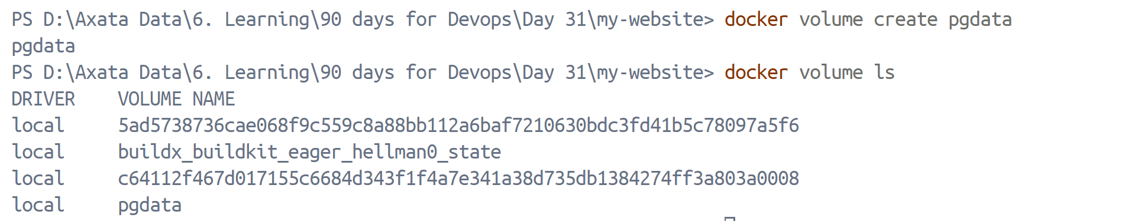
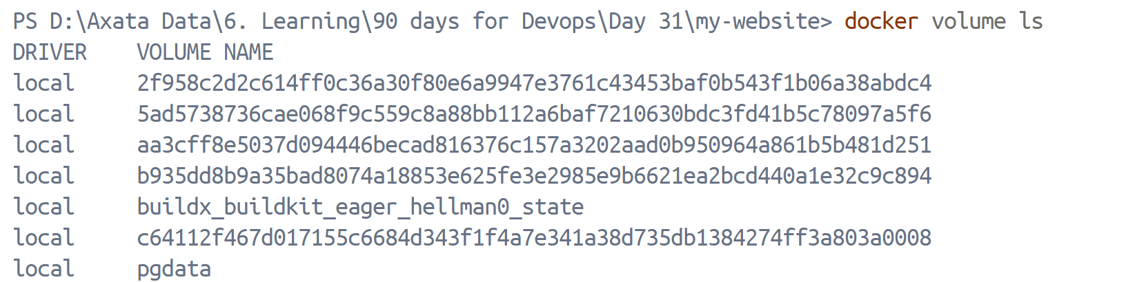
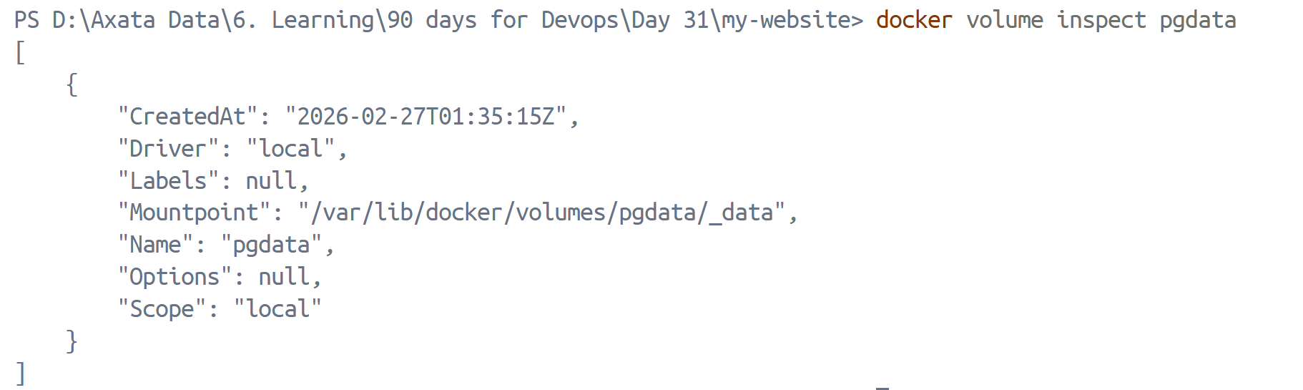
- Run the same database container, but this time attach the volume to it
docker run --name my-postgres -e POSTGRES_PASSWORD=admin -p 5432:5432 -v pgdata:/var/lib/postgresql -d postgres
- Add some data, stop and remove the container
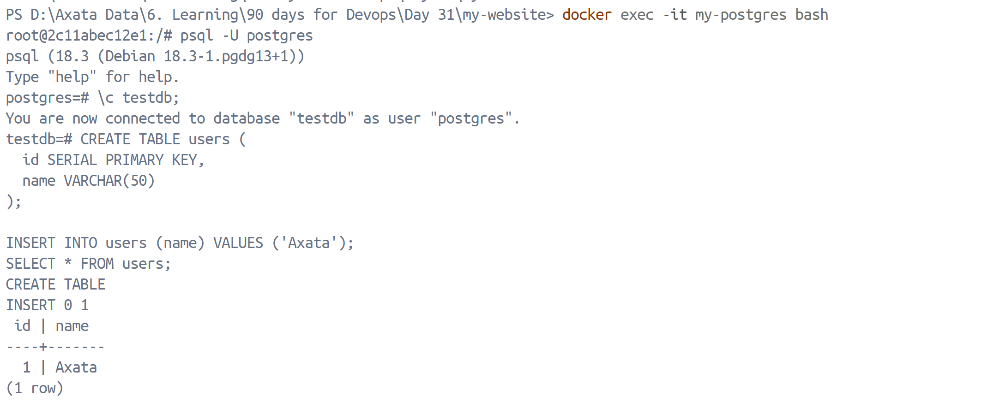
- Run a brand new container with the same volume
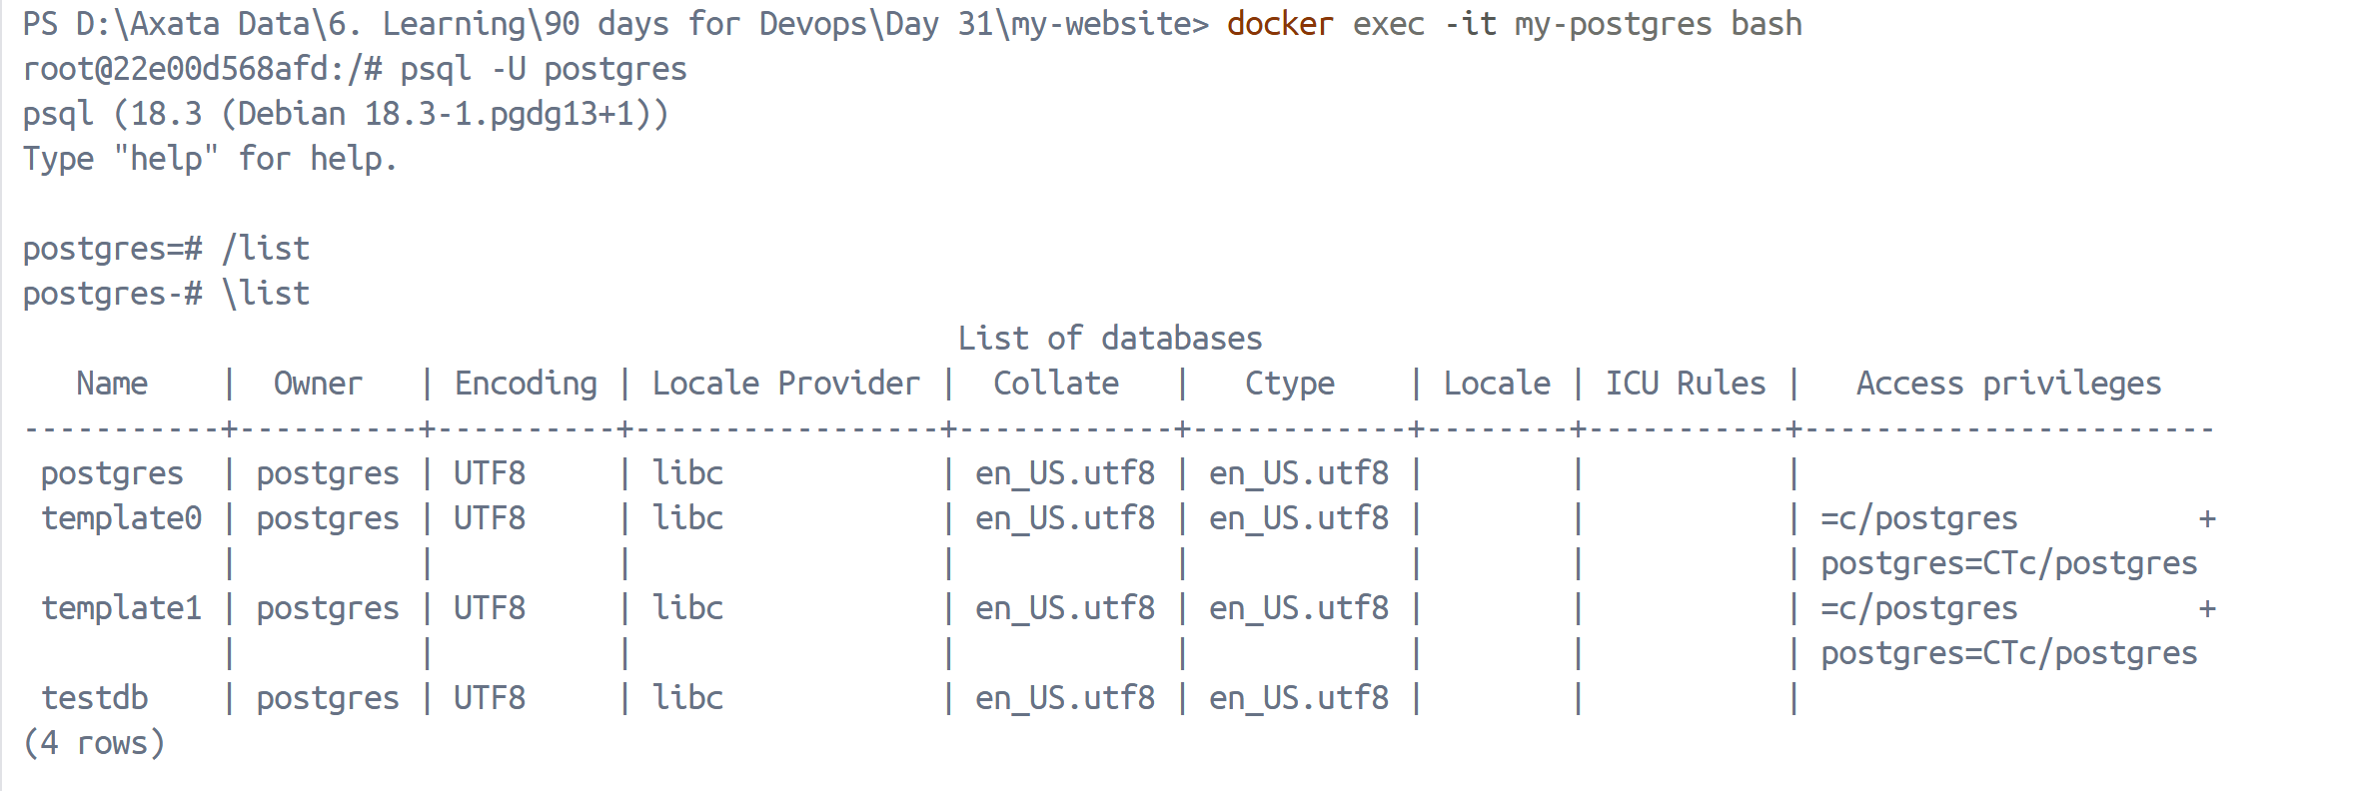
- Is the data still there?
Yes, data is still here
## Task 3: Bind Mounts
- Create a folder on your host machine with an index.html file
- Run an Nginx container and bind mount your folder to the Nginx web directory
docker run --name my-nginx -p 8080:80 -v ${pwd}:/usr/share/nginx/html -d nginx
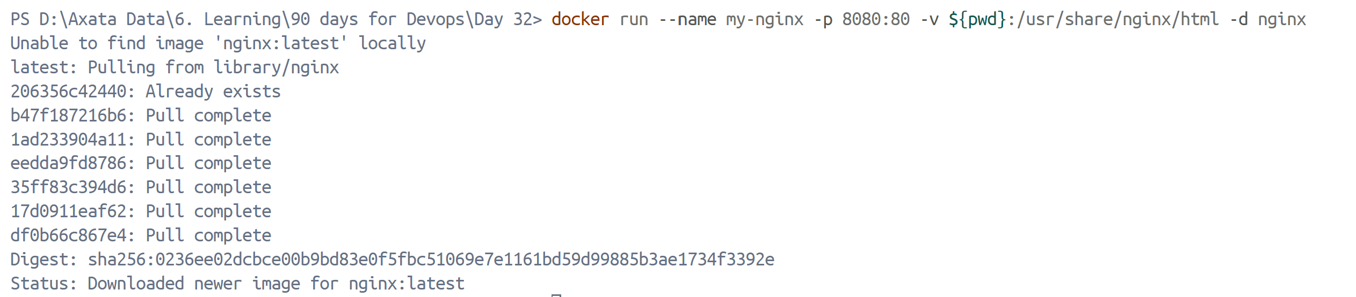
- Access the page in your browser

- Edit the index.html on your host — refresh the browser
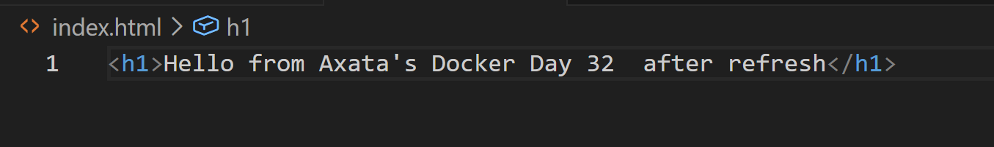

- Write in your notes: What is the difference between a named volume and a bind mount?
| Named Volume | Bind Mount |
| ----------------------------------- | ----------------------------- |
| Managed by Docker | Managed by Host |
| Stored in Docker internal directory | Direct mapping to host folder |
| Better for production databases | Great for development |
| Harder to access directly | Easy to edit files |

## Task 4: Docker Networking Basics
- List all Docker networks on your machine
docker network ls
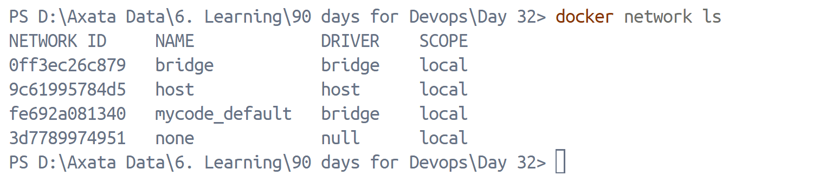
- Inspect the default bridge network
docker network inspect bridge
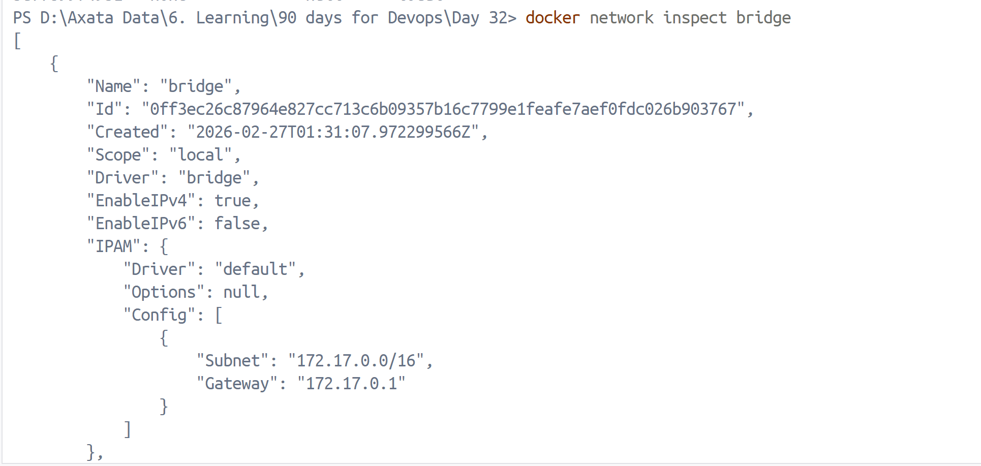
- Run two containers on the default bridge — can they ping each other by name?
docker run -dit --name container1 ubuntu
docker run -dit --name container2 ubuntu
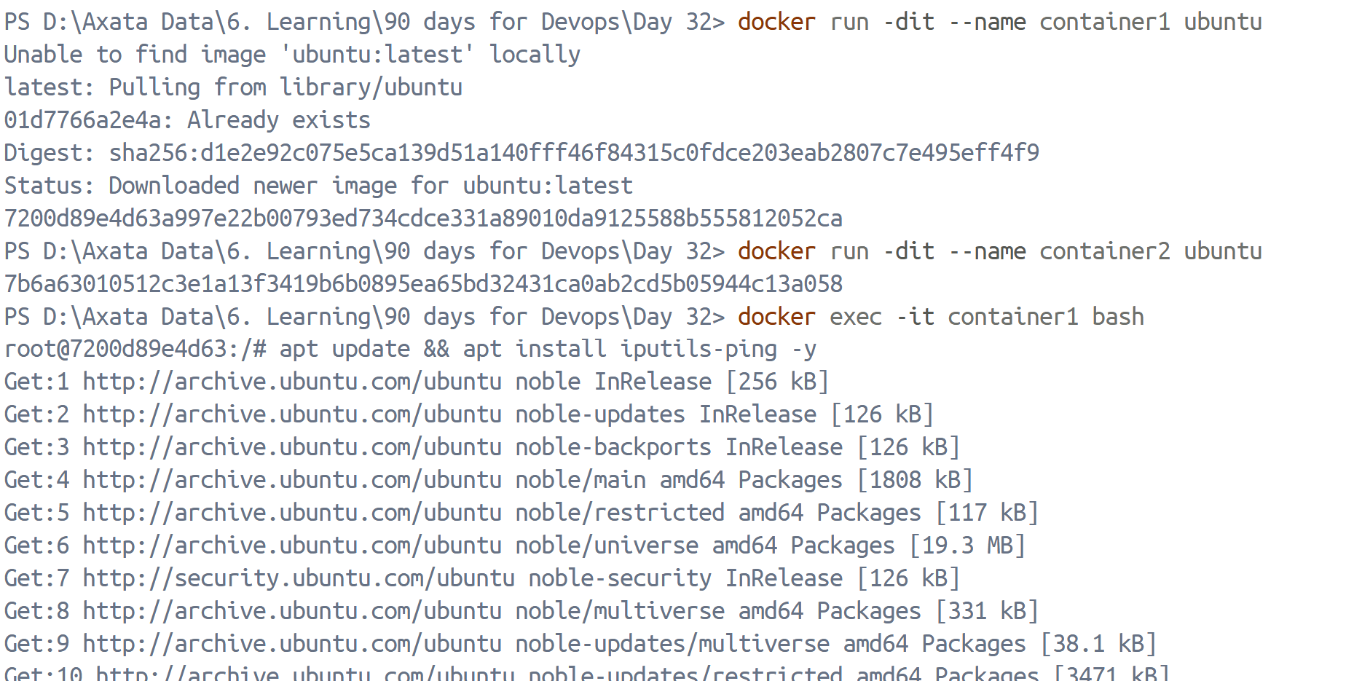
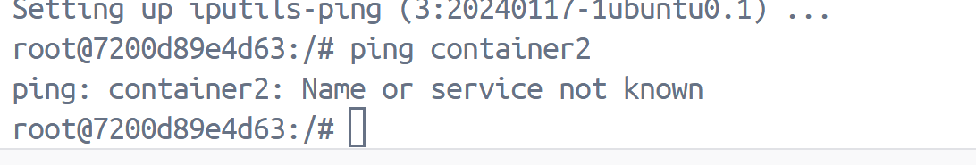
It fails

- Run two containers on the default bridge — can they ping each other by IP?
Identify IP address of container 2 using:
docker inspect container2
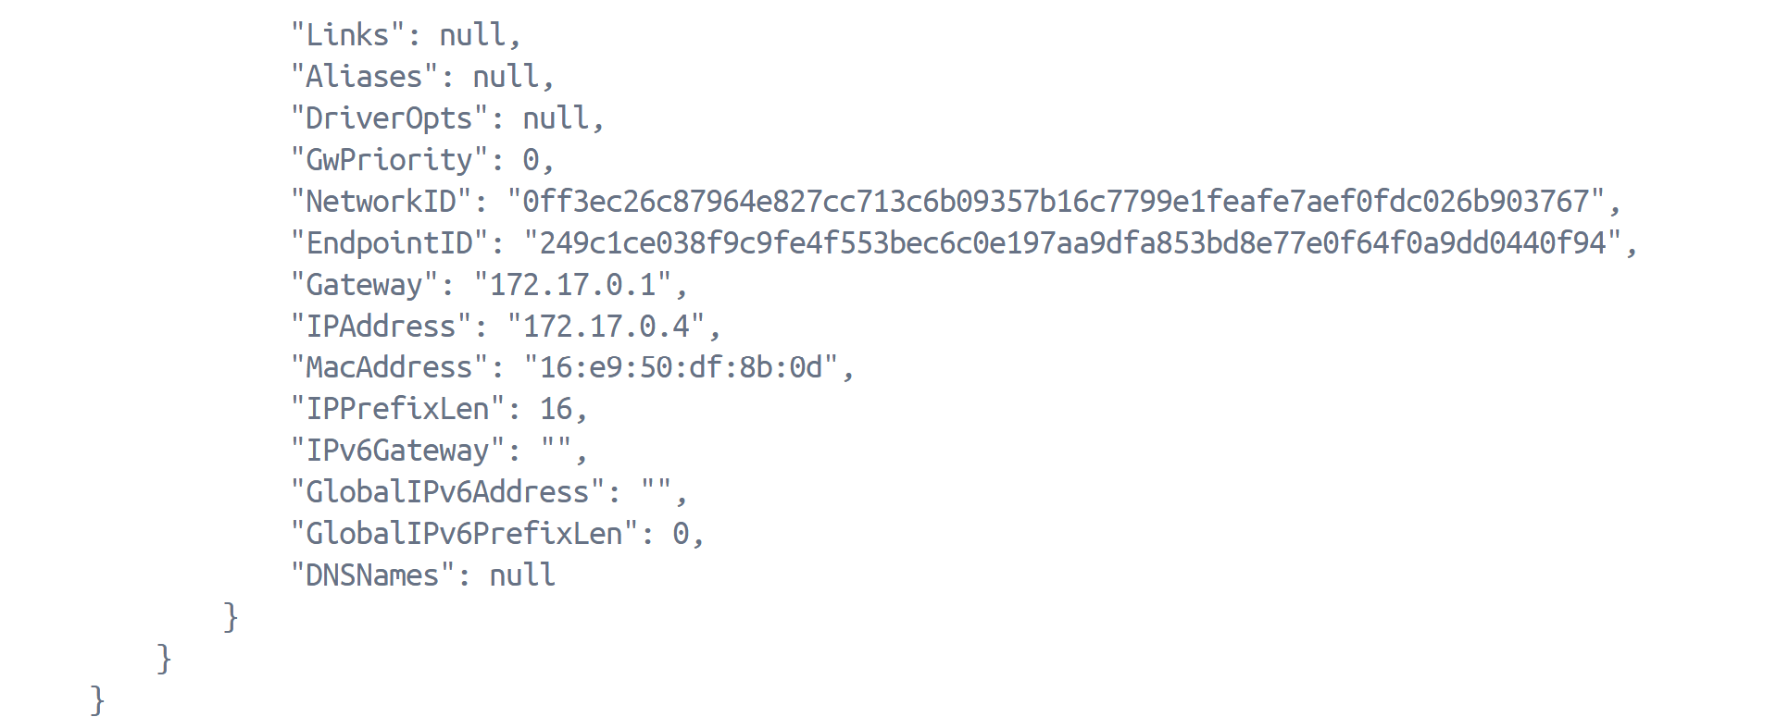
Now from container 1 , ping container2 using ip address:
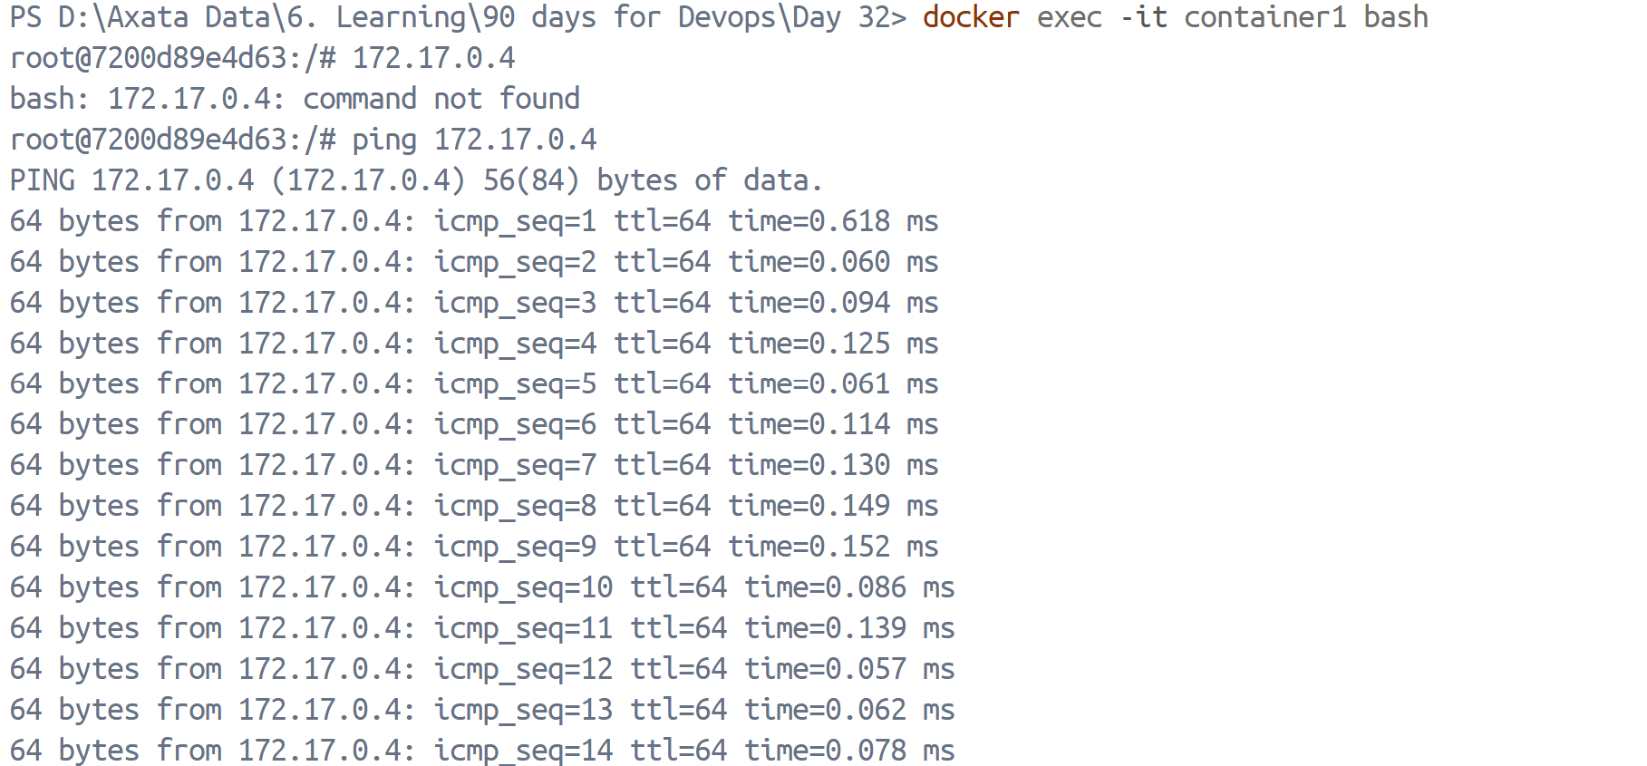
## Task 5: Custom Networks
- Create a custom bridge network called my-app-net
docker network create my-app-net
- Run two containers on my-app-net
docker run -dit --name container1 --network my-app-net ubuntu
docker run -dit --name container2 --network my-app-net Ubuntu
- Can they ping each other by name now?
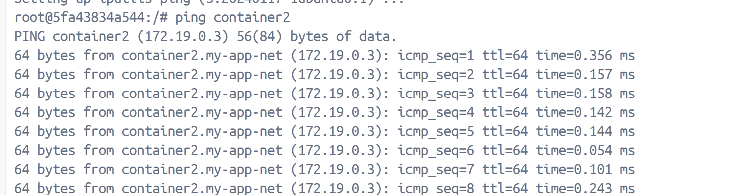
Yes, they can ping each other by name
- Write in your notes: Why does custom networking allow name-based communication but the default bridge doesn't?
- User-defined bridge networks include an embedded DNS server.
- Default bridge does NOT automatically enable name resolution.
## Task 6: Put It Together
- Create a custom network
docker network create my-full-app-net
- Run a database container (MySQL/Postgres) on that network with a volume for data
docker volume create mysql-data
docker run --name mysql-db -e MYSQL_ROOT_PASSWORD=admin -v mysql-data:/var/lib/mysql --network my-full-app-net -d mysql
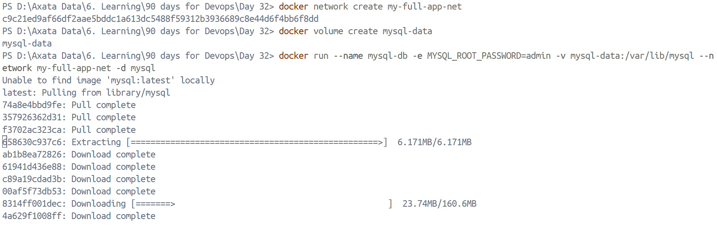
- Run an app container (use any image) on the same network
docker run -it --name app-container --network my-full-app-net ubuntu bash
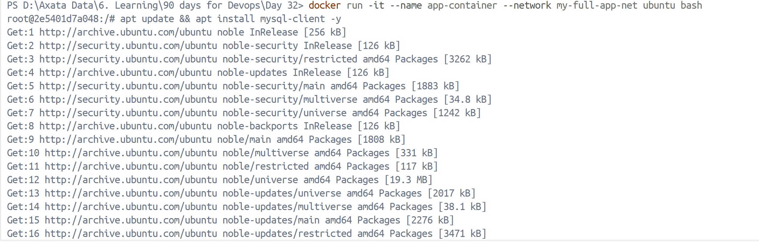
- Verify the app container can reach the database by container name
apt update && apt install mysql-client –y
mysql -h mysql-db -u root -p
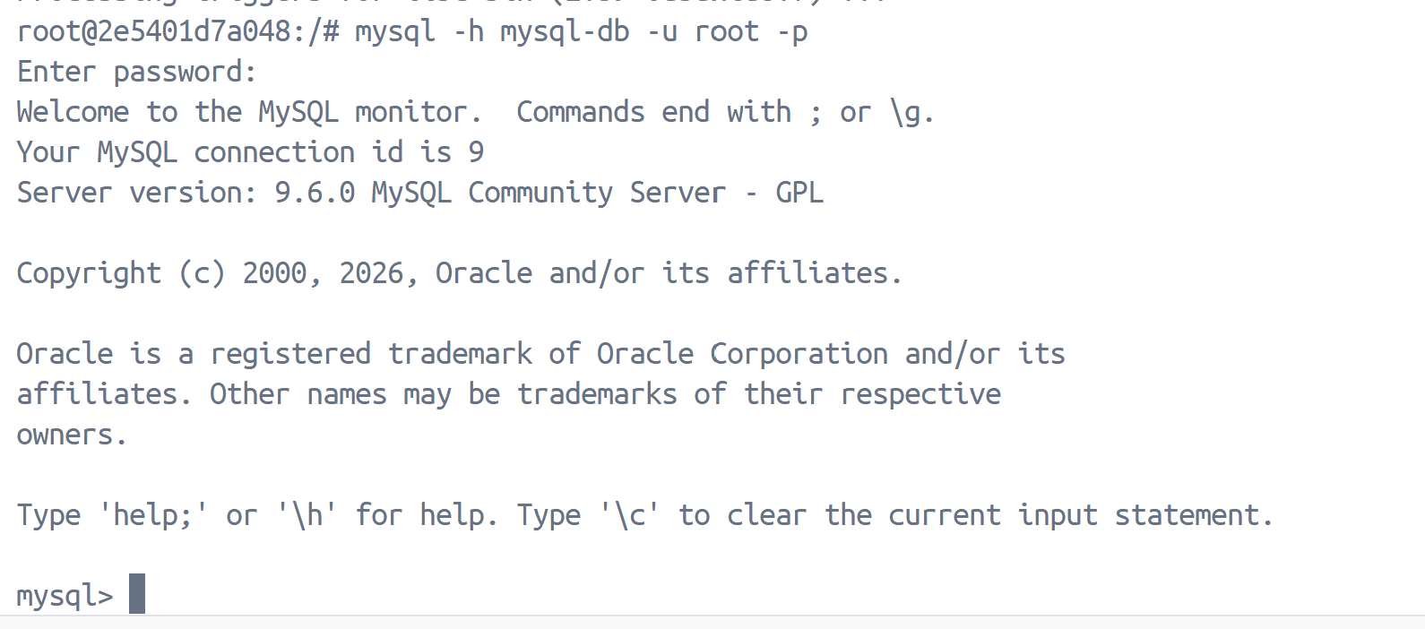
Connection successful.

